IEEE P802.11
Wireless LANs
MAC Comments for Discussion
Date: 2017-09-09
Author(s):
Name | Affiliation | Address | Phone | email
Mark Hamilton | Ruckus/Brocade | 350 W Java Dr  Sunnyvale, CA 94089 | +1.303.818.8472 | mark.hamtilon2152@gmail.com
Abstract

This submission highlights some MAC CIDs for TGm discussion. CIDs included: 3, 15, 40, 106, 116, 134, 174, 197, 198, 180, 266, 283, 290, 326, 337, and 362.

CID | Clause | Page | Line | Submission | Comment | Proposed Change
3 | 10.24.2 | 1523 | 7 |  | Setup of block ack agreement requires too much management overhead | Add an Implicit Block ACK mechanism. Draft text to be provided.

Discussion

Chris Hansen to discuss/present.

RESOLUTION

CID | Clause | Page | Line | Submission | Comment | Proposed Change
15 | 9.4.2.171.2 | 1186 | 13 |  | what is "conditional"? Should it be "optional"? | Change "conditional" to "optional", 2 instances.

Discussion

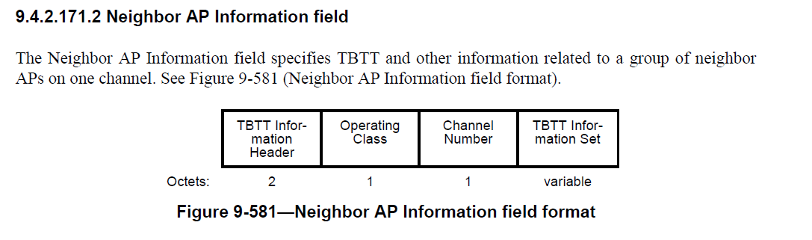
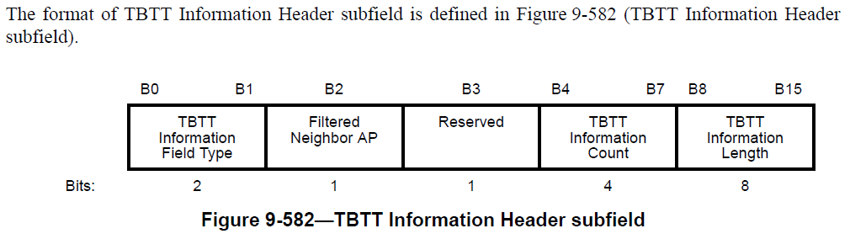
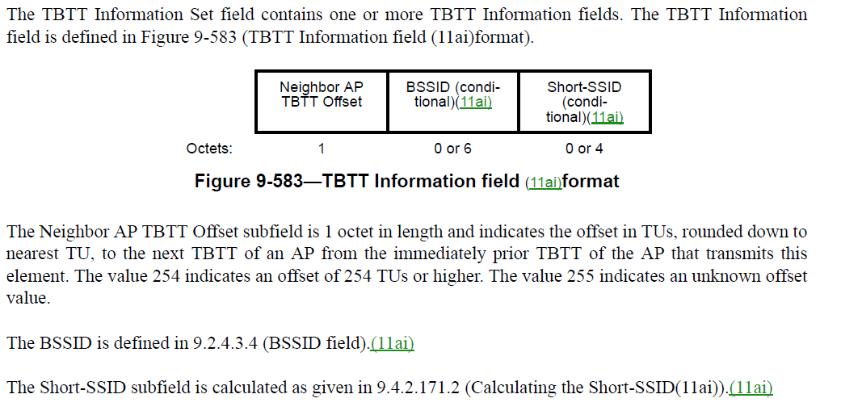

Agree in principle. What is our current convention, if the length is "0 or 6", etc - is that also "optional" or does the "0 or" already make it optional? (Current draft is inconsistent – “Optional” or “(optional)” are mostly “0 or <n>” or “variable”; many “0 or <n>” are not maked optional.)

RESOLUTION

CID | Clause | Page | Line | Submission | Comment | Proposed Change
40 | 11.1.4.3.7 | 1714 | 1 |  | "If a vendor-specific subelement is included in an element within the BSS Configuration Parameter Set," Unfortunately the previous list specifically states that VS IE is excluded so this is confusing. Therefore, delete Vendor Specific element from the list P1713L62 | At P1713 L62 delete "- Vendor Specific element"

Discussion

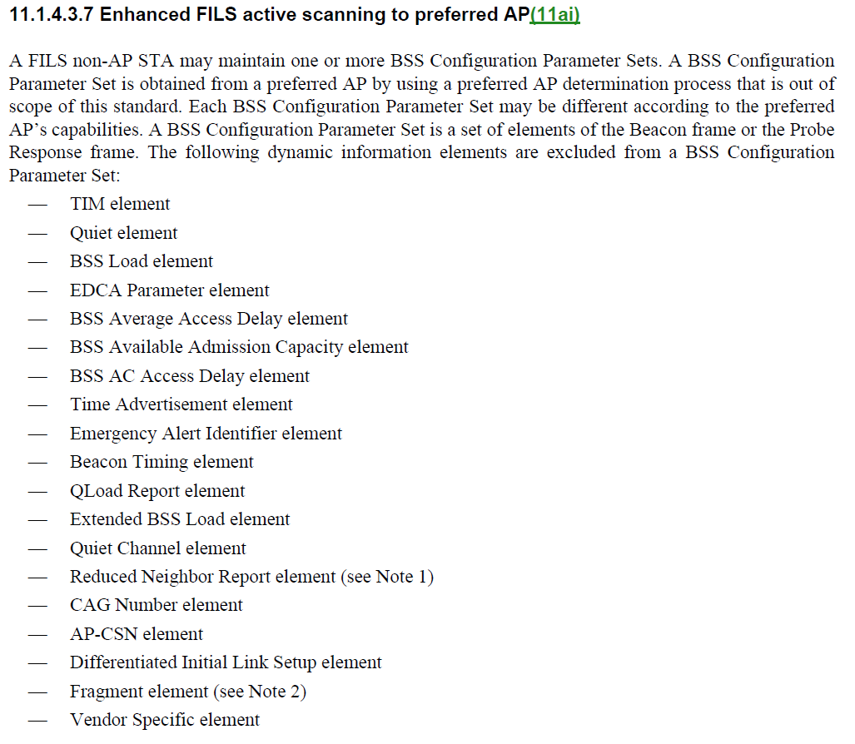
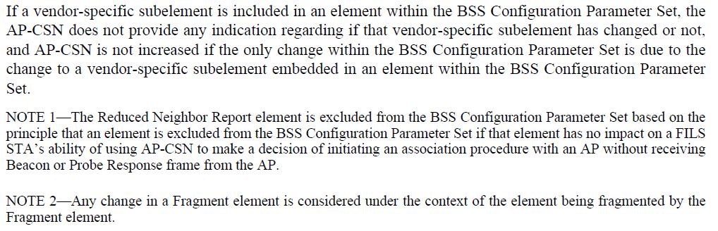

Propose: Rejected. The text at P1714.1 says "is included in an element within the BSS Configuration Parameter Set". So, a VSE is not directly included, but might be included through embedding.

RESOLUTION

CID | Clause | Page | Line | Submission | Comment | Proposed Change
106 | 11.1.3.8 |  |  |  | There has been multiple incompatible interpretation among (or within, as may be the case sometimes) vendors on how Multiple BSSID functionality is supposed to work and how addresses can or cannot change during a lifetime of a BSS. To avoid interoperability issues, it would be good to have a clear statement saying that there is exactly one transmitted BSSID for each nontransmitted BSSID and that transmitted BSSID cannot change during the lifetime of a BSS that uses a nontransmitted BSSID. | If the group agrees with my interpretation in the comment, please add an explicit statement with that clarification into 11.1.3.8 (Multiple BSSID procedure).

Discussion

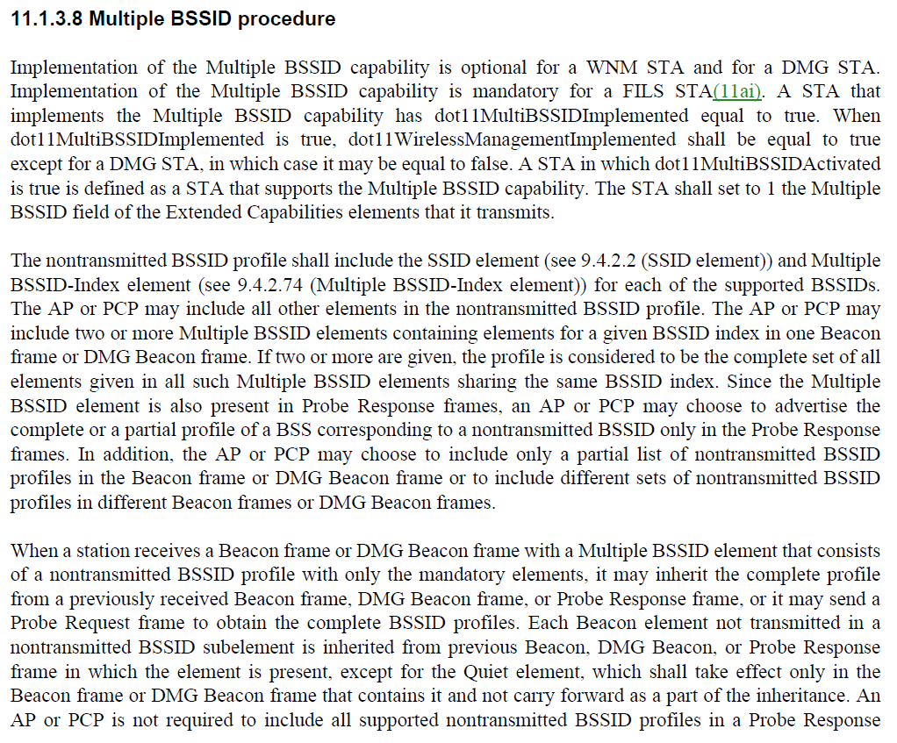
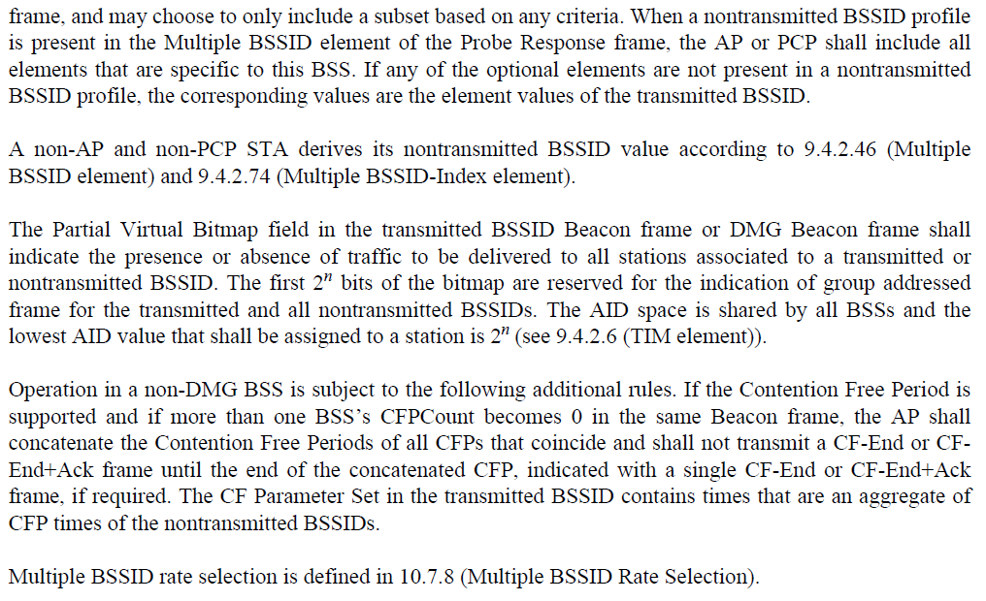

Per the commenter's (Jouni Malinen) request, discuss within TGm.

RESOLUTION

CID | Clause | Page | Line | Submission | Comment | Proposed Change
116 | 10.2.1 | 1398 | 1 |  | HCF doesn't really use DCF architecturally. It 'replaces' DCF. | Change Figure 10-1 to show HCF (EDCA and HCCA) as directly using the PHY. Cleanup text in 10.2, 10.3 and 10.22 to not describe HCF as using DCF.

Discussion

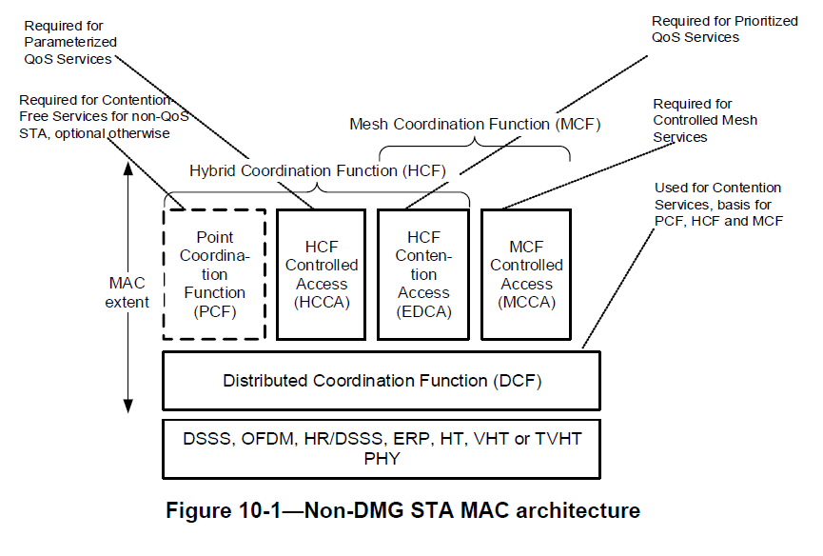

Needs a scrub to be sure the assertion in the Comment is true. Then, would require considerable changes (as noted in the Proposed Change). Discuss with TGm.

RESOLUTION

CID | Clause | Page | Line | Submission | Comment | Proposed Change
134 | 11.16.8 | 1878 | 15 |  | If the DSSS/CCK Mode in 40 MHz subfield is equal to 0 in a beacon/probe response, it is not clear whether the STA is required to set it to 0 in the association request. The description is "An HT STA declares its capability to use DSSS/CCK rates while it has a 40 MHz operating channel width", which is vague (capability to use v. intent to use) | Append "- The DSSS/CCK Mode in 40 MHz subfield transmitted by a (re)associating STA is ignored." at the end of the list in the para after the referenced location

Discussion

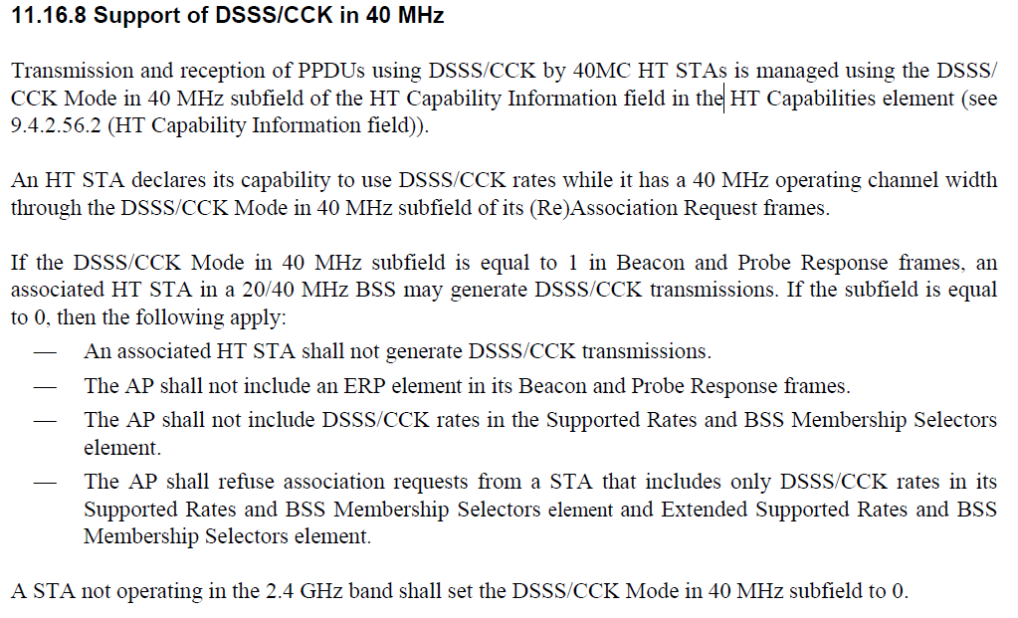

Propose: Accepted. Any issue with this (potential) change in behavior/requirement? (What if some existing APs don't ignore this? - although, it is not clear what they do, then)

RESOLUTION

CID | Clause | Page | Line | Submission | Comment | Proposed Change
174 | 10.21.5 | 1482 | 29 |  | Coverage classes are not interoperable, because there is no mechansim for an AP to know whether a STA supports them (and thence to deny association if it doesn't) | Mark coverage classes as obsolete and subject to deletion in a future version of the standard
197 | 11.9.3 | 1818 | 1 |  | Quiet Channel does not work in an IBSS because it's set by the BSS starter and replicated forever after. See further discussion under CID 7271 in 16/0276 | Delete or deprecate use of Quiet Channel elements in IBSSen
198 | 11.9.3 | 1818 | 1 |  | Quiet Channel does not work in an IBSS and probably doesn't work in an MBSS either. See further discussion under CID 7271 in 16/0276 | Delete or deprecate use of Quiet Channel elements in MBSSen

Discussion

Is there agreement from the TG? Is there any general guidance/agreement on features to be marked as Obsolete?

RESOLUTION

CID | Clause | Page | Line | Submission | Comment | Proposed Change
180 | 11.3.5.4 | 1773 | 54 |  | It is not clear what is reset in the case of (re)association to a different AP | At the end of the last step of 11.3.5.2, .3 add "All states, agreements and allocations shall be deleted or reset to initial values."  At the end of the last step of 11.3.5.5, add "In the case of reassociation to a different AP, all states, agreements and allocations shall be deleted or reset to initial values."

Discussion

Also note CID 179:

Comment: It is not clear what is reset in the case of reassociation to a different AP.

Proposed Change: At the end of step c) add "In the case of reassociation to a different AP, all states, agreements and allocations shall be deleted or reset to initial values."

Proposed Resolution: Revised. Add, as new paragraph at the end of step (c): "In the case of reassociation to a different AP (the CurrentAPAddress parameter is not the new AP's MAC address), all the states, agreements and allocations listed above are deleted or reset to initial values."

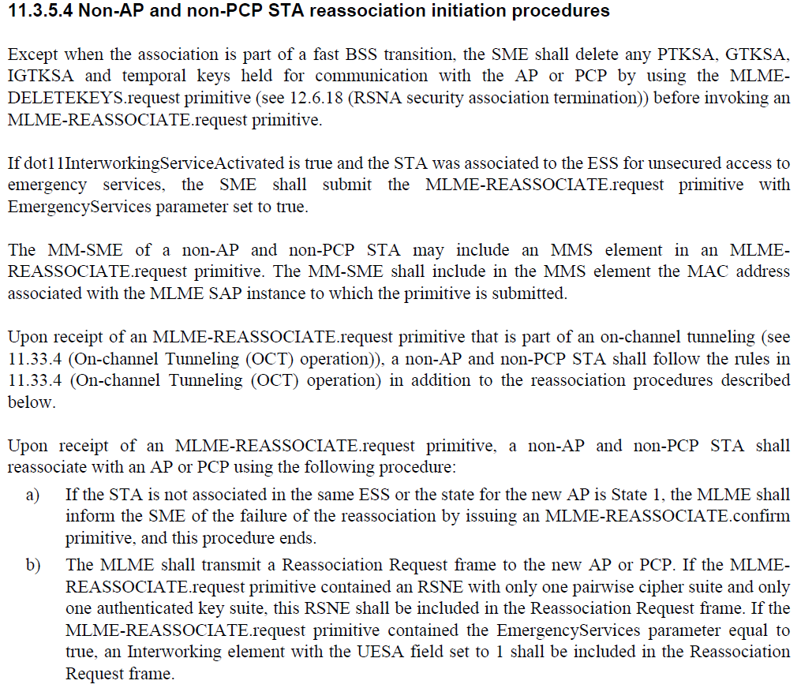
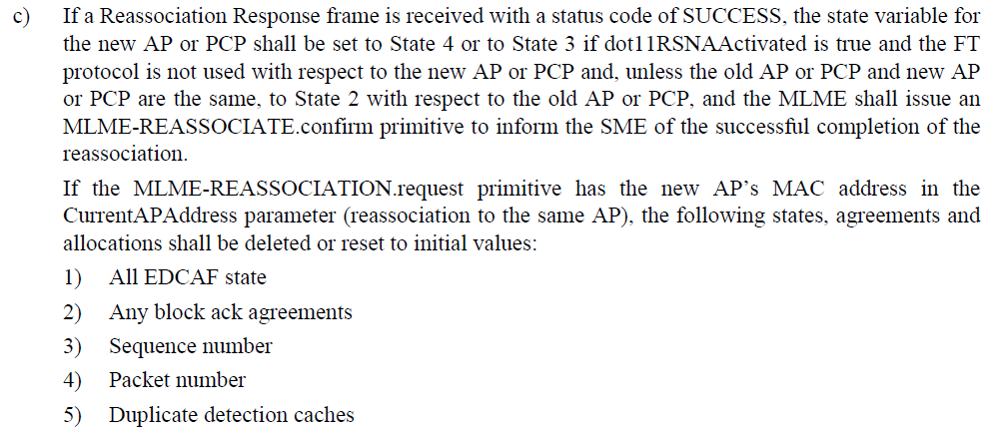
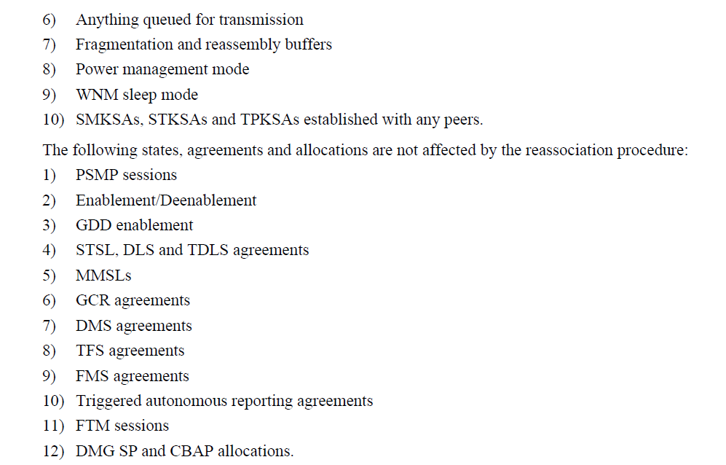

This needs further discussion. 1) Not all state is reset (for example, clearly the state for the AP (link) is not reset, any PMKSA is not reset, etc. So, we need to reference the list in 11.3.5.4, somehow, but probably don’t want to replace the list multiple times. This needs some restructuring, in a submission. 2) Are all the state variables reset if the response is not SUCCESS?

RESOLUTION

CID | Clause | Page | Line | Submission | Comment | Proposed Change
266 | 10.26.3.1 |  |  |  | "If the transmission requires protection and the Use_Protection field within the ERP element is equal to 0 or the  ERP element is not present in the Beacon, HT transmissions shall be protected using one of the mechanisms  identified in Table 10-14 (Applicable HT protection mechanisms)." appears to overlap the first row of Table 10-13---Protection requirements for HT Protection field values nonmember protection mode and non-HT mixed mode, Use_Protection = 0 or ERP element is not present (HT Protection field equal to non-HT mixed mode) | Delete the cited text

Discussion

Note – the cited text is at line 17, below (from P1550 of REVmd D0.1.)

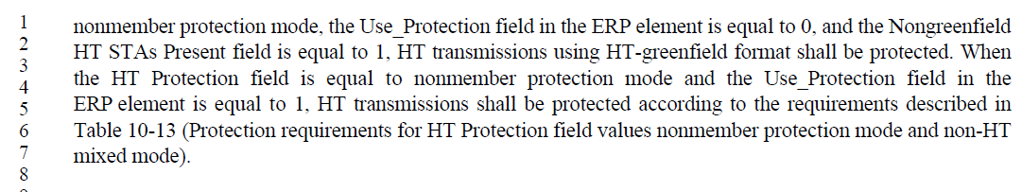
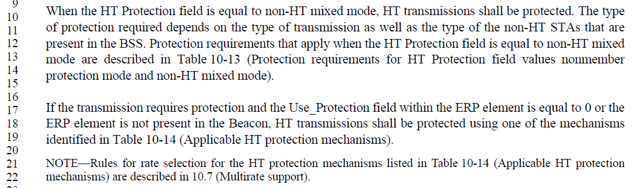
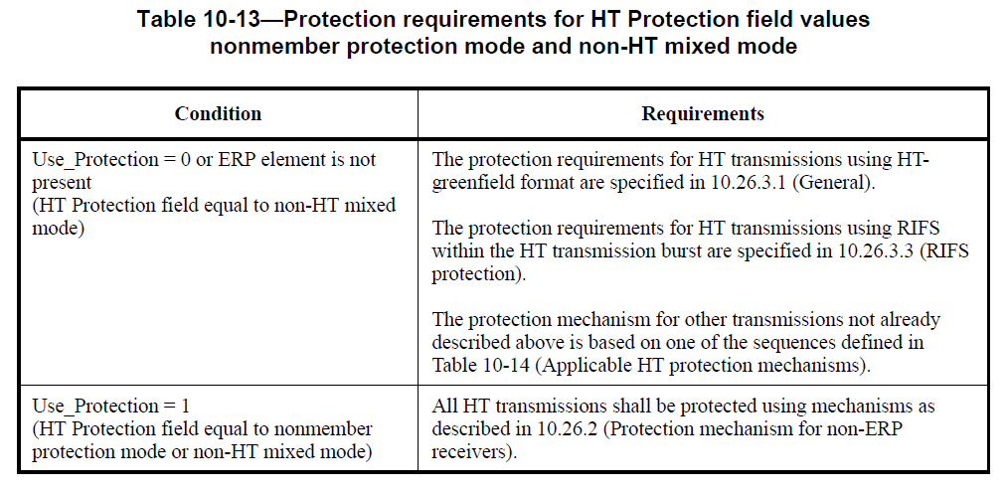
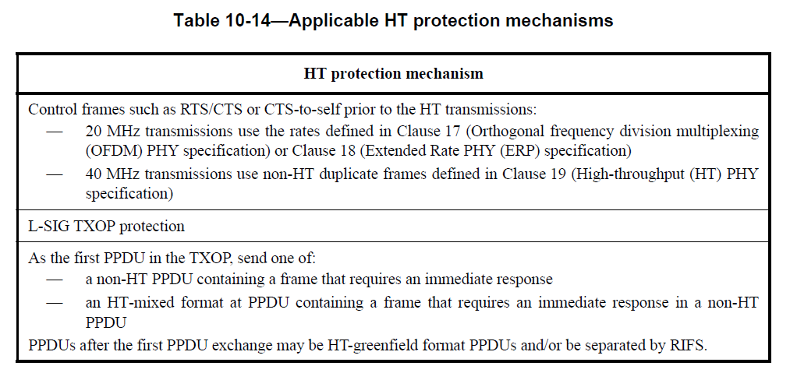

Is the Table 10-13 normative, so that the requirement to refer to Table 10-14 is mandatory, without text saying so? Even if so, is it helpful to have the text explaning the intent of the application of the third paragraph in the Table 10-13 entry?

RESOLUTION

CID | Clause | Page | Line | Submission | Comment | Proposed Change
283 | 9.4.2.1 |  |  |  | "The frame body components specified for many management subtypes result in elements ordered by  ascending values of the Element ID field and then the Element ID Extension field (when present), with the  exception of the MIC Management element (9.4.2.55 (Management MIC element)). If present, the MIC  Management element appears at the end of the robust management frame body." There are other exceptions, e.g. Quiet and TPC Report in beacons, VSIEs, AMPE. There is no general rule; you have to look at each frame's format as specified | Delete the cited text

Discussion

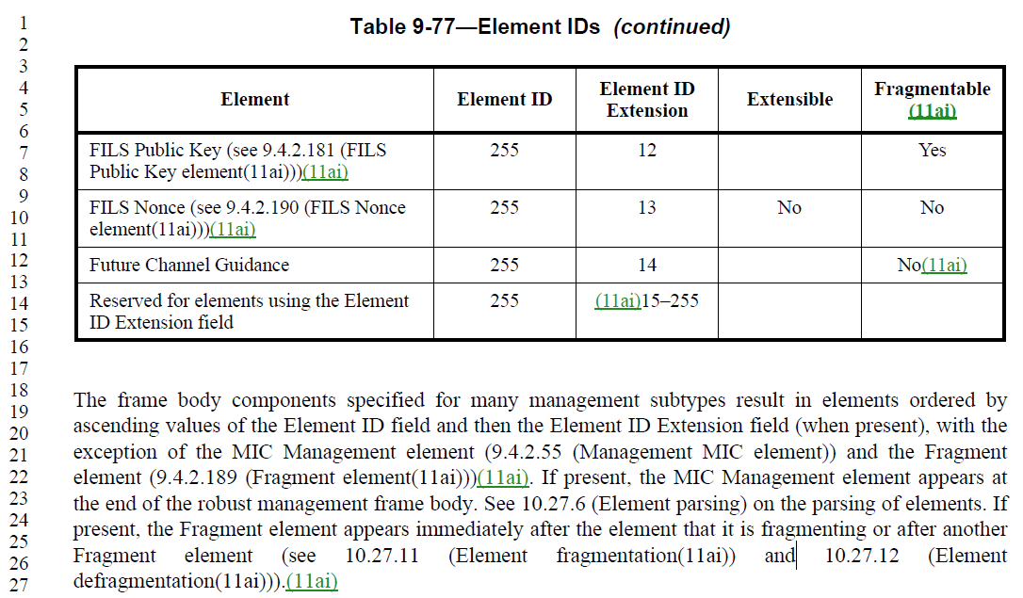

Propose: Accepted. (Editor, the cited text is at P843L18 in D0.1.) But, discuss with TG.

RESOLUTION

CID | Clause | Page | Line | Submission | Comment | Proposed Change
290 | 9.4.1.53 |  |  |  | "indicates the maximum number of spatial streams that the STA can receive" --- it only indicates an upper limit on the number of SS, since other things might further limit the NSS that the STA can receive (e.g. SMPS, Rx Highest Supported Long GI Data Rate). This issue was originally pointed to me by Matt FISCHER | Add "an upper limit on" after "indicates" in the cited text (2 instances)

Discussion

Isn't a "maximum number" already an "upper limit"?

RESOLUTION

CID | Clause | Page | Line | Submission | Comment | Proposed Change
326 |  |  |  |  | An RTT is the time between a signal going out and coming back. It includes any processing time at the other side. The spec uses "RTT" to mean the total time of flight, not the RTT | Delete the RTT definition from 3.4 and instead add "TOF time of flight"  At 83.58 change "round trip time (RTT)" to "distance"  At 1771.20 change "an RTT" to "a two-way TOF"  At 1772.28 change "The round trip time (RTT)" to "The two-way TOF" and change "RTT" to "TOF" in the equation  At 3598.21 change "RTT" to "two-way TOF"  (all references are to mc/D5.0)

Discussion

According to Wikipedia :) the current use of RTT is correct; the term does not include processing delay. But, many definitions are based on an assumption of zero delay at the far end (radar echo, etc.), and generally are written so that far-end delay would be included.
To change the term to time of flight (TOF) results in the need to talk about a "two-way" TOF (which isn't as well-known a phrase, although it is used commonly for two-way ranging), and somewhat more cumbersome wording.
In REVmd Draft, RTT is explicitly defined in equation 11-5, to not include the far-end delay, so this is an issue with "common belief" definition of the term, and not a technical issue with the spec. Thus referring to TGm for discussion.

RESOLUTION

CID | Clause | Page | Line | Submission | Comment | Proposed Change
337 | 10.21.3 | 1481 | 63 | 11-17-0950 | There should be global client operating classes that uniquely specify highest bandwidth offered across all channels, and when present in probe, (re)association requests mean that Supported Channels element(s) is/are not present. For example, a single new 20 MHz global operating class signals 20 MHz global classes 115, 118, 121, 124 and 125 are all supported across channels 36-165. A single new 40 MHz global operating class signals global 20 MHz classes and 40 MHz global classes 115, 117, 119, 120, 122, 123, 126 and 127 are all supported across channels 36-165. A single new 80 MHz global operating class signals global 20 MHz, 40 MHz and 80 MHz global class 128 are all supported across channels 36-165. A single new 160 MHz global operating class signals global 20 MHz, 40 MHz, 80 MHz and 160 MHz global classes 129 and 130 are all supported across channels 36-165. | Commenter will contribute draft text if there is interest in operating super-classes to reduce the time taken in multi-band probe, association and channel switch processes.

Discussion

MAC: 2017-08-18 14:24:28Z: Reviewed 11-17/950r1. Feedback is needed.

RESOLUTION

CID | Clause | Page | Line | Submission | Comment | Proposed Change
362 | 9.3.3.7 | 741 | 35 |  | The Association Response frame contains the Status Code field but not the Reason Code field. The description in the table is mixed up. | Change "Reason Code" in line 35 to "Status Code".

Discussion

A search for "REJECTED_WITH_SUGGESTED_BSS_TRANSITION" finds more places with the error in Reassoc's table, and also in text in 11.3.8. Might need global search for "frame with/has … Reason Code".

RESOLUTION

