IEEE P802.11
Wireless LANs
Channel BW field definition
Date: 2017-09-12
Author(s):
Name | Affiliation | Address | Phone | Email
Saehee Bang | LG |  |  | saehee.bang@lge.com
Jinmin Kim | LG |  |  | jinmin.kim@lge.com
Jinsoo Choi | LG |  |  | js.choi@lge.com
Sungjin Park | LG |  |  | allean.park@lge.com
Sanggook Kim | LG |  |  | sanggook.kim@lge.com
Sunwoong Yun | LG |  |  | Sunwoong.yun@lge.com
Solomon Trainin | Qualcomm |  |  | strainin@qti.qualcomm.com
Amichai Sanderovich | Qualcomm |  |  | amichais@qti.qualcomm.com
Carlos cordeiro | Intel |  |  | carlos.cordeiro@intel.com
Abstract
This document proposes to how indicate the bandwidth of PPDU When the PPDU contains an RTS, a DMG CTS or a DMG DTS frame.

Note: This draft text proposed to add the field value to indicate the bandwidth when
the PPDU contains an RTS, a DMG CTS or a DMG DTS frame.
Current method does not represent all combinations of channel BW cases
(Example: 2.16GHz + 2.16GHz (channel number 1and 5 ,1 and 6 , 2and 6),
4.32 GHz+ 4.32GHz (channe number { 1,2and 3,4 } , { 2,3 and 4,5 } , { 3,4 and 5,6 }
{ 1,2 and 4,5 } , { 2,3 and 5,6 } , { 1,2 and 5,6 } )
For dynamic channel bandwidth signaling in 11ay, the channel bandwidth information should be fully indicated.

We use the Turnaround field and scrambler initialization field for indicating Channel BW. The turnaround bit can be set to 0 or 1. It does not affect PHY performance. The channel BW field value is represented by the turnaround field and the scrambler initialization field of 5 bits.

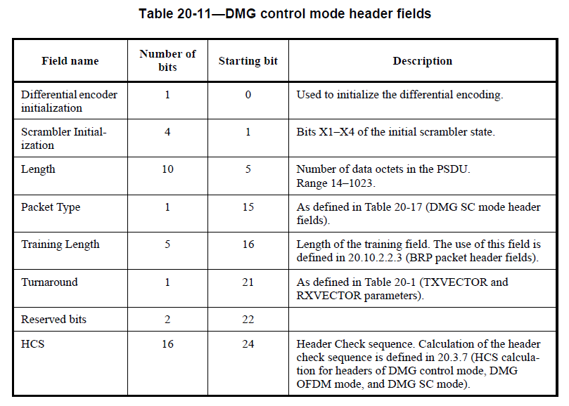

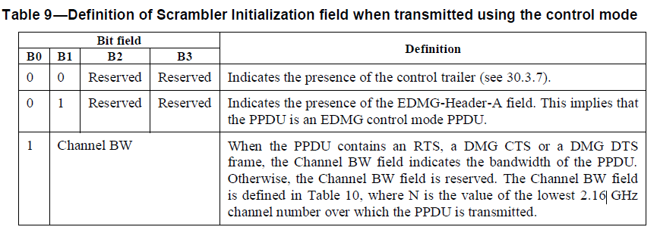
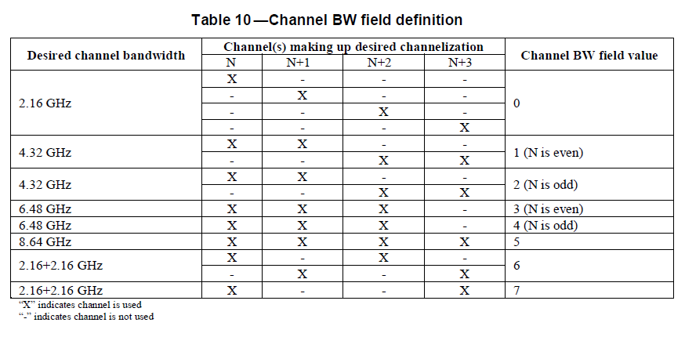

Change the text as follows

30.3.3 EDMG preamble
30.3.3.2 Non-EDMG portion of EDMG format preamble
30.3.3.2.5 L-Header definition
30.3.3.2.5.1 General

The structure of the L-Header field is defined as follows:

⎯ For a control mode PPDU, the L-Header field is the same as the DMG control mode header field
(see Table 20-11) and the reserved bits 22 and 23 shall be both set to 1. In this case:

⎯ The combination of the Scrambler Initialization field and the Turnaround field in the L-Header is interpreted as shown in Table 10.and

⎯ If the control mode PPDU is an EDMG control mode PPDU, the Length field shall be set so
that the spoofing error is non-negative and less than or equal to 150 ns, except for PPDU
durations between 347.56 μs and 347.93 μs and between 349.10 μs and 350.76 μs where the
maximum spoofing error shall be 0.37 μs and 1.66 μs, respectively. Spoofing error is defined
as the difference between the PPDU duration calculated based on L-Header and the actual PPDU duration.

Change the Table 10 as follows

Scrambler Initialization field |  |  |  | Turnaround field | Definition
B0 | B1 | B2 | B3 | B4
0 | 0 | Reserved | Reserved | 0 | Indicates the presence of the control trailer
0 | 1 | Reserved | Reserved | 0 | Indicates the presence of the EDMG-Header-A field. This implies that the PPDU is an EDMG control mode PPDU.
Channel BW |  |  |  |  | The Channel BW field indicates bandwidth of control mode PPDU and is used when the PPDU contains an RTS, a DMG CTS, or a DMG DTS frame. The encoding of the Channel BW field is defined in Table 11. Values not listed in Table 11 are reserved. The Channel BW field is defined in Table 11, where N is the value of the lowest 2.16 GHz channel number over which the PPDU is transmitted.

Change the Table 11 as follows
Table 11 Channel BW field definition
Desired channel bandwidth | 2.16 GHz channel(s) making up desired channelization |  |  |  |  |  | Channel  BW field  Value
 | CH#1 | CH#2 | CH#3 | CH#4 | CH#5 | CH#6
2.16GHz | x | - | - | - | - | - | 16
 | - | x | - | - | - | -
 | - | - | x | - | - | -
 | - | - | - | x | - | -
 | - | - | - | - | x | -
 | - | - | - | - | - | x
4.32GHz or  2.16 GHz + 2.16 GHz | x | x | - | - | - | - | 17
 | - | - | x | x | - | -
 | - | - | - | - | x | x
4.32GHz or  2.16 GHz + 2.16 GHz | - | x | x | - | - | - | 18
 | - | - | - | x | x | -
 | x | - | - | - | - | x
6.48GHz | x | x | x | - | - | - | 19
 | - | - | - | x | x | x
6.48GHz | - | x | x | x | - | - | 20
6.48GHz | - | - | x | x | x | - | 21
8.64GHz or  4.32 GHz+4.32 GHz | x | x | x | x | - | - | 22
8.64GHz or  4.32 GHz+4.32 GHz | - | x | x | x | x | - | 23
8.64GHz or  4.32 GHz+4.32 GHz | - | - | x | x | x | x | 24
2.16 GHz + 2.16 GHz | x | - | x | - | - | - | 25
 | - | - | - | x | - | x
2.16 GHz + 2.16 GHz | - | x | - | x | - | - | 26
 | - | - | x | - | x | -
2.16 GHz + 2.16 GHz | x | - | - | x | - | - | 27
 | - | x | - | - | x | -
 | - | - | x | - | - | x
2.16 GHz + 2.16 GHz | x | - | - | - | x | - | 28
 | - | x | - | - | - | x
4.32 GHz+ 4.32GHz | x | x | - | x | x | - | 29
4.32 GHz+ 4.32GHz | - | x | x | - | x | x | 30
4.32 GHz+ 4.32GHz | x | x | - | - | x | x | 31

SP & Motion

Do you agree to include the text for Channel BW definition proposed in (2017-TECH-LG-0025-06--Channel BW field definition) to the spec draft?

