IEEE P802.11
Wireless LANs
Comments on 11ax clauses 10.1 and 10.2
Date: 2017-09-08
Author(s):
Name | Affiliation | Address | Phone | email
Mark Hamilton | Ruckus/Brocade | 350 W Java Dr  Sunnyvale, CA 94089 | +1.303.818.8472 | mark.hamilton2152@gmail.com
Abstract
This submission builds upon (and shamelessly steals material from) 11-17/1220r2 [1], with proposed recommendations from the ARC SC to TGax, for changes to subclauses 10.1 and 10.2 in Draft 802.11ax.

11-17/1220r2 includes resolutions to P802.11ax Draft 1.0 ballot CIDs 4746, 5373, and 8207.

CID | Page | Clause | Comment | Proposed Change | Resolution
4746 | 113.03 | 10.2.1 | Need to update the MAC architecture (Figure 10-1) and respective definitions to host the enhancements for HE (UL MU, etc). | As in comment. | Revised.  TGax Editor to make changes proposed in <this document>
5373 | 113.05 | 10.2.1 | Update Figure 10-1--Non-DMG STA MAC architecture with new 11ax features (OFDMA, HE PHY, etc) | As in comment | Revised.  TGax Editor to make changes proposed in <this document>
8207 | 113.04 | 10.2 | The 802.11ax amendment introduces MU transmissions which is not supported by any of the control functions in Figure 10-1 of the 802.11-2016. There is a need to introduce a ne MU access function and add to the Figure. | as in comment. | Revised.  TGax Editor to make changes proposed in <this document>

10.1 Introduction
The MAC functional description is presented in this clause. The architecture of the MAC sublayer, including the distributed coordination function (DCF), the point coordination function (PCF), the hybrid coordination function (HCF), the mesh coordination function (MCF), the multi-user coordination function (MUCF), and their coexistence in an IEEE 802.11 LAN are introduced in 10.2 (MAC architecture). These functions are expanded on in 10.3 (DCF), 10.4 (PCF), 10.24 (HCF), 10.25 (Mesh coordination function (MCF)), and 27.2 (HE Channel Access). Fragmentation and defragmentation are defined in 10.5 (MPDU fragmentation(11ai)) and 10.6 (MPDU defragmentation(11ai)). Multirate support is addressed in 10.7 (Multirate support). A number of additional restrictions to limit the cases in which MSDUs are reordered or discarded are described in 10.8 (MSDU transmission restrictions). Operation across regulatory domains is defined in 10.23 (Operation across regulatory domains). The block ack mechanism is described in 10.26 (Block acknowledgment (block ack)). The No Ack mechanism is described in 10.27 (No Acknowledgment (No Ack)). The protection mechanism is described in 10.28 (Protection mechanisms). Rules for processing MAC frames are described in 10.29 (MAC frame processing).
The PCF mechanism is obsolete. Consequently, the PCF mechanism might be removed in a later revision of the standard.
- MAC architecture
- General
The MAC architecture is shown in Figure 10-1 (Non-DMG non-S1G STA MAC architecture), Figure 10-2 (S1G STA MAC architecture) and Figure 10-3 (DMG STA MAC architecture)

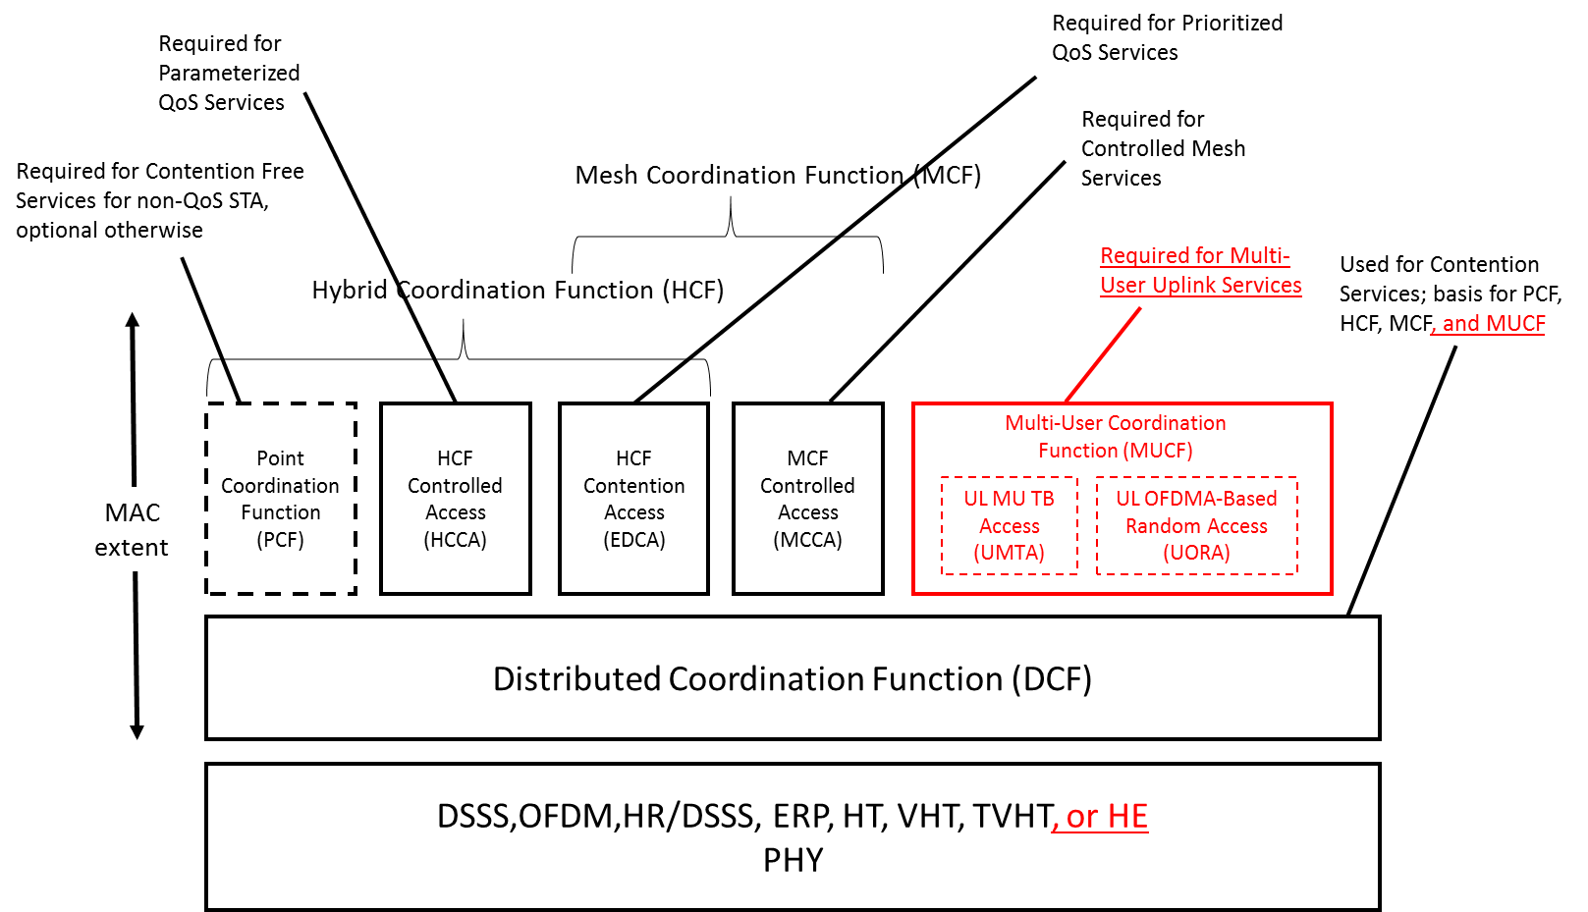
In a non-DMG non-S1G STA:
- The MAC provides the PCF, HCF, MCF and MUCF service using the services of the DCF.
- The PCF is optionally present in nonmesh STAs and absent otherwise.
- The HCF is present in QoS STAs and absent otherwise.
- The MCF is present in mesh STAs and absent otherwise.
- The MUCF is present in HE non-AP STAs and absent otherwise. (#4746, #5373, #8207)
. . .
TGax Editor: Create new subclause 10.2.5a

10.2.5a Multi-User coordination function (MUCF)
An HE non-AP STA also implements the multi-user coordination function (MUCF), which provides two UL multi-user access methods. The UL MU TB access (UMTA) is used when an HE AP triggers a group of HE non-AP STAs to transmit an HE TB PPDU. The UORA allows an HE non-AP STA to access one of a number of resource units designated for random access by the HE AP.
The operation of UMTA is described in 27.5.2 (UL MU operation). The operation of UORA is described in 27.5.4 (UL OFDMA-based random access (UORA)).
- Combined use of DCF, PCF, HCF, and MUCF
The DCF and a centralized coordination function (either PCF,HCF, or MUCF) are defined so they may operate within the same BSS. When a PC is operating in a BSS, the PCF and DCF access methods alternate, with a CFP followed by a CP. This is described in greater detail in 10.4 (PCF). When an HC is operating in a BSS, it may generate an alternation of CFP and CP in the same way as a PC, using the DCF access method only during the CP. The HCF access methods (controlled and contention based) operate sequentially when the channel is in CP. Sequential operation allows the polled and contention based access methods to alternate, within intervals as short as the time to transmit a frame exchange sequence, under rules defined in 10.22 (HCF)
. . .
27.2 HE Channel Access
. . .

References:

[1] 11-17/1220r2, Clause 10.2 Comment Resolution (Osama Aboul-Magd): https://mentor.ieee.org/802.11/dcn/17/11-17-1220-02-00ax-clause-10-2-comment-resolution.docx

