IEEE P802.11
Wireless LANs
Draft text to define non-uniform constellation (CID 517)
Date: 2017-09-06
Author(s):
Name | Affiliation | Address | Phone | email
Thomas Handte | Sony Europe Ltd. | Heldelfinger Strasse 61 | +49 711 5858 236 | thomas.handte @ sony.com
Abstract
This document proposes draft text to define non-uniform constellation (NUC) in Section 30.5.7.4 (CID 517).

CID | Clause | Comment | Proposed Change
517 | 30.1.1 | NUC not defined | Comment resolution will be provided.

Discussion

Background
- It has been agreed that 11ay includes support for a non-uniform constellation (NUC)
  - Section 4.3.25 [1] “EDMG STA has optional support of a 64-point non-uniform constellation”
  - Section 9.4.2.250.1 and 30.3.3.3 [1] include signalling and capability information for NUC.
- However, signal points of NUC are undefined but we have seen various submission in the past e.g. [2,3]
- NUC design depends on
  - Code rates
  - Impairments considered during design process
- From an implementation point of view however, it is desired to define a single constellation which fits best to all code rates and impairments (which are partly implementation specific)

Findings
- NUC is code rate dependent
  - A single NUC for all code rates comes with a performance trade-off
    - It is desired to design a single NUC for high code rates as high code rates have strong sensitivity requirements
    - NUC alleviates those strong sensitivity requirements and simplifies frontend implementation especially for code rates 13/16 and 7/8
- NUC design can consider different PHY impairments
  - AWGN
  - Phase noise (PN)
  - Power amplifier (PA) non-linearity
- Observations
  - PN optimization
    - Residual phase noise is implementation specific as different phase noise mitigation algorithms may be applied
    - Phase noise optimization yields higher PAPR and reduced performance with PA non-linearity
  - PA optimization
    - Characteristic of PAs non-linearity is implementation specific as different PAs and predistortion techniques may be applied
    - Difficult to include in optimization
  - AWGN
    - AWGN design very roubust against impairments
    - Differences to reasonable PN, PA optimization are minor
- Proposal
  - NUC maximizing mutual information in AWGN and for high code rates

Analysis
- Analysis of the proposed 64-QAM non-uniform constellation in various scenarios
- AWGN, Rayleigh, AWGN and Phase Noise, AWGN and Phase Noise with PA non-linearity
- Simulation parameters in Appendix
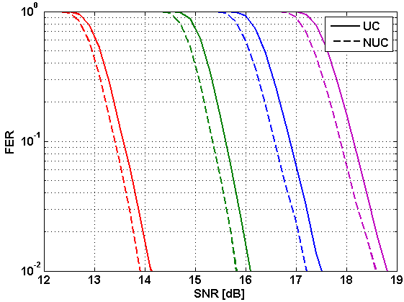  Figure 1: FER in AWGN | 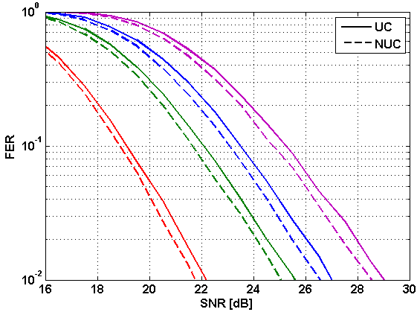  Figure 2: FER in Rayleigh fading channel
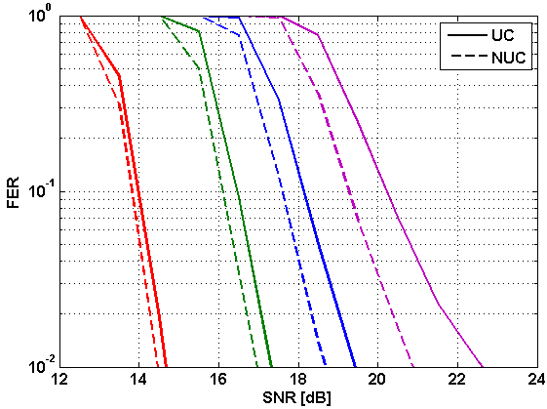  Figure 3: FER in AWGN and phase noise channel | 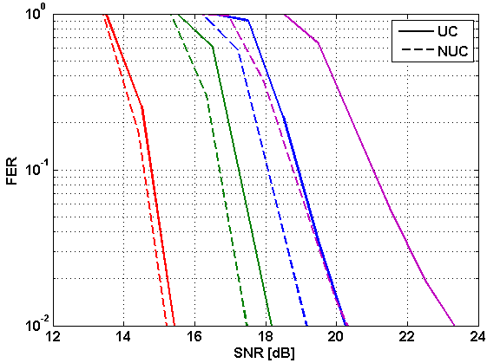  Figure 4: FER in AWGN and phase noise channel with PA non-linearity

Summary
The 64-QAM non-uniform constellation proposed below is optimized to maximize mutual information in AWGN. This constellation has been compared with a rectangular 64-QAM in terms of frame error rate for code rates 5/8, 3/4, 13/16, and 7/8 in various scenarios. The proposed non-uniform constellation achieves gains
- between 0.2 and 0.3dB in AWGN
- between 0.4 and 0.6dB in Rayleigh fading channel
- between 0.2 and 1.8dB in AWGN and phase noise channel
- between 0.2 and 2.9dB in AWGN and phase noise channel with PA non-linearity

30.5.7.4 Modulation mapping

30.5.7.4.1 General

The coded and padded bit stream is converted into a stream of complex constellation points, following the rules defined in 20.6.3.2.4 for π/2-BPSK, π/2-QPSK, π/2-16-QAM, and π/2-64-QAM. The π/2-64-NUC modulation is defined in 30.5.7.4.5.

30.5.7.4.2 Dual carrier modulation (DCM) SQPSK
(…)

30.5.7.4.3 Space-time block coding (STBC)
(…)

30.5.7.4.4 Block interleaver
(…)

30.5.7.4.5 π/2-64-NUC modulation

In π/2-64-NUC modulation, the input bit stream is grouped in sets of 6 bits and mapped according to the following equation:

Each output symbol is then rotated according to the following equation. The constellation bit encoding for the 64-NUC is depicted in Figure 97.

NOTE—The 64-NUC is quadrant symmetric and has an average power of one.
Figure 97 – 64-NUC bit/ symbol encoding

Strawpoll
Do you agree to include the π/2-64-NUC defined in “11-17-1292-01-00ay-Draft-text-to-define-non-uniform-constellation-(CID-517).docx” to the IEEE 802.11ay Draft 0.5?

References
[1] 11ay D0.5
[2] 11-16/0072r0 Performance of Non-Uniform Constellations in Presence of Phase Noise
[3] 11-16/0955r0 Non uniform constellation of HOM for SC in 11ay
[4] 11-15/0866r4 11ay evaluation methodology

Appendix
Simulation Parameters are as follows
- LDPC
  - 11ad code word lengths, code rates 5/8, 3/4, 13/16, 7/8
  - SC interleaver/ deinterleaver
- Transmitter
  - SC modulation
  - Message length 4096 bytes
- Channel model
  - AWGN
  - Rayleigh fading channel with Trms=3ns
    - Exponential decay profile
  - Phase Noise [4]
  - Power amplifier [4], Tx mask [1]
- Receiver
  - Perfect channel knowledge
  - Regular approx. LLR demapper
  - FD equalization
- Sensitivity analysis
  - Reference: Regular uniform 64-QAM [1] with Gray labeling

