IEEE P802.11
Wireless LANs
TGay Coexistence Assurance Document
Date: 2017-09-11
Author(s):
Name | Affiliation | Address | Phone | email
Claudio da Silva | Intel |  |  | claudio.da.silva@intel.com
Abstract
This serves as the coexistence assurance (CA) document for TGay as required by the CSD.

Introduction

This document addresses the coexistence of 802.11ay as required by the CSD [1]. The relevant section is outlined below:
- Response to 1.1.2, “Will the WG create a CA document as part of the WG balloting process as described in Clause 13? YES” [1].

The definition for coexistence is as defined in 802.15.2, with the shared environment being the 60 GHz band in home, enterprise, and outdoor environments.

In 802.11ay [2], Clause 11.35 provides an overview of the features available in the specification that address coexistence with other technologies that operate in the 60 GHz band, including 802.11ad [3], 802.15.3c [4], 802.15.3e [5], and 802.11aj [6]. These features are described in the sections that follows.

In this document, as defined in [2], an enhanced directional multi-gigabit (EDMG) PPDU is a Clause 30 PPDU transmitted with the TXVECTOR parameter FORMAT equal to EDMG, and an EDMG STA is a directional multi-gigabit (DMG) STA whose radio transmitter is capable of transmitting and receiving EDMG PPDUs.

Channelization

802.11ay adopts the same common channelization as defined for 802.11ad, 802.15.3c (channels 1-4), 802.15.3e (channels 1-4), and 802.11aj (for frequency bands above 45 GHz) for 2.16 GHz channels. Similar to 802.11ad and 802.11aj, EDMG STAs shall support channel 2.

For 4.32 GHz, 6.48 GHz, and 8.64 GHz channels, EDMG STAs may operate in the channels defined in Annex A of this document, which correspond to additional rows to be introduced into appropriate tables in Annex E of [7]. These channels represent different bonding combinations of the 2.16 GHz channels. The support of 2.16 GHz and 4.32 GHz channels is mandatory for EDMG STAs, while support of 6.48 GHz and 8.64 GHz is optional.

The transmitted spectrum shall adhere to the spectrum masks shown in Annex B of this document as defined in 30.3.5 [2]. To enhance co-existence of EDMG STAs with others in the 60 GHz band,
- The spectrum mask defined for 2.16 GHz channels is the same one defined in 802.11ad and 802.11aj (for frequency bands above 45 GHz) as shown in Figure 1 of Annex B, which is similar to the one specified for 802.15.3c and 802.15.3e;
- The transmit spectral mask defined for 4.32 GHz, 6.48 GHz, and 8.64 GHz channels, as seen in Figures 2, 3, and 4 in Annex B, is such that it has a 0 dBr region that includes the ones for the underlying 2.16 GHz channels; and
- As seen in Figure 5 of Annex B, the transmit spectral for non-contiguous channel aggregation transmissions is obtained by a procedure in which the masks for the individual 2.16 GHz or 4.32 GHz channel used are combined as described in [2].

In regulatory domains where 2 or more channels are allowed to be used, a DMG STA should support at least 2 channels and the channels are used as per regulatory constraints. This enables 802.11ad and 802.11ay devices to change channels to avoid interference with other systems.

Preamble and Header Design for Coexistence

The PHYs defined in Clause 30 [2] use the same preamble (specifically, non-EDMG short training field and non-EDMG channel estimation field) as 802.11ad and 802.11aj (for frequency bands above 45 GHz). By using the same preamble defined in 802.11ad, PHY-level coexistence with 802.15.3c is maintained as discussed in [8].

To enable co-existence with 802.11ad and 802.11aj stations that may be present in a 2.16 GHz channel included as part of an EDMG PPDU transmitted over a 4.32 GHz, 6.48 GHz, or 8.64 GHz channel, the common preamble is transmitted in non-EDMG duplicate format, which duplicates the transmission in two or more 2.16 GHz channels and allows legacy 802.11 STAs on any one of the 2.16 GHz channels to detect the transmission. Also, if an EDMG PPDU is transmitted with multiple transmit chains, the common preamble is mapped to all transmit chains, with a relative cyclic shift, when transmitted in non-EDMG duplicate format.

EDMG PPDUs include a non-EDMG header field which is the same as the header field of 802.11ad and 802.11aj PPDUs, allowing 802.11ad and 802.11aj STAs to calculate a spoofed duration of EDMG PPDUs.

Coexistence with Non-802.11 Systems
The mechanism for 802.11 devices to co-exist with non-802.11 devices is clear channel assessment (CCA). 802.11ay uses the same 802.11ad CCA rules for 2.16 GHz channels. Specifically, an EDMG PHY shall set its CCA indication to busy for any signal that exceeds a threshold equal to 20 dB above the minimum sensitivity for MCS 1 (–68 + 20 = –48 dBm) for 2.16 GHz channels.

An EDMG STA that is open to any combination of channel bonding or channel aggregation shall set its CCA indication to busy for any signal that exceeds a threshold equal to 20 dB above the minimum sensitivity for MCS 1 (–48 dBm) at any of the channels (primary/secondary/secondary1/secondary2) it is open to receive in. An EDMG STA that has more than one RX chain active shall issue a busy CCA indication if the conditions defined for single antenna operation applies to any DMG antenna connected to an active receive chain.

Coexistence with Legacy 802.11 Systems
The 802.11ay PHY is based on the 802.11ad PHY defined in Clause 20 [7]. 802.11ay adds support for space-time streams, downlink multi-user (MU) transmissions, and multiple channel widths. Additionally, 802.11ay defines an orthogonal frequency division multiplexing (OFDM) PHY.

5.1. Multiple channel transmission

To facilitate the coexistence of 802.11ay with legacy 802.11 systems,
- The channel width of the primary channel is 2.16 GHz;
- The beacon transmission interval (BTI) and the announcement transmission interval (ATI) is only present on the primary channel of an EDMG BSS; and
- The Beacon and Announce frames specified in 802.11ay can be decoded by 802.11ad and 802.11aj STAs.

For an EDMG STA, an EDCA TXOP is obtained based on the activity on the primary channel. An EDMG STA shall maintain physical and virtual CS on the primary channel. The width of transmission is determined by the CCA status of the non-primary channels. The transmission of an EDMG STA shall only include a secondary channel if it was idle during an interval of PIFS immediately preceding the start of the TXOP. The occupied bandwidth of a PPDU transmitted by a TXOP holder shall not be larger than the occupied bandwidth of the last PPDU, if any, transmitted by the TXOP holder in the same TXOP.

Collision inference on secondary channels may be performed with an RTS/DMG CTS exchange. If the RTS frame is transmitted on a 4.32 GHz, 6.48 GHz, or 8.64 GHz channel, it uses a non-EDMG duplicate format (see Section 3). Similarly, if the RTS frame is transmitted on a 4.32 GHz, 6.48 GHz, or 8.64 GHz channel, it uses a non-EDMG duplicate format.

5.2. MIMO transmission
802.11ay supports single-user (SU) multiple input, multiple output (MIMO) and downlink (DL) MU MIMO transmissions. For both SU MIMO and DL MU-MIMO, the total EIRP transmitted by a device is limited by both regulatory restrictions and device costs resulting in energy on the air comparable to 802.11ay SISO transmissions, which in turn is comparable to 802.11ad and 802.11aj.

Channel rules defined for MIMO operation in [2] specify that if an EDMG STA intends to make a transmission using multiple transmit chains, CCA shall be maintained in all antennas to be used. The STATE parameter of PHY-CCA.indication shall only indicate IDLE if the channel is determined to be idle by all transmit chains to be used.

5.3. OFDM PHY
Clause 30 of [2] defines an EDMG PHY based on OFDM. EDMG OFDM PPDUs are expected to have approximately the same, or smaller, coverage area than EDMG SC PPDUs. EDMG OFDM PPDUs use the same preamble discussed in Section 3 that is common to 802.11ad and 802.11aj (for frequency bands above 45 GHz).

BSS Establishment
The rules adopted in 802.11ad for BSS establishment also apply to 802.11ay. Therefore, an AP should not start an infrastructure BSS on a channel where the signal level is at or above aDMGDetectionThres (-48 dBm). Moreover, 802.11ay inherits the additional protection afforded to 802.15.3 systems operating in the same band as DMG systems. For example, an AP should not start an infrastructure BSS on a channel upon detecting a valid IEEE 802.15.3c CMS preamble at a receive level equal to or greater than -60 dBm.

As discussed in [8], commonalities in the preamble design of 802.11ad (and, consequently, 802.11aj and 802.11ay) and 802.15.3c enable detection with a relatively tight threshold. The requirement of detection of 802.15.3c CMS preamble for 802.11ad/802.11aj/802.11ay is 12dB more stringent than 802.11a/n and non-802.11 detection [8].

Spatial Sharing
802.11ay extends the mechanisms defined in 11.32 [7] for DMG STAs to enable spatial sharing and interference mitigation to support its use in more than one 2.16 GHz channel. If an EDMG STA is capable of performing directional channel measurements as defined in 11.32 [2], it can detect both IEEE-802.11 and non-IEEE-802.11 transmissions on one or more 2.16 GHz channels in which measurements are performed, and it can report the results to the AP or PCP.

Interference Mitigation
If a DMG STA detects a non-IEEE-802.11 transmission on its channel or if the AP or PCP receives a report (11.11) from a DMG STA on a non-IEEE-802.11 transmission, the following mechanisms might be used to mitigate interference:
- Change operating channel (11.9)
- Beamforming (10.38)
- Reduce transmit power (11.8)
- Perform FST (11.33)
- Move the TBTT (11.31.2), and thus the beacon interval, in the case of an AP or PCP
- Change the schedule of SPs and CBAPs in the beacon interval (9.4.2.132) in the case of an AP or PCP
- Defer transmission for a later time
- For periods of time in the beacon interval where the STA experiences poor channel quality, the STA can use the Traffic Scheduling Constraint Set field within the DMG TSPEC element (9.4.2.134) to request its AP or PCP to avoid scheduling an SP for that DMG STA during those periods of time in the beacon interval.
- In an EDMG BSS, when operating over multiple channels, the occupied bandwidth of a PPDU transmitted by a TXOP holder may be smaller than the occupied bandwidth of the last PPDU (10.36.11.2 in [2]).

Coexistence Analysis
As described in Section 2, 802.11ay adopts the same common channelization as defined for 802.11ad, 802.15.3c, 802.15.3e, and 802.11aj for 2.16 GHz channels. Also, the spectrum mask defined for 802.11ay for 2.16 GHz channels is the same one defined in 802.11ad and 802.11aj, which is similar to the one specified for 802.15.3c and 802.15.3e. As discussed in Section 3, 802.11 uses the same preamble as 802.11ad and 802.11aj, which is by design similar to the one used by 802.15.3c and 802.15.3e. Further, as described in Section 4, the CCA threshold used in 802.11ay is the same one adopted by 802.11ad and 802.11aj. Therefore, at a system link level the coexistence scenarios, method of analysis, and results described in [8] apply to 802.11ay.

As discussed in Section 5, different PHY and MAC elements were incorporated into the overall 802.11ay design, including that of its new features (multiple channel widths, space-time streams, downlink MU transmission, and OFDM), to enhance coexistence with legacy 802.11 systems. Additionally, 802.11ay includes coexistence strategies used in 802.11ad and 802.11aj, such as rules for BSS establishment, spatial sharing, and interference mitigation.

Definitions
- enhanced directional multi-gigabit (EDMG) physical layer (PHY) protocol data unit (PPDU): A Clause 30 PPDU transmitted with the TXVECTOR parameter FORMAT equal to EDMG.
- non-enhanced directional multi-gigabit (non-EDMG): A modifier meaning directional multi-gigabit (DMG) that is not EDMG.
- non-enhanced directional multi-gigabit (non-EDMG) duplicate: A transmission format of the physical layer (PHY) that duplicates a 2.16 GHz non-EDMG transmission in two or more 2.16 GHz channels and allows a station (STA) in a non-EDMG basic service set (BSS) on any one of the 2.16 GHz channels to receive the transmission. A non-EDMG duplicate format is one of the following:
  - 4.32 GHz non-EDMG duplicate: A transmission format of the PHY that replicates a 2.16 GHz non-EDMG transmission in two adjacent 2.16 GHz channels.
  - 6.48 GHz non-EDMG duplicate: A transmission format of the PHY that replicates a 2.16 GHz non-EDMG transmission in three adjacent 2.16 GHz GHz channels.
  - 8.64 GHz non-EDMG duplicate: A transmission format of the PHY that replicates a 2.16 GHz non-EDMG transmission in four adjacent 2.16 GHz channels.
  - 2.16+2.16 GHz non-EDMG duplicate: A transmission format of the PHY that replicates a 2.16 GHz non-EDMG transmission in two, not necessarily adjacent, frequency segments of one 2.16 GHz channel.
  - 4.32+4.32 GHz non-EDMG duplicate: A transmission format of the PHY that replicates a 2.16 GHz non-EDMG transmission in two frequency segments of two adjacent 2.16 GHz channels where the two frequency segments of channels are not necessarily adjacent.
- secondary channel: In DMG, a 2.16 GHz channel associated with a primary channel used by enhanced directional multi-gigabit (EDMG) STAs for the purpose of creating a 4.32 GHz, 6.48 GHz or 8.64 GHz channel.

Annex A

Table E-1—Operating classes in the United States
Operating class | Global operating class (see Table E-4) | Channel starting frequency (GHz) | Channel spacing (MHz) | Channel set | Channel center frequency index | Behavior limits set
35 | 181 | 56.16 | 4320 | 9-13
36 | 182 | 56.16 | 6480 | 17-20
37 | 183 | 56.16 | 8640 | 25-27

Table E-2—Operating classes in Europe
Operating class | Global operating class (see Table E-4) | Channel starting frequency (GHz) | Channel spacing (MHz) | Channel set | Channel center frequency index | Behavior limits set
19 | 181 | 56.16 | 4320 | 9-11
20 | 182 | 56.16 | 6480 | 17-18
21 | 183 | 56.16 | 8640 | 25

Table E-3—Operating classes in Japan
Operating class | Global operating class (see Table E-4) | Channel starting frequency (GHz) | Channel spacing (MHz) | Channel set | Channel center frequency index | Behavior limits set
60 | 181 | 56.16 | 4320 | 9-11
61 | 182 | 56.16 | 6480 | 17-18
62 | 183 | 56.16 | 8640 | 25

Table E-4—Global operating classes
Operating class | Global operating class (see Table E-4) | Channel starting frequency (GHz) | Channel spacing (MHz) | Channel set | Channel center frequency index | Behavior limits set
181 | E-1-35,  E-2-19,  E-3-60 | 56.16 | 4320 | 9-13
182 | E-1-36,  E-2-20,  E-3-61 | 56.16 | 6480 | 17-20
183 | E-1-37,  E-2-21,  E-3-62 | 56.16 | 8640 | 25-27

Annex B
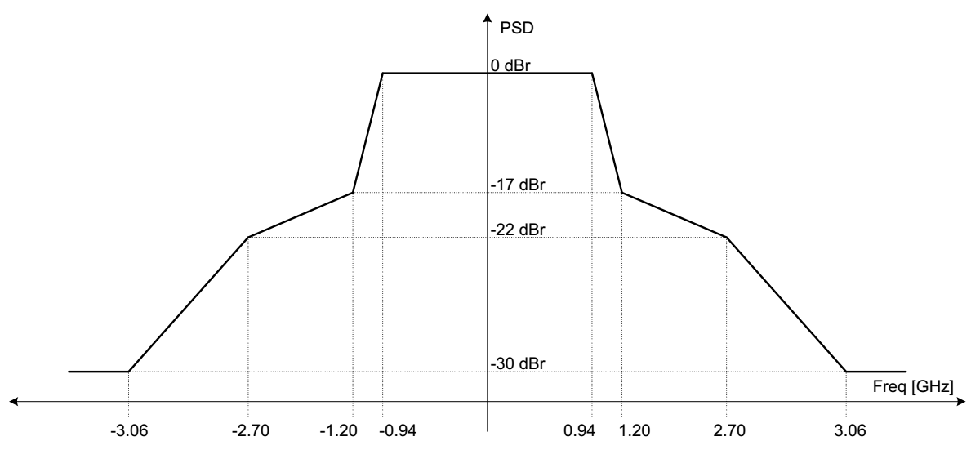
Figure 1. Example transmit spectral mask for a 2.16 GHz mask PPDU.

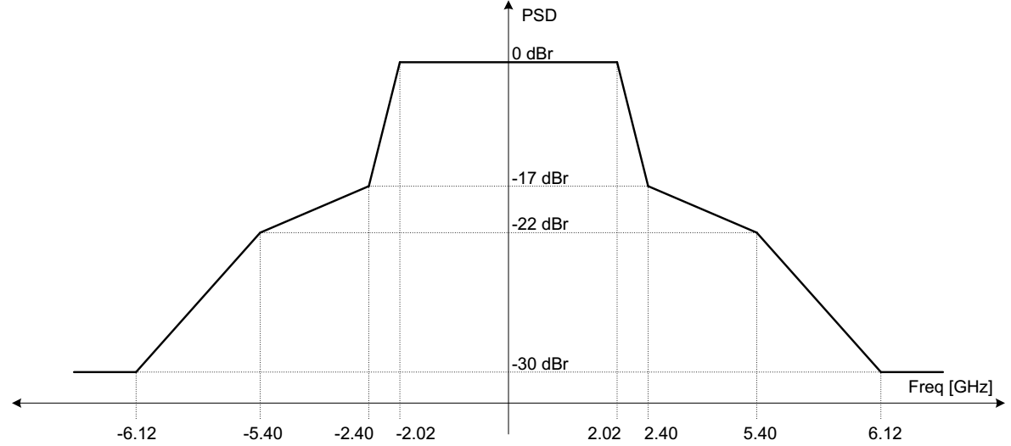
Figure 2. Example transmit spectral mask for a 4.32 GHz mask PPDU.

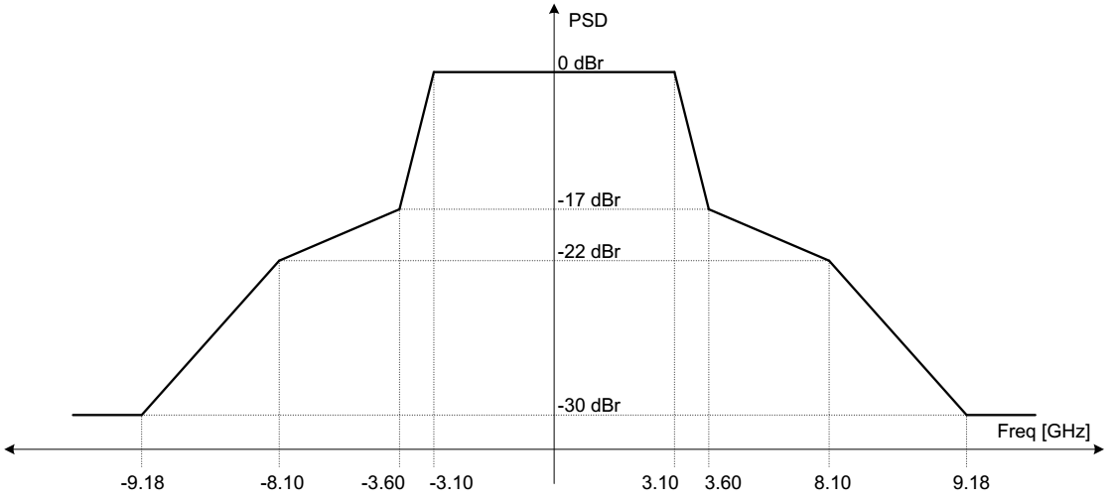
Figure 3. Example transmit spectral mask for a 6.48 GHz mask PPDU.

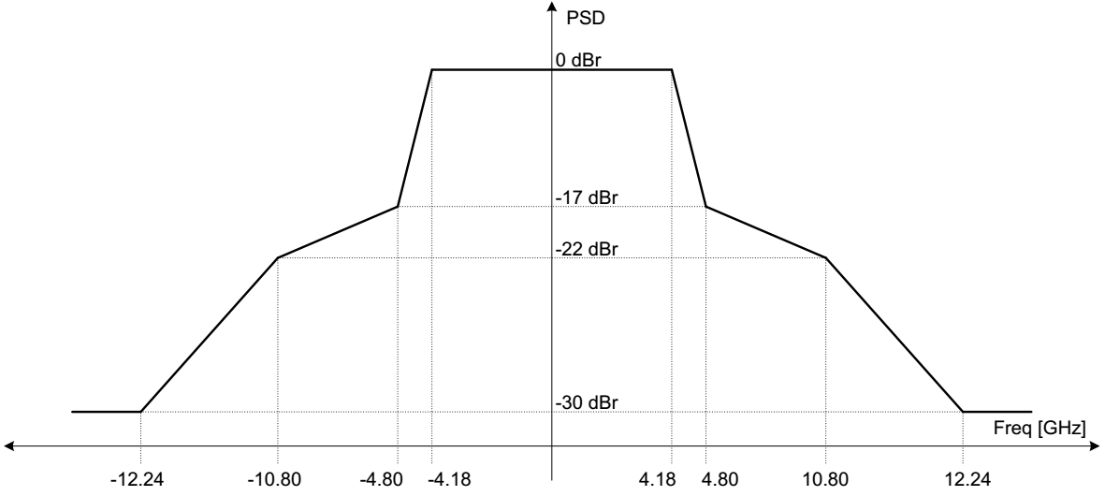
Figure 4. Example transmit spectral mask for a 8.64 GHz mask PPDU.

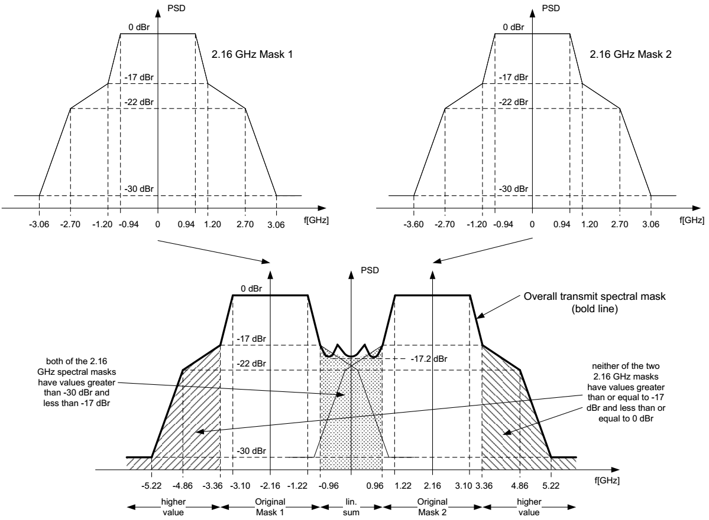
Figure 5. Example transmit spectral mask for a 2.16+2.16 GHz mask PPDU.

References:
[1] NG60 proposed CSD, IEEE 802.11-14/1152r8.
[2] IEEE P802.11ay/D1.0.
[3] 802.11ad
[4] 802.15.3c
[5] 802.15.3e
[6] 802.11aj
[7] 802.11-2016
[8] TGad coexistence assurance document, IEEE 802.11-10/1025r3.

