IEEE P802.11
Wireless LANs
Resolutions for CIDs 163,186,187 on 11md/D0.1
Date: 2017-07
Author(s):
Name | Affiliation | Address | Phone | email
Graham SMITH | SR Technologies | Davie, FL, USA. | 916 799 9563 | gsmith@srtrl.com

Abstract
This submission proposes resolutions for CIDs 163,186,187
Green indicates material agreed to in the group,
yellow material to be discussed, red material rejected by the group and
cyan material not to be overlooked.

The “Final” view should be selected in Word.

CID | Commenter | Clause | Page Line | Comment | Proposed
163 | Mark RISON | 10.22.2.8 | 1493.23 | "The TXOP holder may exceed the TXOP limit only if it does not transmit more than one Data or Management frame in the TXOP" -- it's OK to transmit more than one under MU-MIMO, as long as a given user doesn't get more than one | Change the cited text to "The TXOP holder may exceed the TXOP limit only if it does not transmit more than one Data or Management frame in the TXOP (to any given user, in the case of a DL MU-MIMO transmission)"

Discussion:
The full cited section is

The TXOP holder may exceed the TXOP limit only if it does not transmit more than one Data or Management frame in the TXOP, and only for the following situations:

The proposed change is to make this

The TXOP holder may exceed the TXOP limit only if it does not transmit more than one Data or Management frame in the TXOP (to any given user, in the case of a DL MU-MIMO transmission), and only for the following situations "

This seems reasonable.
I thought I’d check the term “user” and I see at 2669.22
“A downlink MU transmission supports up to four users with up to four space-time streams per user with the total number of space-time streams not exceeding eight.”

Proposed Resolution
ACCEPT

CID | Commenter | Clause | Line | Comment | Proposed
186 | Mark R | 10.3.2.3.1 | 1409.20 | In Figure 10-4 there are two "AIFS[i]"s but they have different properties. This is mathematically impossible) | Replace one with "AIFS[AC]" and the other with "AIFS[AC$prime]", where $prime is the glyph for a prime
187 | Mark R | 10.3.2.3.1 | 1409.20 | In Figure 10-4 there are two "AIFS[i]"s but they have different properties. This is mathematically impossible | Delete the top one (i.e. lines 1-4ish)

Discussion:
Discussed and resolved by Mark R document.

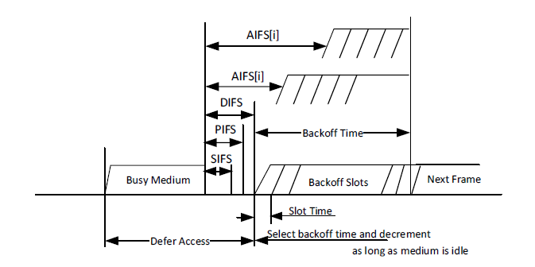

The commenter does not lile it that we have two “AIFS[i]”. He suggests two resolutions,
- Change them to AIFS[AC] and AIFS[AC']
- Delete the top one

This figure was edited in 11mc but the AIFS[i] was left unchanged. The idea of showing two is to get across that AIFS is different for each AC, indeed we read at 1412.34
“A QoS AP or PCP computes the time periods for each AIFS[AC] from dot11QAPEDCATableAIFSN.”

Hence I would support changing the [i] to [AC].

RESOLUTIONS (Discussed on Mark R document
CID 186
REVISED
In Figure 10-4 replace the uppermost “AIFS[i]” with “AIFS[AC']”, and
replace the lower “AIFS[i]” with “AIFS[AC]”

CID 187
REJECT
The intention of showing two AIFSs is to get across the concept that AIFS generally takes on different values for each AC.

