IEEE P802.11
Wireless LANs
Resolution to CID9863
Date: 2017-09-11
Author(s):
Name | Affiliation | Address | Phone | email
Yujin Noh | Newracom | 9008 Research Dr.  Irvine, CA 92618 |  | yujin.noh at newracom.com
Menzo Wentink | Qualcomm | Utrecht, the Netherlands
Abstract
This submission provides resolution to CID9863 on Termination of TXOP.
- Resolution for a comment received from TGax comment collection (TGax Draft D1.0)
- The proposed changes are based on 11ax D1.4 and 11REVmc_D8.0

Revisions:
- Rev 0: Initial version of the document.

CID | P.L | Comment | Proposed Change | Resolution
9863 | 133.47 | In 10.22.2.10 of the baseline spec., rule for termination of TXOP is defined for all PPDU format cases. Here, a TXOP holder should transmit a short control frame as the final transmission in a TXOP to prevent 3rd party STA from invoking EIFS. However, in HE PPDU case, as the TXOP_DURATION is indicated in the PHY header, there's no reason to have this rule unless TXOP_DURATION field is set to all 1s. Clarification is needed for TXOP termination rule for HE PPDU format. | As in the comment. | Revised-  Agreed in principle.  TGax Editor: make changes according to this document 11-17- 1258-00-00ax Resolution to CID9863.

Discussion

11mc has introduced on the concept of “Termination of TXOP” as shown figure below. Considering immediately preceding frame with higher data rate in TXOP which may cause an EIFS in a potentially very large region because the preamble of PPDU travels far beyond the MPDU. When the 3rd party STAs can decode only preamble part, this STA shall wait EIFS to protect ACK transmission. In order to reduce spurious EIFS setting, AP should transmit a short control frame which at the lowest data rate as the final transmission in TXOP. Note that the final transmission is at the lowest data rate within the modulation class.

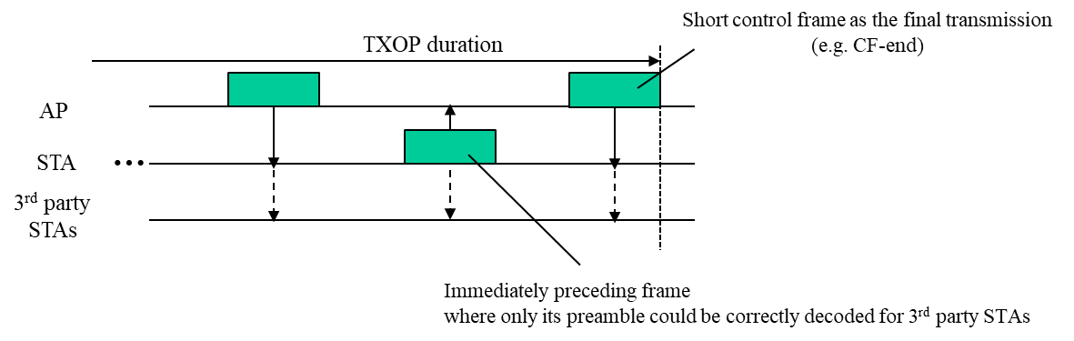

In general, any final packet transmission in a TXOP for which the data portion is encoded such that legacy STAs do not know how to decode it or such that remote STAs will not be able to decode it, should be followed by a short 6 Mbps transmission. In practice, this implies that if the data portion of the final packet in the TXOP is not 6 Mbps OFDM, it should be followed by a short 6 Mbps OFDM terminating transmission.

Because HE defines rates that are less than 6 Mbps, the final entry of Table 10-12 () should be changed such that every modulation class other than 6 Mbps OFDM is followed by a 6 Mbps OFDM terminating transmission:

Other eligible modulation classes, except 6 Mb/s OFDM data rate > 6 Mb/s | 6 Mb/s OFDM

To TGax editor: P182L41 add a new subclause with “10.22.2.10 Termination of TXOP” and modify the current text with the proposed changes below.
------------- Begin Text Changes ---------------

10.22.2.10 Termination of TXOP

A TXOP holder that transmits a PPDU using one of the modulation classes in Table 10-11 (Modulation classes eligible for TXOP termination) should transmit a short control frame as the final transmission in a TXOP, under the conditions specified in Table 10-12 (Rate and modulation class of a final transmission in a TXOP).

Table 10-11 Modulation classes eligible for TXOP termination
Modulation Classes eligible for TXOP termination
DSSS
HD/DSSS
ERP-OFDM
OFDM (20MHz channel spacing)
HT
VHT
HE

Table 10-12 Rate and modulation class of a final transmission in a TXOP
Modulation class and data rate of immediately preceding frame in TXOP | Rate and modulation class of final transmission
DSSS or HR/DSSS with long preamble, data rate > 1 Mb/s | 1 Mb/s DSSS
HR/DSSS with short preamble, data rate > 2 Mb/s | 2 Mb/s HR/DSSS short preamble
Other eligible modulation classes, except 6 Mb/s OFDM data rate > 6 Mb/s | 6 Mb/s OFDM

The final transmission can be a CF-End, or a CTS-to-self when no NAV needs to be truncated.

NOTE—The final transmission at the lowest data rate within the modulation class is needed because a final transmission at a higher rate can cause spurious EIFSs to occur, because the PHY header of such frames travels farther than the MPDU.

------------- End Text Changes ---------------

