IEEE P802.11
Wireless LANs
TGaj August 10, 2017 Conference Call Meeting Minutes
Date: 2017-08-11
Author(s):
Name | Affiliation | Address | Phone | email
Jiamin Chen | Huawei |  |  | Jiamin.chen@mail01.huawei.com
ABSTRACT
This document contains meeting minutes of the TGaj teleconference call on August 10, 2017.

TGaj August 10, 2017 Conference Call Meeting Minutes

Officers:
- Chair: Jiamin Chen (Huawei/HiSilicon)
- Vice Chair: Haiming Wang (SEU)
- Editor: Jiamin Chen (Huawei/HiSilicon)
- Sub-editor: Shiwen He (SEU)

Thursday, August 10, 2017, Conference Call Session (22:00-24:00 ET)

- Called to order at 22:00 ET by Chair Jiamin Chen

- Agenda Document: 11-17/1232r0

- Chair reviewed the IEEE-SA patent policy, participation in IEEE 802 meetings, logistics, and reminders on Task Group rules, including meeting guidelines and attendance recording procedures
- No discussion, question or item identified
- Chair reminded all to record their attendance by sending him an email.

- Chair reviewed the agenda items for the conference call (slide 8, 11-17/1232r0)
- No comment or discussion on the agenda items.
- The agenda was approved unanimously.

- Presentations
- 11-17/0624r2: TGaj editor report for sponsor ballot (Jiamin Chen)
  - Reported the results of the 2nd recirculation Sponsor Ballot in August 2017:
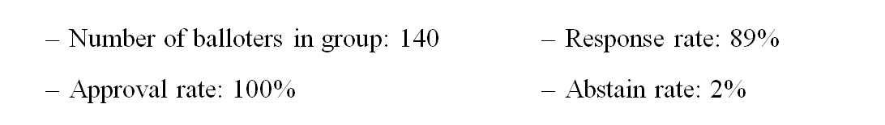
  - In total of 15 comments were received. The corresponding comments database is 11-17/1228r0.
  - No comment.

- 11-17/1235r0 : Proposed resolution to CID 1001, 1002 from the second recirculation Sponsor Ballot (Jiamin Chen)
  - Proposed resolution to CID 1001, 1002
  - Comment: Typo in proposed change. Should change the value of mse from “7” to “4”. Fixed in 11-17/1235r1

- 11-17/1237r1: Proposed Resolutions to CID 1003-1015 (Dejian Li)
  - Proposed resolution to CID 1003 ~ 1015
  - No comment.

- 11-17/1228r1: Comments from TGaj second recirculation sponsor ballot on D7.0
  - Updated according to the revised resolution submissions.

- Motions:
- Motion 1:
- To approve the following comment resolutions in 11-17-1228-03-00aj for the Sponsor Recirculation Ballot on P802.11aj D7.0.
  - Move: Dejian Li
  - Second: Shiwen He
  - Result: Y-5 N-0 A-0
  - Motion passed
- Motion 2
- Having approved the comment resolutions for all of the comments received from the Sponsor Recirculation Ballot on P802.11aj D7.0 as contained in document (https://mentor.ieee.org/802.11/dcn/17/11-17-1228-03-00aj-comments-from-tgaj-second-recirculation-sponsor-ballot-on-d7-0.xlsx), granting the editor editorial license and
- Instruct the editor to prepare Draft 8.0 incorporating these resolutions and
- Approve a 10-day Sponsor Recirculation Ballot asking the question “Should P802.11aj D8.0 be forwarded to RevCom?”
  - Move: Dejian Li
  - Second: Shiwen He
  - Result: Y-5 N-0 A-0
  - Motion passed

- Chair asks if there is any other business. None.

- Chair reminded other participants to send him an email to record their attendance.

- Meeting adjourned at 23: 22 ET.

Appendix A: August 10, 2017, 22:00 ET Conference Call Attendance Log

Name and Affiliation:
- Jiamin Chen (Huawei)
- Shiwen He (SEU)
- Dejian Li (Huawei)
- Jinnan Liu (Hisilicon)
- Qiang LI (Hisilicon)

