IEEE P802.11
Wireless LANs
Text Correction for DCM bit in HE SIG B
Date: 2017-07-10
Author(s):
Name | Affiliation | Address | Phone | email
Tianyu Wu | Mediatek | 2840 Junction Ave, San Jose, CA95134, USA |  | Tianyu.wu@mediatek.com

Abstract
This submission proposes text change for DCM bit in HE SIG B in Clause 28.3.10.8.5 of TGax D1.3:

Revisions:
- Rev 0: Initial version of the document.

Interpretation of a Motion to Adopt

A motion to approve this submission means that the editing instructions and any changed or added material are actioned in the TGax Draft. This introduction is not part of the adopted material.

Editing instructions formatted like this are intended to be copied into the TGax Draft (i.e. they are instructions to the 802.11 editor on how to merge the text with the baseline documents).

TGax Editor: Editing instructions preceded by “TGax Editor” are instructions to the TGax editor to modify existing material in the TGax draft. As a result of adopting the changes, the TGax editor will execute the instructions rather than copy them to the TGax Draft.

Discussion:

In IEEE 2016 May meeting, the following motion is passed and recorded in slide 43 and 64 of IEEE 11-16/0512r4.
Add the following usage of DCM to 11ax SFD
  - DCM is only applied to MCS0, MCS1, MCS3 and MCS4.
  - DCM is only applied to 1 and 2 spatial streams.
  - DCM is only applied to HE SU PPDU, HE extend range SU PPDU, and SU RUs in HE MU PPDU.
  - DCM is not applied to MU-MIMO. The DCM field in the HE-SIGB per user for MU-MIMO is changed to a reserved field.
  - DCM is not applied to STBC.
However, the red part is not included in the current spec draft v1.3. In Draft P802.11ax_D1.3, “Table 28-25 Fields of the User field for an MU-MIMO allocation” on page 384, DCM field is not changed to a reserved field.

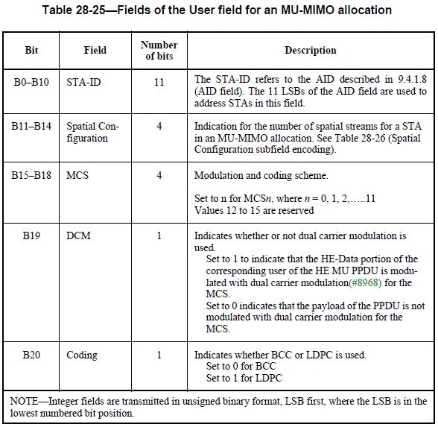

TGax Editor: Please edit D1.3, Pg 384, ln 37 in section 28.3.10.8.5 as follow:
Table 28-25—Fields of the User field for an MU-MIMO allocation
Bit | Field | Number of bits | Description
… | … | … | …
B19 | DCM Reserved | 1 | Indicates whether or not dual carrier modulation is used. Set to 1 to indicate that the HE-Data portion of the corresponding user of the HE MU PPDU is modulated with dual carrier modulation(#8968) for the MCS. Set to 0 indicates that the payload of the PPDU is not modulated with dual carrier modulation for the MCS.  Reserved bit, set to 0.
… | … | … | …

References:
- IEEE P802.11axTM/D1.3, June 2017.

