IEEE P802.11
Wireless LANs
CR on CID 6053
Date: 2017-07-03
Author(s):
Name | Affiliation | Address | Phone | email
Jeongki Kim | LG Electronics | Seocho, Seoul, Korea |  | jeongki.kim@lge.com
Kiseon Ryu | LG Electronics
Suhwook Kim | LG Electronics

Abstract
This submission is a CR document on CID 6053 and 6042.

Interpretation of a Motion to Adopt

A motion to approve this submission means that the editing instructions and any changed or added material are actioned in the TGax Draft. This introduction is not part of the adopted material.

Editing instructions formatted like this are intended to be copied into the TGax Draft (i.e. they are instructions to the 802.11 editor on how to merge the text with the baseline documents).

TGax Editor: Editing instructions preceded by “TGax Editor” are instructions to the TGax editor to modify existing material in the TGax draft. As a result of adopting the changes, the TGax editor will execute the instructions rather than copy them to the TGax Draft.

CID | Page | Clause | Comment | Proposed Change | Resolution
6053 | 200.31 | 27.14.2 | A Trigger frame can carry the trigger information for both scheduled STAs and OFDMA random access STAs. Although the trigger information for OFDMA random access STAs is included in some consecutive Trigger frames(not all) in a TXOP, random access STAs should be awake until receving the Trigger frame including Cascade indication set to 0. A Trigger frame for random access need to carry the information of whether random access RUs will be allocated in the next consecutive TFs in a TXOP or not | As mentioned in comment, add the related operation into subclause 27.14.2 and update the related fields in a Trigger frame | Revised  Agree in principle with the comment.  For the power saving of UORA STAs, AP can indicate that there is no further random access RUs in next Trigger frames.  In this case, RA STAs can enter the doze state when the STAs receives the no further random access RUs indication.  TGax editor makes changes as shown in the as specified in 11-17/1060r3.
6042 | 200.30 | 27.14.2 | Currently the Cascade indication is used to indicate the end of the RU allocations for random access and that no more Trigger frames will be transmitted in the TWT SP. Two indications in the same field may complicate the TWT SP handling and random access termination. A trigger frame without RU allocated for the random access could indicate that there will not be more RUs allocated for the UL OFDMA random access in this TWT SP. This would allow different handling of the STAs that have already an AID and STAs that are performaning the random access. It is likely that first HE Triggered PPDUs are short and contain a many RUs for random access. At the end of the TWT SP there may be larger PPDUs that are used to exchagne data. If there is just the Cascade indication to control STAs availability, the STAs performing random access may need to be available unnecessarily. | Please allow STAs that are performing UL OFDMA random access return to Doze when a Trigger frame does not contain RU allocated for random access. | Revised  Agree in principle with the comment.  Need to provide a method to allow STAs that are performing UL OFDMA random access return to Doze when next Trigger frames does not contain RU allocated for random access.  Same resolution as #6053  TGax editor makes changes as shown in the as specified in 11-17/1060r3.

Discussion:
According to the 11ax draft, an HE AP may transmit a Basic Trigger frame or a BSRP Trigger frame that contains one or more RUs for random access. In some case, multiple Trigger frames can be sent in a TXOP and some of those Trigger frames (e.g., the first N consecutive TFs) can contain RUs for random access (i.e., the following remaining TFs does not contain RUs for random access) as below figure.
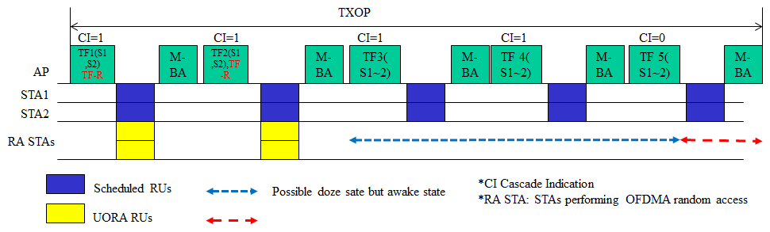
In above figure, TF1 and TF 2 contain RUs for random access and TF3, TF4, and TF5 don’t contain RUs for random access. In this case, STAs which perform the random access (RA STAs) try to enter the doze state after the STAs receive the last Trigger frame with Cascade Indication set to 0 (TF5 in the above figure) although the RA STAs can enter the doze state from TF3 or after receiving TF2.
To avoid this unnecessary power consumption of the RA STAs, AP can inform the RA STAs that the remaining Trigger frames in a TXOP does not contain the RUs for random access.
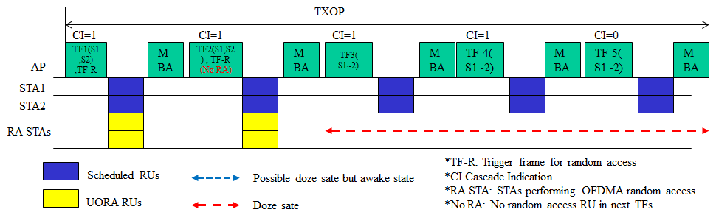
Upon receiving the Trigger frame with no random access RU indication (No RA) in next remaining TFs, RA STAs can enter the Doze state until the end of duration indicated in the Trigger frame. An AP sending a Trigger frame including no random access RU indication, does not send DL frame or allocate UL MU resource to the STAs with dot11OFDMARandomAccessOptionImlemented set to true until the end of duration indicated in the Trigger frame.
In current draft, SS allocation field (6 bits) of User Info field is not used in UORA procedure. A bit (e.g., B31) of SS Allocation field can be used for no RA RU indication in next TFs.
Proposed text

TGax Editor: Modify the last paragraph in subclause 27.14.2 (27.14.2 Power save with UORA) as follows:
An HE STA may use the value indicated in the Cascade Indication field in a Trigger frame to enter the doze state. If the OBO counter decrements to a non-zero value with the UORA(#8142) procedure in a Trigger frame with Cascade Indication field set to 0, it may enter the doze state immediately. If the OBO counter decrements to a non-zero value with the UORA(#8142) procedure in a Trigger frame with Cascade Indication field set to 1, it may remain awake for random access in the cascaded Trigger frame unless the No Further RA RU subfield is euqal to 1 in User Info field(s) with AID12 subfield equal to 0 or 2045 in which case, the STA may enter the doze state immediately until either the end of the current TWT SP or the end of the current TXOP in case of no TWT SP.(#6042, #6053)

TGax Editor: Add the following text in front of the last paragraph in subclause 27.14.2 (27.14.2 Power save with UORA) as follows:
When the No Further RA RU subfield is set to 1, an AP shall not allocate the random access RUs in the subsequent Trigger frames until either the end of the current TWT SP or the end of the current TXOP in case of no TWT SP. (#6042, #6053)

TGax editor: Modify the Figure 9-52f as follows:

Figure 9-52f – User Info field (#6042, #6053)

TGax editor: Modify the suclause 9.3.1.23 (Trigger frame format) as the following: (Track change on)

(…existing texts …)

When the value of the AID12 field is not equal to 0 or 2045, the SS Allocation/Random Access RU Information(#6042, #6053) subfield of the User Info field indicates the spatial streams of the HE TB PPDU that is the response to the Trigger frame(#9993). When the value of the AID12 field is not equal to 0 or 2045, the (#6042, #6053)format of the SS Allocation/Random Access RU Information (#6042, #6053)subfield is defined in Figure 9-52g (SS Allocation/Random Access RU Information subfield format when the value of the AID12 field is not equal to 0 or 2045). (#6042, #6053)
Figure 9-52g—SS Allocation/Random Access RU Information subfield format when the value of the AID12 field is not equal to 0 or 2045 (#6042, #6053)
(…existing texts …)

TGax editor: add the following paragraphs and the Figure 9-52ga after the last paragraph on page 83 in D1.4:

When the value of the AID12 subfield is equal to 0 or 2045, the SS Allocation/Random Access RU Information subfield of the User Info field indicates the random access RU information and the format of the SS Allocation/Random Access RU Information subfield is defined in Figure 9-52ga (SS Allocation/Random Access RU Information subfield format when the value of the AID12 subfield is equal to 0 or 2045)

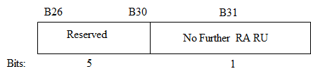
Figure 9-52ga—SS Allocation/Random Access RU Information subfield format when the value of the AID12 subfield is equal to 0 or 2045 (#6042, #6053)
The No Further RA RU subfield set to 1 indicates that random access RUs are not allocated in the subsequent Trigger frames which are sent within either the end of the current TWT SP or the current TXOP in case of no TWT SP. (#6042, #6053)

