IEEE P802.11
Wireless LANs
CR on CID 6053
Date: 2017-07-03
Author(s):
Name | Affiliation | Address | Phone | email
Jeongki Kim | LG Electronics | Seocho, Seoul, Korea |  | jeongki.kim@lge.com
Kiseon Ryu | LG Electronics
Suhwook Kim | LG Electronics

Abstract
This submission is a CR document on CID 6053.

Interpretation of a Motion to Adopt

A motion to approve this submission means that the editing instructions and any changed or added material are actioned in the TGax Draft. This introduction is not part of the adopted material.

Editing instructions formatted like this are intended to be copied into the TGax Draft (i.e. they are instructions to the 802.11 editor on how to merge the text with the baseline documents).

TGax Editor: Editing instructions preceded by “TGax Editor” are instructions to the TGax editor to modify existing material in the TGax draft. As a result of adopting the changes, the TGax editor will execute the instructions rather than copy them to the TGax Draft.

CID | Page | Clause | Comment | Proposed Change | Resolution
6053 | 200.31 | 27.14.2 | A Trigger frame can carry the trigger information for both scheduled STAs and OFDMA random access STAs. Although the trigger information for OFDMA random access STAs is included in some consecutive Trigger frames(not all) in a TXOP, random access STAs should be awake until receving the Trigger frame including Cascade indication set to 0. A Trigger frame for random access need to carry the information of whether random access RUs will be allocated in the next consecutive TFs in a TXOP or not | As mentioned in comment, add the related operation into subclause 27.14.2 and update the related fields in a Trigger frame | Revised  Agree in principle with the comment.  For the power saving of UORA STAs, AP can indicate that there is no further random access RUs in next Trigger frames.  In this case, RA STAs can enter the doze state when the STAs receives the no further random access RUs indication.  TGax editor makes changes as shown in the as specified in 11-17/1060r2.

Discussion:
According to the 11ax draft, an HE AP may transmit a Basic Trigger frame or a BSRP Trigger frame that contains one or more RUs for random access. In some case, multiple Trigger frames can be sent in a TXOP and some of those Trigger frames (e.g., the first N consecutive TFs) can contain RUs for random access (i.e., the following remaining TFs does not contain RUs for random access) as below figure.
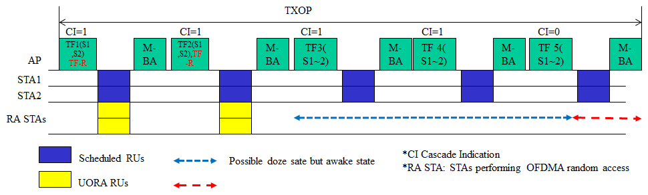
In above figure, TF1 and TF 2 contain RUs for random access and TF3, TF4, and TF5 don’t contain RUs for random access. In this case, STAs which perform the random access (RA STAs) try to enter the doze state after the STAs receive the last Trigger frame with Cascade Indication set to 0 (TF5 in the above figure) although the RA STAs can enter the doze state from TF3 or after receiving TF2.
To avoid this unnecessary power consumption of the RA STAs, AP can inform the RA STAs that the remaining Trigger frames in a TXOP does not contain the RUs for random access.
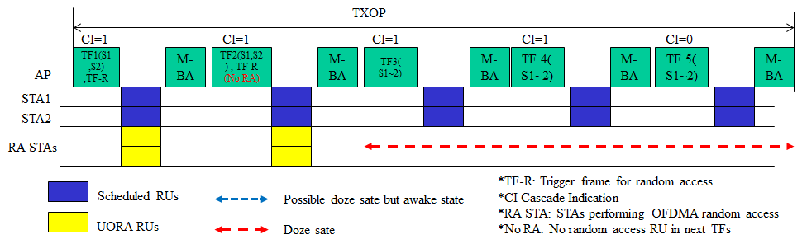
Upon receiving the Trigger frame with no random access RU indication (No RA) in next remaining TFs, RA STAs can enter the Doze state until the end of duration indicated in the Trigger frame. An AP sending a Trigger frame including no random access RU indication, does not send DL frame or allocate UL MU resource to the STAs with dot11OFDMARandomAccessOptionImlemented set to true until the end of duration indicated in the Trigger frame.
In current draft, SS allocation field (6 bits) of User Info field is not used in UORA procedure. A bit (e.g., B31) of SS Allocation field can be used for no RA RU indication in next TFs.
Proposed text

TGax Editor: Modify the last paragraph in subclause 27.14.2 (27.14.2 Power save with UORA) as follows:
An HE STA may use the value indicated in the Cascade Indication field in a Trigger frame to enter the doze state. If the OBO counter decrements to a non-zero value with the UORA(#8142) procedure in a Trigger frame with Cascade Indication field set to 0, it may enter the doze state immediately. If the OBO counter decrements to a non-zero value with the UORA(#8142) procedure in a Trigger frame with Cascade Indication field set to 1, it may remain awake for random access in the cascaded Trigger frame. If the OBO counter decrements to a non-zero value with the UORA procedure in a Trigger frame with the Cascade Indication field set to 1 and the No Further RA RU subfield set to 1 in User Info field(s) with AID12 subfield equal to 0 or 2045, it may enter the doze state immediately until the end of the current TXOP.(#6053)
When the No Further RA RU subfield is set to 1, an AP shall not allocate the random access RUs in the subsequent Trigger frames until the end of the current TXOP.

TGax editor: add the following paragraphs and the Figure before the last paragraph on page 81 in D1.3:

When the value of the AID12 field is equal to 0 or 2045, the SS Allocation/Random Access RU Information subfield of the User Info field indicates the random access RU information. When the value of the AID12 subfield is equal to 0 or 2045, the format of the SS Allocation/Random Access RU Information subfield is defined in Figure 9-52ga (SS Allocation/Random Access RU Information subfield format when the value of the AID12 subfield is equal to 0 or 2045)

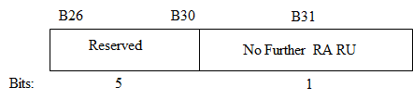
Figure 9-52ga—SS Allocation/Random Access RU Information subfield format when the value of the AID12 subfield is equal to 0 or 2045 (#6053)
The No Further RA RU subfield set to 1 indicates that random access RUs are not allocated by the subsequent Trigger frames which are sent until the end of the current TXOP. (#6053)

