IEEE P802.11
Wireless LANs
CE TRN Transmission in BRP TXSS
Date: 2017-07-11
Author(s):
Name | Affiliation | Address | Phone | email
Claudio da Silva | Intel |  |  | claudio.da.silva@intel.com
Carlos Cordeiro | Intel
Artyom Lomayev | Intel
Miki Genossar | Intel
Jonathan Kosloff | Intel

Abstract
This document suggests text that defines the transmission of TRN subfields used for channel estimation in the BRP TXSS procedure when an antenna switch happens at the beginning of the TRN field.

Discussion
- One of the key features of BRP TXSS is that it enables training of all of the initiator and responder DMG antennas.

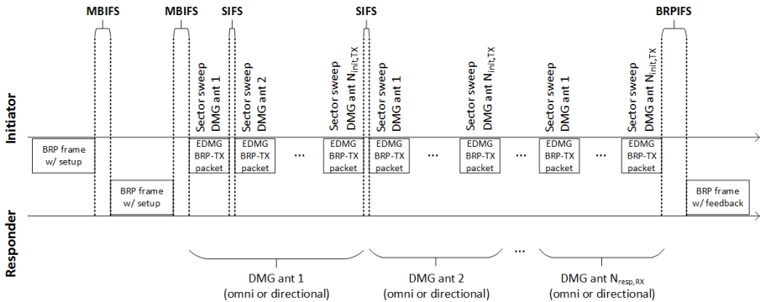

- To enable training of a different antenna from the one used in the setup, the TRN field may be transmitted using a different antenna from the other fields.
  - A dummy TRN-Unit is added to the start of the TRN field to allow time for antenna switching.
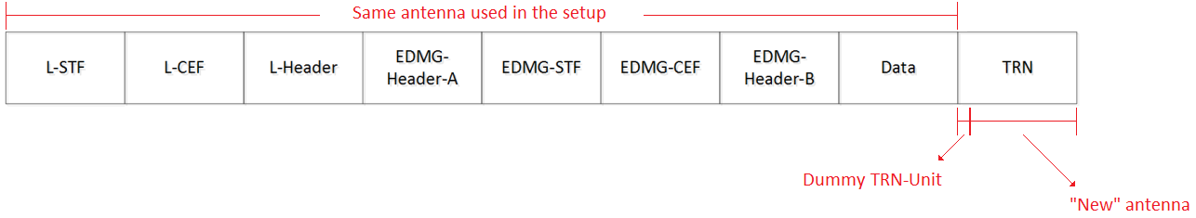

- It is defined in the spec that the TRN subfields used for channel estimation shall be transmitted with the same AWV as the preamble and data field.
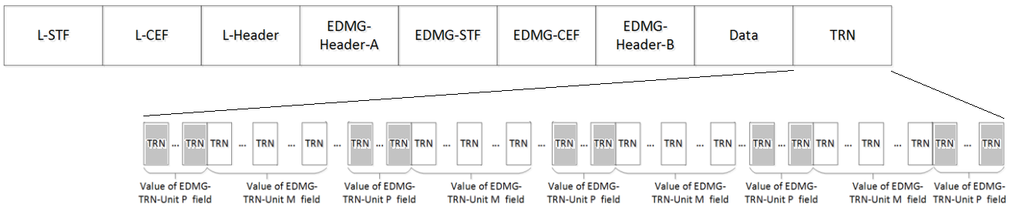

- Possible solutions:
  - Use P = 0.
  - Define that when the TRN field is transmitted with an antenna that is different from the one used in the transmission of the preamble, the TRN subfields used for channel estimation:
    - Shall be transmitted from the antenna being currently used (that is, the “new” one)
    - Choice of AWV used is implementation dependent

Change to D0.35: 30.9.2.2.5 (TRN field definition)

Replace the fifth paragraph of 30.9.2.2.5 with the following

In an EDMG BRP-RX packet, all TRN subfields shall be transmitted using the same AWV as the preamble and data field of the packet.

In EDMG BRP-TX and EDMG BRP-RX/TX packets, the first P TRN subfields of each TRN-Unit are shall be transmitted using the same AWV as the preamble and data field of the packet, except for the case when the DMG antenna used in the transmission of an EDMG BRP-TX packet changes at the beginning of the TRN field, as described in 10.38.9.5.2 for the BRP TXSS procedure. In this particular case, the AWV used in the transmission of the first P TRN subfields of each TRN-Unit shall be selected in an implementation dependent manner, and should be the same for all TRN-Units.

In an EDMG BRP-TX packet, the transmitter may change AWV at the beginning of each of the last M TRN subfields of each TRN-Unit. In an EDMG BRP-RX/TX packet, the transmitter may change AWV once at the beginning of the last M TRN subfields of each TRN-Unit with the constraint that each TRN-Unit is repeated a number of consecutive times with the same AWV configuration. Any transmit signal transients that occur due to TX AWV configuration changes at the beginning of a TRN subfield shall settle within 64×Tc from the beginning of the TRN subfield.

Change the fourth paragraph of 30.9.2.2.5 as follows

Following the transmission of all TRN-Units as indicated by the value of the EDMG TRN Length field, there are P repetitions of the TRN subfield, which shall be transmitted with the same AWV that is used for the transmission of the preamble and Data field of the PPDU containing the TRN field, except for the case when the DMG antenna used in the transmission of an EDMG BRP-TX packet changes at the beginning of the TRN field, as described in 10.38.9.5.2 for the BRP TXSS procedure. In this particular case, the AWV used in the transmission of the P repetitions of the TRN subfield shall be selected in an implementation dependent manner.

Change to D0.35: 10.38.9.5.2 (DMG antenna and TRN-Unit configuration during BRP TXSS)

Insert the following at the end of the subclause

For EDMG BRP-TX packets used in BRP TXSS, the AWV used in the transmission of the first P TRN subfields of each TRN-Unit depends on whether the DMG antenna used in the transmission of an EDMG BRP-TX packet changes at the beginning of the TRN field. As defined in 30.9.2.2.5, if the TRN field of an EDMG BRP-TX packet is transmitted with the same DMG antenna as the remaining fields of the packet, the first P TRN subfields of each TRN-Unit shall be transmitted using the same AWV as the remaining fields of the packet. If the DMG antenna used in the transmission of an EDMG BRP-TX packet changes at the beginning of the TRN field, the AWV used in the transmission of the first P TRN subfields of each TRN-Unit shall be selected in an implementation dependent manner, and should be the same for all TRN-Units.

Change to D0.35: 9.4.2.255 (EDMG BRP Request element)

Change the sixth paragraph as follows

The EDMG TRN-Unit P field indicates the requested number of TRN subfields at the start of a TRN-Unit that use the same AWV, which is the same AWV used in the transmission of the preamble and data field except for the case when the DMG antenna used in the transmission of the packet changes at the beginning of the TRN field, as defined in 30.9.2.2.5. A value of zero indicates zero requested TRN subfields, a value of one indicates one requested TRN subfield, a value of two indicates two requested TRN subfields and a value of three indicates four requested TRN subfields.

Change to D0.35: 30.3.3.3.2.3 (Definition for EDMG SC mode and EDMG OFDM mode PPDUs)

Change Table 17 as follows

Field | Number of bits | Start bit | Description
EDMG TRN-Unit P | 2 | 80 | For EDMG BRP-TX and EDMG BRP-RX/TX packets, the value of this field describes the number of TRN subfields in a TRN-Unit which are transmitted with the same AWV as the preamble and data field, using the same AWV, which is the same AWV used in the transmission of the preamble and data field except for the case when the DMG antenna used in the transmission of the packet changes at the beginning of the TRN field, as defined in 30.9.2.2.5. Possible values for this field are:  - 0: indicates zero TRN subfields  - 1: indicates one TRN subfield  - 2: indicates two TRN subfields  - 3: indicates four TRN subfields  For EDMG BRP-RX packets, this field is reserved.

Change to D0.35: 30.9.2.2.3 (EDMG BRP packet header fields)

Please change the second paragraph of 30.9.2.2.3 as follows

An EDMG STA shall support the following transmit and receive configurations of the EDMG TRN-Unit P, EDMG TRN-Unit M and EDMG TRN-Unit N fields in a PPDU:

⎯ EDMG TRN-Unit P = 2, EDMG TRN-Unit M = 6 5 and EDMG TRN-Unit N = 3 2
⎯ EDMG TRN-Unit P = 2, EDMG TRN-Unit M = 8 7 and EDMG TRN-Unit N = 1 0
⎯ EDMG TRN-Unit P = 0, EDMG TRN-Unit M = 2, 5, 8, 11, and 14, and EDMG TRN-Unit N = 2
⎯ EDMG TRN-Unit P = 0, EDMG TRN-Unit M = 0 through 15, and EDMG TRN-Unit N = 0

All other configurations are optionally supported by an EDMG STA. In all cases, the value of the EDMG TRN-Unit M field plus one shall be an integer multiple of the value indicated in of the EDMG TRN-Unit N field.

Change to D0.35: 9.4.2.250.1 (General)

Delete the following two paragraphs and corresponding fields in Figure 22

The TP0 subfield indicates that the STA is capable of transmitting an EDMG PPDU with TXVECTOR parameter EDMG_TRN_P equal to 0.

The RP0 subfield indicates that the STA is capable of receiving an EDMG PPDU with RXVECTOR parameter EDMG_TRN_P equal to 0.

Change to D0.35: 10.38.9.1 (General)

Insert the following paragraph at the end of the subclause
If the Channel Measurement Requested subfield in the DMG Beam Refinement element within a BRP frame is equal to 1, the TXVECTOR parameter EDMG_TRN_P shall not be set to 0.

Change to D0.35: 9.4.2.255 (EDMG BRP Request element)

Modify the 7th paragraph as follows
The value of the EDMG TRN-Unit M field plus one indicates the requested number of TRN subfields within a TRN-Unit that can change the AWV configuration. The value of this field plus one is an integer multiple of the value indicated in of the EDMG TRN-Unit N field.

Change to D0.35: 30.3.3.3.2.3 (Definition for EDMG SC mode and EDMG OFDM mode PPDUs)

Change Table 17 as follows

Field | Number of bits | Start bit | Description
EDMG TRN-Unit N | 2 | 86 | For EDMG BRP-TX packets, the value of this field indicates the number of consecutive TRN subfields within EDMG TRN-Unit M which are transmitted using the same AWV, as defined in 30.9.2.2.5. Possible values for this field are:  - 0: indicates one TRN subfield  - 1: indicates two TRN subfields  - 2: indicates three TRN subfields if EDMG TRN-Unit M is equal to 3, 6, 9 or 12 2, 5, 8, 11 or 14; indicates eight TRN subfields if EDMG TRN-Unit M is equal to 8 or 16 7 or 15.  - 3: indicates four TRN subfields  For EDMG BRP-RX and EDMG BRP-RX/TX packets, this field is reserved

References:

