IEEE P802.11  
Wireless LANs

|  |  |  |  |
| --- | --- | --- | --- |
| Proposed resolution for CID 9021 | | | |
| Date: 07/10/2017 | | | |
| Author(s): | | | |
| Name | Affiliation | Address | Email |
| Sigurd Schelstraete | Quantenna | 3450 W. Warren Ave  Fremont, CA 94538 | [sigurd@quantenna.com](mailto:sigurd@quantenna.com) |

Abstract

This submission proposes resolutions for CID 9021.

# CID 166Discussion

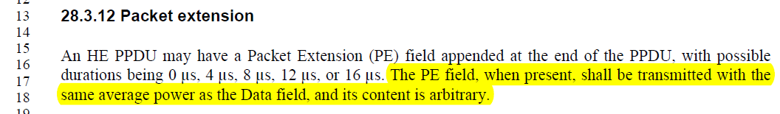

See [1] for a more detailed discussion. This document illustrates that PE as currently specified allows for undesirable behavior. Specifically, a PE built from a given choice of random samples can create significant “out-of-RU” leakage. This is especially problematic for cases with punctured preamble.

This issue was further discussed offline. There appears to be consensus that just leaving the content “arbitrary” is not sufficient as a specification, but there was no consensus on a proposed resolution. One proposal is to have a qualitative statement about leakage, while other proposals were more specific about the level of leakage.

At this point, we propose to have a more generic statement in order to make some progress on the issue. Further rounds of letter ballot may add more detail is appropriate.

# Proposed resolution

Revised

Change text on page 424 of D1.3 starting at line 37 as follows:

An HE PPDU may have a Packet Extension (PE) field appended at the end of the PPDU, with possible durations being 0 μs, 4 μs, 8 μs, 12 μs, or 16 μs. The PE field provides additional receive processing time at the end of the HE PPDU. The PE field, when present, shall be transmitted with the same average power as the Data field and shall not cause significant power leakage outside of the spectrum used by the Data field. Other than that, ~~and~~ its content is arbitrary.

# References

[1] Discussion of CID 9021, IEEE 802.11/2017-0678