IEEE P802.11
Wireless LANs
Miscellaneous HE-SIG-B related CIDs
Date: 07/10/2017
Author(s):
Name | Affiliation | Address | Email
Sigurd Schelstraete | Quantenna | 3450 W. Warren Ave  Fremont, CA 94538 | sigurd@quantenna.com
Abstract
This submission proposes resolutions for the following CIDs: 5253, 8837, 9548, 10394, 10113, 6113, 9221, 9226, 9497, 4917, 4920, 4921, 4922, 5265, 5266, 5267, 5268, 5269, 5283, 7047, 8428, 8834, 8835, 8836, 8938, 8939, 8941, 8942, 8965, 9031, 9755, 10216, 10317 and 10416
CID 166
5253 | 28.3.4 | 242.27 | HE-SIG-A-R is undefined | define
8837 | 28.3.4 | 242.27 | Text mentions the field HE-SIG-A-R. This is not mentioned anywhere else. Should this be used in the definition of the preamble or should be remove it? | Clarify
9548 | 28.3.4 | 242.27 | "The L-STF, L-LTF, L-SIG, RL-SIG, HE-SIG-A, HE-SIG-A-R, and HE-SIG-B fields are ..."  HE-SIG-A-R not defined. | It should be described that the HE-SIG-A-R is repeated HE-SIG-A.
10394 |  | 242.27 | terminology HE-SIG-A-R used | first time defined. Either define and draw it or remove
10113 | 28.3.4 | 242.27 | In Table 28-9, THE-SIG-A and THE-SIG-A-R are defined as 8us and 16us, respectively. Then in Figure 28-7, HE-SIG-A should be replaced with HE-SIG-A-R.  add the definition of HE-SIG-A-R and modify the Figure 29-7 and Table 28-8 to present HE-SIG-A-R field in HE extended range SU PPDU | As in the comment.
Discussion:
All these CIDs are related to the same issue. T_{HE-SIG-A-R} is a notation that is used in Table 28-11 to indicate the “HE-SIG-A field duration in an HE ER SU PPDU”. However, even for an HE ER SU PPDU, we still refer to the field as “HE-SIG-A”, not “HE-SIG-A-R”. As such, there is no field named “HE-SIG-A-R”.
Proposed resolution for CIDs 5253, 8837, 9548, 10394 and 10113:
Revised
Editor instructions:
Make the following modification on line 50, page 323 of draft 1.3:
The L-STF, L-LTF, L-SIG, RL-SIG, HE-SIG-A, HE-SIG-A-R, and HE-SIG-B fields are referred to as the Pre-HE modulated fields, while the HE-STF, HE-LTF and Data fields are referred to as the HE modulated fields.

6113 |  | 242.22 | Add HE-SIG-A-R before HE-SIG-B as in L27 | As in comment
Proposed resolution for CID 6113:
Rejected.
The term “HE-SIG-A-R” has been removed by the resolution of CIDs 5253, 8837, 9548, 10394 and 10113. As such, the issue no longer exists.

9221 | 3.2 | 3.05 | The current definition of user in the baseline covers MU-MIMO but not OFDMA. | Insert the definition of user to clause 3.2 of the draft and change the definition of user to also cover OFDMA.
Discussion:
The baseline defines user as follows:
This definition mentions MU-MIMO, but not OFDMA.
Proposed resolution for CID 9221:
Revised.
Editor instructions:
Add the following text at the end of the definition section (3.2). Change bars are shown relative to the baseline text 802.11-2016.
user: An individual station or group of stations (STAs) identified by a single receive address (RA) in the context of single-user multiple input, multiple output (SU-MIMO) or multi-user multiple input, multiple output (MU-MIMO) or orthogonal frequency division multiple access (OFDMA).

9226 | 3.2 | 3.05 | The definition of HE-MCS should be included. | Add a definition of HE-MCS in clause 3.2.
Discussion:
The definition clause contains definitions for both HT and VHT MCS:
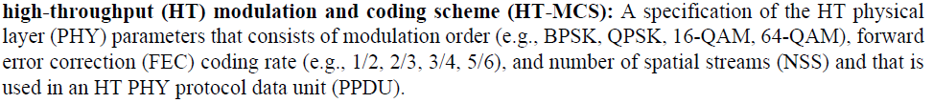
And:
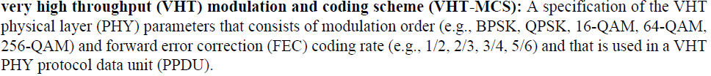
Given this, it seems appropriate to include a definition for HE-MCS as well.
Proposed resolution for CID 9226:
Revised.
Editor instructions:
Add the following definition at the appropriate place in section 3.2.
high efficiency (HE) modulation and coding scheme (HE-MCS): A specification of the HE physical layer (PHY) parameters that consists of modulation order (e.g., BPSK, QPSK, 16-QAM, 64-QAM, 256-QAM, 1024-QAM) and forward error correction (FEC) coding rate (e.g., 1/2, 2/3, 3/4, 5/6) and that is used in an HE PHY protocol data unit (PPDU).

9497 | 3.2 | 3.40 | Definition of "20 MHz physical layer (PHY) protocol data unit (PPDU)" should not include the clause 15 (DSSS PHY specification for the  2.4 GHz band designated for ISM applications) PPDU and the clause 16 (High rate direct sequence spread spectrum (HR/DSSS) PHY specification) PPDU since they occupy more than 20 MHz. | Remove clause 15 (DSSS PHY specification for the 2.4 GHz band designated for ISM applications) PPDU and the clause 16 (High rate direct sequence spread spectrum (HR/DSSS) PHY specification) PPDU.
Discussion:
Agree in principle. However, since this appears in the underlying reference (802.11-2016), the better place to address this may be in TGmd.
Proposed resolution for CID 9497:
Reject.
We propose to address this issue in TGmd.

4917 | 28.3.10.8.2 | 286.34 | Organization of HESIGB is mixed up. Start with data contents (28.3.10.8.1) and continued details 28.3.10.8.4 and 28.3.10.8.5, then work down to encoding / modulaiton / frequency mapping! | Reorganize: start with fields, and meaning of fields, then encoding then modulation then freq-domain mapping [Editor can take care of this but this MUST be done to convert me into a yes voter]
Discussion:
Agreed in principle that “Organization of HESIGB is mixed up”.
This can be seen by comparing the sub-clauses of HE-SIG-A and HE-SIG-B:
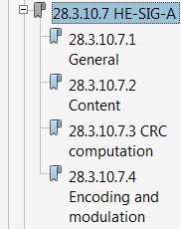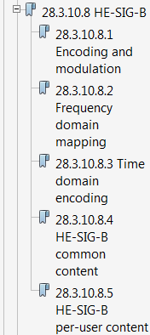

For HE-SIG-A, encoding and modulation come last. For HE-SIG-B, it comes first.
The proposed resolution amounts to more than a simple re-ordering of sections however and is probably beyond the scope of pure editorial clean-up.
Proposed resolution for CID 4917:
Needs further discussion. Is this an effort we want to undertake now or in a later revision of the draft?

4920 | 28.3.10.8.1 | 287.23 | It is very hard to discern if a STA with an RU within one 20M subchannle is guaranteed to get its PER STA Info field on that 20 M channel, or if it has to look at both 20M subchannels | Add an explicit statement here or somewhere underwhat circumstances "load balancing" of PER STA Info is allowed and when it is not. There is a para at P288L44 - but this only for Compression = 0. LB is referred to at P297L20 but this is for larger Rus only. This is all just too vague
Proposed resolution for CID 4920:
Revised. See resolution for CID 4921.

4921 | 28.3.10.8.1 | 288.44 | "when SIGB Compression field ... is set to 0" - what happens when it is set to 1? Is that the content earlier in this section? If so be explicit | "when SIGB Compression field ... is set to 0" - what happens when it is set to 1? Is that the content earlier in this section? If so be explicit
Discussion:
The text is question can be found on page 376 of D1.3:
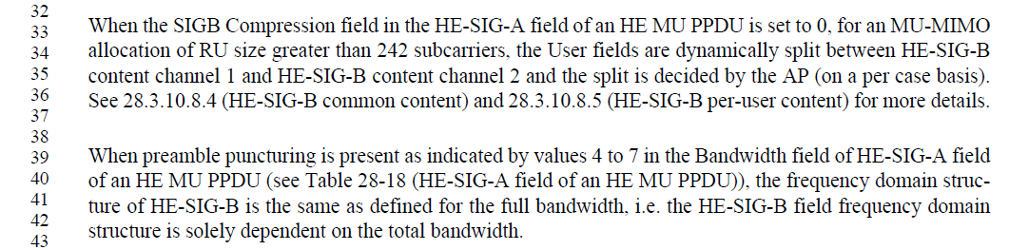
This only talks about the case when SIGB Compression field is set to 0. On page 386, line 1 (D1.3), we have the following text which talks about the case when SIGB Compression field is set to 1:
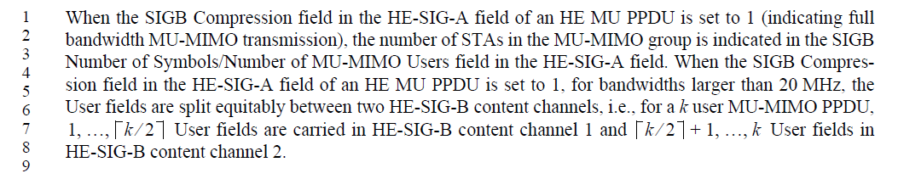
Proposed resolution for CID 4921:
Revised
Editor instructions:
Modify the text on page 376 of D1.3 starting at line 33 as follows:
When the SIGB Compression field in the HE-SIG-A field of an HE MU PPDU is set to 0, for an MU-MIMO allocation of RU size greater than 242 subcarriers, the User fields are dynamically split between HE-SIG-B content channel 1 and HE-SIG-B content channel 2 and the split is decided by the AP (on a per case basis). See 28.3.10.8.4 (HE-SIG-B common content) and 28.3.10.8.5 (HE-SIG-B per-user content) for more details.
When the SIGB Compression field in the HE-SIG-A field of an HE MU PPDU is set to 1, for bandwidths larger than 20 MHz, the User fields are split equitably between two HE-SIG-B content channels, i.e., for a k user MU-MIMO PPDU, 1, …, $\left\lceil k/2\right\rceil$ User fields are carried in HE-SIG-B content channel 1 and $\left\lceil k/2\right\rceil +1, …, k$ User fields in HE-SIG-B content channel 2.
Modify the text on page 386 of D1.3 starting at line 1 as follows:
When the SIGB Compression field in the HE-SIG-A field of an HE MU PPDU is set to 1 (indicating full bandwidth MU-MIMO transmission), the number of STAs in the MU-MIMO group is indicated in the SIGB Number of Symbols/Number of MU-MIMO Users field in the HE-SIG-A field. When the SIGB Compression field in the HE-SIG-A field of an HE MU PPDU is set to 1, for bandwidths larger than 20 MHz, the User fields are split equitably between two HE-SIG-B content channels, i.e., for a k user MU-MIMO PPDU, 1, …, $\left\lceil k/2\right\rceil$ User fields are carried in HE-SIG-B content channel 1 and $\left\lceil k/2\right\rceil +1, …, k$ User fields in HE-SIG-B content channel 2.

4922 | Brian Hart | 28.3.10.8.4 | 290.40 | "full bandwidth 80" is only use here (i.e. is undefined). And a naive reading would look at the last row of fig 28-4 (996 subcarriers) But there is no 26 RU there | Define "full bandwidth 80". I assume it must have a center tone 26?
Discussion
In D1.3, the section under discussion has already been modified as follows:
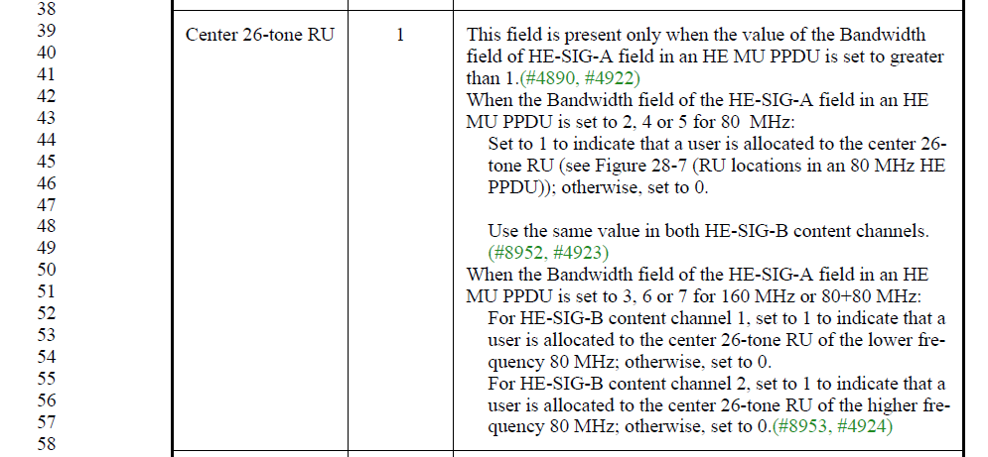
This means that the undefined term “full bandwidth 80” is no longer used. As such, the comment is obsolete.
Proposed resolution for CID 4921:
Revised. Resolved by resolution of CID 4890.
No further action needed.

5265 | 28.3.10.8.2 | 286.44 | The "RU-242" labels in Figure 28-21 are confusing. The main issue is that the label implies one RU, where the content could contain signaling for many RU's. I would delete the "RU-242" block on the left side. I would probably also delete the parallelogram as well, as I don't know what it is trying to convey. In the common field, I would change "RU-242" to "-122:122". In the User Specific Field I would also change "RU-242" to "-122:122". | as in comment
Discussion:
In D1.3, the Figure has become Figure 28-26 and can be found on page 374:
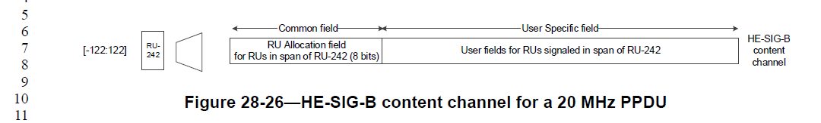
Agreed that the use of RU-242 is confusing. I suppose the intention is to indicate that the transmission bandwidth is 20 MHz, while also taking into account that 242-tone RUs are not perfectly aligned with 20 MHz subchannels. To avoid the confusion, it would be better to just use the notation -122:122 to indicate the exact frequency range in question, as proposed by the commenter.
Proposed resolution:
Revised.
Editor’s instructions:
- Delete block labeled “RU-242” in Figure 28-26 in D1.3
- Delete parallelogram to the left of the block labeled “RU-242” in Figure 28-26 in D1.3
- Change text in the block labeled “User Specific field” from “User fields for RUs signaled in span of RU-242” to “User fields for RUs signaled in Common field”
- Change text in block labeled “Common field” from “RU allocation field for RUs in span of RU-242 (8 bits)” to “RU allocation field for RUs overlapping with tone range -122:122 (8 bits)”

5266 | 28.3.10.8.2 | 287.08 | The "RU-242" labels in Figure 28-22 are confusing. The main issue is that the label implies one RU, where the content could contain signaling for many RU's. I would delete the "RU1-242" and "RU2-242" blocks on the left side. I would probably also delete the parallelograms as well, as I don't know what it is trying to convey. In the common field, I would change "RU1-242" to "-244:-3". In the User Specific Field I would also change "RU1-242" to "--244:-3". Make similar changes to channel 2 | as in comment
In D1.3, the Figure has become Figure 28-27 and can be found on page 374:
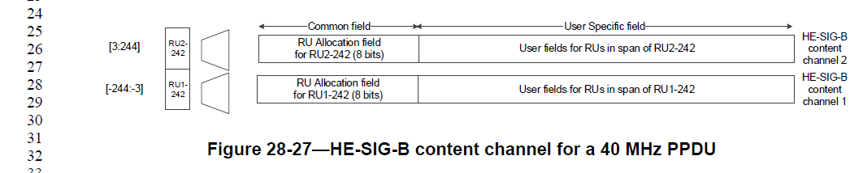
Discussion:
The issues with this figure are similar to the ones discussed for CID 5265.
Additionally, (although not part of the comment) it is not correct to state that content channel 1 contains “User fields for RUs in span of RU1-242” and content channel 2 contains “User fields for RUs in span of RU2-242”. This ignores the possibility of “rebalancing” the user fields as described on e.g. page 376 of D1.3:
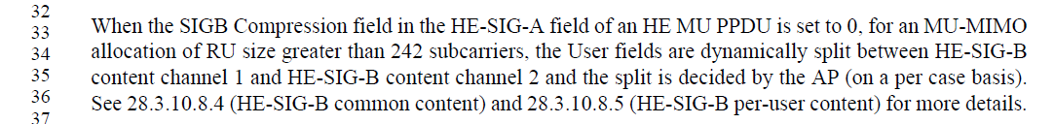
Proposed resolution:
Revised.
Editor’s instructions:
- Delete blocks labeled “RU1-242” and “RU2-242” in Figure 28-27 in D1.3
- Delete parallelograms to the left of these blocks in Figure 28-27 in D1.3
- Change text in the block labeled “User Specific field” from “User fields for RUs in span of RU2-242” to “User fields for RUs signaled in Common field”
- Change text in the block labeled “User Specific field” from “User fields for RUs in span of RU1-242” to “User fields for RUs signaled in Common field”
- Change text in block labeled “Common field” from “RU allocation field for RUs in span of RU2-242 (8 bits)” to “RU allocation field for RUs overlapping with tone range 3:244”
- Change text in block labeled “Common field” from “RU allocation field for RUs in span of RU1-242 (8 bits)” to “RU allocation field for RUs overlapping with tone range -244:-3

5267 | 28.3.10.8.2 | 287.51 | The "RU-242" labels in Figure 28-23 are confusing. The main issue is that the label implies one RU, where the content could contain signaling for many RU's. I would delete the "RUn-242" blocks on the left side. I would probably also delete the parallelograms as well, as I don't know what it is trying to convey. In the common field, I would change "RU1-242" to "-500:-259". In the User Specific Field I would also change "RU1-242" to "-500:-259". Make similar changes to channels 2,3, and 4. | as in comment
Discussion:
The issues with this figure are similar to the ones discussed for CID 5265 and 5266.
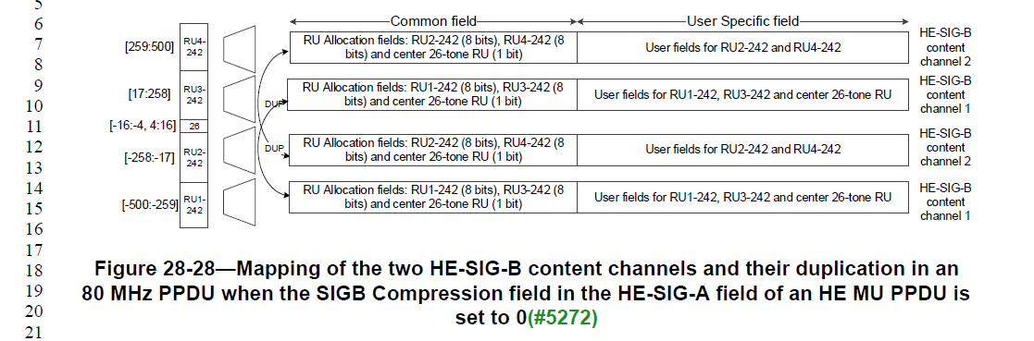
Proposed resolution:
Revised.
Editor’s instructions:
- Delete blocks labeled “RU1-242”, “RU2-242”, “RU3-242” and “RU4-242” in Figure 28-28 in D1.3
- Delete block labeled “26” in Figure 28-28 in D1.3
- Delete parallelograms to the left of these blocks in Figure 28-28 in D1.3
- Change text in the blocks labeled “User Specific field” from “User fields for RU2-242 and RU4-242” to “User fields for RUs signaled in Common field”
- Change text in the blocks labeled “User Specific field” from “User fields for RU1-242, RU3-242 and center 26-tone RU” to “User fields for RUs signaled in Common field”
- Change text in block labeled “Common field” from “RU allocation fields: RU2-242 (8 bits), RU4-242 (8 bits) and center 26-tone RU (1 bit)” to “RU allocation field for RUs overlapping with tone ranges -258:-17, 259:500 and center 26-tone RU”
- Change text in block labeled “Common field” from “RU allocation fields: RU1-242 (8 bits), RU3-242 (8 bits) and center 26-tone RU (1 bit)” to “RU allocation field for RUs overlapping with tone ranges -500:-259, 17:258 and center 26-tone RU”

5268 | 28.3.10.8.2 | 288.21 | Figure 28-24 looks half finished compared to the other figures, complete all the labeling as in the others. | as in comment
Discussion:
This figure (Figure 28-29 in D1.3) needs to be updated along the same lines as changes proposed above for Figures 28-26, 28-27, 28-28. However, it is indeed missing some parts that are presents in these other figures (such as tone ranges, …).
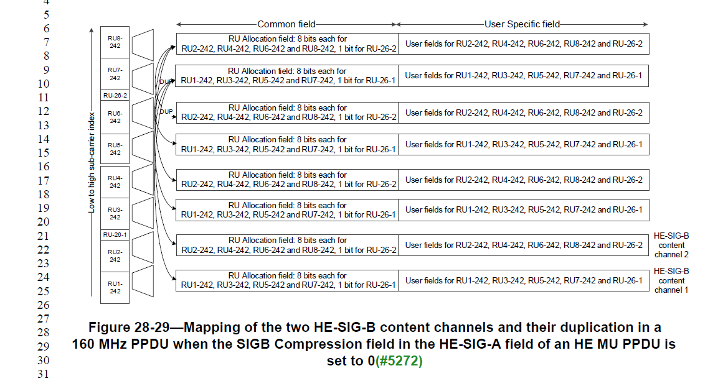
Proposed resolution:
Revised.
Editor’s instructions:
- Delete blocks labeled “RU1-242”, “RU2-242”, “RU3-242”, “RU4-242”, “RU5-242”, “RU6-242”, “RU5-242” and “RU8-242” in Figure 28-29 in D1.3
- Delete blocks labeled “RU-26-1” and “RU-26-2” in Figure 28-29 in D1.3
- Delete parallelograms to the left of these blocks in Figure 28-29 in D1.3
- Add tone ranges corresponding to the various rows:
  - RU1-242 -1012:-771
  - RU2-242 -770:-529
  - RU-26-1 [-528:-516 -508:-496]
  - RU3-242 -495:-254
  - RU4-242 -253:-12
  - RU5-242 12:253
  - RU6-242 254:495
  - RU-26-2 [496:508 516:528]
  - RU7-242 529:770
  - RU8-242 771:1012
- Replicate text “HE-SIG-B content channel 2” to all odd-numbered rows (right of the figure)
- Replicate text “HE-SIG-B content channel 1” to all even-numbered rows (right of the figure)
- Change text in the blocks labeled “User Specific field” from “User fields for RU2-242, RU4-242, RU6-242, RU8-242 and RU-26-2” to “User fields for RUs signaled in Common field”
- Change text in the blocks labeled “User Specific field” from “User fields for RU1-242, RU3-242, RU5-242, RU7-242 and RU-26-1” to “User fields for RUs signaled in Common field”
- Change text in block labeled “Common field” from “RU Allocation field: 8 bits each for RU2-242, RU4-242, RU6-242 and RU8-242, 1 bit for RU-26-2” to “RU allocation field for RUs overlapping with tone ranges -770:-529, -253:-12, 254:495, 771:1012 and [496:508 516:528]”
- Change text in block labeled “Common field” from “RU Allocation field: 8 bits each for RU1-242, RU3-242, RU5-242 and RU7-242, 1 bit for RU-26-1” to “RU allocation field for RUs overlapping with tone ranges -1012:-771, -495:-254, 12:253, 529:770 and [-528:-516 -508:-496]”

5269 | 28.3.10.8.2 | 288.53 | Regarding "is the same as defined for the full bandwidth", does this mean that HE-SIG-B is not punctured? If not, this paragraph needs to be made clearer. | as in comment
Discussion:
In D1.3, the text can be found on page 376:
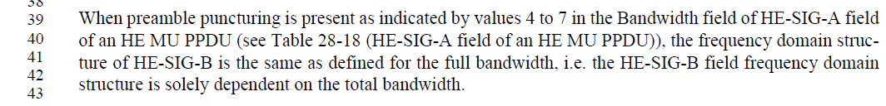
With preamble puncturing, some 20 MHz channels are not transmitted. These channels will also be missing from HE-SIG-B, so the text is somewhat confusing.
Proposed resolution:
Revised.
Editor’s instructions:
Replace the text on page 376, line 39 in D1.3:
When preamble puncturing is present as indicated by values 4 to 7 in the Bandwidth field of HE-SIG-A field of an HE MU PPDU (see Table 28-18 (HE-SIG-A field of an HE MU PPDU)), the frequency domain structure of HE-SIG-B is the same as defined for the full bandwidth, i.e. the HE-SIG-B field frequency domain structure is solely dependent on the total bandwidth.
With:
When preamble puncturing is present and the Bandwidth field in the HE-SIG-A field of an HE MU PPDU (see Table 28-18 (HE-SIG-A field of an HE MU PPDU)) takes values 4 or 5, the frequency domain structure of HE-SIG-B shall be the same as for an 80 MHz PPDU (see Figure 28-28), but with the punctured 20 MHz channels removed.
When preamble puncturing is present and the Bandwidth field in the HE-SIG-A field of an HE MU PPDU (see Table 28-18 (HE-SIG-A field of an HE MU PPDU)) takes values 6 or 7, the frequency domain structure of HE-SIG-B shall be the same as for an 160 MHz PPDU (see Figure 28-29), but with the punctured 20 MHz channels removed.

5283 | 28.3.16 | 344.41 | By Figure 28-36 if appears that only mandatory HE-LTF/GI combinations are allowed with HE NDP. If this is the case add this requirement to the list of properties. | as in comment
Discussion:
Agreed in principle with the comment.

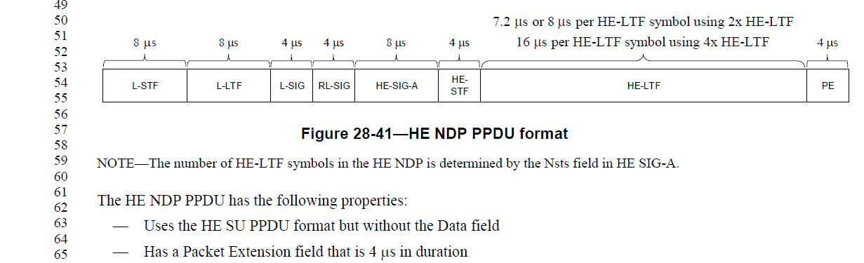
Proposed resolution:
Revised.
Editor’s instructions:
Modify the text starting on line 61 of page 431 of D1.3 as follows:
The HE NDP PPDU has the following properties:
— Uses the HE SU PPDU format but without the Data field
— Has a Packet Extension field that is 4 μs in duration
— Uses one of the following combinations of HE-LTF size and GI duration:
- 2x HE-LTF and 0.8 μs
- 2x HE-LTF and 1.6 μs GI
- 4x HE-LTF and 3.2 μs GI

7047 | 28.3.10.8 | 285.56 | Add a general statement on what HE-SIG-B is for. There is a general statement for HE-SIG-A, but for HE-SIG-B, a technical detail starts immediately at the beginning of the HE-SIG-B section. | Insert the following statement in Line 56.  The HE-SIG-B field provides the OFDMA resource allocation information for the scheduled STAs to look up the corresponding resources in the data portion of the frame.
Discussion:
Agree in principle
Proposed resolution:
Revised
Editor’s instructions:
Add new section 28.3.10.8.1 (and renumber existing sections) on page 373, line 2 of D1.3:
28.3.10.8 HE-SIG-B
28.3.10.8.1 General
The HE-SIG-B field provides the OFDMA resource allocation information to allow the scheduled STAs to look up the corresponding resources in the data portion of the frame.
28.3.10.8.12 Encoding and modulation

8428 | 28.3.16 | 344.33 | Either the HE NDP PPDU is a distinct PPDU format or it isn't. If it is a distinct format it should be listed with the other formats in 28.3.4. If it is a special case of the HE SU PPDU then just describe it as such (in 28.3.4). During the comment period we had it then we removed it then we added it again but in a different place. Let's decide. | Remove clause 28.3.16. Add a sentence to 28.3.4 (PPDU formates): "The HE NDP PPDU is an HE SU PPDU with a zero length Data field and a 4 us Packet Extension field"
Discussion:
The HE NDP PPDU should probably not be considered as a new format. It is essentially an SU PPDU with specific configuration and no Data field. It is still useful to document that only specific configurations should be used for sounding. Instead of positioning this section as a new preamble format, it should be seen as giving some specifics on sounding frame configuration.
This could be captured by keeping the section in place, but giving it a more appropriate title.
Proposed resolution:
Revised.
Editor’s instructions:
Change title of section 28.3.16 from “HE preamble format for sounding PPDUs” to “HE sounding”

8834 | 28.3.4 | 241.14 | Change "that is not a response of a Trigger frame" to "when the PPDU is not a response to a Trigger Frame" | See comment
Proposed resolution:
Revised.
Editor’s instructions:
Change text on page 322, starting at line 38 of D1.3 as follows:
The format of the HE MU PPDU is defined as in Figure 28-9 (HE MU PPDU format). This format is used for transmission to one or more users that is not a response of a Trigger frame when the PPDU is not a response to a Trigger Frame. The HE-SIG-B field is present in this format.

8835 | 28.3.4 | 241.28 | "HE-SIG-A field is repeated". Strictly speaking it is not simply a repetition, since the interleaving is different. | Clarify
D1.3, page 322:
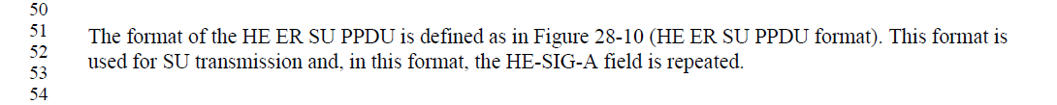
Proposed resolution:
Revised.
Editor’s instructions:
Change text on page 322, starting at line 51 of D1.3 as follows:
The format of the HE ER SU PPDU is defined as in Figure 28-10 (HE ER SU PPDU format). This format is used for SU transmission and, in this format, the HE-SIG-A field is repeated has extra redundancy and is twice as long as for the other formats.

8836 | 28.3.4 | 242.04 | SIGNAL is all-caps for L-SIG and RL-SIG, but not for HE-SIG-A and HE-SIG-B. | Use "SIGNAL" or "Signal" consistently
Proposed resolution:
Revised.
Editor’s instructions:
Change Table 28-10 in D1.3 as follows:
Field | Description
L-STF | Non-HT Short Training field
L-LTF | Non-HT Long Training field
L-SIG | Non-HT SIGNAL field
RL-SIG | Repeated Non-HT SIGNAL field
HE-SIG-A | HE Signal SIGNAL A field
HE-SIG-B | HE Signal SIGNAL B field
HE-STF | HE Short Training field
HE-LTF | HE Long Training field
Data | The Data field carrying the PSDU(s)
PE | Packet Extension field

8938 | 28.3.10.8.2 | 286.55 | Change "fall between" to "fall in the range" | See comment
Proposed resolution:
Revised.
Editor’s instructions:
Change text on page 374, starting at line 13 of D1.3 as follows:
The 40 MHz PPDU contains two HE-SIG-B content channels(#10060), each occupying a 20 MHz segment. Each HE-SIG-B content channel contains a Common field(#10060) followed by User Specific field as shown in Figure 28-27 (HE-SIG-B content channel for a 40 MHz PPDU). The HE-SIG-B content channels(#10060) are ordered in increasing order of the absolute frequency i.e., the first HE-SIG-B content channel carries Common field(#10060) and User Specific field corresponding to RUs whose subcarrier indices fall between in the range [-244: -3] and the second HE-SIG-B content channel(#10060) carries Common field(#10060) and User Specific field corresponding to RUs whose subcarrier indices fall between in the range [3:244]. The

8939 | 28.3.10.8.2 | 287.17 | The explanation on lines 17 to 22 would be clearer by explicitly indicating the indices of the 242-tone RU. E.g.: content channel 1 on RU with indices -500:-259, content channel 2 on indices -258:-17, with CC1 repeated on 17:58, ... | Clarify text by explicitly using the subcarrier indices
Discussion:
The text in question can be found on page 374 of D1.3. This text is more convoluted than it needs to be in its description of Figure 28-28.
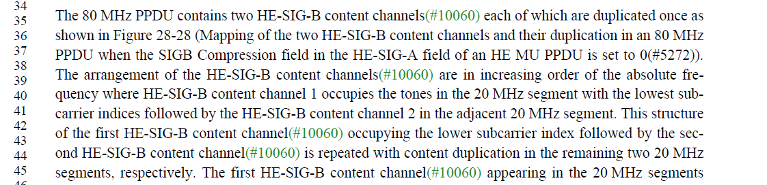
Proposed resolution:
Revised.
Editor’s instructions:
Change text on page 374, starting at line 35 as follows:
The 80 MHz PPDU contains two HE-SIG-B content channels(#10060) each of which are duplicated once as shown in Figure 28-28 (Mapping of the two HE-SIG-B content channels and their duplication in an 80 MHz PPDU when the SIGB Compression field in the HE-SIG-A field of an HE MU PPDU is set to 0(#5272)). The arrangement of the HE-SIG-B content channels(#10060) are in increasing order of the absolute frequency where HE-SIG-B content channel 1 occupies the tones in the 20 MHz segment with the lowest sub-carrier indices -500:-259 and is duplicated on tones 17:258. followed by the HE-SIG-B content channel 2 occupies tones -258:-17 and is duplicated on tones 259:500. in the adjacent 20 MHz segment. This structure of the first HE-SIG-B content channel(#10060) occupying the lower subcarrier index followed by the second HE-SIG-B content channel(#10060) is repeated with content duplication in the remaining two 20 MHz segments, respectively. The first HE-SIG-B content channel(#10060) appearing in the 20 MHz segments carries a Common field(#10060) and User Specific field corresponding to RUs whose subcarriers indices overlap those segments.

8941 | 28.3.10.8.2 | 287.40 | "When RUs greater than 242 subcarriers are signaled in the RU allocation  signaling in a portion of the bandwidth, the signaling is carried in both content channels placed in the order of the absolute subcarrier index.". I do not understand the requirement expressed here. Please clarify. | Clarify
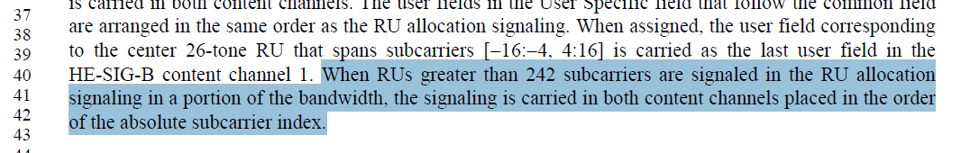
Proposed resolution:
Revised.
Editor’s instructions:
Change text on page 374, starting at line 48 as follows:
The Common field(#10060) of HE-SIG-B content channel 1 contains the following: an RU Allocation field(#10061) for RUs with subcarrier indices in the range [-500:-259] (or overlapping with [-500:-259] if the RU is larger than 242 subcarriers), followed by a second RU Allocation field(#10061) for RUs with subcarrier indices between [17:258] (or overlapping with [17:258] if the RU is larger than 242 subcarriers) and 1 bit to indicate the presence of the User field corresponding to the center 26-tone RU that spans subcarriers [-16:-4, 4:16]. The second HE-SIG-B content channel(#10060) carries a Common field(#10060) and User Specific field corresponding to RUs whose subcarrier indices fall in those segments. The Common field(#10060) of HE-SIG-B content channel 2 contains the following: an RU Allocation field(#10061) for RUs whose subcarrier indices fall in the range [-258:-17] (or overlapping with [-258:-17] if the RU is larger than 242 subcarriers), followed by a second RU Allocation field(#10061) for RUs with sub-carrier indices between [259:500] (or overlapping with 259:500] if the RU is larger than 242 subcarriers) and 1 bit to indicate presence of the User field corresponding to the center 26-tone RU that spans subcarriers [-16:-4, 4:16]. When an RU overlaps with more than one segment, it has an RU allocation field for each of the segments with which it overlaps.
The same value for the bit signaling presence of the center 26-tone RU is carried in both HE-SIG-B content channels(#10060). The User fields in the User Specific field that follow the Common field are arranged in the same order as the RU allocation signaling. When assigned, the User field corresponding to the center 26-tone RU that spans subcarriers [-16:-4, 4:16] is carried as the last User field in the HE-SIG-B content channel 1. When RUs greater than 242 subcarriers are signaled in the RU allocation signaling in a portion of the bandwidth, the signaling is carried in both HE-SIG-B content channels placed in the order of the absolute subcarrier index.

8942 | 28.3.10.8.2 | 288.01 | Clarify description of 160 MHz mapping of content channels by explicitly refering to indices of RU's (lines 1 to 5) | See comment
Proposed resolution:
Revised.
Editor’s instructions:
Change text on page 375, starting at line 20 of D1.3 as follows:
The 160 MHz PPDU contains two HE-SIG-B content channels each of which are duplicated four times as shown in Figure 28-29 (Mapping of the two HE-SIG-B content channels and their duplication in a 160 MHz PPDU when the SIGB Compression field in the HE-SIG-A field of an HE MU PPDU is set to 0(#5272)). The arrangement of the HE-SIG-B content channels are in increasing order of the absolute frequency. The first HE-SIG-B content channel 1 occupies the tones -1012:-771 and is replicated on tones -495:-254, 12:253 and 529:770. HE-SIG-B content channel 2 occupies the tones -770:-529 and is replicated on tones -253:-12, 254:495 and 771:1012. in the 20 MHz segment with the lowest subcarrier indices and the second content channel in the adjacent 20 MHz segment. This pattern of arranging HE-SIG-B content channel 1 and HE-SIG-B content channel 2 is duplicated over the other segments.

8965 | 28.3.10.8.4 | 295.29 | Change "the RU carries no data" to "no user is assigned to the RU" | See comment
Discussion:
Now on D1.3, page 383:
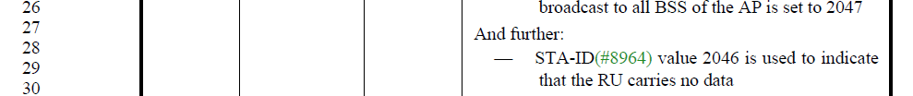
Proposed resolution:
Accepted.
Editor’s instructions:
Change text on page 383, line 29 as follows:
STA-ID(#8964) value 2046 is used to indicate that no user is assigned to the RU the RU carries no data

9031 | 28.3.16 | 344.56 | Add the allowed HE-LTF modes for an HE-NDP in the bullet list. | See comment
Discussion:
This CID deals with the same issue as CID 5283
Proposed resolution:
Revised. See resolution of CID 5283

9755 | 28.3.4 | 242.22 | "The RL-SIG, HE-SIG-A, HE-SIG-B, HE-STF, HE-LTF, and PE fields exist only in HE PPDUs."  Isn't it too much obvious? | Remove this sentence.
Discussion:
It is fairly obvious. It makes a little more sense in combination with the subsequent sentence “The HESIGB field is present only in the HE MU PPDU.” It may still be worthwhile to point out which fields appear in all formats and which fields are specific to certain formats.
Proposed resolution:
Revised.
Editor’s instructions:
Change text on page 323, line 45 of D1.3 as follows:
The RL-SIG, HE-SIG-A, HE-SIG-B, HE-STF, HE-LTF, and PE fields exist only in HE PPDUs are present in all HE PPDU formats.

10216 | 28.3.10.8.2 | 286.33 | HE-SIG-B for 80+80 MHz PPDU is not defined. | Define it.
Discussion:
This is correct. There is explicit text for 20, 40, 80 and 160 MHz. In general, we try to keep 80+80 similar to 160 MHz. Especially at the bit-level, there should be no difference.
Proposed resolution:
Revised.
Editor’s instructions:
Add the following text below Figure 28-29 of D1.3:
The 80+80 MHz PPDU contains two HE-SIG-B content channels each of which are duplicated four times. The general structure is identical to the one of a 160 MHz PPDU. The only difference is that the tone ranges of the upper and lower four 20 MHz segments are not contiguous.

10317 | 28.3.4 | 240.57 | Define a preamble puncuture mode for Non-HT DUP for the protection of the HE DL/UL MU operation | per comment
Discussion:
This section defines HE PPDU formats, not non-HT formats, so it is not clear what changes are needed.
Moreover, preamble puncturing is indicated in HE-SIG-A, so non-HT duplicate could not even signal the type of puncturing that is used. It’s not clear whether what is proposed is even technically feasible.
Proposed resolution:
Reject. No clear technical solution available.

10416 |  | 295.32 | When a STA transmits on the uplink using the  HE MU PPDU format, the STA-ID field is  populated by the AID of the transmitter  assigned by the AP. Need clarification of use case or scenario where this happens. "AID of the transmitter  assigned by the AP". AID of STA transmitting with AID value assigned by AP ? HE-MU-PPDU format decided autonomously by STA or directed by AP? Where is signaling ? | create table with all PPDUs and direction of transmission. Explain explicitly use of HE MU PPDU in uplink transmission.
Discussion:
There appear to be two issues contained in this CID:
- The current wording “populated by the AID of the transmitter assigned by the AP” is awkward and open to misinterpretation.
- Provide some background as when a STA might use HE MU PPDU format for an STA-to-AP transmission
The first issue can be easily addressed. For the second issue, it’s not clear whether the standard should provide this kind of guidance.
Proposed resolution:
Revised
Editor’s instructions:
Make the following changes in Table 28-24 of D1.3 (starting on line 31):
When a STA transmits on the uplink using the HE MU PPDU format, the STA-ID field is populated by the AID of the transmitter assigned by the AP equal to the 11 LSBs of the AID of the transmitting STA.

