IEEE P802.11
Wireless LANs
802.11ak
Figs 4-13
Date: 2017-08-07
Author(s):
Name | Company | Address | Phone | Email
Philippe Klein | Broadcom Ltd | 5300 California Ave. Irvine, CA 92617 | +972 (54) 3134500 | philippe.klein@broadcom.com

Abstract

This submission is a proposal of Figure 4-13a,b & c.

History:
r0 – initial submission
r1 – fix: replace the 2 GKL APs with a single GLK AP in the GLK BSS
replace “802.2 LLC” with “LLC Sublayer”
r2 – fix: replace the 2 GLK Convergence Fct Layer entities with a single one
above the GLK BSS
r3- add a new fig to describe the IEEE Std 802.1AC MAC Service Sublayer for 802.11; update fig 4-13a, b & c
r4 – modify the 3 figures to incorporate the comments from the minutes of the 802.11ak TG July 2017 meeting in Berlin (https://mentor.ieee.org/802.11/dcn/17/11-17-1106-03-00ak-802-11ak-july-2017-minutes.doc) and Aug 7, 2017 teleconference
r5 – incorporate the comments from the Aug 7th, 2017 call:
- Replace “ISS to MAC-SAP Convergence” with ““ISS to MAC-SAP Function” in all the figs
- Switch position of the 2 MAC Relay entities in top of the AP to illustrate a redundancy case in which 2 bridges are connected thru 2 GLK links in fig 4-13b
- -Selection option #2 of the fig4-13c

Replace fig 3-14a with the figure below:
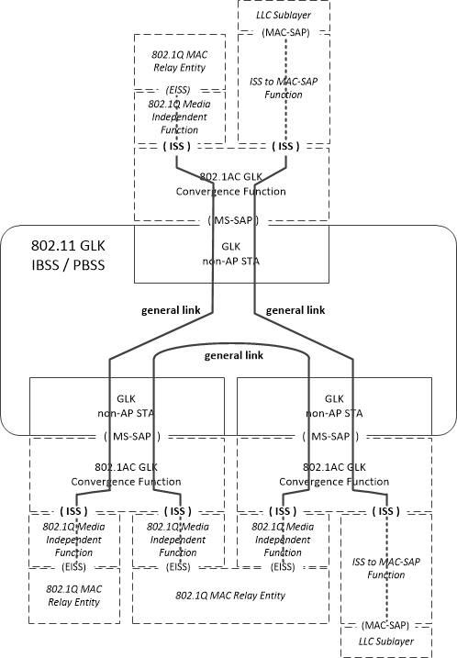

Figure 4-13a—GLK IBSS or PBSS

Replace fig 3-14b with the figure below:

Figure 4-13b—infrastructure BSS with general links

Replace figs 3-14c the figure below:

Figure 4-13c—Example of GLK Architecture

