IEEE P802.11
Wireless LANs
TGaz Meeting minutes – May 9-11th, 2017

Date: 2017-05-09
Author(s):
Name | Affiliation | Address | Phone | email
Roy Want | Google | 1600 Amphitheatre Parkway, Mountain View, CA 94043 USA | 650-691-3600 | roywant@google.com
Abstract
Minutes for the TGaz meeting beginning on May 9th, 2017.

IEEE 802.11 Task Group AZ
May 9th-11th, 2017

- TGaz – 9 May 2017 –
  - Called to order by TGaz chair, Jonathan Segev (Intel Corporation) at 01.30 PM UTC + 9hrs.
  - TGaz secretary position appointed to Roy Want (Google).
  - Agenda Doc. IEEE 802.11-17/0534r2
  - Review Patent Policy and logistics
    - Chair reviewed the IEEE-SA Patency Policy, additional guidelines about IEEE-SA meeting and logistics
    - Chair called for any potentially essential patent, no one stepped up.
    - Chair reminded all to record their attendance
    - Recorded Participation requirement
      - Headcount: ~26 present
  - Review Agenda
    - Called for any additional submissions for the week.
    - Reviewed and modified the agenda
    - Chair called for any additional feedback and changes to agenda.
  - Motion: We approve the agenda for document IEEE 802.11-17/0534r3
    - Approved by unanimous consent
  - Approve previous meeting minutes
    - March Minutes (Carlos Aldana) 11-17-0577r0-00
      - Motion to approve document 11-17-577r0 as TG meeting minutes for March
      - Mover: Ganesh Venkatesan, Seconder: Erik Lindskog
      - Discussion of the motion: None.
      - Y: 14, N: 0, A: 1. Motion passes
    - April Telecom Minutes (Roy Want)
      - Motion to approve document 11-17-0610r1 as TG minutes for April Telecon.
      - Mover: Ganesh Venkatesan, Seconder: Allan Zhu
      - Discusion of the motion: None.
      - Y: 14, N: 0, A: 1. Motion passes

  - Chittabrata Ghosh presented 11-17-0598r1-00:
    - Title: submission Polling for MU measurements
    - C: The proposal is to send a polling request prior to measurement. Clarification if the AP must execute the polling phase.
    - R: Motion changed to indicate it must have a polling phase.
    - Motion: Move to adopt the following text to the SFD and instruct the SFD editor to include it in TGaz SFD under Subsection 3.1 and grant editorial license to the SFD editor.
      - In the HEz mode, the protocol shall define a polling phase for ranging request feedback prior to NDP sounding-based measurement.
    - Mover: Ganesh Venkatesan, Seconder: Chittabrata Ghosh
    - Y: 12, N: 0, A: 2. Motion passes

  - Chittabrata Ghosh presented submission 11-17-0758r0-00:
    - Title: Trigger Frame Format for 11az
    - Discussion of straw poll: None.
    - Straw Poll: Do you support defining a single Trigger Type field value for the 11az amendment and a Trigger Sub-type subfield in Trigger Dependent Common Info field?
    - Y: 15, N: 0, A: 2:
    - Motion: Move to adopt the following text to the SFD and instruct the SFD editor to include it in TGaz SFD under section 3.2 and grant editorial license to the SFD editor.
The protocol shall define a single Trigger Type field value for the 11az amendment and a Trigger Sub-type subfield in Trigger Dependent Common Info field.
    - Mover: Ganesh Venkatesan, Seconder: Chittabrata Ghosh
    - Y: 14: N: 0: A 3: Motion passes

  - Chittabrata Ghosh presented submission 11-17-0801r0-00.
    - Title: Discussion on FTM Frame Protection
    - C. Is the spoofing done on the dominant path – a spoofer would be higher power.
    - R. How would the spoofer know what is the dominant path at the receiving STA? Spoofer is not necessarily higher power because of multipath.
    - Straw Poll: Do you agree that for REVmc, HEz, and VHTz FTM modes the fields over which range measurements is performed shall be protected for spoofing prevention against a Type B adversary?
    - Y: 14, N: 0, A: 2;
    - Motion: Move to adopt the following text to the SFD and instruct the SFD editor to include it in TGaz SFD under the security section and grant editorial license to the SFD editor.
REVmc, HEz, and VHTz FTM modes, the fields over which range measurements are performed shall be protected against a Type B adversary attack.
    - Mover: Nehru Bhandaru, Seconder: SK Yong.
    - Y: 17, N: 0, A: 1; Motion passes

  - Chittabrata Ghosh presented submission 11-17-0802r0-00:
    - Title: Resource Allocation for Unassociated STAs
    - C: AID 2045, is this something that is already in AX?
    - R: Yes, already approved into the 11ax draft, we are just repurposing it.
    - C: the SFD is yet to specify which of the different modes are supported for SU and MU negotiation part (e.g. SU-MU, MU-MU). Believe this step is required prior to selecting the framework for the negotiation scheme.
    - C: In SFD already specify the Initial FTM Request is transmitted in both SU and MU modes. This submission only touches on what mechanism is used for MU transmission of this part. The Initial FTM Response and the mechanism that is used for communicating is not within the scope of this submission.
    - Straw Poll: Do you support the resource allocation for initial FTM request in MU negotiation for unassociated STAs to be based on OFDMA random access as depicted in Slide 3?
    - Y: 10, N: 0, A: 6
    - Motion: Move to adopt the following text to the SFD and instruct the SFD editor to include it in TGaz SFD under section 3.2 and grant editorial license to the SFD editor.
    - Do you support the resource allocation for initial FTM request in MU negotiation for unassociated STAs to be based on OFDMA random access as depicted in Slide 3?
    - Mover: Ganesh Venkatesan, Seconder: Chittabrata Ghosh
    - Discussion of motion: None
    - Y: 12, N: 0, A: 4: Motion passes

  - Eric Lindskog presented submission 11-17-779r1-00:
    - Title: MU Ranging Measurement Multiplexing
    - C: Is this strictly spatial multiplexing
    - R: P-matrix is used to separate out the channels
    - C: Normally spatial multiplexing refers to case where there are number of data streams, each transmitted and received from set of antennas (more than 1 stream).
    - C: Believe this is more like code multiplexing where multiple separate soundings are transmitted from multiple anttennas but may be received by a single antenna.
    - Straw Poll: Within the MU measurement phase the UL sounding shall use one or more of the following multiplexing techniques: 1) Spatial Multiplexing using P-Matrix encoding, 2) OFDMA multiplexing 3) TDMA multiplexing (various methods, TBD)
    - Y: 16, N: 0: A: 1;
    - Motion: Move to adopt the following text to the SFD and instruct the SFD editor to include it in TGaz SFD under section 3.1 and grant editorial license to the SFD editor.
    - Within the MU measurement phase the UL sounding shall use one or more of the following multiplexing techniques: 1) Spatial Multiplexing using P-Matrix encoding, 2) OFDMA multiplexing, 3) TDMA multiplexing (various methods, TBD)
    - Mover: Ganesh Venkatesan, Seconder: Allan Zhu
    - Discussion of the motion: None.
    - Y: 15, N: 0: A: 1; Motion passes.
  - Revised agenda as captured during discussion is document IEEE 802.11-17/0534r3.
  - NOW AT RECESS
  - WEDNESDAY May 10th Slot #2 PM1
  - Called to order by TGaz chair, Jonathan Segev (Intel Corporation) at 01.30 PM
  - TGaz secretary Roy Want (Google).
  - Agenda uploaded in latest revision 802.11-17/0534r4
  - Reminded group about Patent Policy and logistics
    - IEEE-SA Patency Policy, additional guidelines about IEEE-SA meeting and logistics
    - Chair called for any potentially essential patents, no one stepped forward.
    - Reviewed obligation to participate on a professional individual basis reviewed.
    - Chair reminded all to record their attendance
    - Recorded Participation requirement
      - Headcount: ~18 present

  - Ganesh Venkatesan presented submission 11-17-0591r1 uploaded as 11-17-0591r2:
    - Title: Ranging Protocol Parameter Negotiation Protocol
    - C: Do we have common terminology that is used for FTM in REVmc and az
    - R: The group needs to create terminology for VHTz and HEWz in the SFD
    - Straw Poll: Which of the following Security negotiation options do you support? Option-1: a separate step within the Negotiation Phase; Option-2: an integrated Negotiation Phase
    - OPT-1: 11, OPT 2: 1, A: 2: Option #2 favored
    - Motion: Move to adopt the security setup for 802.11az to be
-Negotiated in a separate optional step prior to the 802.11az protocol parameter negotiation
-Note that in lieu of security negotiation, keys derived using an out-of-band mechanism may be used to secure the exchange between the initiator and the responder

And include it in the 802.11az SFD (Cl. 3.2 Protocol Description), granting the SFD Editor editorial license.
    - Mover: Ganesh Venkatesan, Seconder: Nehru Bhandaru
    - Y: 15: N: 1: A 2: Motion passes
    - Straw Poll: We agree to adopt the following high level frame structure for .11az FTM negotiation:
Initial FTM Request includes
- at least one of
-FTM Parameters element
-NGP Parameters element (optional subelements for ranging protocol- specific parameters)
-Optionally LCI and/or Location Civic Measurement Request element
-Trigger Field
-Trigger field set to 1 (for 802.11-2016 FTM backward compatibility)
Initial FTM frame includes
-one of FTM, NGP Parameters element
-Optionally LCI and/or Location Civic Measurement Report element
    - C. Doesn’t a station know that it is talking to an az vs mc device before FTM negotiation?
    - R. Yes – there will potentially be more bits in the beacon indicating this.
    - C. Is each field in the figure in slide 11 an element?
    - R. Confirmed.
    - Y: 10, N: 0, A: 4
    - Motion: Move to adopt the following high level frame structure for .11az FTM negotiation and include it in the 802.11az SFD (Cl. 8 Frame Formats), granting the SFD Editor editorial license:
Initial FTM Request includes
- at least one of
-FTM Parameters element
-NGP Parameters element (optional subelements for ranging protocol- specific parameters)
-Optionally LCI and/or Location Civic Measurement Request element
-Trigger Field
-Trigger field set to 1 (for 802.11-2016 FTM backward compatibility)
Initial FTM frame includes
-one of FTM, NGP Parameters element
-Optionally LCI and/or Location Civic Measurement Report element
    - Mover: Ganesh Venkatesan, Seconder: SK Yong
    - Y: 10: N: 0: 2; Motion passes
  - Erik Lindskog presented submission 11az 11-17-0780r2:
    - Title: Ranging PHY Security
    - C. How many possible cyclic shifts per measurement
    - R: It will define the resolution, but currently have not calculated it.
    - C. It would be useful to calculate this number (acknowledged)
    - Expect to bring more on this topic to the group at a future meeting.
  - Li Qinghua presented submission 11-17-0776:
    - Title: Uplink Sounding Sequence Design for MU Scenario in
    - C. Define new trigger frame – isn’t the space limited for the group of mobile devicew. How big is the mobile group?
    - R. 100 of users might be in a hotspot. Previously we can only accommodate 8.
    - C: option 2 may be more flexible on group size
    - R. Agreed.
    - C. After each trigger frame – what is the multiplexing (spatial, time, frequency)
    - R. Yet to be determined.
    - C: “simultaneous NDP” sounds like its not time multiplexing, so we should change the text
    - R: Text updated, not to specify time.
    - Straw Poll: Do you support that:
The measurement phase for the MU ranging protocol shall consists of one or more rounds of uplink sounding followed by one round of downlink sounding, where each round of uplink sounding consists of one trigger frame solicitationg one or more NDP sounding frames and one round of downlink sounding consists of one NDPA frame and one NDP sounding frame?
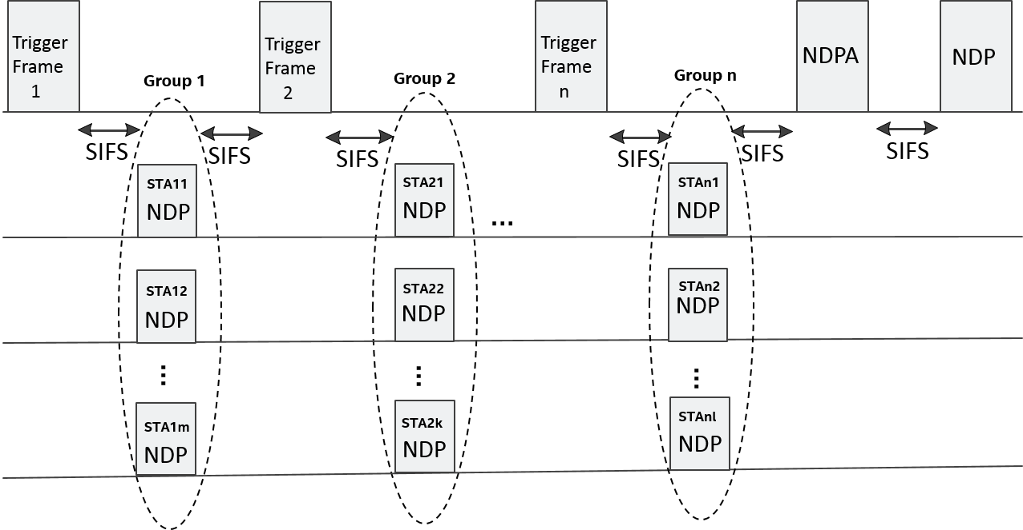
    - Y: 14, N: 0, A: 1
    - Motion: Move to adopt the text and sequence shown below to spec framework document and instruct the SFD editor to include it in the TGaz SFD under the subsection 3.2 And grant the SFD editor editorial license.
The measurement phase for the MU ranging protocol shall consists of one or more rounds of uplink sounding followed by one round of downlink sounding, where each round of uplink sounding includes one trigger frame soliciting one, or more NDP sounding frame(s) from STA(s) and the downlink sounding consists of one NDPA frame and one NDP sounding frame.
Details of the NDP sounding structure are TBD.
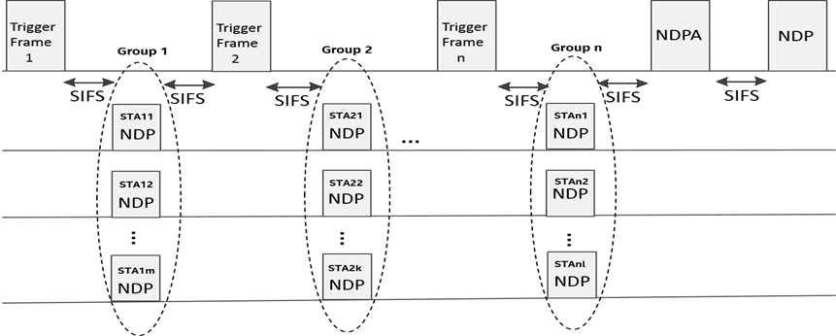
    - Mover: EriK Lindskog, Seconder: Edward Au
    - Disusssion of the motion: None
    - Y: 14, N: 0: A 0: Motion passes
  - Li Qinghua presented submission 11-17-0795r1:
    - Title: PHY Level Security Protection
    - C. How will you deal with channel estimation when devices are moving
    - R. This mainly for indoor enviroments – we can estimate motion using the Doppler shift to compensate for it. The error for walking will only be on the order of microseconds.
    - Next Steps: Carry out more studies, and bring a presentation to the next meeting.
  - NOW AT RECESS
  - THURSDAY May 11th Slot #3 PM2
  - Called to order by TGaz chair, Jonathan Segev (Intel Corporation) at 04.00 PM
  - TGaz secretary Roy Want (Google).
  - Agenda uploaded in latest revision 11-17-0534r5
  - Reminded group about Patent Policy and logistics
    - IEEE-SA Patency Policy, additional guidelines about IEEE-SA meeting and logistics
    - Chair called for any potentially essential patents, no one stepped forward.
    - Obligation reviewed and nobody stepped forward.
    - Chair reminded all to record their attendance
    - Recorded Participation requirement
      - Headcount: ~20 present

  - Chao Chun Wang presented submission: 11az 11-17-0805r0
    - C. Clarify the Frame type sequence, as the frame type may need to be updated from REVmc. (acknowledged)
    - C. Needs to be to be combined in the SFD with the frame structure proposed in the motion yesterday (11-17-0591r2)
    - Discussion of the motion: none
    - Motion: Move to adopt the following text to the SFD under section 3.2 and grant editorial license to the SFD editor.
The SU – SU negotiation procedure in the 11az shall have the following properties:
-Frame exchange sequence is the same as REVmc:
-FTM Request and Response frame formats needs to be updated, for example the response frame for unassociated STAs carry an ID (Ranging, Pre) and the NGP IE.
    - Y: 16, N: 0, A: 0; motion passes.
  - Erik Lindskog presented submission: 11az 11-17-0778r1
    - Straw Poll: Do you support adding the following text to the 802.11az Functional Requirements document at the end of the ‘Scalability’ section?
“In a scalable mode with STA centric location calculation, i.e. STA terminated location calculation, the 802.11az protocol shall support an unlimited number of STAs to concurrently compute their location”
    - C: should we combine this with the 250-station requirement in the FRD.
    - R: yes, unlimited is the superset of 250.
    - Discussion of straw poll: None.
    - Y: 16, N: 0, A: 2
    - Motion: Move to adopt the following text to the 802.11 az Functional Requirements Document (FRD) under the scalability section and grant editorial license to the SFD editor.
    - “In a scalable mode with STA centric location calculation, i.e. STA terminated location calculation, the 802.11az protocol shall support an unlimited number of STAs to concurrently compute their location”
    - Mover: Erik Lindskog, Seconder: Roy Want
    - Y: 13, N: 0 A: 1; Motion passes.

  - Chao Chun Want presented submission 11-17-0462r3 with new edits to the SFD:
    - Changes were reviewed
    - These changes will be uploaded to 11-17-0642r4

  - Jonathan Segev presented document 11-17-0534r6 with changes made during discussion post meeting r7 of the agenda document (11-17-0534r7):
    - Reviewed TG progress in comparison to the approved TG timelines.
    - Discussion: none
    - Reviewed plans for FRD: Maturity – Freeze
    - C: Supportive of option 3 as it will force more detailed thinking and discussion through comment collection.
    - C: Why 45 days?
    - R: will give us to 1 week before the meeting, and 1 week during the meeting (2wks total) to resolve comments.
    - C. Seems short – but okay.
    - R. It’s a balance between the project timelines and collecting all comments. In the July meeting we can decide if we want to extend comment collection with the potential impact on the project timeline.
    - C: What happens if the group does not complete the comment resolution by end of July meeting?
    - R: both timelines and FRD comment resolution would be approved TG motions, thus TG will need to decide if it continues FRD development on expense of revisiting and delaying the timeline, or alternatively keep the current timelines and freeze the FRD.
    - Motion: Move to approve the FRD 11-17-424-05 with additions made during the May meeting and start a 45-day comment collection, limiting the duration of the subsequent comment resolution up to the end of the July IEEE 802.11 WG Meeting.
    - Mover: Ganesh Vebjatesan, Seconder: Chao Chuyn Wang
    - Y:22, N: 0, A: 0; Motion passes.
    - Goals for July Meeting
    - -Complete 45-day comment collection for TG approved FRD.
Complete subsequent comment resolution by the end of the July IEEE 802.11 WG meeting.
-Continue SFD development.
-Consider technical proposals
    - Motion: We commit to the July meeting goals as the TGaz Plan of Record
    - Mover Ganesh Venkatesan. Seconder: Eric Lindskog
    - Y: 20, N: 0, A: 0; Motion passes.
    - Telecon planed for: May 31st (Wed) 11AM ET for 1 hr.
    - C. Do we need any more calls? None requested.

  - Call for AOB – none identified.
  - Adjourned

References:

https://mentor.ieee.org/802.11/dcn/17/11-17-0534-07-00az-tgaz-may-meeting-agenda.pptx
https://mentor.ieee.org/802.11/dcn/17/11-17-0577-00-00az-802-11az-meeting-minutes-march-2017-session.docx
https://mentor.ieee.org/802.11/dcn/17/11-17-0610-01-00az-tgaz-teleconference-minutes-april-19th-2017.docx
https://mentor.ieee.org/802.11/dcn/17/11-17-0598-02-00az-polling-for-mu-measurements.pptx
https://mentor.ieee.org/802.11/dcn/17/11-17-0758-01-00az-trigger-frame-format-for-11az.pptx
https://mentor.ieee.org/802.11/dcn/17/11-17-0801-01-00az-discussion-on-ftm-frame-protection.pptx
https://mentor.ieee.org/802.11/dcn/17/11-17-0802-01-00az-mu-ranging-for-unassociated-stas.pptx
https://mentor.ieee.org/802.11/dcn/17/11-17-0779-01-00az-mu-ranging-measurement-multiplexing.pptx
https://mentor.ieee.org/802.11/dcn/17/11-17-0591-02-00az-ranging-protocol-parameter-negotiation-protocol.pptx
https://mentor.ieee.org/802.11/dcn/17/11-17-0780-02-00az-ranging-phy-security.pptx
https://mentor.ieee.org/802.11/dcn/17/11-17-0776-03-00az-uplink-sounding-sequence-design-for-mu-scenario-in-11az.pptx
https://mentor.ieee.org/802.11/dcn/17/11-17-0795-02-00az-phy-level-security-protection.ppt
https://mentor.ieee.org/802.11/dcn/17/11-17-0805-01-00az-resource-negotiation-for-unassociated-stas-in-su-operation.pptx
https://mentor.ieee.org/802.11/dcn/17/11-17-0778-01-00az-scalable-location.pptx
https://mentor.ieee.org/802.11/dcn/17/11-17-0462-04-00az-11-az-tg-sfd.docx
https://mentor.ieee.org/802.11/dcn/16/11-16-0424-05-00az-proposed-802-11az-functional-requirements.docx

