IEEE P802.11
Wireless LANs
Light Communications (LC) for 802.11:
Use Cases and Functional Requirements:
Guidelines for PAR and CSD Development
Date: 2017-05-07
Author(s):
Name | Affiliation | Address | Phone | Email
Nikola Serafimovski | pureLiFi |  |  | nikola.serafimovski@purelifi.com
Dobroslav Tsonev | pureLiFi |  |  | dobroslav.tsonev@purelifi.com
Abdullah S. Nufaii | Saudi Aramco |  |  | abdullah.nufaii@aramco.com
Ahmed J. Ghamdi | Saudi Aramco |  |  | ahmad.ghamdi.54@aramco.com
Murat Uysal | Ozyegin University |  |  | murat.uysal@ozyegin.edu.tr
Vinko Erceg | Broadcom |  |  | vinko.erceg@broadcom.com
Tuncer Baykas | Istnabul Medipol University |  |  | tbaykas@ieee.org
Michael McInnis | Boeing |  |  | michael.d.mcinnis@boeing.com
Alphan Sahin | InterDigital, Inc. |  |  | alphan.sahin@interdigital.com
Rui Yang | InterDigital, Inc. |  |  | rui.yang@interdigital.com
Li Qiang | Huawei |  |  | john.liqiang@huawei.com
Volker Jungnickel | Fraunhofer HHI |  |  | volker.jungnickel@hhi.fraunhofer.de
Abstract
This document contains the output of the Light Communications TIG, intended to describe the use cases, requirements, and technical feasibility of Light Communications in 802.11.

Chair
Nikola Serafimovski

Editors
Li Qiang

Introduction

We live in an increasingly connected world. The demand for mobile wireless communications is increasing at over 50% per year according to the Cisco Visual Networking Index. This demand is expected to continue to increase as the Internet of Things (IoT) becomes a reality, and the number of connected devices grows from 5 billion to over 20 billion by 2020. Unsurprisingly, in 2016, over 50% of all wireless data went through a Wi-Fi access point. This enormous utilisation results in a need for a continued increase in capacity of wireless networks, depending directly on the availability of additional unlicensed spectrum.

Undeniably, there are multiple solutions that can provide an increase in the available spectrum and increased confinement of the RF signal. As an example, WiGig solutions, defined in IEEE 802.11ad, .11mc, .11aj and being revised in 802.11ay. However, the continued deployment and growth of 802.11 technology relies on accessing further unlicenses spectrum satisfying complementary use-cases.

The light spectrum, for the most part, has been underutilised. The visible light spectrum alone stretches from approximately 430 THz to 770 THz, which means that there is potentially more than 1000x the bandwidth of the entire RF spectrum of approx. 300 GHz. Both the visible light spectrum and the infrared spectrum are unlicensed. The TIG looks at the need and feasibility of expanding 802.11 protocols to efficiently access the light spectrum and satisfy various use-cases.

LC use cases

- Enterprise
- Home
  - Fast setup
- Retail
  - Location-based connectivity and services
- IoT
  - Home
  - Smart cities
  - Factories of the future - Industrial and manufacturing
    - Why is RF potentially not suitable for use in this environment?
    - How is LC complementary?
  - Healthcare

LC Metrics

- Data rate
- SNR Link Margin (for PIN/APD detectors under illumination constraints)
  - Provide typical Transmission range examples
- Latency – average range
  - PHY and MAC
- Channel access fairness
- Area capacity (area spectral density (bit/s/sqm))
- Considerations for the MAC efficiency on the capacity – measured at the MAC SAP

LC requirements

- Integration and backward compatibility with legacy 802.11
- low-latency data delivery
- Asymetric device capability support (power, directivity, wavelength, sensitivity, backhaul network latency timings, etc.)

LC Technical Feasibility
- General Questions
  - How does LC work?
    - Any baseband electrical signal that is supplied to a light-emitting or laser diode (LED/LD) generates a light output with power proportional to the amplitude of the electrical signal. As a diode only works for positive current/voltage, the electrical signal needs to be positive only. Bipolar communication signals are typically realized around a positive bias (operating) point for which the LED/LD is active and has a linear input-output characteristic. The relationship between voltage and current is nonlinear, but the current-to-power relationship is rather linear, but only for positive drive currents. Note that temporary zero-crossing towards negative drive currents is inevitably clipped and cause severe waveform distortion. As a result, the information is typically encoded into a positive current of the electrical signal used to drive the LED/LD. The LED/LD effectively serves the purpose of an upconverter in RF that generates light-frequency waves with intensity proportional to the electrical current that flows through the device. The spectrum of the electromagnetic radiation is not noticeably correlated with the information signal and is dependent on the material/physical implementation of the LED/LD. For LEDs, this spectrum is typically very wide, while for LDs it is typically much narrower, yet still quite wider than the bandwidth of the baseband information signal itself. [1,2]
    - Any light that is incident on a photodetector such as a photodiode leads to current flowing through the device, which is proportional to the light intensity. As a result, a photodiode converts light variations into current variations or a light information signal into a current information signal. The conversion from power to photocurrent is linear. The current information signal conveyed via the light from the transmitter to the receiver is then treated as any other electrical baseband information signal in a communication system. But it is real-valued and has non-negative amplitude. [1,2]
  - How does LC work in a bright room with sunlight?
    - The information signal is encoded in the light intensity variations. For high speed communication, these intensity variations are quite fast as the bandwidth of the information signal is in the order of tens to hundreds of MHz. Variations in sunlight and ambient light from light sources are quite constant relative to the light used for communication. As a result, they lead to zero or low-frequency signal interference that is easily avoided/filtered out. This is especially easy when an OFDM based communication protocol is used.
    - A first possible distortion effect due to ambient light can occur when the ambient light is strong enough to saturate the receiver. This is very hard to achieve in practice for any reasonable communication scenario. Further issue caused by background light is additional shot noise (modelled as Gaussian noise) in the photodiode. Shot noise is related to the quantum nature of photons arriving randomly at the receiver over time. Usually, the corresponding fluctuation is much smaller than the signal, and the shot noise is only significant in bright sun or ambient light conditions. In typical short-distance scenarios, the shot noise is not strong enough to compromise the system performance. A typical light communication system can function even at high indirect sunlight illumination levels. [1,11]
  - How does LC work when you turn off the lights?
    - Visible light communication would typically no longer work, when you turn off the lights, i.e., there is no power transmitted in the visible light spectrum. In certain scenarios, one could resort to very low light illumination (lights are dimmed down to the point when they appear to be completely off) using extremely sensitive light detectors such as photomultipliers or avalanche photodiodes (APDs). However, for typical visible light communication systems that are currently being envisioned, communication would not be possible when the lights are off. In such a scenario, one would resort to infrared light for communication and/or radio frequency communication. [1,4,8,12]
  - Can we see LC lights flicker?
    - The human eye cannot really discern light changes above 10 kHz. Because communication lights change intensity (flicker) at rates in the order of 10s or 100s of MHz, no visible flickering effects should occur in a VLC system. [3]
  - Is the flicker created by modulation safe?
    - No extensive studies have been done on this effect. However, one would assume that it is no more harmful than is the flickering of a TV screen, computer screen or a mobile phone screen. [3]
  - Is LC a line of sight technology?
    - By design, light communication can be made line-of-sight or non-line-of-sight technology. It all depends on the communication scenario (received power, light propagation) and the technology that is employed. [1,4,5]

Figure 1 An example of LoS and NLoS scenarios for LC operation
Transmitter
Detector
NLoS Scenario
Transmitter
Detector
LoS Scenario
  - If LC is a non-line-of-sight technology then how is it more secure than other wireless technologies?
    - Light radiation (especially visible light radiation) is significantly easier to constrain and police compared to RF radiation. In addition, the extremely short light wavelengths lead to significant attenuation effects even over moderate distances. This leads to more confined operating environments where secrecy rates become relevant. [6, 7] In addition, jamming light communication signals is harder to achieve than with RF solutions.
  - Will LC work in my pocket?
    - No, it is expected that when a LC enabled device is placed in one’s pocket, the communication protocol that is used will rely on RF communication. Light communication is envisioned as a technology adjunct to RF communication for devices that have multi-radio capabilities. [8]
  - Can we enable LC to be Full-Duplex in 802.11?
    - Yes, it could theoretically be achieved. Full-duplexing in light communication can be achieved using the same or different wavelengths (colors) for the uplink and downlink. The uplink could use infrared radiation at a certain wavelength, whereas the downlink could use visible light or infrared radiation depending on the illumination scenario. [9] However, as in RF, full duplex is a matter of cost, in particular in small user devices. Excellent RF isolation is obviously needed between transmitter and receiver in the same device.
  - Are LC systems subject to multipath fading?
    - Light communication systems typically employ incoherent modulation and demodulation. The light photons themselves interact constructively and destructively between each other. As there is no correlation between the individual light modes, the light that reaches a given surface on average is the same. At the same time, a typical photodiode detector has an area (in the order of mm) that is much larger than the size of an individual photon (in the order of hundreds of nm to a few um). Hence, receiver diversity over thousands of transmission wave modes is achieved in a photodetector, which mitigate some fading effects [1,10]. This should not be confused with multipath interference and inter-symbol interference, which still exist.
  - What modulation techniques are available in the literature for LC?
    - There have been many modulation techniques for light communication studied in the literature. A good overview of most modulation schemes is presented in [14]. This paper also has plenty of references to other papers on the topic of modulation scheme comparison.
    - About 30 different modulation shemes are presented in [14]. They can basically be categorized into two groups: single carrier modulation (SCM) such as on-off keying (OOK), pulse-position modulation (PPM), discrete Fourier transformation spread OFDM (DFT-S-OFDM), and multi carrier modulation (MCM), such as orthogonal frequency division multi⁃plexing (OFDM). Below, two modulation schemes, each of which represents one group, are introduced for illustration.
Use of OFDM for baseband modulation and the need for mitigation of multipath
      - Implementation and typical symbol length: Implementation is almost equivalent to the implementation for RF communication with the additional constraint required to generate a real signal. The symbol lengths with FFT between 64 and 512 that are already present in the different 802.11 flavours work quite well for light communication as well. The guard intervals depend on the channel conditions, but for most channels (especially LoS) a very short cyclic prefix is required, as an example. We believe that the capabilities that are already available in 802.11 are suitable to the needs of light communication.
      - Reference receiver design/architecture: The link margin calculation touches upon this topic. In addition, Figure 4 shows a general system level architecture for a LC deployment. The visible light spectrum can be used to provide both illumination and communicaitons, while the infrared spectrum can be used from mobile devices to provide the uplink.
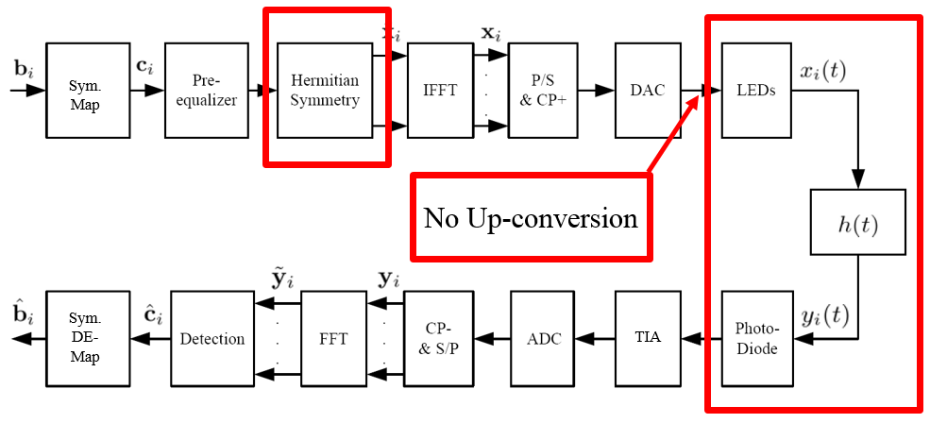
Figure 2: Example of an OFDM modulation and demodulation chain for LC.
Use of DFT-s-OFDM for baseband modulation
DFT-spread OFDM is one of the single carrier modulation schemes for LC that have lower PAPR property than most of MCM schemes such as OFDM. In LC, a signal with high PAPR can be distorted by not only a nonlinear power amplifier, but also a large DC bias which can seriously degrade system power efficiency. One of the advantages of DFT-s-OFDM comparing to other SCM schemes is that the orthogonal multiple access in frequency domain can be easily achieved. In LTE, it is called Single Carrier Frequency Domain Multiple Access (SC-FDMA). Figure 3 depicts an example of a DFT-s-OFDM modulation and demodulation chain for LC.
Figure 3 Example of a DFT-s-OFDM modulation and demodulation chain for LC

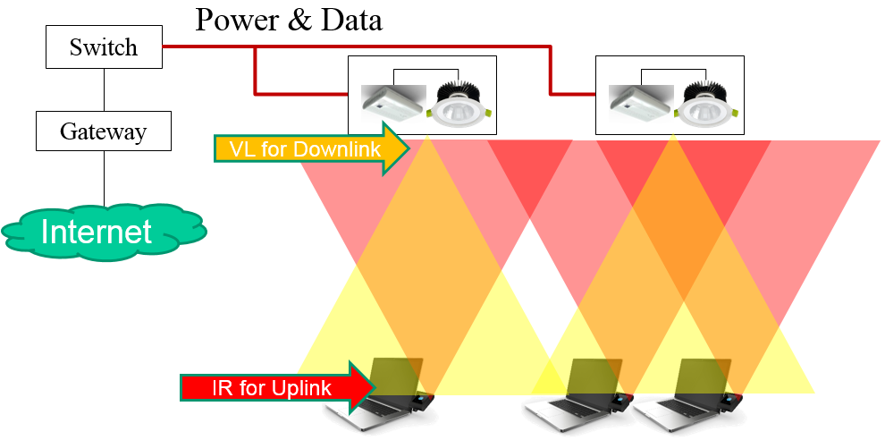
Figure 4: Example of the overall architecture for LC.

  - How does the backhaul work?
    - The backhaul in light communication systems is expected to work as the backhaul for any wireless access network. The information signal at the two ends of the backhaul network (transmitting and receiving) is equivalent for an RF and for a light communication system. In terms of networking, the light communication systems are expected to provide much denser deployment of access points, which would lead to better frequency reuse from the point of view of the wireless access network, however, it would lead to denser and potentially more complicated backhaul networks. The tendency in wireless communications, however, has always been towards smaller and more densely deployed cells. Light communication is a natural extension of the existing communication paradigm stemming from this tendency. As an example, power over Ethernet (PoE) could be used to provide both data and power to the LED lighting. This has been done very effectively in the Edge Building in Amsterdam where over 6500 LED lights have been connected using PoE to provide saving in both installation costs and time [13]. For retrofitting of light communications into building environments where modern communication infrastructure does not exist, however, power line communication (PLC) could also be used. [9]
  - How does uplink of LC-systems work?
    - Light communication can also be used for uplink. Yet for certain use cases, a LC based uplink can be challenging due to potential energy limitations of mobile devices and potential glare from the produced light. For these use cases, the uplink could use infrared radiation. For devices that have RF capabilities, it is envisioned that RF communication may be used for uplink (hybrid LC/RF), as well as in parallel to light communication for “carrier aggregation” for both up- and downlink (aggregated LC/RF) [17].
  - Can network connectivity be maintained under mobility scenarios?
    - It is envisioned that LC systems are mainly used for indoor low mobility use cases. The network connectivity can be easily maintained within the coverage of a LC-light by adapting the data rate to the channel conditions. Still, the coverage of a LC-transmitter can be limited. When a user moves among neighboring LC-lights, fast handoff may be beneficial to reduce interruption time. For devices with RF capabilities, RF may be used as a fallback solution to maintain the connection during mobility.
- System Architecture
  - Stand alone?
  - Sub-standard (802.11.3) or amendment (802.11xx)?
- Reuse of 802.11 MAC – which MAC (ah/ad?)?
  - Assumptions that are potentially not valid in the LC context
- Compatibility with other 802 wireless protocols
- Difference with on-going 802 light communication standards (eg., 802.15.7m/802.15.13) and ITU-T G.vlc
- Demonstrated Systems

LC Economic Feasibility
- Balanced costs
- Known cost factors
- Consideration of installation costs
- Consideration of operation costs
- Market size/opportunity

LC Regulatory perspective (spectrum and health)

Recommendations

References

[1] J. M. Kahn and J. R. Barry, “Wireless Infrared Communications”, IEEE Proceedings, vol. 85, issue 2, February 1997.
[2] R. Mesleh, H. Elgala and H. Haas, “Performance Analysis of Indoor OFDM Optical Wireless Communication Systems”, IEEE Wireless Communications and Networking Conference (WCNC) 2012, 1 – 4 April, 2012.
[3] W. O. Popoola, “On Visible Light Communication and Quality of Light Emitted from Illumination LEDs”, IEEE Photonics Society Summer Topical Meeting Series 2016, 11 – 13 July 2016.
[4] O. Almer et al., “A SPAD-Based Visible Light Communications Receiver Employing Higher Order Modulation”, IEEE Global Communications Conference (GLOBECOM) 2015, 6 – 10 December 2015.
[5] J. Kosman et al., “60 Mb/s, 2 Meters Visible Light Communications in 1 klx ambient Using an Unlensed CMOS SPAD Receiver”, IEEE Photonics Society Summer Topical Meeting Series 2016, 11 – 13 July 2016.
[6] C. Rohner et al., “Security in Visible Light Communication: Novel Challenges and Opportunities”, Sensors & Transducers, vol. 192, issue 9, September 2015, pp. 9 – 15.
[7] A. Mostafa and L. Lampe, “Physical-layer Security for Indoor Visible Light Communications”, IEEE International Conference on Communications (ICC) 2014, 10 – 14 June 2014.
[8] S. Shao et al., “An Indoor Hybrid WiFi-VLC Internet Access System”, IEEE International Conference on Mobile Ad Hoc and Sensor Systems (MASS) 2014, 28 – 30 October 2014.
[9] H. Burchardt et al., “VLC: Beyond Point-to-Point Communication”, IEEE Communications Magazine, vol. 52, issue 7, July 2014, pp. 98 – 105.
[10] J. B. Carruthers, J. M. Kahn, “Modeling of Nondirected Wireless Infrared Channels,” IEEE Transactions on Communications, vol. 45, issue 10, October 1997, pp. 1260 – 1268.
[11] M. Beshr, I. Andonovic and M. H. Aly, “The Impact of Sunlight on the Performance of Visible Light Communication Systems over the Year”, SPIE Proceedings, September 2012.
[12] T. Borogovac et al., “Lights-off Visible Light Communications”, IEEE Global Communications Conference (GLOBECOM) 2015, 5 – 9 December 2011.
[13] Philips Lighting - http://www.philips.com/a-w/about/news/archive/standard/news/press/2015/20150625-Philips-shines-light-on-opening-of-the-office-of-the-future-the-Edge-in-Amsterdam.html
[14] M. Sufyian and H. Haas, “Modulation Techniques for Li-Fi”, ZTE Communications, April 2016, vol. 14 No. 2. Available at:
http://wwwen.zte.com.cn/endata/magazine/ztecommunications/2016/2/articles/201605/t20160512_458048.html
[15] V. Jungnickel, V. Pohl, S. Nonnig and C. von Helmolt, "A physical model of the wireless infrared communication channel," in IEEE Journal on Selected Areas in Communications, vol. 20, no. 3, pp. 631-640, Apr 2002.
[16] https://en.wikipedia.org/wiki/Stimulated_emission
[17] M. Ayyash et al., "Coexistence of WiFi and LiFi toward 5G: concepts, opportunities, and challenges," in IEEE Communications Magazine, vol. 54, no. 2, pp. 64-71, February 2016.

LEDs have by nature of their spontaneous emission a spectral width typically covers 10s of nanometers in the optical domain. For LDs having singlemode characteristics, spectral width can be much lower, due to stimulated emission [16].

