IEEE P802.11
Wireless LANs
Proposed Text Change in MU-MIMO Section
Date: 2017-05-09
Author(s):
Name | Affiliation | Address | Phone | email
Dzevdan Kapetanovic | Ericsson |  |  | dzevdan.kapetanovic@gmail.com
Abstract
Improve current text in the MU-MIMO section and include the UL MU-MIMO training mechanism.

Proposed changes in Section 10.38.9.2.4
10.38.9.2.4 MU-MIMO beamforming
10.38.9.2.4.1 General
An EDMG STA is MU-MIMO capable if the MU-MIMO Supported field in the STA’s EDMG Capabilities
element is one. The MU-MIMO beamforming protocol enables a MU-MIMO capable initiator and one or
more MU-MIMO capable responders in an MU group to establish an antenna configuration which allows
the initiator to transmit an EDMG MU PPDU to the responders in the MU group, such that the mutual
interference among the streams transmitted in the MU PPDU is minimized. In this context, the method of
minimizing interference is implementation dependent.
The MU-MIMO beamforming protocol is started and controlled by the initiator, and comprises the
following consecutive phases:
⎯ SISO phase, and
⎯ MIMO phase
The execution of the MU-MIMO beamforming protocol uses the EDMG Group ID Set element transmitted
by the AP or PCP of the BSS. The AP or PCP shall transmit an EDMG Group ID Set element prior to
performing MU-MIMO beamforming protocol. The EDMG Group ID Set element shall include all existent
groups in a BSS. A MU-MIMO capable EDMG STA shall store the groups in the last received EDMG
Group ID Set element transmitted by the AP or PCP.

10.38.9.2.4.2 SISO phase
The goal of the SISO phase is to collect feedback on one or more suitable initiator’s TX and responder’s
RX DMG antennas and sectors between the initiator and each responder intended to be part of the MU
group. This information is then used to perform the following MIMO phase. All transmissions during the
SISO phase should use the DMG control mode.
Figure 51 depicts the SISO phase, which consists of two subphases, namely, an I-TXSS subphase and a
SISO Feedback subphase. The initiator may perform the I-TXSS subphase. The I-TXSS subphase enables
the initiator to obtain feedback from the responders in the MU group on one or more sectors for each of the
initiator’s TX DMG antenna.
The initiator performs the I-TXSS subphase through the use of the Short SSW packet (see 30.9.1). In each
Short SSW packet transmitted as part of the I-TXSS, the initiator shall set the Direction field to zero, shall
set the Addressing Mode field to indicate MU-MIMO and shall set the Destination AID field to contain a
group ID announced by the PCP or AP in the last transmitted EDMG Group ID Set element. In addition,
the CDOWN field shall be set to the number of Short SSW packets remaining until the end of the I-TXSS
subphase and the Setup Duration field shall be set to the duration of the following SISO Feedback
subphase.
A MU-MIMO capable EDMG STA that receives a Short SSW packet indicating MU-MIMO transmission
determines that it is an intended recipient of the packet by matching the value of the Destination AID field
in the packet with a value of the EDMG Group ID field contained in the last received EDMG Group ID Set
element. In case a match is found, the EDMG STA is an intended recipient of the packet if its AID is
included in the EDMG Group ID field of the corresponding group. Otherwise, the EDMG STA is not an
intended recipient of the packet and can ignore the remaining of the I-TXSS and SISO Feedback subphase,
which can be done through the use of the value of the CDOWN and Setup Duration fields contained in the
received Short SSW packet.
The initiator shall perform the SISO Feedback subphase. If the I-TXSS is present, the SISO Feedback
subphase shall start MBIFS following the end of the I-TXSS subphase. During the SISO Feedback
subphase, the initiator transmits a BRP frame to poll each responder intended to be part of the MU group to
obtain a list of sectors per each TX DMG antenna, and their associated quality indicators, between the
initiator and each responder. A responder shall respond to a received BRP frame with a BRP frame, which
contains the sectors for each TX DMG antenna of the initiator and the sector’s corresponding quality
indicator. The BRP frame shall be transmitted SIFS following the reception of the corresponding BRP
frame.

10.38.9.2.4.3 MIMO phase
The MIMO phase shall consist of a downlink MIMO phase or of an uplink MIMO phase.
The downlink MIMO phase shall be supported by all EDMG STAs that are MU-MIMO capable. The uplink MIMO phase may be supported by EDMG STAs that are MU-MIMO capable.
The initiator shall start the MIMO phase MBIFS following the end of the SISO phase.
10.38.9.2.4.3.1 Downlink MIMO phase
The downlink MIMO phase is
shown in Figure 52 and consists of four subphases, namely, a downlink MU-MIMO BF setup subphase, a downlink MU
MIMO BF training subphase, a downlink MU-MIMO FB poll subphase, and a MU-MIMO selection subphase.
Each subphase shall be separated by MBIFS.
Based on the feedback from the SISO phase, in the downlink MU-MIMO BF setup subphase the initiator may
exclude some responders from the following downlink MU-MIMO BF training subphase and downlink MU-MIMO FB poll
subphase if the multiuser interference the responders are expected to suffer due to MU-MIMO transmission
is negligible. If all of the responders are excluded from the following downlink MU-MIMO BF training subphase and
downlink MU-MIMO FB poll subphase, these two subphases are not present in the downlink MIMO phase.
In the downlink MU-MIMO BF setup subphase, the initiator shall transmit a BF Setup frame to each intended
responder. The BF Setup frame indicates the AID of each remaining responder, the training type (downlink MU-
MIMO BF training), a unique dialog token identifying MU-MIMO training, the number of simultaneous TX
DMG antennas employing orthogonal waveforms, the order in which transmit sectors are trained. To
reduce the downlink MU-MIMO training time, the initiator may select a subset of TX sectors for each DMG antenna
and the number of receive training fields based on the feedback from responders received at the SISO
phase. The initiator should transmit the minimum number of BF Setup frames to reach all responders. All
frames transmitted during the downlink MU-MIMO BF setup subphase should be sent using the DMG control mode.
A responder whose AID does not match any AID included in the received BF Setup frame can ignore
frames transmitted in the following downlink MU-MIMO BF training subphase and downlink MU-MIMO FB Poll subphase.
In the downlink MU-MIMO BF training subphase, the initiator shall transmit BRP frames using the EDMG PHY.
Each transmitted BRP frame is used to train one or more transmit sectors and, for each transmit sector, a
number of receive AWVs. In each BRP frame the initiator shall include, for each selected sector, TRN
Units in the TRN field for intended responders to perform receive sector training. The number of TRN-Unit
included in the TRN field should be the maximum number of receive sectors across all the remaining
intended responders based on the feedback from the SISO phase. An initiator may transmit a BRP frame
with orthogonal waveforms to train multiple (up to 4) transmit DMG antennas simultaneously through the
same BRP frame and hence reduce the training time. The downlink MU-MIMO BF training subphase is performed
by setting, for a BRP frame, the TXVECTOR parameter EDMG_TRN_LEN to a value greater than zero
and the parameter RX_TRN_PER_TX_TRN to a value greater than one.
In the downlink MU-MIMO FB poll subphase, the initiator shall transmit a BF Poll frame to poll each remaining
intended responder to collect MU-MIMO feedback from the preceding downlink MU-MIMO BF training subphase.
Each BF Poll frame and BF Feedback frame sent back by the responder shall be separated by SIFS. Each
BF Poll frame carries the dialog token that identifies the MU-MIMO training. The BF Feedback frame
carries the list of received initiator’s transmit DMG antennas/sectors, each with its corresponding
responder’s receive DMG antenna/sector and the associated quality indicated.
In the MU-MIMO selection subphase, the initiator shall transmit a BF Selection frame to each responder in
the MU group containing the dialog token identifying the downlink MU-MIMO training, one or multiple sets of the
MU transmission configurations, and the intended recipient STAs for each MU transmission configuration.
The final set of selected responders in the MU group contained in the BF Selection frame does not have to
be the same as the initial set of intended responders. The initiator should transmit the minimum number of
BF Selection frames to selected responders.

10.38.9.2.4.3.2 Uplink MIMO phase

The initiator may initiate an uplink MIMO phase procedure if the corresponding subfield (TBD) in initiator’s and intended recipients EDMG Capabilities element equals one (for this to hold it is required, at least, that the initiator has antenna pattern reciprocity). This might potentially shorten the MU-MIMO BF training duration.
The uplink MIMO phase is shown in Figure 53 and consists of three subphases, namely, an uplink MU-MIMO BF setup subphase, an uplink MU-MIMO BF training subphase and a MU-MIMO selection subphase. The frames used in the MU-MIMO selection subphase are the same as in Section 10.38.9.2.4.3.2. Each subphase shall be separated by MBIFS.
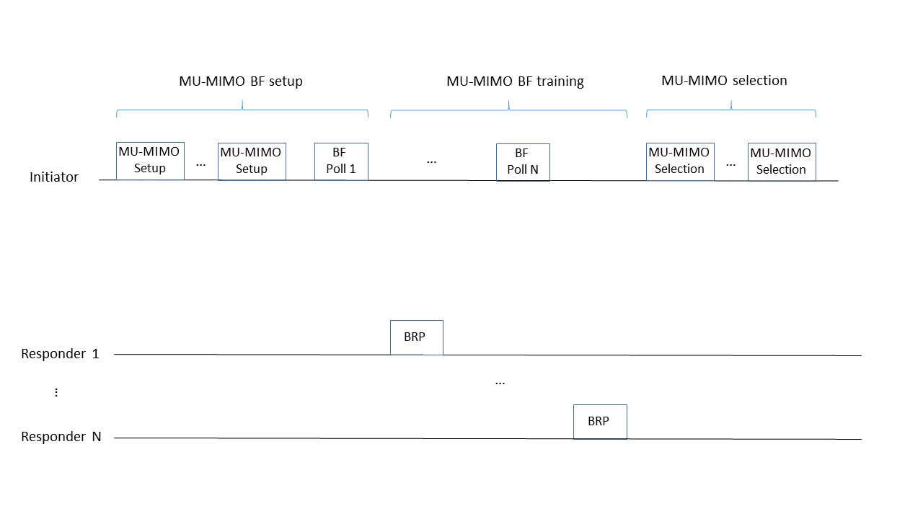
Figure 53.

Based on the feedback from the SISO phase, in the uplink MU-MIMO BF setup subphase the initiator may
exclude some responders from the following uplink MU-MIMO BF training subphase. This might happen
if the multiuser interference the responders are expected to suffer due to MU-MIMO transmission
is negligible or if they do not support the uplink MIMO BF training subphase. If all of the responders are excluded from the following uplink MU-MIMO BF training subphase, this subphase is not present in the uplink MIMO phase.
In the uplink MU-MIMO BF setup subphase, the BF Setup frame (same format as in Section 10.38.9.2.4.3.1, TBD) transmitted to each STA shall indicate the AID of each remaining responder, the training type (uplink MU-MIMO BF training), and a unique dialog token identifying MU-MIMO training. The initiator should transmit the minimum number of BF Setup frames to reach all responders. All
frames transmitted during the uplink MU-MIMO BF setup subphase should be sent using the DMG control mode. A responder whose AID is not present in the AID list of the BF Setup frame can ignore the subsequent uplink MU-MIMO BF training phase.

In the uplink MU-MIMO BF training subphase, the initiator shall transmit a BF Poll frame (TBD) to each STA in the MU group. Each
BF Poll frame carries the dialog token that identifies the MU-MIMO training. In the BF Poll frame, the L-RX field from the EDMG BRP Request element is set to a value larger than 0 by the initiator to train its receive AWVs. No transmit or receive AWV training is performed by the BF Poll frame. Upon receiving the BF poll frame, the responder shall transmit a single BRP-RX/TX frame to the initiator, where the TXVECTOR parameter EDMG_TRN_LEN is set to a value larger than zero and the parameter RX_TRN_PER_TX_TRN is set to the L-RX value received in the previous BF poll frame. Additionally, the BRP-RX/TX frame contains the number of simultaneous TX DMG antennas employing orthogonal waveforms. The BRP frame is used to train different transmit AWVs of the responder as well as receive AWVs of the initiator. Each BF poll frame and BRP-RX/TX frame sent by the responder shall be separated by SIFS.

References:
- Training Protocols for DL MU-MIMO in 802.11ay (11-17-0419r1)

