IEEE P802.11
Wireless LANs
Proposed resolutions to CID 838-845
Date: 2017-6-8
Author(s):
Name | Company | Address | Phone | Email
Dejian Li | Huawei |  |  | dejian.li@huawei.com
Jiamin Chen | Huawei |  |  | jiamin.chen@mail01.huawei.com

Abstract

This document proposes resolutions to CID 838-845 for TGaj D5.0.
Revision History
R0: Initial version.
R1: Fixed some typos.
R2: Improved resolution to CID 845, 839, 840, 841.

Editorial comments:
CID | Clause | Page | Line | Type | Comment | Proposed Change
843 | Abstract | ii | 3 | E | Grammer mistake in "at around 60 GHz" and "at around 45 GHz" | Change to "around 60 GHz" and "around 45 GHz"
Discussion: Do as the suggested remedy.
Proposed resolution: Accept
Change "at around 60 GHz" and "at around 45 GHz" to " around 60 GHz" and "around 45 GHz".

CID | Clause | Page | Line | Type | Comment | Proposed Change
844 | 24.3.6.1 | 170 | 65 | E | Typo in letter "F" | Delete the letter "F"
Discussion: Do as the suggested remedy.
Proposed resolution: Accept
24.3.6.1 General
Change the first paragraph as follows:
…The format of the preamble consists of a Short Training field followed by a Channel Estimation field. Figure 24-2 (CDMG SC mode preamble) illustrates the SC packet preamble.

CID | Clause | Page | Line | Type | Comment | Proposed Change
845 | 9.4.2.132 | 42 | 50 | E | typo in "Figure 9-517--Allocation field format" | Change to "Figure 9-517--Allocation Control field format". So does P43L9.
Discussion: Inaddition to the proposed change, the figure index should be "Figure 5-18"..
Proposed resolution: Revised
Change the title of 9-517 and 9-517a as follows:
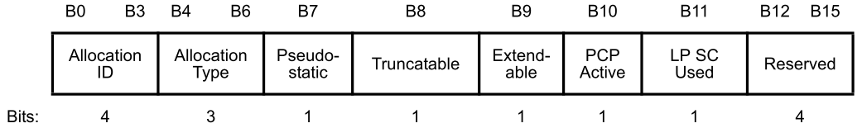
Figure 9-518—Allocation Control field format (DMG)
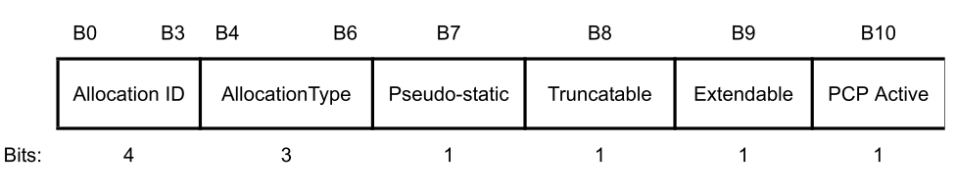
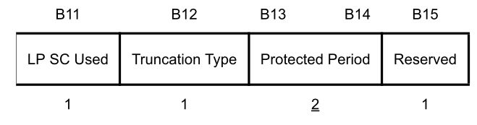
Figure 9-518a—Allocation Control field format (CDMG)
Technical comments:
CID | Clause | Page | Line | Type | Comment | Proposed Change
838 | 10.64.2.2 | 141 | 1 | T | Channel number 5,6,7,8 have been changed to 35,36,37,38 in annex E. | Change the channel number 5,6,7,8 to 35,36,37,38 throughout the 11aj D5.0, respectively.
Discussion:
In Table E-5, the channel number 5,6,7,8 has been change to 35,36,37,38, respectively. So do as the suggested remedy.
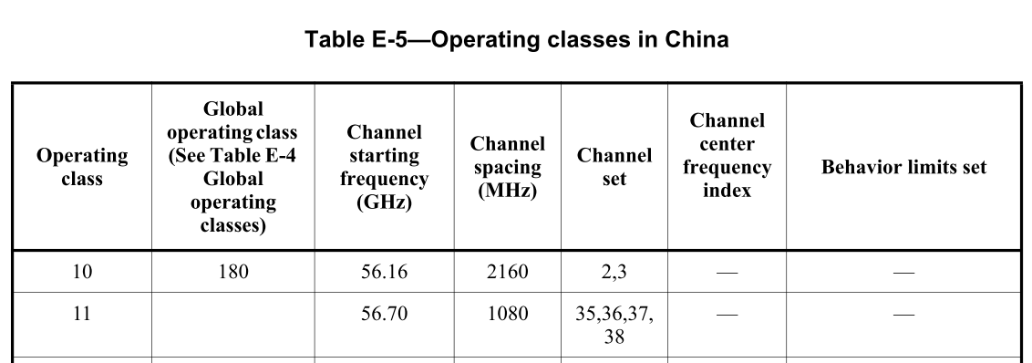
Proposed resolution: Accept
Change the channel number 5,6,7,8 to 35,36,37,38 throughout the 11aj D5.0, respectively.

839 | 10.64.2.2 | 141 | 1 | T | It is not clear for the purpose of the step f | Change to "The AP or PCP shall join the S-AP's cluster at the selected cluster time offset on the channel of the S-AP and transmit DMG Beacon frames with the AP or PCP Clustering Control field."
Discussion: It is not clear for the purpose of the step f). The suggested remedy can make the step f more clear. Make additional changes to make it more clear as follows.
Proposed resolution: Revised
Change the last bullet f) as follows
"f) The AP or PCP shall join the cluster of S-AP at the selected cluster time offset on the channel of the S-AP and transmit DMG Beacon frames with the AP or PCP Clustering Control field."
9.4.2.132 Extended Schedule element
Change the bullet at P43L56 as follows:
— The Truncatable subfield is equal to 1 and the Truncation Type subfield is equal to 0.
10.36.8.2 CDMG dynamic truncation of service period
Change the first sentence of the fourth paragraph of 10.36.8.2 as follows:
A CDMG AP or PCP should determine the Truncatable subfield and the Truncation Type subfield according to the allocation type requirements of the STAs in its BSS, in order to satisfy the channel access requirements of the STAs using the potential released time of SPs. …
840 | 10.37a.2.2 | 128 | 61 | T | It is not clear what is "the current cluster" | Change "the current cluster" to "the current S-AP's cluster"

Proposed resolution: Accepted
Change bullet c) at P128L61 as follows:
c) The CDMG AP or PCP should determine whether to join the current S-AP’s cluster or other S-AP(s)’s cluster based on the signal quality, the states of Beacon SPs during a BI indicated by the Available Cluster Offset Bitmap field in the ECPAC Policy element of the S-AP or the member APs or member PCPs of the current S-AP’s cluster, and other S-AP(s)’s cluster information. If the AP or PCP elects to join the current cluster, proceed to step d); …
841 | 9.4.2.147 | 45 | 45 | T | In 802.11ad, we use the term "ECPAC", which denotes "Extended Centralized PCP or AP Cluster". However, in 802.11-2016, we use the term ECAPC (Extended Centralized AP or PCP Cluster). We need to align this definition with 802.11-2016 | Change all the "ECPAC" to "ECAPC" throughout the 11aj D5.0.
Discussion: Do as the suggested remedy.
Proposed resolution: Accept
Change all the "ECPAC" to "ECAPC" throughout the 11aj D5.0.

842 | 10.64.1 | 140 | 32 | T | It is not clear in "A pair of CDMG BSSs operating on the adjacent 1.08 GHz channels (e.g. Channel 5 and Channel 6) within a 2.16 GHz channel (i.e. Channel 2) should maintain synchronization with each other". | It is not appropriate to say "a pair of BSSs" should maintain synchronization with each other. Change "a pair of BSSs" to "a pair of APs or PCPs".
Discussion: It is not appropriate to say "a pair of BSSs" should maintain synchronization with each other. Do as the suggested remedy.
Proposed resolution: Accepted
Change "a pair of BSSs" to "a pair of APs or PCPs ".

