IEEE P802.11
Wireless LANs
Light Communications (LC) for 802.11:
Draft response to the Technical Feasibility Questions
Date: 2017-04-18
Author(s):
Name | Affiliation | Address | Phone | email
Ivica Stevanovic | OFCOM (CH) |  |  | ivica.stevanovic@bakom.admin.ch
Nikola Serafimovski | pureLiFi |  |  | nikola.serafimovski@purelifi.com
Abstract
This document contains the considedrations of the benefits and advantages of light communications (LC) relative to other radio frequency (RF) communications as well as providing a regulatory input for the light spectrum.

Benefits and Advantages of LC vs. RF Communications

Recently, communication by visible light has been gaining popularity as a complement to RF communication due to the following advantageous features (see also Table 1):

- RF Congestion and Capacity Crunch:
The RF spectrum is a natural resource of the state and its usage is regulated to mitigate interference and pollution and to ensure its efficient usage. According to Cisco predictions [1], overall mobile data traffic is expected to grow to 49 exabytes per month by 2021, which amounts to a sevenfold increase over 2016 (Fig. 1). According to the same report, mobile off-load will increase from 60 percent (10.7 exabytes/month) in 2016 to 63 percent (83.6 exabytes/month) by 2021. The demand for broadband wireless data access is constantly increasing and the radio frequency spectrum, that is limited and for the most part licensed, is becoming progressively more congested.
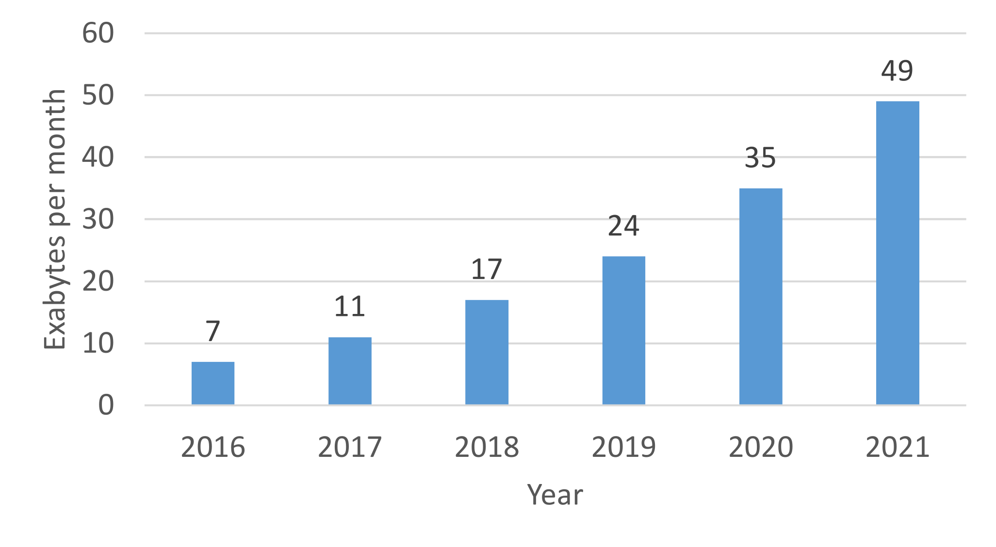
On the other hand, the visible light spectrum is unlicensed and currently largely unused for communications. Moreover, potential bandwidth of visible light (~ 400 THz to ~ 780 THz) is thousand times wider than the conventional RF bandwidth (~ 3 kHz to ~ 300 GHz). As a result, LC systems have huge amount of available unregulated spectrum to complement short-range wireless transmission and to potentially alleviate the RF spectrum congestion that is especially apparent in the 2.4-GHz Industrial, Scientific, and Medical (ISM) band [3].

- Spatial Reuse:
Since visible light does not penetrate through building walls or other opaque materials and can be directed to the desired working area, LC can exhibit a high degree of spatial reuse. LC signals in adjacent areas, rooms, or apartment units would not interfere with each other, thereby potentially admitting a far higher spatial density of communication rates than it is achievable with RF.

- Security:
RF waves pass through walls and are susceptible to eavesdropping. An intruder or hacker outside a building can tap into the Wireless Fidelity (WiFi) data communications of computers inside the building. With the confinement property of visible light, on the other hand, there are well defined coverage zones that enhance communication security by preventing eavesdropping from outside of a room, apartment, or building. Although, some recent research has shown the feasibility of eavesdropping using the light signals leaked through the gap between floor and door, keyhole and even partially covered windows [4].

- Electromagnetic Interference (EMI):
Radio waves create EMI that can impair normal operation of electrical instruments and equipment in airplanes and hospitals, and is especially dangerous in hazardous industrial zones, such as power/nuclear generation or oil and gas drilling. LC uses light instead of radio waves, which is intrinsically safe and does not create EMI. It is important to note, however, that recent measurements by European Broadcasting Union (EBU) have shown EMI coming from incorrectly installed light emitting diode (LED) lamps [5]. Original transformers will no more comply with electromagnetic compatibility limits if full-load halogen lamps are simply replaced by low-load LED lamps as harmonics of the switching frequency of the transformer under low-load conditions can occur across the entire RF spectrum.

- Safety:
In illumination conditions, in principle, there are no health hazards of visible light. Studies have shown some health concerns relating to flicker that may induce biological human response (photosensitive epilepsy) [6, 7]. Moreover, glare of certain blue-rich LED designs is thought to have psychological effects such as disrupting people’s sleep patterns and harming nocturnal animals [8].
- Multipath:
At frequencies of the visible light, constructive and destructive interference occur on a micron scale and get averaged by the receiver that is thousand times greater in size. Therefore, LC exhibits no fading caused by multipath propagation or Doppler shift.

- Complexity:
Due to the fact that LC is a non-coherent mode of communication, the front-end components of both transmitters and receivers are relatively simple and cheap devices that operate in the baseband and do not require frequency mixers or sophisticated algorithms for the correction of RF impairments such as phase noise and IQ imbalance.

- Existing Infrastructure:
LC can be implemented into existing lighting infrastructure with the addition of a few relatively simple and low-cost front-end components operating in baseband.

- Energy Efficiency:
LC is combined with LED illumination. Since LEDs are energy efficient and highly controllable light sources, LC belongs to eco-friendly green communication technology.

- Accurate Indoor Positioning:
RF based positioning schemes cannot provide sub-meter accuracy. LC provides a promising way to perform accurate (centimeter-level) indoor positioning of mobile devices due to the high directivity of visible light.

Table 1: Comparison of LC and RF Communication (adapted from [2, 9])

Parameter | RF | LC
Spectrum | ~ 300 GHz (licensed) | ~ 400 THz (unlicensed)
Security | Limited | High
EMI | Yes | No
Safety | Intensity regulated | Unregulated
Coverage | Wide | Limitted
Multipath | Yes | No
Complexity | High | Low
Infrastructure | Access point | Illumination
Power consumption | Medium | Low (combined with LED illumination)
Indoor positioning | m-level | cm-level

LC Economic Feasibility
- Balanced costs
- Known cost factors
- Consideration of installation costs
- Consideration of operation costs
- Market size/opportunity
  - With 12 billion light bulbs around the world with unlicensed, reusable bandwidth, there can be potentially as many LC transmitters and access points [2].
  - According to recent market research predictions, LC technology is expected to reach the market value of USD 14.9 Billion by 2022 [10].

LC Regulatory perspective (spectrum and health)

The LC technology uses unregulated spectrum of visible light that does not need licensing. It has to be ensured, however, that LC systems do not present any health hazards (related to light intensity, color, or flicker) and that they are properly installed so as not to create any electromagnetic interference.

References

[1] Cisco, “Cisco Visual Networking Index (VNI) Update Global Mobile Data Traffic Forecast, 2016-2021,”
Tech. Rep., 2017. Available at:
http://www.cisco.com/c/en/us/solutions/collateral/service-provider/visual-networking-index-vni/mobile-white-paper-c11-520862.html
[2] D. Karunatilaka, F. Zafar, V. Kalavally, and R. Parthiban, “LED based indoor visible light communications:
State of the art,” IEEE Communications Surveys Tutorials, vol. 17, no. 3, pp. 1649–1678, 2015.
[3] A. Jovicic, J. Li, and T. Richardson, “Visible light communication: Opportunities, challenges and the path to market,” IEEE Communications Magazine, vol. 51, no. 12, pp. 26–32, 2013.
[4] P. H. Pathak, X. Feng, P. Hu, and P. Mohapatra, “Visible light communication, networking, and sensing: A survey, potential and challenges,” IEEE Communications Surveys and Tutorials, vol. 17, no. 4, pp. 2047–2077, 2015.
[5] EBU, “LED Lighting Interference,” 2014. [Online]. Available: https://tech.ebu.ch/docs/factsheets/ebu_tech_fs_ledinterference.pdf
[6] A. Wilkins, J. Veitch, and B. Lehman, “LED lighting flicker and potential health concerns: IEEE standard PAR1789 update,” 2010 IEEE Energy Conversion Congress and Exposition, ECCE 2010 - Proceedings, pp. 171–178, 2010.
[7] A. J. Wilkins, “Designing to mitigate the effects of flicker reducing risks to health and safety,” IEEE Power Electronics Magazine, pp. 18–26, September 2014.
[8] J. Hecht, “LED streetlights are giving neighborhoods the blues,” IEEE Spectrum, pp. 1–7, Oct. 2016. Available at: http://spectrum.ieee.org/green-tech/conservation/led-streetlights-are-giving-neighborhoods-the-blues
[9] I. Stevanovic, “Light Fidelity (LiFi),” Tech. Rep., Federal Office of Communications OFCOM, Switzerland, Apr. 2017. Available at: https://www.bakom.admin.ch/dam/bakom/de/dokumente/bakom/das_bakom/Informationen%20des%20BAKOM/BAKOM%20Infomailing/lifi_report.pdf.download.pdf/lifi_report.pdf
[10] Markets and Markets. (Feb. 2017) Free Space Optics (FSO) and Visible Light Communication (VLC) Market by Component (LED, Photo Detector, Microcontroller, and Software), Transmission Type (Unidirectional and Bidirectional), Application, and Geography - Global Forecast to 2022. Available at http://www.marketsandmarkets.com/Market-Reports/visiblelight-communication-market-946.html

1 exabyte = 1000 terabytes

