IEEE P802.11
Wireless LANs
Light Communications (LC) for 802.11:
Link Margin Calculations
Date: 2017-03-14
Author(s):
Name | Affiliation | Address | Phone | email
Dobroslav Tsonev | pureLiFi |  |  | dobroslav.tsonev@purelifi.com
Nikola Serafimovski | pureLiFi |  |  | nikola.serafimovski@purelifi.com
Murat Uysal | Center of Excellence in Optical Wireless Communication Technologies (OKATEM) |  |  | murat.uysal@ozyegin.edu.tr
Tuncer Baykas | Istnabul Medipol University |  |  | tbaykas@ieee.org
Volker Jungnickel | HHI |  |  | volker.jungnickel@hhi.fraunhofer.de
Abstract
This document contains the detailed calculations discussing the link margin for a light communications system using realistic assumpations for the device power and sensitivities.

1. Introduction
1.1. Transmitter Concept and Modelling
An optical transmitter is typically modelled as a point source or as a very small surface area radiating light (this calculation is typically independent of the wavelength/spectrum profile of the optical source and the equations apply to any individual wavelengths or combination of wavelengths). Bare LED dies as well as diffusers typically radiate light uniformly in all directions and are treated as so called Lambertian emitters. This means that the light intensity emitted by the source changes with cos(φ), where φ is the angle at which the source is viewed. This effect is caused by the reduced area of the source when the source is viewed at an angle. Using lenses, diffusers and engineered optics in general allows for the creation of sources with more uniform or more directional emission profiles. A generalized Lambertian model for the source intensity suggests that the light intensity changes with cos^{m}(φ), where m = - 1/log₂(cos(φ_{1/2})) and φ_{1/2} is the angle at which the source intensity is half compared to the intensity when the source is viewed straight on axis. Therefore, if the total radiant flux of the emitter is P_{t} [W], the transmitted light intensity at a given angle φ is [1]:
P_{tx} = P_{t} ∙ (m+1)/2π ∙ cos^{m}(φ) [W]. (1)
1.2. Optical Channel Concept and Modelling
The geometry of light propagation leads to an attenuation of the light intensity with the square of the transmission distance d, i.e., the light intensity that reaches the receiver system along a line-of-sight (LoS) path is expressed as [1]:
P_{r} = P_{tx} /d² [W/m²]. (2)
The light that is collected at the receiver system is proportional to the receiver collection area as well as cos(ψ), where ψ is the angle at which the light hits the receiver. The latter term comes from the geometric losses associated with the reduction in effective area of a receiver that is tilted with respect to the direction of the incoming light. The effective area of the receiver is the light collection area and is typically expressed as the detector area multiplied by the gain of any optics introduced for improved light collection [1]:
A_{eff} = A_{d} G_{o} [m²] (3)
The detector area is the area of the photodiode that is employed and the optical gain is the ratio between the area of the aperture of the light collection optics and the area of the photodetector. The Etendue limit in optics provides a fundamental limit to the optical gain that an optical system with a certain field-of-view (FOV) can provide. The FOV is the maximum angle at which light incident on the optics can be successfully guided to the detector. This concept is illustrated in Fig. 1, where a compound parabolic concentrator with a square aperture is presented. Any rays that hit the concentrator with an angle above the FOV exit the system without reaching the detector. The gain of the concentrator is the ratio of the top flat surface (input aperture) and the bottom flat surface (exit aperture). The Etendue limit in optics puts a fundamental limit of the concentrator gain at [1]:
G_{o} = n²/sin²(FOV) (4)
where n is the refractive index of the concentrator material. Typical values of n for glass and plastic are in the order of n ≈ 1.5. Suitably designed concentrators are able to approach the fundamental Etendue limit in practice. Hence, (4) can be used to accurately model the gain of the optics on the receiver side.
Figure 1: A compound parabolic concentrator (CPC) with square input/output apertures coupled with a photodiode.
FOV
Optics
Detector / Photodiode
Thus, the received optical power at the detector can be expressed as [1]:
P_{rx} = P_{r} ∙ cos(ψ) ∙ A_{eff} (5)
In order to calculate the light intensity that reaches the detector on a Non-line-of-sight (NLoS) propagation path, a ray tracing algorithm needs to be used. The ray tracing algorithm is specific for a specific communication scenario. The typical approach is to model all surrounding surfaces as collections of very small detector areas, which collect incoming light (on a LoS path) and re-emit a portion of the light depending on the properties of the surface material. The emission profiles for the different surfaces are also dependent on the surface materials. See [2] for a more detailed explanation of this modelling technique.
1.3. Detector Concept and Modelling
V_{out}
-
+
R_{f}
i_{amp}
i_{shot}
-
+
v_{f}
-
+
v_{amp}
i_{signal}
Figure 2: Transimpedance amplifier configuration.
A photodetector can be realized using different technologies. The most widely used photodetectors for OWC are photodiodes, which typically generate small current changes in response to changes in the incident light. The low current levels through the photodiode need to be amplified and turned into a voltage signal before processed in subsequent electronics. Hence, a photodiode is typically coupled with a transimpedance amplifier (TIA) as depicted in fig. 2. Different concepts for the TIA circuit exist. A common one is the shunt-feedback configuration presented in fig. 2. See [1] or any good book on photodetectors for alternative implementations. For the system configuration in fig. 2, the signal at the output of the amplifier can be represented as:
V_{out} = i_{signal} ∙ R_{F} + i_{shot} ∙ R_{F} + i_{amp} ∙ R_{F} + v_{F} + v_{amp.} (6)
The individual components of this signal can be described as follows:
i_{signal} = ρ∙Θ∙G_{a}, where ρ is the PD responsivity in A/W, Θ is the incident light in W and G_{a} is the internal (avalanche) gain of the PD. In Conventional positive-intrinsic-negative (PIN) photodiodes G_{a} = 1.
i_{shot} is current shot noise generated by the quantum effects inside the PD. Its noise PSD is proportional to the amount of current flowing through the PD, and hence, it is proportional to the leakage current (dark current → I_{D}, flowing when no light is incident on the PD) as well as the current generated by the incident light i_{signal}.
i_{amp} is current noise generated at the amplifier inputs and is specific to the operational amplifier that is employed. This component is amplified by the transimpedance gain of the amplifier and appears as i_{amp}∙R_{F} at the output.
v_{F} is thermal noise generated by the feedback resistor R_{F}.
v_{amp} is voltage noise at the amplifier output and is specific to the operational amplifier that is employed.
The calculation of the different noise components is explained in Section 1.4.
1.4. Signal-to-noise Ratio (SNR) Calculations
The optical shot noise power spectral density (PSD) that appears at the output of the TIA can be calculated as:
σ_{shot} = √(2∙q∙(I_{D} + ρ∙Θ)∙F)∙G_{a}∙G_{TIA} [V/√Hz] (7)
where q = 1.60217662 × 10⁻¹⁹ C is the elementary charge of an electron, I_{D} is the photodiode dark current, ρ is the PD responsivity in A/W, Θ is the optical power collected by the PD in W, F is the excess noise factor specified in the APD datasheet, G_{a} is the avalanche gain of the PD (G_{a}=1 for a PIN PD) and G_{TIA} is the transimpedance gain of the TIA, typically equal to the feedback resistor value R_{F}, for a detector with a flat frequency response. The excess noise factor can be calculated as G_{a}^{E}, where E is the excess noise index often specified in the datasheet in place of F, which would vary as a function of G_{a}.
The thermal noise that appears at the TIA output (typically referring only to the thermal noise caused by R_{F} as the main thermal noise contributor) can be calculated as:
σ_{thermal} = √(4∙k∙T∙R_{F}) [V/√Hz] (8)
where k = 1.38E-23 J/K is the Boltzmann constant and T is the temperature in Kelvin (typically assumed as the room temperature of approximately T = 300K).
The amplifier noise consists of two components:
1) The current noise appears at the amplifier input and is amplified by the TIA at the output. Hence, at the output, it can be calculated as:
σ_{current} = σ_{i} ∙R_{F} [V/√Hz] (9)
where σ_{i} is the current noise specified in the amplifier datasheet.
2) The voltage noise appears at the output of the amplifier with the value specified in the datasheet.
The overall noise coming from the transimpedance amplifier (TIA) configuration can be calculated as:
σ _{TIA} = √(σ²_{thermal} + σ²_{current} + σ²_{voltage}) [V/√Hz]. (10)
The overall noise is calculated as:
σ_{noise} = √(σ²_{TIA} + σ²_{shot}) [V/√Hz], (11)
where σ_{n} is assumed to be the standard deviation of the overall noise component.
The PSD of the signal can be calculated as:
σ_{signal} = Θ_{p-p}/8∙ρ∙G_{a}∙G_{TIA} /√B [V/√Hz] (12)
where B is the communication bandwidth (this calculation assumes that the signal power is equally distributed within the bandwidth, which means that the transmitter front-end has a flat frequency profile) and the division by 8 is applied because it is assumed that the peak-to-peak signal contains 8 standard deviations of the time-domain OFDM signal (the interval [-4σ;4σ]).
In the calculation of the shot noise it is assumed that: Θ = Θ_{p-p}/2.
The signal-to-noise ratio (in dB) can be calculated as:
SNR = 20∙log10(σ_{signal}/σ_{noise}). (13)
2. Link Margin Calculations
2.1. Assumptions

A transmitter with maximum optical power output P = 10 W is assumed. Typical white light emission spectrum has optical efficacy of 300 lm/W of optical power. A light source that is modulated over its entire active range of 10 W would have an average optical power of 5 W, so it would emit 1500 lm. At a distance of 2 m, and a φ_{1/2} = 30º, the area covered would be approximately 4 m², so the illumination levels would be approximately 375 lux (375 lm/m²) which is around the typical requirement for a well-lit environment of 400 lux. The Lambertian order of such a source is m = - 1/log₂(cos(30º)) = 4.82.
A receiver positioned right below the light at a transmission distance of d = 2 m and an optical aperture of 5 mm (A_{eff} = 5 mm ∙ 5 mm = 25E-6 m²) collects:
Θ_{p-p} = (4.82+1)/2π ∙ 10 W / 2² m² ∙ 25E-6m² = 57.9 µW.
The same receiver positioned at an angle of 30º to the transmitter (approximately at the edge of the coverage area at 1.15 m from the center of the coverage area) on the same plane collects:
Θ_{p-p} = (4.82+1)/2π ∙ cos^{4.82}(30º) ∙ 10 W / 2² m² ∙ cos(30º) ∙ 25E-6m² = 25.1 µW.
The typical responsivity of state-of-the-art photodiodes is presented in fig. 3 as a function of the optical wavelength. The average responsivity of the photodiode to the incoming light is dependent on the light spectrum, but a good approximation for typical white light used for illumination purposes is an average value of about ρ = 0.35 A/W.
The bandwidth used for this calculation is assumed to be B = 200 MHz.
The gain of the TIA is set by the feedback resistor R_{F} and is dependent on the system bandwidth, the parasitic capacitance of the photodetector and the operational amplifier gain-bandwidth product. A good practical value for most devices is around 1kΩ for the target bandwidth of 200 MHz, which is what is assumed in this calculation. However, this is a design issue for practical devices.
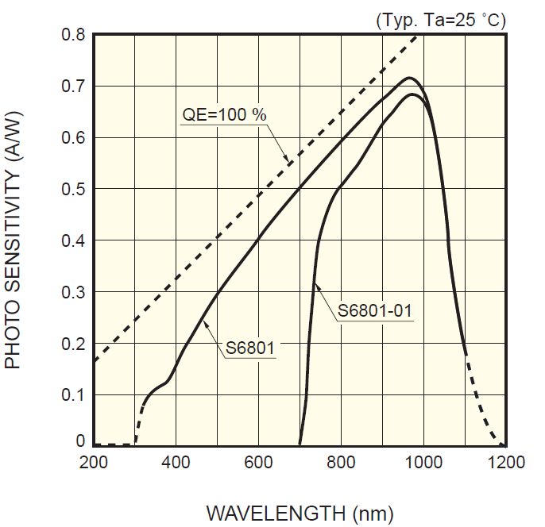
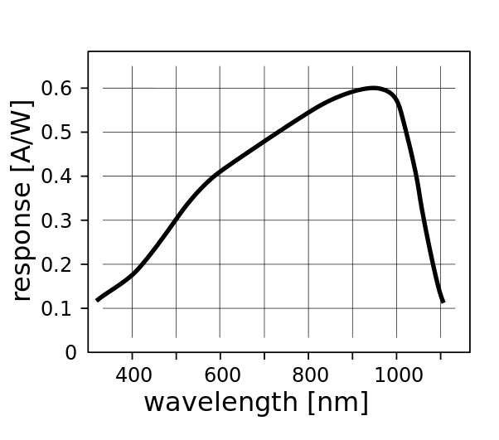
An off-the-shelf operational amplifier such as the Texas Instruments OPA847 is chosen for this calculation. The current noise of the amplifier is σ_{i} = 2.7E-12 A/√Hz according to the datasheet, and the voltage noise is specified at σ_{voltage} = 0.85E-9 V/√Hz.
Figure 3: Responsivity of typical off-the-shelf photodiodes.
The avalanche photodiode Hamamatsu S8664-20K is selected as the photodetector of choice for this calculation. The APD datasheet specifies an excess noise index of E = 0.2. The gain of the APD is set to G_{a} = 20 in order to overcome the TIA noise, which leads to an excess noise factor of F = G_{a}^{E} = 20^{0.2} = 1.82. Note that the S8664-20K has a diameter of 2 mm, so optics with an aperture of 5 mm provides a gain of G_{o} = 6.25. This gain is easily achievable for a plastic concentrator (n = 1.5) and a FOV of 30º according to equation (4).
2.2. SNR Results
Using equations (1) – (13) and the values assumed in Section 2.1, then the individual quantities required for the link margin estimation can be calculated as:
At the center
σ_{signal} = 57.9 µW / 8 ∙ 0.35 A/W ∙ 20 ∙ 1000 Ω / √200E6 Hz = 3.6E-6 [V/√Hz];
σ_{shot} = √(2 ∙ 1.6E-19 ∙ (600 pA + 0.35 A/W ∙ 28.95 µW) ∙ 1.82 ) ∙ 20 ∙ 1000 Ω = 50.93E-9 V/√Hz.
At the edge
σ_{signal} = 18.95 µW / 8 ∙ 0.35 A/W ∙ 20 ∙ 1000 Ω / √200E6 Hz = 1.6E-6 [V/√Hz];
σ_{shot} = √(2 ∙ 1.6E-19 ∙ (300 pA + 0.35 A/W ∙ 12.55 µW) ∙ 1.82 ) ∙ 20 ∙ 1000 Ω = 33.53E-9 V/√Hz;
σ_{current} = 2.7E-12 A/√Hz ∙ 1000 Ω = 2.7E-9 V/√Hz;
σ_{voltage} = 0.85E-9 V/√Hz;
σ_{thermal} = √(4 ∙ 1.38E-23 J/K ∙ 300 K ∙ 1000 Ω) = 4.07E-9 V/√Hz.
In this communication scenario, the shot noise due to the light signal dominates all other noise components for the chosen avalanche detector gain G_{a} = 20. The achievable signal-to-noise ratio at the center of the coverage area is then:
SNR = 20 ∙ log₁₀(3.6E-6/√ (50.93E-9² + 2.7E-9² + 0.85E-9² + 4.07E-9²)) = 36.94 dB.
The achievable SNR at the edge of the coverage area is then:
SNR = 20 ∙ log₁₀(1.6E-6/√ (33.53E-9² + 2.7E-9² + 0.85E-9² + 4.07E-9²)) = 33.48 dB.

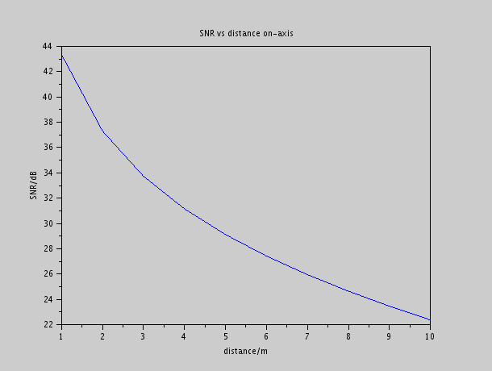
Figure 4: SNR vs distance when the receiver is on-axis/aligned with the transmitter
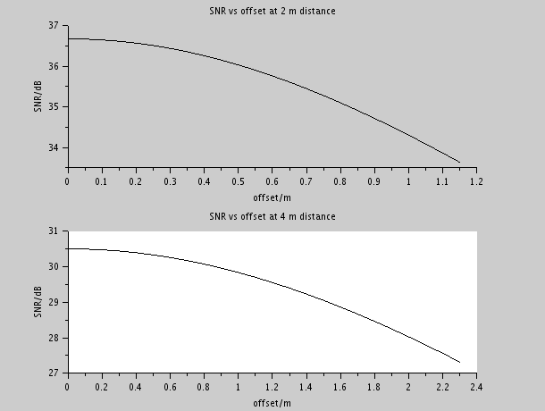
Figure 5: SNR vs offset distance as the receiver moves from the on-axist alignement with the transmistter at a set on-axis distance from the transmitter to the receiver

3. References

[1] J. M. Kahn and J. R. Barry, “Wireless Infrared Communications”, IEEE Proceedings, vol. 85, issue 2, February 1997.
[2] J. B. Carruthers, J. M. Kahn, “Modeling of Nondirected Wireless Infrared Channels,” IEEE Transactions on Communications, vol. 45, issue 10, October 1997, pp. 1260 – 1268.

