IEEE P802.11
Wireless LANs
Draft text for BRP Transmit Sector Sweep
Date: 2017-03-13
Author(s):
Name | Affiliation | Address | Phone | email
Claudio da Silva | Intel |  |  | claudio.da.silva@intel.com
Carlos Cordeiro
Jonathan Kosloff
Artyom Lomayev
Miki Genossar
Tom Harel
Abstract
This document suggests text that defines a BRP transmit sector sweep procedure.

10.38.9.5 BRP transmit sector sweep (BRP TXSS)

9 10.38.9.5.1 General

Beam refinement protocol transmit sector sweep (BRP TXSS) is a procedure which makes use of BRP frames to perform transmit sector sweep and determine improved antenna configuration for transmission.

In BRP TXSS, a set of transmit AWVs is tested against a quasi-omni receive pattern for all possible combinations of transmit DMG antenna and receive DMG antenna. The total number of AWV combinations trained is thus given by the sum of all sectors employed on all DMG antennas of the initiator multiplied by the number of DMG antennas of the responder. An example of BRP TXSS is shown in Figure 1. In Figure 1 and in the remainder of 10.38.9.5, ${\text{N}}_{\text{init,TX}}$ is the number of transmit DMG antennas of the initiator and ${\text{N}}_{\text{resp,RX}}$ is the number of receive DMG antennas of the responder.

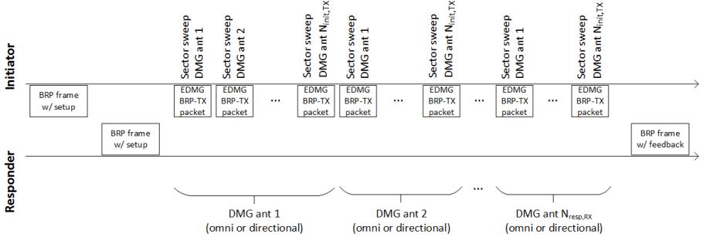
Figure 1—Example of BRP TXSS

As defined in 10.38.9.5.3, a BRP TXSS starts with the transmission of a BRP frame which indicates the need for transmit sector sweep by the initiator. After receiving confirmation of the BRP TXSS request from the responder, the initiator transmits EDMG BRP-TX packets to perform transmit sector sweep using each of its DMG antennas, and the process is repeated for each DMG antenna of the receiver. The last packet of a BRP TXSS contains feedback of the corresponding procedure based on measurements performed by the responder during the reception of EDMG BRP-TX packets. The feedback type is defined in the BRP frame that started the procedure.

The configurations of the DMG antennas and of the TRN-Units used in BRP TXSS are defined in 10.38.9.5.2. In BRP TXSS, the receive antenna pattern utilized by the responder in the reception of the training field of the EDMG BRP-TX packets may be quasi-omni or, in a specific case, directional. The receive antenna pattern to be utilized by the responder is determined in the BRP frame that started the procedure.

As defined in 30.9.2.2.2, the TRN field in EDMG BRP packets sent as part of BRP TXSS is transmitted over the entire signal bandwidth of the channel. Therefore, the BRP TXSS allows for transmit sector sweep over the bonded channel when the initiator and responder operate on a 4.32 GHz, 6.48 GHz, or 8.64 GHz channel.

10.38.9.5.2 DMG antenna and TRN-Unit configuration during BRP TXSS

All fields except for the TRN field of EDMG BRP-TX packets used in BRP TXSS shall be transmitted with the same DMG antenna and antenna configuration used in the transmission of the BRP frame that started the BRP TXSS procedure. The TRN field of EDMG BRP-TX packets used in BRP TXSS may be transmitted with a different DMG antenna than the one used in the transmission of the remaining fields of the same EDMG BRP-TX packet.

All fields of EDMG BRP-TX packets used in BRP TXSS except for the TRN field shall be received with the same DMG antenna and antenna configuration used in the reception of the BRP frame that started the BRP TXSS procedure. The TRN field of EDMG BRP-TX packets used in BRP TXSS may be received with a DMG antenna that is not the same one used in the reception of the remaining fields of the same EDMG BRP-TX packet. The TRN field of EDMG BRP-TX packets used in BRP TXSS may be received with either a quasi-omni receive pattern or a directional antenna pattern.

When the subfield TXSS-REQ-RECIPROCAL within the EDMG BRP Request element in the BRP frame sent by the initiator to start the BRP TXSS is set to 0, then:
- The total number of AWV combinations trained shall be equal to the sum of all sectors employed on all DMG antennas of the initiator multiplied by the number of DMG antennas of the responder.
- The responder shall use a quasi-omni pattern when receiving the training field of EDMG BRP-TX packets used in the procedure

The subfield TXSS-REQ-RECIPROCAL within the EDMG BRP Request element in the BRP frame sent by the initiator to start the BRP TXSS may only be set to 1 only if:
- The DMG Antenna Reciprocity subfield in the DMG STA Capability Information field of the responder and the DMG Antenna Reciprocity subfield in the DMG STA Capability Information field of the responder are both equal to 1; and
- The last BRP TXSS performed between the BRP frame transmitter (that is, the initiator in the current BRP TXSS) and the BRP frame receiver (that is, the responder in the current BRP TXSS) was performed with the BRP frame transmitter in the role of responder and the BRP frame receiver in the role of initiator.

If the subfield TXSS-REQ-RECIPROCAL within the EDMG BRP Request element in the BRP frame sent by the initiator to start the BRP TXSS is equal to 1, then:
- The initiator shall only transmit EDMG BRP-TX packets using the DMG antenna corresponding to the best sector identified in the last BRP TXSS procedure between the two STAs and that was initiated by the responder of the current BRP TXSS procedure.
- The responder shall use a directional antenna pattern when receiving the EDMG BRP-TX packets sent by the initiator. The AWV used by the responder shall be the best sector identified in the last BRP TXSS procedure between the two STAs and that was initiated by the responder of the current BRP TXSS procedure.

The BRP packet sent by the responder with feedback of a BRP TXSS shall be transmitted with the same DMG antenna and antenna configuration used in the transmission of the first BRP frame sent by the responder in the BRP TXSS procedure. The BRP packet sent by the responder with feedback of a BRP TXSS shall be received by the initiator with the same DMG antenna and antenna configuration used in the reception of the first BRP frame sent by the responder in the BRP TXSS procedure.

The first TRN-Unit in an EDMG BRP packet used in a BRP TXSS may be used for the initiator and responder to switch DMG antennas and shall not be processed by the responder. Therefore, for EDMG BRP-TX packets transmitted during BRP TXSS, the value of the TXVECTOR parameter EDMG_TRN_LEN shall be set to k + 1, where k is the number of TRN-Units used for sector sweep.

When transmitting an EDMG BRP-TX packet as part of a BRP TXSS, an EDMG STA may change the DMG antenna used in the transmission of its TRN field during the first TRN-Unit and shall not change DMG antenna during the remaining TNR-Units.

When receiving EDMG BRP-TX packets as part of BRP TXSS, an EDMG STA may change the DMG antenna used in the reception of the TRN field during the first TRN-Unit and shall not change DMG antenna during the remaining TNR-Units.

10.38.9.5.3 BRP TXSS execution

A BRP frame exchange is used to initiate a BRP TXSS procedure and negotiate the beamforming training parameters.

An initiator starts a BRP TXSS procedure by sending a BRP frame with the TXSS-REQ field in the EDMG BRP Request element set to 1 and the TXSS-SECTORS field set to indicate the total number of transmit sectors the initiator uses in the BRP TXSS procedure combined over all of its DMG antennas. The FBCK-REQ subfield in the DMG Beam Refinement element carried within the BRP frame shall be set to 10001 (binary). The first EDMG BRP packet sent in a BRP TXSS procedure shall not include a TRN field.

To confirm the BRP TXSS execution, the responder shall respond with a BRP frame containing a DMG Beam Refinement element with the BRP-TXSS-OK subfield set to 1 MBIFS interval after the reception of the first BRP frame. This is indicated in Figure 2. The initiator shall transmit the first EDMG BRP-TX packet as part of the BRP TXSS MBIFS interval after the reception of the BRP frame sent by the responder confirming the BRP TXSS execution.

If the TXSS-REQ-RECIPROCAL subfield within the EDMG BRP Request element in the BRP frame sent to start the BRP TXSS is 0, the initiator shall transmit ${\text{N}}_{\text{init,TX}}$ EDMG BRP-TX packets per each DMG antenna of the responder. The total number of sectors trained in the ${\text{N}}_{\text{init,TX}}$ EDMG BRP-TX packets sent is N, where N is equal to the value of the TXSS-SECTORS subfield in the EDMG BRP Request element sent in the BRP frame that started the BRP TXSS procedure. If the responder has more than one receive DMG antenna, the initiator repeats the transmission of the ${\text{N}}_{\text{init,TX}}$ EDMG BRP-TX packets for the number of DMG antennas indicated in the last negotiated Number of RX DMG Antennas field transmitted by the responder to the initiator.

If the TXSS-REQ-RECIPROCAL subfield within the EDMG BRP Request element in the BRP frame sent to start the BRP TXSS is 1, the initiator shall transmit an EDMG BRP-TX packet to the responder. The total number of sectors trained in the packet sent is N, where N is equal to the value of the TXSS-SECTORS subfield in the EDMG BRP Request element sent in the BRP frame that started the procedure.

The one or more EDMG BRP-TX packet sent by the initiator in a BRP TXSS procedure shall be separated by SIFS interval provided sufficient time is available for the complete transmission of those packets within the SP allocation or TXOP.

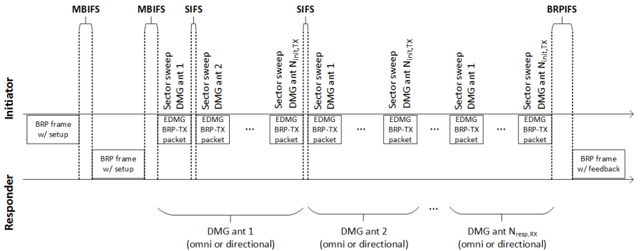
Figure 2—Timing parameters for BRP TXSS

For each EDMG BRP-TX packet transmitted in a BRP TXSS procedure, the Packet Type field within the L-Header and the EDMG TRN Length, EDMG TRN-Unit P, EDMG TRN-Unit M, and EDMG TRN-Unit N fields in the EDMG-Header-A are set to indicate the configuration of the TRN field appended to the packets.

10.38.9.5.4 BRP TXSS feedback

The responder shall send a BRP frame to the initiator containing feedback based on measurements the responder performed during a BRP TXSS performed with the initiator. The feedback transmitted by the responder is separated from the last EDMG BRP-TX packet transmitted by the initiator by a BRPIFS interval provided sufficient time is available for the complete transmission of those frames within the SP allocation or TXOP. Otherwise, the feedback shall be sent at the next available transmit opportunity.

The BRP frame with feedback sent by the responder shall have the BRP-TXSS-response subfield within the DMG Beam Refinement element set to 1.

The feedback type sent by the responder shall be as requested in the FBCK-REQ subfield in the DMG Beam Refinement element present in the BRP frame that started the procedure.

The BRP TXSS procedure is completed when the responder transmits the BRP packet containing the feedback.

9.4.2.130 DMG Beam Refinement element

Insert the following at the end of the subclause

A value of 1 in the BRP-TXSS-OK field confirms a previous BRP TXSS training request received by a STA. Otherwise, this field is set to 0.

A value of 1 in the BRP-TXSS-response field indicates that the frame containing this element contains an EDMG Channel Measurement Feedback element. Otherwise, this field is set to 0.

9.4.2.255 EDMG BRP Request element

Insert the following at the end of the subclause

The TXSS-REQ-RECIPROCAL field is set to one to indicate the request for reciprocal BRP TXSS training (see 10.38.9.5). Otherwise, this field is set to zero.

The TXSS-REQ field is set to one to indicate the request to perform the BRP TXSS training defined in 10.38.9.5. Otherwise, this field is set to zero.

If the TXSS-REQ field is equal to one, the TXSS-SECTORS field indicates the total number of transmit sectors the transmitter of this element uses in the BRP TXSS procedure combined over all of its DMG antennas. Otherwise, this field is reserved.

10.3.2.3.10 MBIFS

Change the first paragraph as follows

The MBIFS shall be used between the BTI and the A-BFT and between the ISS, RSS, SSW-Feedback, and SSW-Ack. In a BRP TXSS, MBIFS shall be used in between the first three transmitted BRP packets (see 5 10.38.9.5). MBIFS is equal to 3×aSIFSTime. An implementation of a DMG STA shall not allow the space between frames that are defined to be separated by an MBIFS, as measured on the medium, to vary from the nominal MBIFS by more than –0% or +10% × (aSlotTime – aAirPropagationTime).

10.3.2.3.11 LBIFS

Change the first paragraph as follows

The LBIFS shall be used between transmissions employing different DMG antennas and when the recipient STA is expected to switch DMG antennas. LBIFS is equal to TXTIME(SSW) + 2×SBIFS, except when used as part of an ISS or an RSS employing Short SSW packets, in which case LBIFS is equal to 14 2×TXTIME(Short SSW) + 3×SBIFS. An implementation of a DMG STA shall not allow the space between frames that are defined to be separated by an LBIFS, as measured on the medium, to vary from the nominal LBIFS by more than –0% or +10% × (aSlotTime – aAirPropagationTime).

Straw Poll
Do you agree that the text in contribution 17/0323r0 (Draft text for BRP Transmit Sector Sweep) shall be incorporated into the next draft 11ay specification?

References:

