IEEE P802.11
Wireless LANs
CRs on 28.3.10.8
Date: 2017-05-07
Author(s):
Name | Affiliation | Address | Phone | email
Yujin Noh | Newracom | 9008 Research Dr.  Irvine, CA 92618 |  | yujin.noh at newracom.com
Sigurd Schelstraete | Quantenna Communications | 3450 W. Warren Ave  Fremont, CA 94538 | +1 510 743 2288 | Sigurd at quantenna.com
Dongguk Lim | LG Electronics | 19, Yangjae-daero 11gil, Seocho-gu, Seoul 137-130, Korea |  | dongguk.lim at lge.com
Abstract
This submission shows
- Resolution for a comment received from TGax comment collection (TGax Draft D1.0)
- The proposed changes are based on 11ax D1.2.

The submission provides resolutions to comment related to HE-SIG-B field.
- The submission provides solutions to CIDs: 10060, 10061

Revisions:
- Rev 0: Initial version of the document.
- Rev 2:
  - Add sentences make the resolution clear
  - Modify the Figures based on resolved CID

Interpretation of a Motion to Adopt

A motion to approve this submission means that the editing instructions and any changed or added material are actioned in the TGax Draft. This introduction is not part of the adopted material.

Editing instructions formatted like this are intended to be copied into the TGax Draft (i.e. they are instructions to the 802.11 editor on how to merge the text with the baseline documents).

TGax Editor: Editing instructions preceded by “TGax Editor” are instructions to the TGax editor to modify existing material in the TGax draft. As a result of adopting the changes, the TGax editor will execute the instructions rather than copy them to the TGax Draft.

CID | P.L | Comment | Proposed Change | Resolution
10060 | 285.55 | HE-SIG-B section mixes some terminologies in use when refering to "Common Block field" vs "Comon field" and "User Specific field" vs "User Block field" vs "User field". It can make readers confused to understand this section. For rest sections, those terminologies are mixed up as well when refered.  A Common Block field should be used when describing on the encoding process through the spec if it is refered.  A Common field should be used when describing on the whole content through the spec if it is refered.  A User Block field should be used when describing on the encoding process through the spec if it is refered.  A User specific field should be used when describing on the whole content through the spec if it is refered.  A User field should be used when describing on each user content through the spec if it is refered. | As in the comment. | Revised  Agreed in principle.  TGax Editor: make changes according to this document 11-17-0289-02-00ax CRs on HE-SIG-B terminologies.
10061 | 286.55 | Different texts as "RU Allocation subfield", "RU Allocation signalling field", "RU allocation signalling" and so on are used to indicate RU Allocation field through HE-SIG-B section.  Those different texts need to be replaced with "RU Allocation field" through the spec when it is refered. |  | Revised  Agreed in principle.  TGax Editor: make changes according to this document 11-17-0289-02-00ax CRs on HE-SIG-B terminologies.

Discussion

- In section 28.3.10.8,
- HE-SIG-B section mixes terminology in the description between “Common Block field” vs “Comon field” and “User Specific field” vs “User Block field” vs “User field”.
  - Common Block field should be replaced with Common field to keep consistency.
  - User field should be used when describing individual user content (see 28.3.10.8.5 HE-SIG-B per-user content).
  - User Block field should be used when describing the field which made up of two User fields (or one User field depending on the number of assigned users), CRC bits and tail bits (see Figure 28-20).
  - User Specific field consisting of the User fields and padding bits (if present) should be used when describing on the whole content.
- Different texts as “RU Allocation subfield”, “RU Allocation signalling field”, and so on are used to indicate RU Allocation field. RU Allocation field should be used to keep consistency.
- Propose to clean up the text and use the consistent terminology.

To TGax editor: P285L58 replace the current text with the proposed changes below.
------------- Begin Text Changes ---------------

- Encoding and modulation
The HE-SIG-B field is separately encoded on each 20 MHz band. The encoding structure in one such 20 MHz band is shown in Figure 28-21 (HE-SIG-B field encoding structure in each 20 MHz(#4918)). It consists of a Common field followed by a User Specific field which together are referred to as the HE-SIG-B content channel.
(Figure omitted)
- HE-SIG-B field encoding structure in each 20 MHz(#4918)

The Common field of an HE-SIG-B content channel contains information regarding the resource unit allocation such as the RU assignment in frequency domain, the RUs allocated for MU-MIMO and the number of users in MU-MIMO allocations. The Common field is described in detail in 28.3.10.8.4 (HE-SIG-B common content).
The User Specific field of an HE-SIG-B content channel consists of one or more User Block fields. Each User Block field, except the last one, is made up of two User fields that contain information for two STAs to decode their payloads. The last User Block field may contain information for one or two STAs depending on the number of users indicated by the RU Allocation field and the Center 26-tone RU field. See 28.3.10.8.5 (HE-SIG-B per-user content) for a description of the contents of the User field.
When the SIGB Compression field in the HE-SIG-A field of an HE MU PPDU is set to 1 (indicating full bandwidth MU-MIMO transmission), the Common field is not present and the HE-SIG-B content channel consists of only the User Specific field.
When the SIGB Compression field in the HE-SIG-A field of an HE MU PPDU is set to 1 (indicating full bandwidth MU-MIMO transmission) and the Number Of HE-SIG-B Symbols Or MU-MIMO Users field in the HE-SIG-A field of an HE MU PPDU is set to 0 (indicating 1 MU-MIMO user), the User Specific field in the HE-SIG-B field consists of a single User Block field containing one User field(#5264) for a non-MU-MIMO allocation as shown in Table 28-22 (Fields of the HE-SIG-B user field for an non-MU-MIMO allocation).(#5412)(#6194)(#7032)(#9770)
- Frequency domain mapping
The 20 MHz PPDU contains one HE-SIG-B content channel in which the Common field and User Specific field are carried as shown in Figure 28-22 (HE-SIG-B content channel for a 20 MHz PPDU). The Common field contains the RU allocation signaling for RUs that occur within the 242-tone RU boundary.

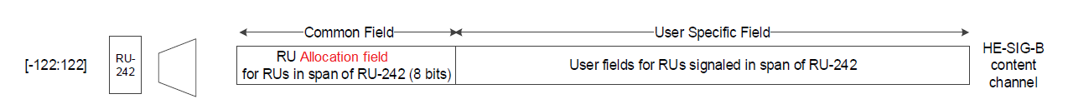
- HE-SIG-B content channel for a 20 MHz PPDU

The 40 MHz PPDU contains two HE-SIG-B content channels, each occupying a 20 MHz segment. Each HE-SIG-B content channel contains a Common field followed by User Specific field as shown in Figure 28-23 (HE-SIG-B content channel for a 40 MHz PPDU). The HE-SIG-B content channels are ordered in increasing order of the absolute frequency i.e., the first HE-SIG-B content channel carries Common field and User Specific field corresponding to RUs whose subcarrier indices fall between [-244: -3] and the second HE-SIG-B content channel carries Common field and User Specific field corresponding to RUs whose subcarrier indices fall between [3:244].

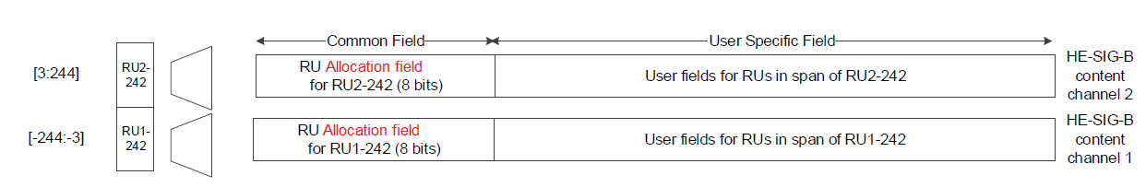
- HE-SIG-B content channel for a 40 MHz PPDU

The 80 MHz PPDU contains two HE-SIG-B content channels each of which are duplicated once as shown in Figure 28-24 (Mapping of the two HE-SIG-B content channels and their duplication in an 80 MHz PPDU). The arrangement of the HE-SIG-B content channels are in increasing order of the absolute frequency where HE-SIG-B content channel 1 occupies the tones in the 20 MHz segment with the lowest subcarrier indices followed by the HE-SIG-B content channel 2 in the adjacent 20 MHz segment. This structure of the first HE-SIG-B content channel occupying the lower subcarrier index followed by the second HE-SIG-B content channel is repeated with content duplication in the remaining two 20 MHz segments, respectively. The first HE-SIG-B content channel appearing in the 20 MHz segments carries a Common field and User Specific field corresponding to RUs whose subcarriers indices overlap those segments. The Common field of HE-SIG-B content channel 1 contains the following: an RU Allocation field for RUs with subcarrier indices in the range [-500:-259], followed by a second RU Allocation field for RUs with subcarrier indices between [17:258] and 1 bit to indicate the presence of the User field corresponding to the center 26-tone RU that spans subcarriers [-16:-4, 4:16]. The second HE-SIG-B content channel carries a Common field and User Specific field corresponding to RUs whose subcarrier indices fall in those segments. The Common field of content channel 2 contains the following: an RU Allocation field for RUs whose subcarrier indices fall in the range [-258:-17], followed by a second RU Allocation field for RUs with subcarrier indices between [259:500] and 1 bit to indicate presence of the User field corresponding to the center 26-tone RU that spans subcarriers [-16:-4, 4:16]. The same value for the bit signaling presence of the center 26-tone RU is carried in both HE-SIG-B content channels. The User fields in the User Specific field that follow the Common field are arranged in the same order as the RU allocation signaling. When assigned, the User field corresponding to the center 26-tone RU that spans subcarriers [-16:-4, 4:16] is carried as the last User field in the HE-SIG-B content channel 1. When RUs greater than 242 subcarriers are signaled in the RU allocation signaling in a portion of the bandwidth, the signaling is carried in both HE-SIG-B content channels placed in the order of the absolute subcarrier index.

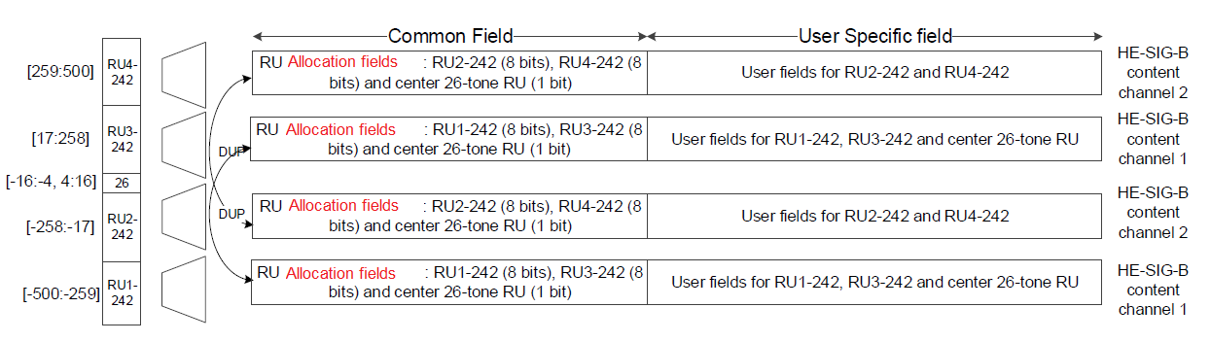
- Mapping of the two HE-SIG-B content channels and their duplication in an 80 MHz PPDU when the SIGB Compression field in the HE-SIG-A field of an HE MU PPDU is set to 0

The 160 MHz PPDU contains two HE-SIG-B content channels each of which are duplicated four times as shown in Figure 28-24 (Mapping of the two HE-SIG-B content channels and their duplication in a 160 MHz PPDU). The arrangement of the HE-SIG-B content channels are in increasing order of the absolute frequency. The first HE-SIG-B content channel occupies the tones in the 20 MHz segment with the lowest subcarrier indices and the second HE-SIG-B content channel in the adjacent 20 MHz segment. This pattern of arranging HE-SIG-B content channel 1 and HE-SIG-B content channel 2 is duplicated over the other segments. The HE-SIG-B content channel 1 and HE-SIG-B content channel 2 carries RU allocation signaling at 242-tone RU granularity that overlap with the 20 MHz segments in which the HE-SIG-B content channels are carried (including duplication). The signaling for the presence of the User field corresponding to a center 26-tone RU in the 80 MHz segment with the lower subcarrier index is carried in HE-SIG-B content channel 1 as a 1-bit Center 26-tone RU field after the RU Allocation field in the Common field. Similarly, signaling for the center 26-tone RU in the 80 MHz segment with the higher subcarrier index is carried in HE-SIG-B content channel 2 as 1-bit Center 26-tone RU field after the RU Allocation field in the Common field. When assigned, the User field corresponding to the center 26-tone RU in the 80 MHz segments is carried as the last User field in their respective HE-SIG-B content channels. When RUs greater than 242 subcarriers are signaled in the RU Allocation field in a portion of the bandwidth, the signaling is carried in both HE-SIG-B content channels placed in the order of the absolute subcarrier index.

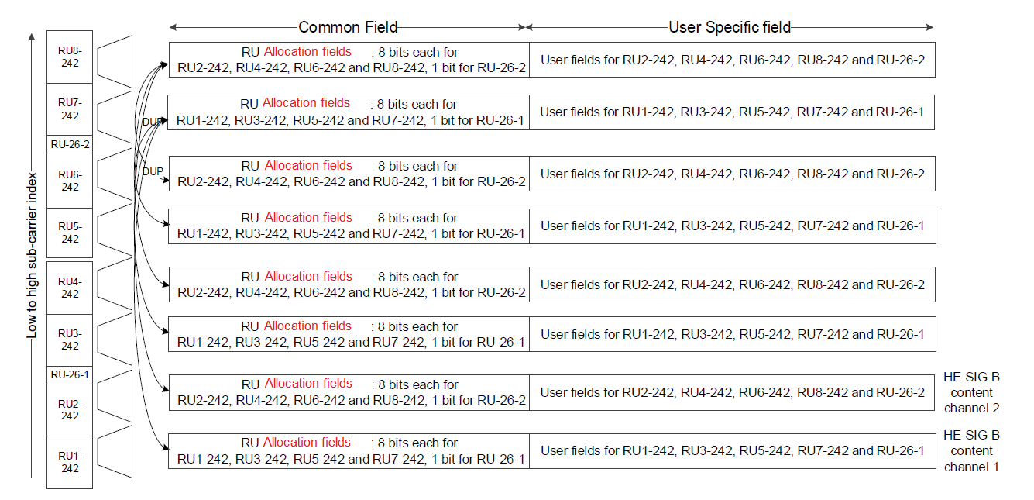
- Mapping of the two HE-SIG-B content channels and their duplication in a 160 MHz PPDU when the SIGB Compression field in the HE-SIG-A field of an HE MU PPDU is set to 0

When the SIGB Compression field in the HE-SIG-A field of an HE MU PPDU is set to 0, for an MU-MIMO allocation of RU size greater than 242 subcarriers, the User fields are dynamically split between HE-SIG-B content channel 1 and HE-SIG-B content channel 2 and the split is decided by the AP (on a per case basis). See 28.3.10.8.4 (HE-SIG-B common content) and 28.3.10.8.5 (HE-SIG-B per-user content) for more details.
When preamble puncturing is present as indicated by values 4 to 7 in the Bandwidth field of HE-SIG-A field of an HE MU PPDU (see Table 28-17 (HE-SIG-A field of an HE MU PPDU)), the frequency domain structure of HE-SIG-B is the same as defined for the full bandwidth, i.e. the HE-SIG-B field frequency domain structure is solely dependent on the total bandwidth.

- Time domain encoding
In each 20 MHz band, the bits in the Common field shall have CRC and tail bits added and then be BCC encoded at rate R = ½. The CRC bits are computed as described in 28.3.10.7.3 (CRC computation). Padding bits are not added after the Common field.
In the User Specific field, in any 20 MHz band, each User Block field shall have CRC and tail bits added and then be BCC encoded at rate R = 1/2(#8944, #8945, #8946). If the number of User fields in the HE-SIG-B content channel is odd, CRC and tail bits are added after the last User field, which is not grouped. Padding bits are appended right after the tail bits corresponding to the last User Block field in each HE-SIG-B content channel to round up to the next multiple of number of data bits per HE-SIG-B symbol, as described in 17.3.5.4 (Pad bits (PAD)). Further padding bits are appended to each HE-SIG-B content channel so that the number of OFDM symbols after encoding and modulation in the HE-SIG-B content channel equals the Number Of HE-SIG-B Symbols Or MU-MIMO Users field in the HE-SIG-A field for an HE MU PPDU. Thus, padding ensures that the HE-SIG-B content channels in different 20 MHz bands end at the same OFDM symbol. For both the Common field and User Block fields, the information bits, tail bits and padding bits (if present) are BCC encoded at rate R = ½ using the encoder described in 17.3.5.6 (Convolutional encoder). When the code rate of the HE-SIG-B MCS is not equal to ½, the convolutional encoder output bits for each field are concatenated, then the concatenated bit streams are punctured as described in 17.3.5.6 (Convolutional encoder).

------------- End Text Changes ---------------

