IEEE P802.11
Wireless LANs
LB225 CR Sub-clause 10.22.2.5
Date: 2017-01-31
Author(s):
Name | Affiliation | Address | Phone | email
Yongho Seok | NEWRACOM | 9008 Research Drive, Irvine, CA, 92618 |  | yongho.seok@newracom.com
Abstract
This submission proposes resolutions of comments received from TGax LB225.
(The proposed change is based on TGax Draft 1.1.)
- CIDs: 7667, 9693, 6529 (3 CID)

Interpretation of a Motion to Adopt

A motion to approve this submission means that the editing instructions and any changed or added material are actioned in the TGax Draft. This introduction is not part of the adopted material.

Editing instructions formatted like this are intended to be copied into the TGax Draft (i.e. they are instructions to the 802.11 editor on how to merge the text with the baseline documents).

TGax Editor: Editing instructions preceded by “TGax Editor” are instructions to the TGax editor to modify existing material in the TGax draft. As a result of adopting the changes, the TGax editor will execute the instructions rather than copy them to the TGax Draft.

CID | Page | Clause | Comment | Proposed Change | Resolution
7667 | 130.44 | 10.22.2.5 | Add MU puncturing mode here. | As in comment | Revised-  Agree in principle.  Add the missing case of an HE DL MU PPDU with preamble puncture.  TGax editor makes changes as shown in the as specified in 11-17/0209r0.
9693 | 130.45 | 10.22.2.5 | Channels indicated idle by the channel-list parameter (shown on Table 10-10) shall supports an HE punctured PPDU. | Add new channel-list parameter for supporting an HE punctured PPDU. | Revised-  Agree in principle.  Add the missing case of an HE DL MU PPDU with preamble puncture.  TGax editor makes changes as shown in the as specified in 11-17/0209r0.
6529 | 131.20 | 10.22.2.5 | Missing case: the editing to accommodate the HE case has had the effect of rendering the timing undefined for the HT case operating at 2.4 GHz. Without the addition of the underlined text, it's clear that the relevant interval is PIFS, but with the addition we have "PIFS interval for the 5 GHz band or DIFS interval for an HE STA operating in the 2.4 GHz band." What about an HT STA operating in the 2.4 GHz band? | Revise the definition to fill in the missing case. | Rejected-  The EDCA channel access rule of an HT STA operating in the 2.4 GHz band is specified in 11.16.9 (STA CCA sensing in a 20/40 MHz BSS).
Discussion:
Please refer the below document:
https://mentor.ieee.org/802.11/dcn/16/11-16-0898-00-00ax-bw-field-in-he-mu-format.pptx

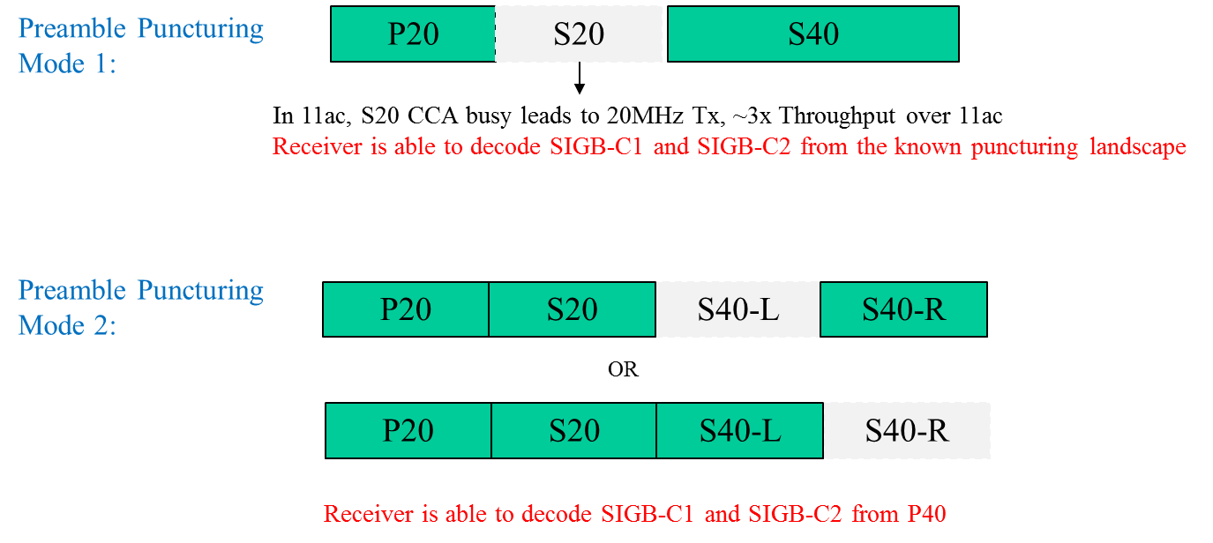
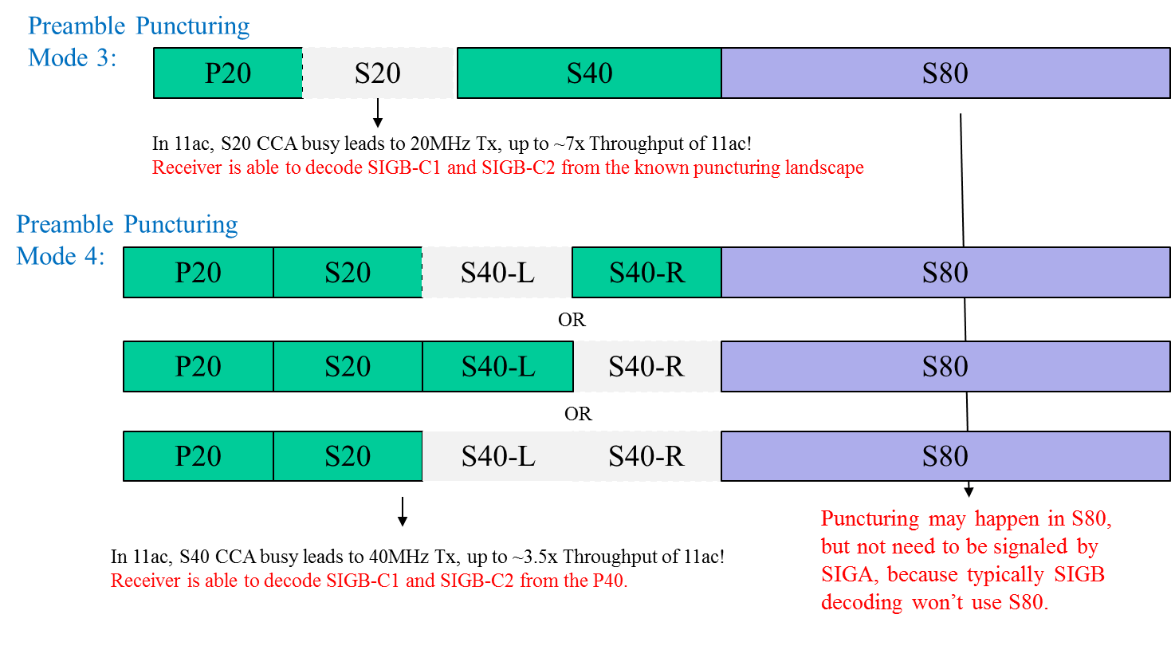

10.22.2.5 EDCA channel access in a VHT, HE or TVHT BSS
TGax editor: Change table 10-10 as follows:
Table 10-10—Channels indicated idle by the channel-list parameter
PHY-CCA.indication primitive channel-list element | Idle channels
primary | None
secondary | Primary 20 MHz channel
secondary40 | Primary 20 MHz channel and secondary 20 MHz channel
secondary80 | Primary 20 MHz channel, secondary 20 MHz channel, and secondary 40 MHz channel
per20MHz bitmap | Each bit of the per20MHz bitmap that is equal to 0 indicates an idle channel (see 28.3.17.6.5 (Per-20MHz CCA sensitivity))

TGax editor: Change subclause 10.22.2.5 as follows:
If a STA is permitted to begin a TXOP (as defined in 10.22.2.4 (Obtaining an EDCA TXOP)) and the STA has at least one MSDU pending for transmission for the AC of the permitted TXOP, the STA shall perform exactly one of the following actions:
- Transmit a 160 MHz or 80+80 MHz mask PPDU if the secondary channel, the secondary 40 MHz channel, and the secondary 80 MHz channel were idle during an interval of PIFS immediately preceding the start of the TXOP.
- Transmit an 80 MHz mask PPDU on the primary 80 MHz channel if both the secondary channel and the secondary 40 MHz channel were idle during an interval of PIFS immediately preceding the start of the TXOP.
- Transmit a 40 MHz mask PPDU on the primary 40 MHz channel if the secondary channel was idle during an interval of PIFS for the 5 GHz band and DIFS for an HE STA operating in the 2.4 GHz band immediately preceding the start of the TXOP.
- Transmit a 20 MHz mask PPDU on the primary 20 MHz channel.
- Restart the channel access attempt by invoking the backoff procedure as specified in 10.22.2 (HCF contention based channel access (EDCA)) as though the medium is busy on the primary channel as indicated by either physical or virtual CS and the backoff timer has a value of 0.
- Transmit a TVHT_4W or TVHT_2W+2W mask PPDU if the secondary TVHT_W channel and the secondary TVHT_2W channel were idle during an interval of PIFS immediately preceding the start of the TXOP.
- Transmit a TVHT_2W or TVHT_W+W mask PPDU if the secondary TVHT_W channel was idle during an interval of PIFS immediately preceding the start of the TXOP.
- Transmit a TVHT_W mask PPDU on the primary TVHT_W channel.
- Transmit an HE MU PPDU with preamble puncturing in 80 MHz where in the preamble only the secondary 20 MHz is punctured, if the primary channel and the secondary 40MHz channel were idle during an interval of PIFS immediately preceding the start of the TXOP.
- Transmit an HE MU PPDU with preamble puncturing in 80 MHz where in the preamble only one of the two 20 MHz sub-channels in secondary 40 MHz is punctured, if the primary channel, the secondary 20 MHz channel, and one of the two 20 MHz sub-channels in secondary 40 MHz were idle during an interval of PIFS immediately preceding the start of the TXOP.
- Transmit an HE MU PPDU with preamble puncturing in 160 MHz or 80+80 MHz where in the primary 80 MHz of the preamble only the secondary 20 MHz is punctured, if the primary channel, the secondary 40MHz channel, and at least one of the four 20 MHz sub-channels in the secondary 80 MHz channel were idle during an interval of PIFS immediately preceding the start of the TXOP.
- Transmit an HE MU PPDU with preamble puncturing in 160 MHz or 80+80 MHz where in the primary 80 MHz of the preamble the primary 40 MHz is present, if the primary channel, the secondary 20MHz channel, and at least one of the four 20 MHz sub-channels in the secondary 80 MHz channel were idle during an interval of PIFS immediately preceding the start of the TXOP.
NOTE 1—In the case of rule e), the STA selects a new random number using the current value of CW[AC], and the retry counters are not updated (as described in 10.22.2.7 (Multiple frame transmission in an EDCA TXOP); backoff procedure invoked for event a)).
NOTE 2—For both an HT, and a VHT and an HE STA, an EDCA TXOP is obtained based on activity on the primary channel (see 10.22.2.4 (Obtaining an EDCA TXOP)). The width of transmission is determined by the CCA status of the nonprimary channels during the PIFS interval for the 5 GHz band or DIFS interval for an HE STA operating in the 2.4 GHz band before transmission (see VHT description in 10.3.2 (Procedures common to the DCF and EDCAF)).
NOTE 3—In the case of rule j), the punctured 20 MHz sub-channel in secondary 40 MHz is different with an idle 20 MHz sub-channel in secondary 40 MHz.

TGax editor: Change subclause 28.3.18.1 as follows:

28.3.18 Transmit specification
28.3.18.1 Transmit spectral mask
The bandwidth of the spectral mask applied to an HE SU PPDU, an HE trigger-based PPDU and an HE MU PPDU with the Bandwidth subfield of the HE-SIG-A field equal to 0, 1, 2 or 3 shall be determined by the bandwidth indicated in the Bandwidth subfield of the HE-SIG-A field. The bandwidth of the spectral mask applied to an HE ER SU is 20 MHz. The bandwidth of the spectral mask applied to an HE MU PPDU with the Bandwidth subfield of the HE-SIG-A field equal to either 4 or 5 is 80 MHz. The bandwidth of the spectral mask applied to an HE MU PPDU with with the Bandwidth subfield of the HE-SIG-A field equal to either 6 or 7 is 160 MHz. All HE PPDU formats shall be compliant with the transmit spectral mask described in this section.

TGax editor: Change subclause 28.3.17.6.3, 28.3.17.6.4, 28.3.17.6.5 as follows:

28.3.17.6.3 CCA sensitivity for signals occupying the primary 20 MHz channel
When the dot11HECCAIndicationMode is equal to either 0 (singleelement) or 1 (per20bitmap), tThe PHY shall issue a PHY-CCA.indication(BUSY, {primary}) primitive if one of the conditions listed in Table 28-43 (Conditions for CCA BUSY on the primary 20 MHz) is met in an otherwise idle 20 MHz, 40 MHz, 80 MHz, 160 MHz, or 80+80 MHz operating channel width. With >90% probability, the PHY shall detect the start of a PPDU that occupies at least the primary 20 MHz channel under the conditions listed in Table 28-43 (Conditions for CCA BUSY on the primary 20 MHz) within a period of aCCATime (see 21.4.4 (VHT PHY)) and hold the CCA signal busy (PHY-CCA.indication(BUSY, channel-list) primitive) for the duration of the PPDU, unless it receives a CCARESET.request primitive before the end of the PPDU for instance during spatial reuse operation as described in 27.9 (Spatial reuse operation).

28.3.17.6.4 CCA sensitivity for signals not occupying the primary 20 MHz channel for a STA attempting a non-preamble puncturing transmission
When the dot11HECCAIndicationMode is equal to 0 (singleelement), tThe PHY shall issue a PHY-CCA.indication(BUSY, {secondary}) primitive if the conditions for issuing PHY-CCA.indication(BUSY, {primary}) primitive are not present and one of the following conditions are present in an otherwise idle 40 MHz, 80 MHz, 160 MHz, or 80+80 MHz operating channel width:
- Any signal within the secondary 20 MHz channel at or above a threshold of –62 dBm within a period of aCCATime after the signal arrives at the receiver’s antenna(s); then the PHY shall not issue a PHY-CCA.indication(BUSY,{secondary40}), PHY-CCA.indication(BUSY,{secondary80}), or PHY-CCA.indication(IDLE) primitive while the threshold continues to be exceeded.
- A 20 MHz NON_HT, HT_MF, HT_GF, VHT PPDU or HE PPDU detected in the secondary 20 MHz channel at or above max(–72 dBm, OBSS_PD_20MHz) with >90% probability within a period aCCAMidTime (see 28.4.3 (HE PHY)).
TGax editor: Change the below as the separate paragraph:
When the dot11HECCAIndicationMode is equal to 0 (singleelement), tThe PHY shall issue a PHY-CCA.indication(BUSY, {secondary40}) primitive if the conditions for issuing a PHY-CCA.indication(BUSY, {primary}) and PHY-CCA.indication(BUSY, {secondary}) primitive are not present and one of the following conditions are present in an otherwise idle 80 MHz, 160 MHz, or 80+80 MHz operating channel width:
- Any signal within the secondary 40 MHz channel at or above a threshold of –59 dBm within a period of aCCATime after the signal arrives at the receiver’s antenna(s); then the PHY shall not issue a PHY-CCA.indication(BUSY, {secondary80}) primitive or PHY-CCA.indication(IDLE) primitive while the threshold continues to be exceeded.
- A 40 MHz non-HT duplicate, HT_MF, HT_GF, VHT PPDU or HE PPDU detected in the secondary 40 MHz channel at or above max( –72 dBm, OBSS_PD_20MHz) with >90% probability within a period aCCAMidTime (see 28.4.3 (HE PHY)).
- A 20 MHz non-HT, HT_MF, HT_GF, VHT PPDU or HE PPDU detected in any 20 MHz sub-channel of the secondary 40 MHz channel at or above max( –72 dBm, OBSS_PD_20MHz) with >90% probability within a period aCCAMidTime.
When the dot11HECCAIndicationMode is equal to 0 (singleelement), tThe PHY shall issue a PHY-CCA.indication(BUSY, {secondary80}) primitive if the conditions for PHYCCA.indication(BUSY, {primary}), PHY-CCA.indication(BUSY, {secondary}), and PHYCCA.indication(BUSY, {secondary40}) primitive are not present and one of the following conditions are present in an otherwise idle 160 MHz or 80+80 MHz operating channel width:
- Any signal within the secondary 80 MHz channel at or above –56 dBm.
- An 80 MHz non-HT duplicate, VHT PPDU or HE PPDU detected in the secondary 80 MHz channel at or above max(–69 dBm, OBSS_PD_20MHz) with >90% probability within a period aCCAMidTime (see 28.4.3 (HE PHY)).
- A 40 MHz non-HT duplicate, HT_MF, HT_GF, VHT or HE PPDU detected in any 40 MHz sub-channel of the secondary 80 MHz channel at or above max(–72 dBm, OBSS_PD_20MHz) with >90% probability within a period aCCAMidTime.
- A 20 MHz NON_HT, HT_MF, HT_GF, VHT or HE PPDU detected in any 20 MHz sub-channel of the secondary 80 MHz channel at or above max(–72 dBm, OBSS_PD_20MHz) with >90% probability within a period aCCAMidTime.

28.3.17.6.5 Per-20MHz CCA sensitivity for signals not occupying the primary 20 MHz channel for a STA attempting a preamble puncturing transmission
When the dot11HECCAIndicationMode is equal to 1 (per20bitmap), tThe PHY shall issue a PHY-CCA.indication(BUSY, {per20MHz bitmap}) primitive if the conditions for issuing PHY-CCA.indication(BUSY, {primary}) primitive are not present and one of the following conditions are present in an otherwise idle 20 MHz, 40 MHz, 80 MHz, 160 MHz, or 80+80 MHz operating channel width:
- Any signal within the any 20 MHz sub-channel of secondary 20 MHz, secondary 40 MHz or secondary 80 MHz at or above a threshold of –62 dBm within a period of aCCATime after the signal arrives at the receiver’s antenna(s); then the PHY shall not issue PHY-CCA.indication(IDLE) primitive while the threshold continues to be exceeded.
- A 20 MHz NON_HT, HT_MF, HT_GF, VHT, or HE PPDU detected in the any 20 MHz sub-channel of secondary 20 MHz, secondary 40 MHz or secondary 80 MHz at or above max( –72 dBm, OBSS_PD_20MHz) with >90% probability within a period aCCAMidTime (see 28.4.3 (HE PHY)).

When the dot11HECCAIndicationMode is equal to 2 (per20bitmapsifs), the PHY shall issue a PHY-CCA.indication(BUSY, {per20MHz bitmap}) primitive if one of the following conditions are present in an otherwise idle 40 MHz, 80 MHz, 160 MHz, or 80+80 MHz operating channel width:
- Any signal within the any 20 MHz sub-channel of primary 20 MHz, secondary 20 MHz, secondary 40 MHz or secondary 80 MHz at or above a threshold of –62 dBm within a period of aCCATime after the signal arrives at the receiver’s antenna(s); then the PHY shall not issue PHY-CCA.indication(IDLE) primitive while the threshold continues to be exceeded.

The per20MHz bitmap is 8 bits in length. For 160 MHz or 80+80 MHz operation, the first bit to the 8th bit correspond to the 20 MHz sub-channel with the lowest frequency to the 20 MHz sub-channel with the highest frequency respectively. When a 20 MHz sub-channel is BUSY, the corresponding bit is set to 1, otherwise it is set to 0. When the dot11HECCAIndicationMode is equal to 1 (per20bitmap), tThe bit corresponding to the primary 20 MHz is set to 0.
For 80 MHz operation, the first bit to the 4th bit corresponds to the 20 MHz sub-channel with the lowest frequency to the 20 MHz sub-channel with the highest frequency respectively. When a 20 MHz sub-channel is BUSY, the corresponding bit is set to 1, otherwise it is set to 0. When the dot11HECCAIndicationMode is equal to 1 (per20bitmap), tThe bit corresponding to the primary 20 MHz is set to 0. And, and the last 4 bits are reserved and set to 1s.

TGax editor: Insert the following MIB variable to Annex C as the follows:

-- **********************************************************************
-- * End of dot11PPEThresholdsMappings TABLE
-- **********************************************************************

-- **********************************************************************
-- * dot11 Phy HE TABLE
-- **********************************************************************
dot11PhyHETable OBJECT-TYPE
SYNTAX SEQUENCE OF Dot11PhyHEEntry
MAX-ACCESS not-accessible
STATUS current
DESCRIPTION
"Entry of attributes for dot11PhyHETable. Implemented as a table indexed on ifIndex to allow for multiple instances on an Agent."
::= { dot11phy <ANA> }

dot11PhyHEEntry OBJECT-TYPE
SYNTAX Dot11PhyHEEntry
MAX-ACCESS not-accessible
STATUS current
DESCRIPTION
"An entry in the dot11PhyHEEntry Table. ifIndex - Each IEEE Std 802.11 interface is represented by an ifEntry. Interface tables in this MIB module are indexed by ifIndex."
INDEX {ifIndex}
::= { dot11PhyHETable 1 }

Dot11PhyHEEntry ::=
SEQUENCE {
dot11HECCAIndicationMode INTEGER
}

dot11HECCAIndicationMode OBJECT-TYPE
SYNTAX INTEGER {
singleelement (0),
per20bitmap (1),
per20bitmapsifs (2) }
MAX-ACCESS read-write
STATUS current
DESCRIPTION
"This is a control variable.
It is written by an external management entity.
Changes take effect as soon as practical in the implementation.
The current CCA method in operation for an HE PHY. Valid values are:
When the channel-list of a PHY-CCA.indication primitive contains only single element, it is set to 0 (singleelement).
When the channel-list of a PHY-CCA.indication primitive contains a per20MHz bitmap and the channel-list is used for the preamble puncturing transmission, it is set to 1 (per20bitmap).
When the channel-list of a PHY-CCA.indication primitive contains a per20MHz bitmap measured during the SIFS time and the channel-list is used for the HE trigger-based PPDU transmission and BQR operation, it is set 2 (per20bitmapsifs)."
::= { dot11PhyHEEntry 1 }

