IEEE P802.11
Wireless LANs
Light Communications (LC) for 802.11:
Draft response to the Technical Feasibility Questions
Date: 2017-02-20
Author(s):
Name | Affiliation | Address | Phone | email
Dobroslav Tsonev | pureLiFi |  |  | dobroslav.tsonev@purelifi.com
Nikola Serafimovski | pureLiFi |  |  | nikola.serafimovski@purelifi.com
Abstract
This document contains the primilinary answers to some of the technical feasibility questions asked in the Light Communications TIG draft output report.

LC Technical Feasibility
How does LC work?
Any baseband electrical signal that is supplied to a light-emitting diode (LD) generates a light output with intensity proportional to the amplitude of the electrical signal. As a diode only works for positive current/voltage, the electrical signal needs to be positive only. Bipolar communication signals are typically realized around a positive bias (operating) point for which the LED/LD is active and has a linear input-output characteristic. The relationship between voltage and current is somewhat linear, but the current-to-light relationship of the device is typically more linear. As a result, the information is typically encoded into the current of the electrical signal used to drive the LED/LD. The LED/LD diode effectively serves the purpose of an upconverter that generates light-frequency waves with intensity proportional to the electrical current that flows through the device. The spectrum of the electromagnetic radiation is not correlated with the information signal and is dependent on the material/physical implementation of the LED/LD. For LEDs, this spectrum is typically very wide, while for LDs it is typically much narrower, yet still quite wider than the bandwidth of the baseband information signal itself. [1,2]
Any light that is incident on a photodetector such as a photodiode leads to current flowing through the device, which is proportional to the light intensity. As a result, a photodiode converts light variations into current variations or a light information signal into a current information signal. The current information signal is then treated as any other electrical baseband information signal in a communication system. [1,2]
How does LC work in a bright room with sunlight?
The information signal is encoded in the light intensity variations. For high speed communication, these intensity variations are quite fast as the bandwidth of the information signal is in the order of tens to hundreds of MHz. Variations in sunlight and ambient light from light sources are quite constant relative to the light used for communication. As a result, they lead to low-frequency signal interference that is easily avoided/filtered out. This is especially easy when an OFDM based communication protocol is used.
The only possible detrimental effects due to ambient light can occur when the ambient light is strong enough to saturate the receiver. This is very hard to achieve in practice for any reasonable communication scenario. Further issue caused by background light is additional shot noise (modelled as Gaussian noise) in the receiver circuitry. In typical short-distance scenarios, this noise component is not strong enough to significantly compromise the system performance. A typical communication system can function even under very high sunlight illumination levels. [1,11]
How does LC work when you turn off the lights?
Visible light communication would typically not work, when you turn off the lights, ie., there is no power transmitted in the visible light spectrum. In certain scenarios, one could resort to very low light illumination (lights are dimmed down to the point when they appear to be completely off) using extremely sensitive light detectors such as photomultipliers or avalanche photodiodes (APDs). However, for typical visible light communication systems that are currently being envisioned, communication would not be possible when the lights are off. In such a scenario, one would resort to infrared light for communication and/or radio frequency communication. [1,4,8,12]
Can we see LC lights flicker?
The human eye cannot really discern light changes above 10 kHz. Because communication lights change intensity (flicker) at rates in the order of 10s or 100s of MHz, no visible flickering effects should occur in a VLC system. [3]
- Include the human eye-safety considerations as a design constraint from 802.15.7m
This should be a copy paste from the standard and then any adjustments would need to be made by the study group.
Is the flicker created by modulation safe?
No extensive studies have been done on this effect. However, one would assume that it is no more harmful than is the flickering of a TV screen, computer screen or a mobile phone screen. [3]
Is LC a line-of-sight technology?
By design, light communication can be made line-of-sight or non-line-of-sight technology. It all depends on the communication scenario and the technology that is employed. [1,4,5]
- Add examples to illustrate what is meant by LoS and non-LoS

Transmitter
Detector
NLoS Scenario
Transmitter
Detector
LoS Scenario

If LC is a non-line-of-sight technology, then how is it more secure than other wireless technologies?
Light radiation (especially visible light radiation) is significantly easier to constrain and police compared to RF radiation. In addition, the extremely short light wavelengths lead to significant attenuation effects even over moderate distances. This leads to more confined operating environments where secrecy rates become relevant. [6,7] In addition, jamming light communication signals is harder to achieve than other RF solutions.
Will LC work in my pocket?
No, it is expected that when a LC enabled device is placed in one’s pocket, the communication protocol that is used will rely on RF communication. Light communication is envisioned as a technology adjunct to RF communication for devices that have multi-radio capabilities. [8]
Can we enable LC to be Full-Duplex in 802.11?
Yes, it could theoretically be achieved. Full-duplexing in light communication can be achieved using the same or different wavelengths (colors) for the uplink and downlink. The uplink could use infrared radiation at a certain wavelength, whereas the downlink could use visible light or infrared radiation depending on the illumination scenario. [9]
Are LC systems subject to multipath fading?
Light communication systems typically employ incoherent modulation and demodulation. The light photons themselves interact constructively and destructively between each other. As there is no correlation between the individual light modes, the light that reaches a given surface on average is the same. At the same time, a typical photodiode detector has an area (in the order of mm) that is much larger than the size of an individual photon (in the order of hundreds of nm to a few um). Hence, receiver diversity over thousands of transmission wave modes is achieved in a photodetector, which mitigate some fading effects [1,10]. This should not be confused with multipath interference and inter-symbol interference, which still exist.
- Use of OFDm for baseband modulation and the need for mitigation of multipath
  - Implementation and typical symbol length
Implementation is almost equivalent to the implementation for RF communication with the additional constraint required to generate a real signal. The symbol lengths with FFT between 64 and 512 that are already present in the different 802.11 flavours work quite well for light communication as well. The guard intervals depend on the channel conditions, but for most channels (especially LoS) a very short cyclic prefix is required, as an example. We believe that the 802.11ac as well as 802.11ad OFDM/single carrier specification are the closest to the light communication specification in this aspect.
- Reference receiver design/architecture
The link margin calculation touches upon this topic.
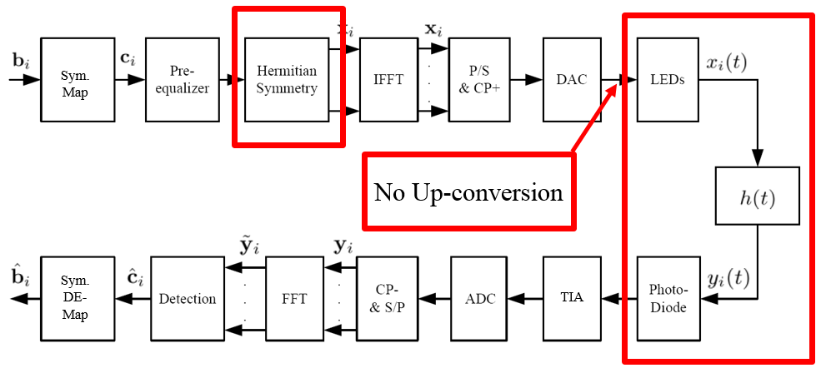
Figure 1: Example of an OFDM modulation and demodulation chain for LC.
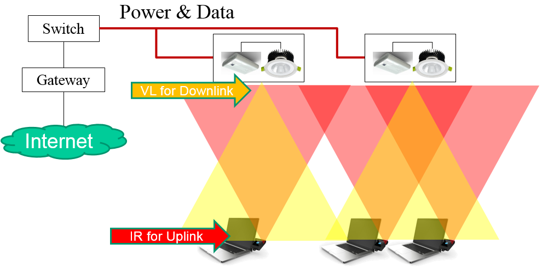
Figure 2: Example of the overall architecture for LC.
- Reference for comparison of OFDM vs. PPM/PWM/etc.
A good overview of most modulation schemes for light communication is presented in [14]. This paper also has plenty of references to other papers on the topic of modulation scheme comparison.
How does the backhaul work?

The backhaul in light communication systems is expected to work as the backhaul for any wireless access network. The information signal at the two ends of the backhaul network (transmitting and receiving) is equivalent for an RF and for a light communication system. In terms of networking, the light communication systems are expected to provide much denser deployment of access points, which would lead to better frequency reuse from the point of view of the wireless access network, however, it would lead to denser and potentially more complicated backhaul networks. The tendency in wireless communications, however, has always been towards smaller and more densely deployed cells. Light communication is a natural extension of the existing communication paradigm stemming from this tendency. As an example, power over Ethernet (PoE) could be used to provide both data and power to the LED lighting. This has been done very effectively in the Edge Building in Amsterdam where over 6500 LED lights have been connected using PoE to provide saving in both installation costs and time [13]. For retrofitting of light communications into building environments where modern communication infrastructure does not exist, however, power line communication (PLC) could also be used for retrofitting purposes. [9]

[1] J. M. Kahn and J. R. Barry, “Wireless Infrared Communications”, IEEE Proceedings, vol. 85, issue 2, February 1997.
[2] R. Mesleh, H. Elgala and H. Haas, “Performance Analysis of Indoor OFDM Optical Wireless Communication Systems”, IEEE Wireless Communications and Networking Conference (WCNC) 2012, 1 – 4 April, 2012.
[3] W. O. Popoola, “On Visible Light Communication and Quality of Light Emitted from Illumination LEDs”, IEEE Photonics Society Summer Topical Meeting Series 2016, 11 – 13 July 2016.
[4] O. Almer et al., “A SPAD-Based Visible Light Communications Receiver Employing Higher Order Modulation”, IEEE Global Communications Conference (GLOBECOM) 2015, 6 – 10 December 2015.
[5] J. Kosman et al., “60 Mb/s, 2 Meters Visible Light Communications in 1 klx ambient Using an Unlensed CMOS SPAD Receiver”, IEEE Photonics Society Summer Topical Meeting Series 2016, 11 – 13 July 2016.
[6] C. Rohner et al., “Security in Visible Light Communication: Novel Challenges and Opportunities”, Sensors & Transducers, vol. 192, issue 9, September 2015, pp. 9 – 15.
[7] A. Mostafa and L. Lampe, “Physical-layer Security for Indoor Visible Light Communications”, IEEE International Conference on Communications (ICC) 2014, 10 – 14 June 2014.
[8] S. Shao et al., “An Indoor Hybrid WiFi-VLC Internet Access System”, IEEE International Conference on Mobile Ad Hoc and Sensor Systems (MASS) 2014, 28 – 30 October 2014.
[9] H. Burchardt et al., “VLC: Beyond Point-to-Point Communication”, IEEE Communications Magazine, vol. 52, issue 7, July 2014, pp. 98 – 105.
[10] J. B. Carruthers, J. M. Kahn, “Modeling of Nondirected Wireless Infrared Channels,” IEEE Transactions on Communications, vol. 45, issue 10, October 1997, pp. 1260 – 1268.
[11] M. Beshr, I. Andonovic and M. H. Aly, “The Impact of Sunlight on the Performance of Visible Light Communication Systems over the Year”, SPIE Proceedings, September 2012.
[12] T. Borogovac et al., “Lights-off Visible Light Communications”, IEEE Global Communications Conference (GLOBECOM) 2015, 5 – 9 December 2011.
[13] Philips Lighting - http://www.philips.com/a-w/about/news/archive/standard/news/press/2015/20150625-Philips-shines-light-on-opening-of-the-office-of-the-future-the-Edge-in-Amsterdam.html
[14] M. Sufyian and H. Haas, “Modulation Techniques for Li-Fi”, ZTE Communications, April 2016, vol. 14 No. 2. Available at: http://wwwen.zte.com.cn/endata/magazine/ztecommunications/2016/2/articles/201605/t20160512_458048.html

