IEEE P802.11
Wireless LANs
Bridging Architecture Considerations
Date: 2017-01-19
Author(s):
Name | Affiliation | Address | Phone | email
Mark Hamilton | Ruckus/Brocade | 350 W Java Dr.  Sunnyvale, CA 94089 | +1-303-818-8472 | mark.hamilton@brocade.com
Discussion
Abstract
This document follows discussions about how 802.11 architecture fits into an 802.1Q Bridge architecture (per 11ak direction), and a (potential?) desire to show SAP interfaces as horizontal lines in architecture figures (“up is up, and down is down), per 11-16/720.

In this document, concepts are built toward the above two goals, starting from the 802.1Q “Baggy Pants” figure, for discussion by ARC SC and 802.1, leading to discussions and recommendations to TGak.
Revision History
R0 – First revision.
R1 – Updated legacy AP/DS figure, for clarity
R2 – Updated per discussion in ARC, Atlanta F2F, Wednesday (Jan 18, 2017), to better flesh out the discussion about the (local) LLC and higher layers on an AP, building into the 11ak mixed-mode scenario.

Over recent months, there has been an ongoing discussion about ensuring all 802 – or at least 802.11 – architectural drawings show service interfaces (SAPs) as horizontal lines, with the service user entity(ies) shown above the service provider entity. This has become known as the “up is up, down is down” view of architecture figures. This is particularly focused on data plane structures, but generally applies to management/control planes as well.

There has been some challenge to this view, for example one member has formulated an alternative view in 11-16/457r1 starting at slide 22. The other side of this discussion has also been presented in 11-16/720r0, through slide 9, although ending with a realization that there are other styles in current use in specifications such as 802.1Q. This “up is up, down is down” view was reviewed by the ARC SC during the September 2016 face to face meeting. There was general agreement and support for the direction, with some requests for clarifications.

This document attempts to continue in that general direction, looking toward the implications on 802.1Q’s “Baggy pants” figure, and TGak’s approach to architecture figures for GLK/11ak.

This is the “Baggy pants” figure (Figure 8-2) from 802.1Q-2014:

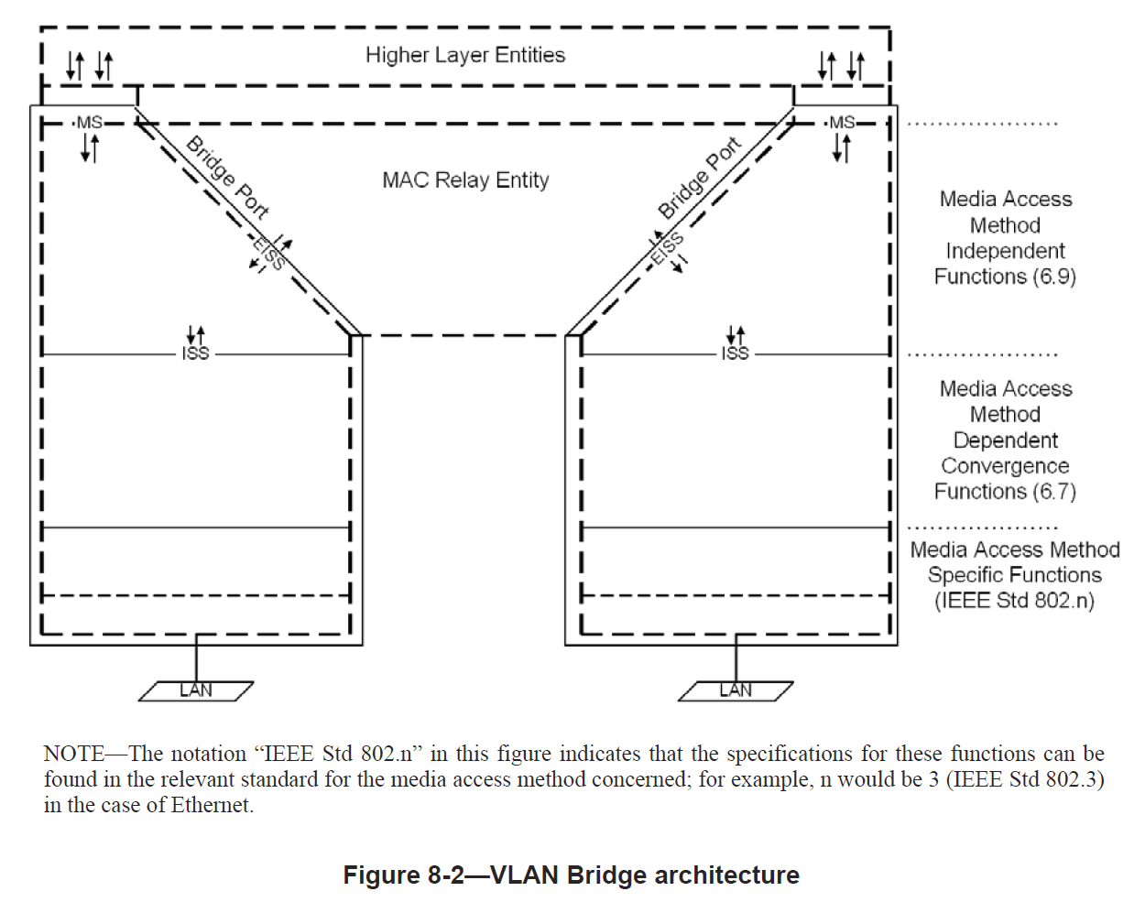

This is a proposed “redraw” of this figure, with “up is up, down is down”:

At a “leaf node” (including an 802.11 non-AP STA), we have this (derived from 802.1AC concepts):

When used within a larger system, the resulting bridged network is as shown:

The above is where we are today, with 802.1Q and 802.1AC concepts.

The following introduces 802.11 concepts (in particular, the AP) added by 802.11ak, to map the above to 802.11.

802.11 APs are defined to not require 802.1Q components for the bridging relay/forwarding functions. As such, 802.11 APs lack any switching capabilities, relying on the DS instead. And, the methods by which the DS accomplishes all the traffic relaying within the ESS is not specified, and does not (necessarily) couple properly with the methods used within 802.1Q bridged networks.

Which is part of why current (as specified) 802.11 APs cannot form part of an 802.1Q bridged network. (Lack of enough addresses carried in data frames is the other major reason.) Of course, proprietary extensions can be added that solve this – but we’re trying to focus on 802 Standard-based solutions in this discussion …

This mapping of the 802.1Q/802.1AC concepts to an 802.11 AP is easier to understand for an 802.11ak AP. For 11ak to add appropriate facilities to allow an 802.11AP to act as the lower layers of a 802.1Q Bridge Port, we get this, pretty straightforward mapping of the 802.1Q model:

However, by way of background, note that the current architecture for an 802.11 AP does not fit this structure so well. For reasons described in 11-15/540, the local LLC sub-layer and higher layers on an 802.11AP have access to/are accessed by the larger network by attaching beyond the Portal. That is, these entities are not part of the 802.11 domain, and 802.11 facilities (like the DS) are not used to manage this access.

NB: This implies that in most real-world, practical implementations, not only is the DS function distributed to have some component locally on each AP (see 11-14/562), but so is the Portal function similarly distributed.

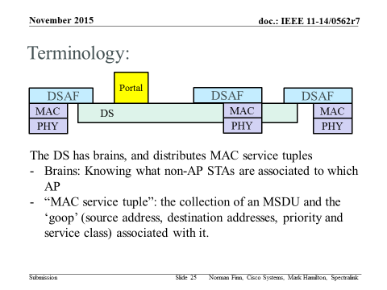
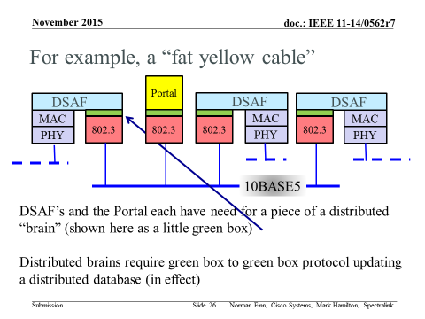

This has led to a simple view of the architecture of an 802.11AP, by ignoring the local LLC/Higher Layers local to the “AP device”:
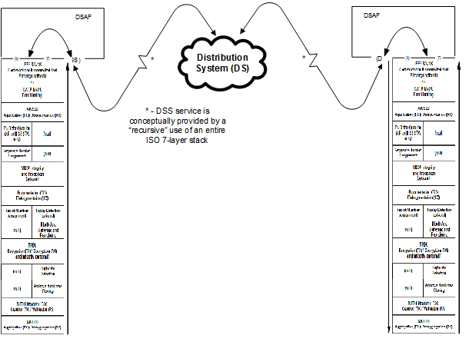
In 802.11ak, we desire to combine support for legacy non-AP STAs (which don’t support/provide enough addresses, for example) and the bridge-supporting concepts shown just above, into a “mixed-mode” AP. Thus, now trying to also show the Portal access to a local LLC (a possible/likely instantiation of “Some medium” in this figure would be the memory bus inside the “AP device”:

And, finally, for an 802.11 GLK non-AP STA, we get this:

