IEEE P802.11 Wireless LANs
Proposed Resolution to CID 601-607, 609-616, and 623 on TGaj D4.0 in LB226
Date: 2017-01-16
Author(s):
Name | Company | Address | Phone | Email
Shiwen HE | SEU |  |  | shiwenhe@seu.edu.cn
Haiming WANG | SEU |  |  | hmwang@seu.edu.cn

Abstract

This document proposes resolutions to CID 601-607, 609-616, and 623 on TGaj D4.0 in LB226.

CID | Clause | Page | Line | Type | Comment | Proposed Change | Remark
601 | 26.2.2 | 197 | 16 | T | Regarding CID 502, even though parameter DUPLICATE_MODULATION is defined, the transmission mechanism of CMMG duplicate PPDU is still missing.  Please refer 21.3.10.12 (Non-HT duplicate transmission) of IEEE 802.11REVmc.  Like sub-clause 21.3.10.12, the CMMG duplicate transmission shall be defined. Otherwise, current CMMG PHY does not support the CMMG duplicate PPDU. | As per comment.
Proposed resolution: Revised
Propose to add the corresponding CMMG duplicate transmission for SC mode and OFDM mode and insert the following subclauses and renumber related subclauses accordingly:
26.5.6.8 Duplication Transmission
When the TXVECTOR parameter DUPLICATE_MODULATION is present, the transmitted PPDU is a duplicate. The modulated data symbols are duplicated as described in 26.3.10 (Duplication Transmission on 1080 MHz channel).
26.6.5.3 Duplication
If the channel bandwidth is 1080 MHz, the modulated SIG symbols are duplicated as described in 26.3.10 (Duplication Transmission on 1080 MHz channel).
26.6.5.4 Symbol blocking, CSD and GI insertion
Please see 26.5.5.4.5 (Symbol blocking, CSD and GI insertion).
26.6.8.12 Duplication Transmission
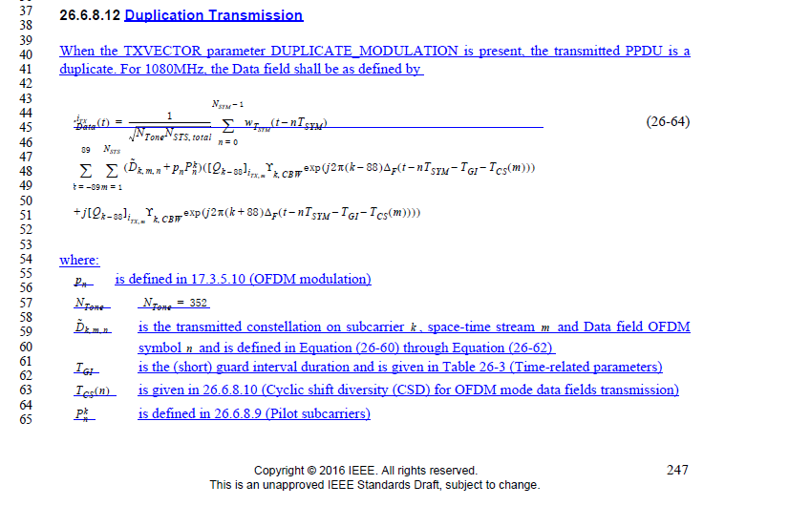
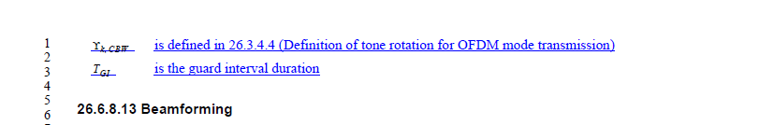

CID | Clause | Page | Line | Type | Comment | Proposed Change | Remark
602 | 9.2.3 | 23 | 14 | T | The CMMG control field is not properly added to the MAC frame format. The field is now called HT/CMMG Control, which is the field name. The field cannot be referred to anywhere in the document as only HT Control field or CMMG Control field - note for reference, the Duration/ID field which is always referred to by that full name. Also, the description added as a note is not actually a note. It is a definitive statement of fact, and not just a note. | Modify the caption of the existing figure 9-1 MAC frame format to be "MAC frame format of MPDUs contained in PPDUs that are not CMMG PPDUs" and ensure that the name of the field inside of this diagram remains as HT Control and has no mention of CMMG in it and a new diagram for the CMMG case with an obvious caption and with the field name "CMMG Control" without any reference to HT - make appropriate reference changes. Remove the "NOTE" designation of the NOTE and actually, once a separate diagram is created for CMMG, you can simply delete the note. You'll probably have to define what a CMMG PPDU is somewhere in the draft.
Proposed resolution: Revised
Propose to add a new Figure 9-1a that describes the MAC frame format for CMMG PDDUs.
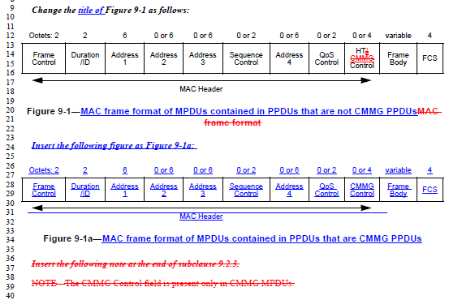

CID | Clause | Page | Line | Type | Comment | Proposed Change | Remark
603 | 9.2.4.1.8 | 23 | 39 | T | both what? | change "by a CMMG AP" to "by a CMMG AP to a CMMG STA"
Proposed resolution: Accepted.
Change the following paragraph as follows:
“The More Data subfield is set to 1 in individually addressed frames transmitted by a CMMG AP to a CMMG STA when both support the CMMG TXOP power save feature (as determined from their CMMG Capabilities elements) to indicate that at least one additional buffered BU is present for the STA, see 11.2.2.21 (CMMG TXOP power save).”

CID | Clause | Page | Line | Type | Comment | Proposed Change | Remark
604 | 9.2.4.1.10 | 23 | 51 | T | You have to modify the baseline text as well, otherwise it still applies to CMMG STA - does this apply to CDMG STA as well? | Change the existing paragraph for the description of the +HTC/Order bit to begin "For a non-CMMG STA" - also be careful to add "for a non-CMMG STA" and "for a CMMG STA" to both of the occurrences of "Otherwise, the Order subfield is set to 0." Clarify whether the changes apply to CDMG STA
Proposed resolution: Revised
In 11aj, a CDMG STA is a DMG STA, so this does not apply to CDMG STA as noted in 9.2.4.1.10 (+HTC/Order subfield) in the REVmc:
“NOTE—The +HTC/Order subfield is always set to 0 for frames transmitted by a DMG STA.”
Propose to revise the 9.2.4.1.10 as follows:
“9.2.4.1.10 +HTC/Order subfield
Insert the following paragraphs after the third paragraph of 9.2.4.1.10:
A CMMG STA uses the +HTC/Order subfield for two purposesThe +HTC/Order subfield is 1 bit in length. It is used for two purposes::
- It is set to 1 in a non-QoS Data frame transmitted by a non-QoS CMMG STA to indicate that the frame contains an MSDU, or fragment thereof, that is being transferred using the StrictlyOrdered service class.
- It is set to 1 in a QoS Data or Management frame transmitted with a value of HT_GF, HT_MF, or VHT for the FORMAT parameter of the TXVECTOR to indicate that the frame contains an HT Control field.
- It is set to 1 in a QoS Data or Management frame transmitted by a QoS CMMG STA to indicate that the frame contains a CMMG Control field.
Otherwise, the Order subfield is set to 0.”
CID | Clause | Page | Line | Type | Comment | Proposed Change | Remark
605 | 9.2.4.6a | 24 | 10 | T | You cannot have subfields in the CMMG Control field that have identical names to subfields in other fields in the standard unless these subfields are identical. This is like having ten children and naming them all Dave. | Change the names of the MRQ, MFB, MFSI CSI/Steering, RDG/More PPDU fields and any others that were copied from existing field names, UNLESS they have identical meaning, in which case, it is fine to keep the copied names, but then, instead of defining the meaning of those fields that do have the same meaning, you must instead insert a reference that says, for example, MRQ subfield is defined in 9.2.4.6.2
Proposed resolution: Revised
TGaj consulted WG editor on this issue. The result is as follows:
“Where a field has an individual entry in 9.4.1, there would not create something with the same name and a different definition.
All other field/subfield definitions are local to the element/field they are contained in. In this case, no issue re-using an existing name, because which type of enclosing structure is the relevant one should be obvious from context. It might be worthwhile repeating " ... of the xyz field", just to avoid ambiguity.”
According to the comment and suggestion from commenter and WG editor, we propose to still use the same subfield name with different meaning/definition. For a subfield that has the same name and meaning/definition, propose to remove the copied txt and insert a reference to the existing subfield. Meanwhile in order to avoid ambiguity, repeat " ... of the xyz field" when mention the subfield in the draft. The proposed changes are as follows:
P25, L64-65:
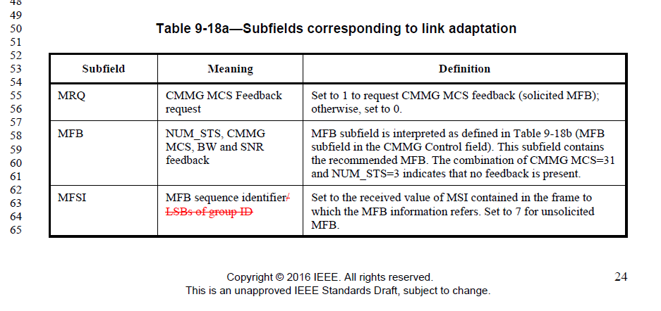
P. 26, L23-43:

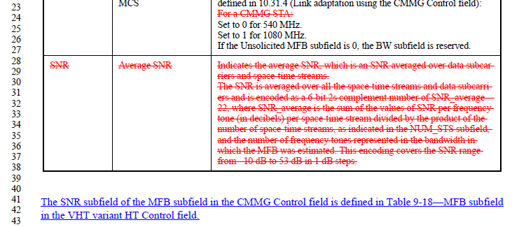

P. 27, L. 1-18:
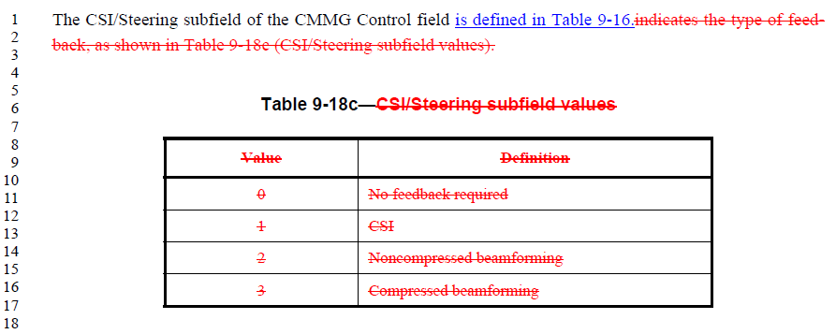
P. 27, L. 26-46:
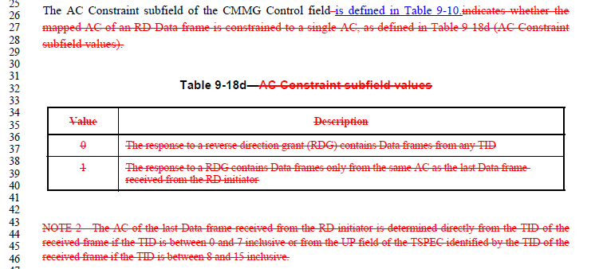
P. 27, L. 48-65:
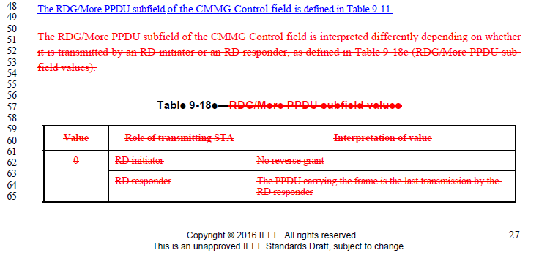
P. 28, L. 1-10:
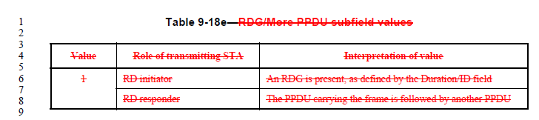

CID | Clause | Page | Line | Type | Comment | Proposed Change | Remark
606 | 9.2.4.6a | 27 | 44 | T | Your table 9-18e RDG/More PPDU is identical (with one minor difference) to an existing baseline table 9-11 RDG/More PPDU - wow! You cannot copy something completely and then have two references to the same name! | simply change the reference in the text paragraph from table 9-18e to table 9-11 and remove your table 9-18e, i.e. you should simply refer to the existing field with the same name, since the definitions are identical, unless the thing about Duration is needed, but I doubt it
Proposed resolution: Revised
Remove the copied definition in 11aj and refer to the existing subfield in IEEE 802.11 spec as follows:
“The RDG/More PPDU subfield of the CMMG Control field is defined in Table 9-11.
The RDG/More PPDU subfield of the CMMG Control field is interpreted differently depending on whether it is transmitted by an RD initiator or an RD responder, as defined in Table9-18e (RDG/More PPDU subfield values)
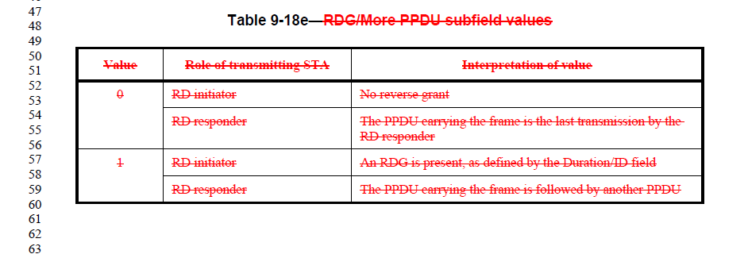”

CID | Clause | Page | Line | Type | Comment | Proposed Change | Remark
607 | 9.4.1.61 | 33 | 42 | T | Again, I think that you should be pointing to the existing subfields in the baseline that have the same definitions and names. | As stated in the comment. Someone should make an official enquery to the 802.11 editor in chief as to whether it is ok to reuse names like this.
Proposed resolution: Rejected
TGaj consulted WG editor on this issue. The result is as follows:
“Where a field has an individual entry in 9.4.1, there would not create something with the same name and a different definition.
All other field/subfield definitions are local to the element/field they are contained in. In this case, no issue reusing an existing name, because which type of enclosing structure is the relevant one should be obvious from context. It might be worthwhile repeating " ... of the xyz field", just to avoid ambiguity.”
Also in IEEE 802.11 2016，there are some subfields shared the same names for different fields with different field names. For examples, there are some same subfield names in Figure 9-11—MAI subfield and Figure 9-13—HT Control Middle subfield of the VHT variant HT Control field, in Figure 9-332—HT Capability Information field and Figure 9-559—VHT Capabilities Information field. Therefore, some subfields still share the same field names with the other subfields which is defined for different fields.
According to the comment and suggestion from commenter and WG editor, we propose to still use same subfield name with different meaning/definition. For a subfield that has the same name and meaning/definition, we propose to remove the copied txt and insert a reference to the existing subfield. Meanwhile in order to avoid ambiguity, repeat " ... of the xyz field" when mention the subfield in the draft

CID | Clause | Page | Line | Type | Comment | Proposed Change | Remark
609 | 10.34a.1 | 108 | 27 | T | Need to say NDP here. | change "is a CMMG PPDU" to "is a CMMG NDP"
Proposed resolution: Accepted
Change the sentence at P.107, L. 28 as follows:
“An RXVECTOR LENGTH parameter equal to 0 indicates that the PPDU is a CMMG PPDUNDP.”

CID | Clause | Page | Line | Type | Comment | Proposed Change | Remark
610 | 10.34a.2 | 109 | 17 | E | Extra text | change "all shall be" to "shall be"
Proposed resolution: Accepted
Change the sentence at P. 109, L.18 as follows:
“— STBC all shall be set to 0.”
CID | Clause | Page | Line | Type | Comment | Proposed Change | Remark
611 | 10.34a.2 | 109 | 28 | T | There are a couple of different descriptions for identifying the destination and source of a CMMG NDP - the first two are confusingly written and the next two are a bit better, but still have some problems and in any case, there should only be one description | I would think that the correct fix is to remove the destination and source determinations found at P109L26 through P109L32 and then fix the ones at P109L36 through P109L63 - the fixing needed includes: - 1) the destination/source determination is only for the first NDP so need more detail of how to determine the non-first NDP source/destination values 2) change "within CMMG NDP announcement" to "within the CMMG NDP announcement" 3) change "by examining the CMMG NDP announcement" to "by examining the CMMG NPD announcement within the TXOP containing this NDP" - but even this change is problematic, because it might be possible to miss an NDP and then not know if this is the same TXOP as that CMMG NDP announcement or not...
Proposed resolution: Revised
The following sentences are proposed to be removed from IEEE802.11aj draft 4.0 (P.109, L27-46).
“The destination of a CMMG NDP in the NDP sequence is equal to the RA of the immediately preceding MPDU within CMMG NDP announcement.
The source of a CMMG NDP in the NDP sequence is equal to the TA of the immediately preceding MPDU within CMMG NDP announcement.”
The following description in IEEE 802.11aj draft 4.0 (P109, L34-63) is similar with the descriptions in IEEE 802.11-2016 (P. 1487,10.34.3-4), so only a few description need to change.
“10.34a.3 Determination of CMMG NDP destination
The destination of an CMMG NDP is determined at the NDP receiver by examining the CMMG NDP announcement as follows:
- The destination of the first CMMG NDP in the NDP sequence is equal to the RA of any MPDU within the CMMG NDP announcement.
- If Calibration Position subfield is equal to 1 in the CMMG NDP announcement at the NDP receiver, the destination of the second CMMG NDP is equal to the TA of that frame. Otherwise, the destination of the second and any subsequent CMMG NDPs is equal to the destination of the previous CMMG NDP.
10.34a.4 Determination of CMMG NDP source
The source of a CMMG NDP is determined at the NDP receiver by examining the NDP sequences’s starting PPDU as follows:
- If any MPDU within the CMMG NDP announcement contains two or more addresses, the source of the first CMMG NDP is equal to the TA of that frame.
- Otherwise (i.e., the CMMG NDP announcement contains one address), the source of the first CMMG NDP is equal to the RA of the MPDU to which the CMMG NDP announcement is a response.
- If the Calibration Position subfield is equal to 1 in an MPDU in the CMMG NDP announcement, the source of the second CMMG NDP is equal to the RA of that MPDU. Otherwise, the source of the second and any subsequent CMMG NDPs is equal to the source of the previous NDP.”

CID | Clause | Page | Line | Type | Comment | Proposed Change | Remark
613 | 10.36.3 | 111 | 8 | T | Figure 10-55a example of access periods within a BI for CMMG - what is the vertical dimension? Is it frequency? Is it spatial separation of some sort? | Add some text to describe the details indicated in the diagram.
Proposed resolution: Revised
The corresponding description in IEEE 802.11aj draft (P100, L43-51) are rewritten as follows:
“For a 1080 MHz CMMG BSS, Tthe DTI for a CMMG BSS, alsocan comprises contention-based access periods (CBAPs) and scheduled service periods (SPs), and the bandwidth of the allocation in DTI can be 540 MHz and 1080 MHz. Figure 10-55a (Example of access periods within a BI for CMMG) illustrates an example of access periods within a beacon interval for a 1080 MHz CMMG BSS, comprising a BHI, that may contains BTI, A-BFT, and ATI, and two 540 MHz CBAPs and SPs within the DTI and one 1080 MHz CBAPs and SPs within the DTI. Any combination in the number and order of SPs and CBAPs can be present in the DTI. For a CMMG BSS, the BHI shall be sent in primary 540 MHz channel, and can be sent in 1080 MHz channel with duplicate format.”

CID | Clause | Page | Line | Type | Comment | Proposed Change | Remark
614 | 10.36.6.6.2 | 114 | 35 | T | Missing/wrong articles/clearer wording needed | Change "if any of its NAV timers that corresponding to this channel is not equal to zero." to "if any of its NAV timers corresponding to this channel are not equal to zero.
Proposed resolution: Accepted
The corresponding description is revised as follows in IEEE 802.11aj draft 4.0 (P114, L34-38):
“A CMMG STA shall not issue an RTS frame to establish a CMMG protected period on a channel if any of its NAV timers that corresponding to this channel isare not equal to zero. A CMMG STA can issue an RTS frame to establish a CMMG protected period on a channel that the bandwidth of the channel is less than the SP allocated channel bandwidth and all of its NAV timers that corresponding to this channel is 0.”

CID | Clause | Page | Line | Type | Comment | Proposed Change | Remark
615 | 10.36.6.6.2 | 114 | 47 | T | Missing/wrong articles/clearer wording needed | Change "shall not transmit the RTS has a bandwidth that larger than the allocated bandwidth" to "shall not transmit an RTS that has a bandwidth that is larger than the allocated bandwidth"
Proposed resolution: Revised
The corresponding description is revised as follows in IEEE 802.11aj draft 4.0 (P114, L43-49):
“A CMMG STA that transmits an RTS to establish a CMMG protected period during an SP in which it is a source CMMG STA shall not transmit the RTS outside of the SP and the value of the Duration field of the RTS shall not exceed the duration of the portion of the SP that remains following the RTS transmission. And a CMMG STA that transmits an RTS to establish a CMMG protected period during an SP in which it is a source CMMG STA shall not transmit thean RTS frame that has a bandwidth that is larger than the allocated bandwidth.”

CID | Clause | Page | Line | Type | Comment | Proposed Change | Remark
616 | 10.36.6.6.2 | 114 | 51 | T | Missing/wrong articles/clearer wording needed | Change "a CMMG STA that receives a valid RTS with the RA equal to the recipient CMMG STA MAC address and the TA corresponding to" to "a CMMG STA that receives a valid RTS addressed to itself and a TA value corresponding to"
Proposed resolution: Revised
The corresponding description is revised as follows in IEEE 802.11aj draft 4.0 (P114, L52-57).
During an SP in which it is the destination CMMG STA, a CMMG STA that receives a valid RTS framewith the RA equal to the recipient CMMG STA MAC address andaddressed to itself and the TA corresponding to the source CMMG STA of the SP shall not respond with a CTS frame on the channel if at the start of the reception of the RTS the recipient CMMG STA has a nonzero value in at least one of its NAV timers corresponding to this channel.

CID | Clause | Page | Line | Type | Comment | Proposed Change | Remark
623 | 12.2.2 | 163 | 11 | T | Missing/wrong articles/clearer wording needed | Change "the same with" to "the same as"
Proposed resolution: Accepted
The corresponding description is revised as follows in IEEE 802.11aj draft 4.0 (P114, L52-57):
“The RSN operations in a CMMG BSS shall be the same withas the RSN operations in a DMG BSS.”

