IEEE P802.11
Wireless LANs
LB218 Hamilton proposed comment resolutions
Date: 2016-11-10
Author(s):
Name | Company | Address | Phone | email
Mark Hamilton | Ruckus/Brocade | 350 W. Java Dr  Sunnyvale, CA | +1 303 818 8472 | mark.hamilton2152@gmail.com
Abstract
This document contains proposed resolutions for some TGak LB218 CIDs, assigned to Mark Hamilton.

R0 – Initial document.
R1 – Per face-to-face discussions, changed “path selection function” to “switching function” in Figure 5-10. CID 1232 minor rewording. CIDs 1287 and 1289 proposed resolutions added.
R2 – Minor changes, after TGak review.

CID 1063
4.09 | 9 | 3.2 | Due to the primary usage of TGak (for bridging connectivity), there is no value in "fast transitions" from one BSS to another, nor value in "hidding" the topology change of a BSS transition from the immediately higher layers (802.1Q). As such, the concepts of ESS and Fast Transition are not relevant to GLK devices | Delete GLK ESS concept from the specification. Since non-GLK non-AP STAs can only transition between BSSs that are or support non-GLK connections, the legacy concept of ESS should be clarified to include only BSSs (and STAs) that support (and are doing) non-GLK operation, thus the mixed-mode AP is part of a legacy ESS but the associated GLK STAs are not part of the ESS. Text around and including Figure 4-13c will need to be modified to sort this out. The Reassociation service description should be clarified for GLK, that it is supported, but the wording about "moving an association" is not really applicable, but instead, the association is torn down from the orignal and established at the new. Disassociation should be similarly aligned. The concept of "mobility transparency" to "layers above IEEE 802.11" (such as clause 4) should be clarified that mobility transparency with GLK in a bridged LAN is only above the bridges (and mobility is not transparent to the bridges themselves).

Discussion:

While Fast Transition may not be necessary or as useful for GLK links, it is still helpful for implementations to be allowed to use FT security methods for consistency internal to the implementation between GLK and non-GLK links. Thus propose to modify how Fast Transition is defined, to allow it to be orthogonal to ESS (in the GLK case, at least), so it can still be used with GLK.

Otherwise, agree with the intent and direction of 11-16/251r10 to remove the ESS concept from GLK’s infrastructure architectural model.

Proposed Resolution:

In 3.2, delete the term and definition for “general link (GLK) extended service set (ESS)”.

Modify the third paragraph of 4.3.23.4.3 as shown:
BSSs that support general links can be components of an extended form of network by using the general links within an IEEE Std 802.1Q bridged network, for example as shown in the middle and left of Figure 4-13c (Example of ESS with GLK BSSs). In such a bridged network, the concept of the DS in a non-GLK ESS can effectively be replaced by the other components of the IEEE Std 802.1Q network. However, such a GLK topology is more general than the non-GLK infrastructure model. For example, as shown in Figure 4-13c (Example of ESS with GLK BSSs), a network extended with GLK might consist of GLK STAs connected by IEEE Std 802.1Q bridged networks connected in some cases to an Internal Sublayer Service SAP provided by a GLK AP and in other cases provided by a GLK non-AP STA.

CID 1066
18.21 | 21 | 5.1.5.7 | Data flow SAPs should have clear "up" and "down" for indication and request | Fix Figure 5-8 to show the (MAC) SAP as at the top of the GLK CF box. Also, show the ISS, and it might be good to indicate that the layer above is assumed to be (at least optionally, if not mandatory?) a Bridge.

Discussion:

Agree with the intent of this comment. However, to fix Figure 5-8 and have it fit into the larger architecture envisioned by 802.1AC, will require changes to Figures 5-1 and 5-2, also.

Proposed Resolution:

Modify the text for subclause 5.1.5.7 as shown:

In a GLK STA the MAC data plane architecture includes provision of the MAC service interface with the inclusion of a station vector to enable providing service to an 802.1AC GLK convergence function in its role-specific behavior block, as shown in Figure 5-8 (Role-specific behavior block for GLK STA). This block performs destination address filtering, as described in 10.2.8 (MAC data service), and provides access to the GLK convergence function and ultimately to the bridge ports.

Replace Figure 5-8 with:
Figure 5-8—Role-specific behavior block for GLK STA

Add editing instructions as follows:

Replace the upper portion of Figure 5-1 with:
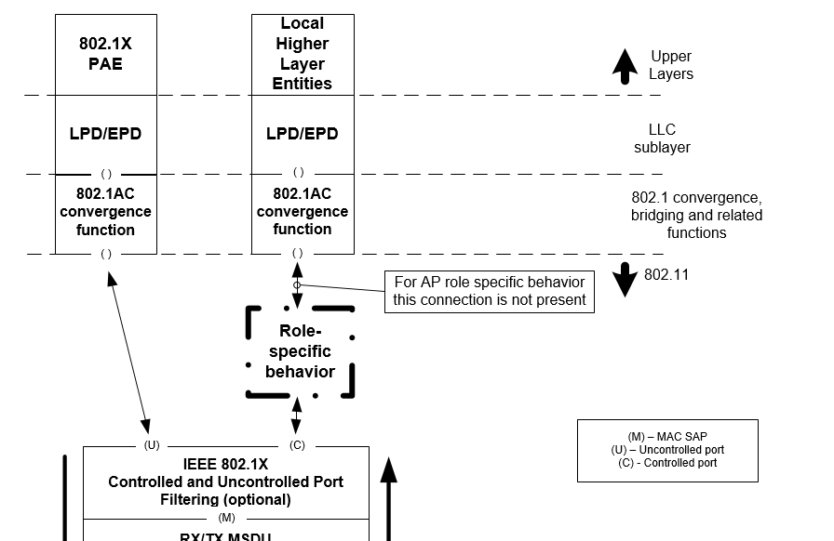

CID 1073
18.25 | 25 | 5.1 | Clause 5.1 needs subclauses for GLK AP, GLK Mesh STA and GLK Mesh Gate. | Add clauses and figures for GLK AP, GLK Mesh STA and GLK Mesh Gate

Discussion:

An AP with only general links (GLK Required) has the same general architectural structure as a GLK non-AP STA. Thus, Figure 5-8, and the existing 5.1.5.7 text are sufficient for such a GLK AP.

However, it would be helpful to have text and a figure to explain a “mixed-mode” GLK AP.

The only type of mesh STA with GLK support, is, by definition, the equivalent of a mesh gate, with the DS and portal replaced by connections to bridge ports in a similar concept to a GLK AP. Thus, the GLK mesh gate has the same general architectural structure as a non-GLK mesh STA, so 5.1.5.4 in REVmc D8.0 is sufficient, with slight wording fixes.

Proposed Resolution:

Add editing instructions as follows:

Insert the following new subclauses after 5.1.5.7:

5.1.5.8 GLK AP role
A GLK AP that supports only general links (dot11GLKRequired is true) has the same general architectural structure as described in 5.1.5.7 (GLK STA role) for a general GLK STA.

A GLK AP that supports both general links and non-GLK links must provide access between the bridge ports and general links, and between the DS and non-GLK links. The DSAF behavior of such an AP is extended by adding a switching function to direct received MSDUs to either the DS or toward a bridge port, as appropriate, as shown in Figure 5-9.

Figure 5-9—Role specific behavior block for a mixed-mode GLK AP

5.1.5.9 GLK mesh STA role
The only type of mesh STA that has explicit support for GLK is the GLK mesh STA, which is the equivalent of a mesh gate, except it is attached to a bridge rather than a DS. Other mesh STA types implicitly support GLK functions and can support general links with the role specific structure shown in 5.1.5.4.

The MAC data plane architecture of a GLK mesh STA, like that for a non-GLK mesh STA, is completed by replacing the role-specific behavior block with that shown in Figure 5-10 (Role-specific behavior block for a GLK mesh STA). The function of this block in a mesh STA is described in Figure 10.35 (Mesh forwarding framework). In a GLK mesh STA, this block provides access to bridge ports, through provision of the station vector parameter, rather than access to only the local DA address like a non-GLK mesh STA.

This role is not applicable when transparent FST is used, and does not apply to Figure 5-2 (MAC data plane architecture (transparent FST)).

Figure 5-10—Role specific behavior block for a GLK mesh STA

CID 1232
55.07 | 7 | 10.2.8 | What is a "filtered" DA field? | Do not insert the word "filtered" here

Discussion:

Agree. Also, remove ambiguity of “or” and “and” in the first half of this sentence, by restructuring the sentence.

Proposed Resolution:

Replace
“When the Address 1 field or a filtered DA field contains a group address and the receiver is a non-GLK STA, address filtering is performed by comparing …”
with
“In the case of a non-GLK STA receiver, when the Address 1 field or DA field contains a group address, address filtering is performed by comparing …”.

CID 1287
62.08 | 8 | 11.2.2.1 | What happens for BUs destined to all STAs, both non-GLK and GLK (e.g. a broadcast)? | Add wording to clarify that the BU is delivered both after the next DTIM (for non-GLK STAs) and in individual MPDUs (for GLK STAs)

Discussion:

Reject the idea that the BU is delivered both ways. Instead add text to clarify that the two “worlds” are kept distinct and isolated.

Proposed Resolution:

Change the text as follows:

If any non-GLK STA in an AP’s BSS is in PS mode, the AP shall buffer all non-GCR-SP group addressed BUs that arrived via the DS and deliver them to all non-GLK STAs immediately following the next Beacon frame containing a DTIM transmission. If any GLK STA in a GLK AP’s BSS is in PS mode, the AP shall not include any such STAs as a SYNRA destination, and shall buffer all group addressed BUs that arrived from the attached bridge and are destined to such STAs, delivering them with individually addressed MPDUs using power save delivery methods.

NOTE -- The group addressed BUs for GLK STAs and for non-GLK STAs are not repeated by the AP to the other type of STAs. Network entities external to the AP, such as the bridged network, may repeat these MSDUs to both types of STAs by other means, outside the scope of this standard.

CID 1289
62.21 | 21 | 11.2.2.6 | StrictlyOrdered is obsolescent and not supported for HT anyway | Don't support StrictlyOrdered for GLK

Discussion:

See proposed resolution.

Proposed Resolution:

Reject. StrictlyOrdered service class is obsolete for all of 802.11 already, per 5.1.3.

