IEEE P802.11
Wireless LANs
Proposed resolutions to CID 516-519 in LB223
Date: 2016-11-09
Author(s):
Name | Company | Address | Phone | Email
Dejian Li | Huawei |  |  | dejian.li@huawei.com

Abstract

This document proposes resolutions to CID 516-519 for TGaj D3.0.
Revision History
R0: Initial version.

Technical comments:
CID | Clause | Page | Line | Type | Comment | Proposed Change
516 | 25.5.3.1.2 | 176 | 61 | T | In 802.11 REVmc, a new 7/8 rate 64-QAM is added. Consider if the same case exists in 11aj. | Consider to add a 7/8 rate 64-QAM, as the same way of 802.11 REVmc.
Discussion:
In 802.11REVmc D8.0, there are 3 additional new MCSs in Table 20-19 compared to 802.11aj D3.0. The implementation of 2.16 GHz is easily be reused by 1.08 GHz PHY, so these 3 new MCSs should be accepted in 11aj. However, the MCS index has not been resolved yet for the new MCSs. So, it is better to accept these new MCSs when all issues are solved.
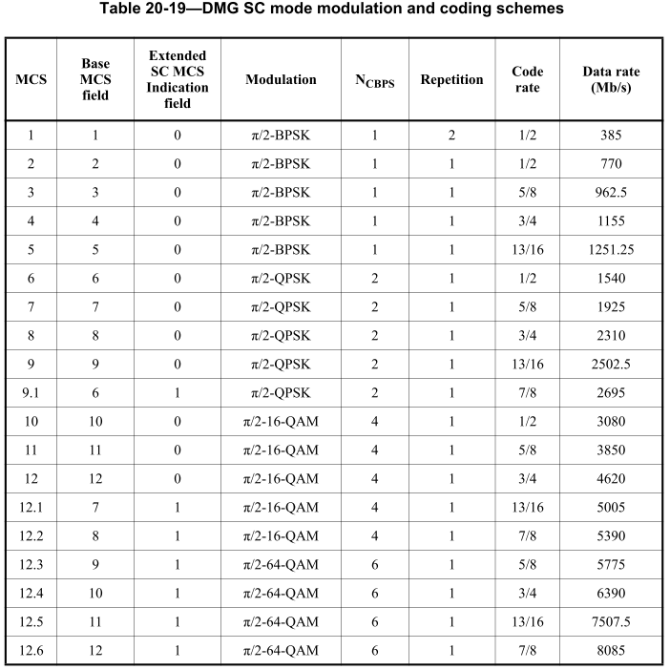
Proposed resolution: Reject

CID | Clause | Page | Line | Type | Comment | Proposed Change
517 | 25.3.6.2 | 169 | 19 | T | The new defined "single frequency sequence (SFS)" is stated that it is used for I/Q imbalance estimation. It is not clear how this SFS realizes I/Q imbalance estimation. | More description on how to use this new SFS should be provided. Also, the relationship between the SFS and CE fields should described.
Discussion:
Do as the suggested remedy.
Proposed resolution: Revised
Change the first paragragh of 25.3.6.1 as follows:
“The preamble is the part of the PPDU that is used for packet detection, AGC, frequency offset estimation, synchronization, I/Q imbalance estimation, indication of modulation (SC) and channel estimation. The SFS field in the preamble enables the receiver to perform estimation and compensation for the packet in a time domain and the frequency domain according to the STF field. The format of the preamble consists of a Short Training field followed by a Channel Estimation field. Figure 25-2 (SC preambles) illustrates the SC packet preamble.”
Change the first paragragh of 25.3.6.3 as follows:
“The Channel Estimation field is used for channel estimation, as well as indication which modulation is going to be used for the packet, and enables the receiver to suppress nonlinear impact generated in a power amplification process according to the CE field. The Channel Estimation field is composed of a concatenation of two sequences Gu512(n) and Gv512(n) where the last 128 samples of Gu512(n) are equal to the last 128 samples used in the Short Training field. They are followed by a 128 samples sequence Gv128(n) equal to the first 128 samples of both Gu512(n) and Gv512(n). ”

CID | Clause | Page | Line | Type | Comment | Proposed Change
518 | 25.3.6.3 | 169 | 47 | T | The structure of CE is the same to the DMG CE? If the OFDM mode is obselete, is it still necessary for the CE to indicate the modulation of packet? | Clarify whether the CDMG CE is the same with DMG CE. Re-consider the modulation inidiation function of CDMG CE.
Discussion:
It is a similar case with CID 516. Some issues will occur if the OFDM PHY mode is obsolete. However, the text changes have not been made to the 802.11REVmc D8.0 yet. So it is better to make the same changes after the modification is completed in 802.11REVmc.
Proposed resolution: Reject

CID | Clause | Page | Line | Type | Comment | Proposed Change
519 | 10.37a.2.1 | 126 | 33 | T | It is not clear how the AP/PCP operating on a 1.08 GHz channel that is NOT involved in the synchronization pair of joins the AP/PCP cluster on the 2.16 GHz channel. | Specify all the actions that AP/PCP operating on a 1.08 GHz channel that is NOT involved in the synchronization pair joining the AP/PCP cluster on the 2.16 GHz channel.
Discussion:
Do as the suggested remedy. Furthermore, some text needs to be refined, such as add the operating channel 1.08 GHz or 2.16 GHz for the STAs or some allocations, in order to describe the STAs more clearly. Also, the first paragraph in 9.4.2.179 (Cluster Probe element) contains many descriptions which need to be moved to the subclause that this element is used.
Proposed resolution: Revised
Change the paragraphs in 10.37a.2.1 as follows:
“In case when a decentralized clustering enabled AP or PCP operating on a 1.08 GHz channel still experiences poor channel conditions after performing all the actions in an attempt to mitigate any interference, it may broadcast one or more Cluster Probe elements using the DMG Beacon frame or Probe Request frame to detect the presence of a cluster actively on the 2.16 GHz common channel during its NPs, SPs or CBAPs. In addition to transmitting Cluster Probe elements included in the DMG Beacon frames on the 2.16 GHz common channel during NPs, the AP or PCP operating on a 1.08 GHz channel may reserve multiple SPs during DTI and switch to the 2.16 GHz channel during the SPs to transmit Cluster Probe elements included in Probe Request frames on the 2.16 GHz common channel.”

“If the decentralized clustering enabled AP or PCP on the 1.08 GHz channel does not receive any Probe Response frame from an S-AP or S-PCP during the reserved SPs on the 2.16 GHz channel in the whole DTI, it may reschedule multiple SPs whose positions are adjusted stochastically in the following DTI.”
Change the first paragraph in 9.4.2.179 (Cluster Probe element) as follows:
“The Cluster Probe element is used to probe the presence of a CDMG AP or PCP cluster operating on the common 2.16 GHz channel by the CDMG AP or PCP operating on a 1.08 GHz channel. This element can be included in DMG Beacon frame, Announce frame and the Probe Request frame. The Cluster Probe element is shown in Figure 9-587l (Cluster Probe element format).”

Change the paragraphs in 10.37a.2.1 as follows:
“The S-AP or S-PCP that is operating on the 2.16 GHz common channel and receives a Cluster Probe ele-ment shall respond with one or more Probe Response frames including an Extended Cluster Report element in each SP scheduled according to the Cluster Probe element, in order to indicate its presence by including the cluster synchronization and control information of the S-AP or S-PCP in the Extended Cluster Report element. The Cluster Probe element contains timing information for the CDMG S-AP or S-PCP operating on the 2.16 GHz channel to transmit Probe Response frame for the Cluster Probe element. This element defines a sequence of SPs that are scheduled in DTI or next NP by both the cluster probe requesting AP or PCP and responder AP or PCP for receiving and transmitting the response frames. The multiple SPs are reserved corresponding to the SPs during which the Cluster Probe elements are transmitted.
After receiving a Probe Response frame from an S-AP or S-PCP operating on the 2.16 GHz common channel, during at least one of the reserved SPs in DTI, the decentralized clustering enabled AP or PCP operating on 1.08 GHz channel may switch to the 2.16 GHz common channel by using the cluster synchronization and control information in the Extended Cluster Report element in the Probe Response frame of the S-AP or S-PCP operating on the 2.16 GHz channel, in an attempt to discover an empty Beacon SP and transmit DMG Beacon frames during the empty Beacon SP if there exists an empty Beacon SP, to become a member AP or member PCP of this cluster following the procedures described in 10.37.2.1 (Decentralized AP or PCP cluster formation).”
“Upon receiving a Cluster Report element included in the Announce frame from a non-AP and non-PCP STA operating on the 1.08 GHz channel with the Cluster Report field set to 1 and the Cluster Channel Number field set to 0, a decentralized cluster enabled AP or PCP operating on a 1.08 GHz channel may reserve multiple SPs on the 1.08 GHz channel to identify whether there is an empty Beacon SP. The AP or PCP may reschedule SPs and CBAPs in its beacon interval, move the BTI if the clustering enabled AP or PCP is an S-AP or S-PCP in a decentralized AP or PCP cluster, or change the cluster time offset if the clustering enabled AP or PCP is a member AP or member PCP, or perform other actions, in an attempt to mitigate any interference from the transmissions as indicated in the received Cluster Report element. The AP or PCP may also create SPs in its beacon interval with the source and destination AID set to 255 to prevent transmissions during specific periods in the beacon interval. In addition, the AP or PCP operating on a 1.08 GHz channel can reserve multiple SPs in DTI based on the clustering synchronization and control information included in the Cluster Report element, monitoring the Beacon SPs on the 2.16 GHz channel, to identify whether there is an empty Beacon SP of the decentralized cluster operating on the channel indicated by the Cluster Channel Number field.”
Insert the following paragraph before the last paragraph of page 124
“The AP or PCP operating on the 1.08 GHz channel should determine its Beacon Interval on the 2.16 GHz channel equal to the Beacon Interval of the S-AP or S-PCP on the 2.16 GHz channel according to the cluster synchronization and control information of the S-AP or S-PCP. The AP or PCP operating on the 1.08 GHz channel should continue transmitting DMG Beacon frames on the 2.16 GHz channel during the Beacon SP according to the Beacon Interval on the 2.16 GHz channel. The AP or PCP operating on the 1.08 GHz channel shall switch back to the 1.08 GHz channel to transmit DMG Beacon frames during BTI on the 1.08 GHz channel according to the Beacon Interval on the 2.16 GHz channel.”

