IEEE P802.11
Wireless LANs
Commont Resolution and Text Change Proposal of 26.3.10.8 HE-SIG-B
Date: 2016-11-07
Author(s):
Name | Affiliation | Address | Phone | email
Yujin Noh | Newracom | 9008 Research Dr.  Irvine, CA 92618 |  | yujin.noh@newracom.com
Young Hoon Kwon |  |  |  | younghoon.kwon@newracom.com
Yongho Seok |  |  |  | yongho.seok@newracom.com
Reza Hedayat |  |  |  | reza.hedayat@newracom.com
Minho Cheong |  |  |  | minho.cheong@newracom.com
Abstract
This submission shows
- Resolution for a comment received from TGax comment collection (TGax Draft D0.1)

The proposed changes are based on 11ax D0.5.

Revisions:
- Rev 0: Initial version of the document.

Interpretation of a Motion to Adopt

A motion to approve this submission means that the editing instructions and any changed or added material are actioned in the TGax Draft. This introduction is not part of the adopted material.

Editing instructions formatted like this are intended to be copied into the TGax Draft (i.e. they are instructions to the 802.11 editor on how to merge the text with the baseline documents).

TGax Editor: Editing instructions preceded by “TGax Editor” are instructions to the TGax editor to modify existing material in the TGax draft. As a result of adopting the changes, the TGax editor will execute the instructions rather than copy them to the TGax Draft.

CID | P.L | Comment | Proposed Change | Resolution
2867 | 111.48 | "RU assignment" and "RU arrangement" are mixed in this section. | It may be better to use "RU assignment" through this section | Accepted  TGax Editor: make changes according to this document 11-16-1375-00-00ax CR-for-CID2867-on-HE-SIG-B.

Changes to Section 26.3.10.8.1

To TGax editor: P230L15 replace the current text with the proposed changes below.

------------- Begin Text Changes ---------------
The Common Block field of a HE-SIG-B content channel(#2020) contains information regarding the resource unit allocation such as the RU assignment(#2867) in frequency domain, the RUs allocated for MU-MIMO and the number of users in MU-MIMO allocations. The Common Block field is described in 26.3.10.8.4 (HE-SIG-B common content).

------------- End Text Changes ---------------

Changes to Section 26.3.10.8.4

To TGax editor: P234L24 replace the current text with the proposed changes below.
.
------------- Begin Text Changes ---------------

- Common Block field(#2024)
Subfield | Number of bits | Description
RU Allocation | N x 8 | Indicates the RU assignment in the frequency domain. It also indicates the number of user fields in each RU. For RUs of size greater than or equal to 106-tones that support MU-MIMO, it indicates the number of users multiplexed using MU-MIMO.  N = 1 for a 20 MHz and a 40 MHz HE MU PPDU  N = 2 for an 80 MHz HE MU PPDU  N = 4 for a 160 MHz or 80+80 MHz HE MU PPDU
Center 26-tone RU | 1 | This field is present only for full bandwidth 80 MHz, 160 MHz and 80+80 MHz.  For full bandwidth 80 MHz:  Set to 1 to indicate that the center 26-tone RU is allocated in the Common Block fields of both HE-SIG-B content channels with the same value.  Set to 0, otherwise.  For full bandwidth 160 MHz or 80+80 MHz:  Set to 1 to indicate that the center 26-tone RU is allocated for one individual 80 MHz in the Common Block fields of both HE-SIG-B content channels.  Set to 0, otherwise.
CRC | 4 | See 26.3.10.7.3 (CRC computation)
Tail | 6 | Used to terminate the trellis of the convolutional decoder. Set to 0
NOTE—Integer fields are transmitted in unsigned binary format, LSB first, where the LSB is in the lowest numbered bit position.(#1010)

An RU Allocation subfield in the Common Block field of HE-SIG-B consists of 8 bits that indicates the following for a 20 MHz PPDU BW:
- The RU assignment in the frequency domain: indexes the size of the RUs and their placement in the frequency domain.
- Number of user fields in each RU in the HE-SIG-B content channel: the number of users multiplexed in the RUs indicated by the arrangement; for RUs of size greater than or equal to 106 tones that support MU-MIMO, it indicates the number of users multiplexed using MU-MIMO.
The mapping of the 8-bit RU Allocation subfield to the RU assignment and the number of user fields per RU is defined in the Table 26-21 (RU allocation signaling: arrangement and number of MU-MIMO allocations(#2032)). In the table, the number of entries column refers to the number of 8-bit indices that refer to the same RU assignment in the frequency domain but differ in the number of users fields per RU. The RU assignment and the number of user fields per RU together indicate the number of user-fields in the User specific field of HE-SIG-B. Signaling for the center 26-tone RU in BW  80 MHz follows the RU Allocation subfields. For full BW 80 MHz, 1 bit is added to indicate if center 26-tone RU is allocated in the Common Block fields of both HE-SIG-B content channels with same value. For full BW 160 MHz, 1 bit is added to indicate if center 26-tone RU is allocated for one individual 80 MHz in common block fields of both HE-SIG-B content channels(#1001).

------------- End Text Changes ---------------

Changes to Section 26.3.10.8.5
To TGax editor: P237L52 replace the current text with the proposed changes below.
.
------------- Begin Text Changes ---------------
- HE-SIG-B per-user content
The user-specific field consists of multiple user fields. The user fields follow the common block field of HE-SIG-B. The RU allocation subfield in the Common block field and the position of the user field in the HE-SIG-B user specific field together identify the RU used to transmit a STA’s data. Multiple RU allocations addressed to a single STA shall not be allowed in 802.11ax. Therefore, the signaling that enables STAs to decode its data is carried in only one userfield.(#1010) An example for the mapping of the 8-bit RU allocation subfield and the position of the userfield to an STA’s data is illustrated in Figure 26-25 (Illustration for the mapping of the 8-bit RU allocation subfield and the position of the user-field to the STA's assignment(PHY Motion #172)). The RU allocation signaling indicates an arrangement of 106-tone RU followed by five 26-tone RUs and that the 106-tone RU contains three user-fields, i.e., the 106-tone RU supports multiplexing of three users using MU-MIMO. The eight user fields in the HE-SIG-B userspecific field thus map to the 6 RUs, with the first three user fields indicating MU-MIMO allocations in the first 106-tone RU followed by user fields corresponding to the each of the five 26-tone RUs.

------------- End Text Changes ---------------

To TGax editor: P238L19 replace the current text with the proposed changes below.
------------- Begin Text Changes ---------------
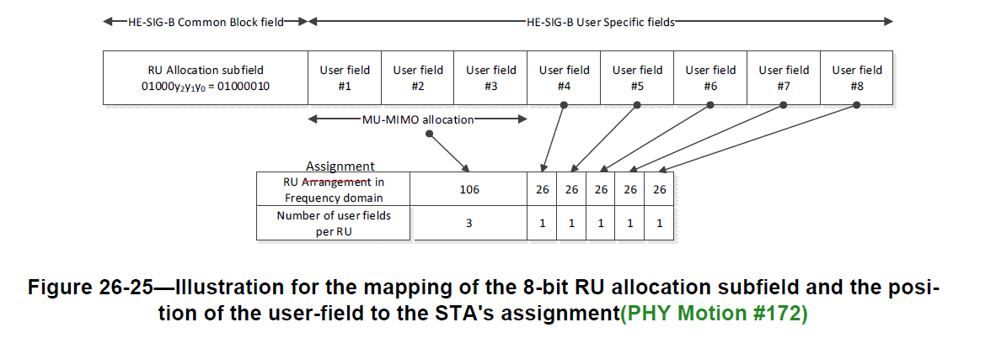

------------- End Text Changes ---------------

