IEEE P802.11
Wireless LANs
11ax D0.5 MU Comment Resolution for Some Remaining NAV CIDs
Date: 2016-10-18
Author(s):
Name | Affiliation | Address | Phone | email
Po-Kai Huang | Intel Corporation | 2200 Mission College Blvd, Santa Clara, CA 950542200 |  | po-kai.huang@intel.com
Abstract
This submission proposes resolutions for comments of TGax Draft 0.1 with the following CIDs:
- 729, 1069, 806, 2261, 2909, 1468, 1637, 998, 730, 245, 246, 247, 248, 399, 421, 1464, 588, 256, 812, 1661

Revisions:

- Rev 0: Initial version of the document.
- Rev 1: Minor Editoral change. The difference is marked with green.

Interpretation of a Motion to Adopt

A motion to approve this submission means that the editing instructions and any changed or added material are actioned in the TGax D0.5 Draft. This introduction is not part of the adopted material.

Editing instructions formatted like this are intended to be copied into the TGax D0.5 Draft (i.e. they are instructions to the 802.11 editor on how to merge the text with the baseline documents).

TGax Editor: Editing instructions preceded by “TGax Editor” are instructions to the TGax editor to modify existing material in the TGax draft. As a result of adopting the changes, the TGax editor will execute the instructions rather than copy them to the TGax Draft.

CID | Commenter | P.L | Clause | Comment | Proposed Change | Resolution
729 | Jarkko Kneckt | 39.57 | 10.3.2.8a.1 | The MU-RTS mechanism does not include CTS Timeout mechanism for the third devices that overhear the MU-RTS but do not receive PHY-RXSTART.indication within the duration specified in 10.3.2.4. This timeout is key to make the MU-RTS CTS signaling efficient and to reduce overheads of the unsuccesful reservations. | Add a posibility to third devices to reset the NAV or a possiblity that NAV expires if the third device does not receive a PHY-RXSTART.indication within the 2*SIFS+CTS +PREAMBLE+2*Slot time. | Revised –  Agree in principle with the commenter. The NAV reset mechanism for MU-RTS has been proposed and accepted in 11-16/0925r1 and 11-16/1173r2.  TGax editor to make the changes shown in 11-16/0925r1 and 11-16/1173r2.
1069 | Kiseon Ryu | 39.52 | 10.3.2.4 | Clarify TBD mechanism in the text "An HE AP may use a TBD mechanism to configure the use of RTS/CTS initiated by non-AP STA." | Clarify it. | Revised –  Agree in principle with the commenter. The proposed texts for the TBD mechanism has been proposed and accepted in 11-16/1211r2.  TGax editor to make the changes shown in 11-16/1211r2.
806 | Jinsoo Ahn | 39.53 | 10.3.2.4 | MU RTS NAV needs to be cancelled by RTS timer | Insert the following at the 10.3.2.4 line 38  "A STA that used information from an MU-RTS frame soliciting CTSs from multiple STAs as the most recent basis to update its NAV setting is  permitted to reset its NAV if no PHY-RXSTART.indication primitive is received from the PHY during a period with a duration of (2 ΓêÖ aSIFSTime) + (CTS_Time) + aRxPHYStartDelay + (2 ΓêÖ aSlotTime) starting when the MAC receives a PHY-RXEND.indication primitive corresponding to the detection of the MU-RTS frame.  The "CTS_Time" shall be calculated using the length of the CTS frame and the data rate at which the MU-RTS frame used for the most recent NAV update was received" | Revised –  Agree in principle with the commenter. The NAV reset mechanism for MU-RTS has been proposed and accepted in 11-16/0925r1 and 11-16/1173r2.  TGax editor to make the changes shown in 11-16/0925r1 and 11-16/1173r2.
2261 | Weimin Xing | 39.45 | 10.3.2.4 | In REVmc, a NAV resetting rule is "A STA that used information from an RTS frame as the most recent basis to update its NAV setting is permitted to reset its NAV if no PHY-RXSTART.indication primitive is received from the PHY during a period with a duration of (2*aSIFSTime) + (CTS_Time) + aRxPHYStartDelay + (2*aSlotTime) starting at the PHY-RXEND.indication primitive corresponding to the detection of the RTS frame."  Does this rule is also apply for MU-RTS frame case for HE STA? | We need define the NAV Setting and resetting rules for MU-RTS, and we will give possible reslutions for this comments in a proposal. | Revised –  Agree in principle with the commenter. The NAV reset mechanism for MU-RTS has been proposed and accepted in 11-16/0925r1 and 11-16/1173r2.  TGax editor to make the changes shown in 11-16/0925r1 and 11-16/1173r2.
2909 | Guido Hiertz | 39.52 | 10.3.2.4 | RTS/CTS response based on node type in the enterprise scenario for UL/DL synchronisation. | If an AP detects an RTS sent by an OBSS AP, i.e. From DS = 1, or CTS sent from an OBSS STA, i.e. To DS = 1, then the AP does not set NAV. Similarly, if a STA detects an RTS sent by an OBSS STA, From DS = 1, or a CTS by an OBSS AP, To DS = 1, it does not set NAV. | Rejected –  It is unclear what the issue that the commenter wants to address is.  The proposed texts also does not align with the current spec. Specifically, in 9.2.4.1.4 To DS and From DS subfields in Draft P802.11REVmc_D8.0, the spec describes the following.  In Control frames, To DS and From DS, when present, are both zero.  Hence, the To DS and From DS subfields in RTS or CTS frame are always set to zero.
1468 | Mark RISON | 53.04 | 25 | There are references to "PSDU" in this clause, but generally MACs refer to PPDUs, not PSDUs | Change "PSDU" to "PPDU" throughout this clause | Rejected –  PSDU refers to the unit transferred between MAC and PHY. Hence, it is possible for MAC to refer to PSDU to reflect the accurate reference. For example, in 10.3.2.4 Setting and resetting the NAV in Draft P802.11REVmc_D8.0, the sepc describes the following.  A STA that receives at least one valid frame in a PSDU can update its NAV with the information from any valid Duration field in the PSDU.  As a result, we do not need to change "PSDU" to "PPDU" throughout this clause.
1637 | Matthew Fischer | 53.05 | 25 | Unclear what precedence is in force between clause 25 and clause 10. Clause 25 describes MAC behavior that might conflict with MAC behavior described in clause 10. It is not clear what precedence is to be followed when such conflicts exist. | Define the precedence between clause 10 and clause 25 when operations conflict. | Rejected –  The new style for amending the MAC for 11ax spec writing requires explicit statements about which parts of the baseline apply and which don't. Hence, if both clause 10 and clause 25 refers to the same operation, then in clause 10, statements should be added to refer the operation to clause 25, and in clause 25, statements should be added to describe which operation in clause 10 applies to HE STA.  It is not precise if we directly say clause 10 takes precedence over clause 25 or caluse 25 takes precedence over clause 10 for each conflict operation. It is recommended that specific section that does not follow the rule as described above is pointed out, and corresponding revision can then be made.
998 | kaiying Lv | 53.65 | 25.2 | Channel Access mode negotiation should be allowed to enable STAs to request channel access mode based on its requirement | Comment resolution and supporting PPT will be provided. | Revised –  After talking offline with the commenter, the commenter indicates that the comment has been resolved in 11-16/1180r1.  TGax editor to make the changes shown in 11-16/1180r1.
730 | Jarkko Kneckt | 40.52 | 10.3.2.8a.1 | Unclear sentence. | Replace the sentence "in each 20..." with "At least one STA shall be requested to send a CTS frame on each reserved 20 MHz channel. | Revised –  Agree in principle with the commenter. The referred sentence has been revised in 11-16/807r2 for clarification, and the document has been approved in July F2F.  TGax editor to make the changes shown in 11-16/807r2.
245 | Anton Kiryanov | 53.26 | 25.2.1 | NAV is updated if greater value is received | when the received value of the Duration field is greater than the STA's current regular NAV value | Revised –  Agree in principle with the commenter. The NAV update rule has been revised with itemized list and clarified in 11-16/1106r2 and 11-16/1173r2. 11-16/1106r2 and 11-16/1173r2 have been approved in Sep F2F.  TGax editor to make the changes shown in 11-16/1106r2 and 11-16/1173r2.
246 | Anton Kiryanov | 53.30 | 25.2.1 | NAV is updated if greater value is received | when the received value of the Duration field is greater than the STA's current regular NAV value | Revised –  Agree in principle with the commenter. The NAV update rule has been revised with itemized list and clarified in 11-16/1106r2 and 11-16/1173r2. 11-16/1106r2 and 11-16/1173r2 have been approved in Sep F2F.  TGax editor to make the changes shown in 11-16/1106r2 and 11-16/1173r2.
247 | Anton Kiryanov | 53.33 | 25.2.1 | NAV is updated if greater value is received | when the received value of the TXOP Duration field is greater than the STA's current Intra-BSS NAV value | Revised –  Agree in principle with the commenter. The NAV update rule has been revised with itemized list and clarified in 11-16/1106r2 and 11-16/1173r2. 11-16/1106r2 and 11-16/1173r2 have been approved in Sep F2F.  TGax editor to make the changes shown in 11-16/1106r2 and 11-16/1173r2.
248 | Anton Kiryanov | 53.37 | 25.2.1 | NAV is updated if greater value is received | when the received value of the TXOP Duration field is greater than the STA's current regular NAV value | Revised –  Agree in principle with the commenter. The NAV update rule has been revised with itemized list and clarified in 11-16/1106r2 and 11-16/1173r2. 11-16/1106r2 and 11-16/1173r2 have been approved in Sep F2F.  TGax editor to make the changes shown in 11-16/1106r2 and 11-16/1173r2.
399 | Brian Hart | 40.11 | 10.3.2.888.1 | Split STA1 and STA2 into two separate lines | Split and duplicate | Revised –  Agree in principle with the commenter.  TGax editor to make the changes shown in 11-16/1339r1 under all headings that include CID 399.
421 | Brian Hart | 53.20 | 25.2.1 | A billion English speakers around the world wince whenever an American speaker uses "regular" to mean "normal" | Replace "regular NAV" by "Basic NAV", which is the usual 802.11 modifier | Accepted –  Agree with the commenter. Discuss with the editor on the proposal and agree that Basic NAV is a better name.  TGax editor to make the changes shown in 11-16/1339r1 under all headings that include CID 421.
1464 | Mark RISON | 53.00 | 25.2.1 | "regular NAV" is an appalling Americanism | Change "regular" to "all-BSS" | Revised –  Agree in principle with the commenter. All-BSS is not a good name because all-BSS includes intra-BSS as well. Propose to use Basic NAV.  TGax editor to make the changes shown in 11-16/1339r1 under all headings that include CID 421.
588 | EVGENY KHOROV | 53.19 | 25.2.1 | The term Regular NAV is ambiguous. It can be mixed with the legacy one. Inter-BSS NAV seems to be better. | Replace in the whole draft Regular NAV with Inter-BSS-NAV | Revised –  Agree in principle with the commenter. Inter-BSS NAV is not a good name because the NAV counter may be set by frame that can not be determined as Intra-BSS or Inter-BSS. Propose to use Basic NAV, and the definition of Basic NAV will differentiate it from the legacy one.  TGax editor to make the changes shown in 11-16/1339r1 under all headings that include CID 421.
256 | Anton Kiryanov | 63.52 | 25.9.2 | It is about regular NAV | Replace "NAV" with "regular NAV" | Revised –  Agree in principle with the commenter. The referred sentence has been deleted and revised in 11-16/1106r2. 11-16/1106r2 has been approved in Sep F2F.  TGax editor to make the changes shown in 11-16/1106r2.
812 | Jinsoo Ahn | 53.62 | 25.2.1 | Inter-BSS NAV shall be replaced by regular NAV | Change the following  "For all other received HE-SIG-As that are identified by the STA as Inter-BSS, the STA shall update its 'regular' (Inter-BSS) NAV when the received value of the TXOP Duration field is greater than the STA's current regular NAV value." | Revised –  Agree in principle with the commenter. The typo has been revised in 11-16/1106r2. 11-16/1106r2 has been approved in Sep F2F.  TGax editor to make the changes shown in 11-16/1106r2.
1661 | NARENDAR MADHAVAN | 53.61 | 25.2.1 | Inter-BSS NAV' is used instead of 'regular NAV' | As in comment, change 'Inter-BSS NAV' to 'regular NAV' | Revised –  Agree in principle with the commenter. The typo has been revised in 11-16/1106r2. 11-16/1106r2 has been approved in Sep F2F.  TGax editor to make the changes shown in 11-16/1106r2.

Discussion: None.

Propose:
Revised for CID 399 per discussion and editing instructions in 11-16/1339r1.

TGax editor: Delete the figures in 10.3.2.8a.1 General and add the underlined figures as the following:

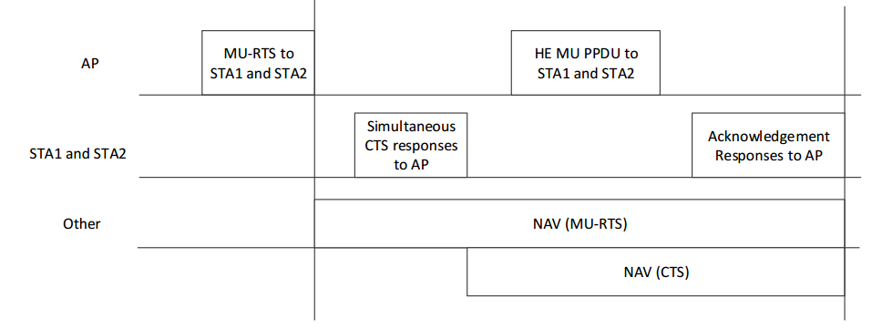

Figure 10-9a—Example of MU-RTS/CTS/DL MU PPDU/Acknowledgement Response and
NAV setting(#2224)

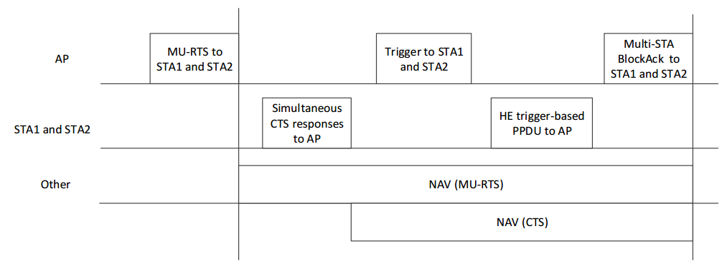

Figure 10-9b—Example of MU-RTS/CTS/Trigger/HE trigger-based PPDU/Multi-STA BlockAck
and NAV setting(#2224)

Propose:
Revised for CID 421 per discussion and editing instructions in 11-16/1339r1.

TGax editor: Replace Regular NAV (or regular NAV) with Basic NAV (or basic NAV) in the spec.

