IEEE P802.11  
Wireless LANs

|  |  |  |  |  |
| --- | --- | --- | --- | --- |
| Text change proposal of RXTIME and TXTIME in 26.3.19 and 26.4.3 | | | | |
| Date: 2016-09-12 | | | | |
| Author(s): | | | | |
| Name | Affiliation | Address | Phone | email |
| Yujin Noh | Newracom | 9008 Research Dr.  Irvine, CA 92618 |  | yujin.noh@newracom.com |
| Reza Hedayat |  | reza.hedayat@newracom.com |
| Young Hoon Kwon |  | younghoon.kwon@newracom.com |
| Yongho Seok |  | yongho.seok@newracom.com |
| Daewon Lee |  | daewon.lee@newracom.com |
| Minho Cheong |  | minho.cheong@newracom.com |

Abstract

* This submission shows the modification of wrong reference in 26.3.19 (HE receive procedure) and TXTIME equations in 26.4.3 (TXTIME and PSDU_LENGTH calculation).
* The proposed changes are based on 11ax D0.4.

**Discussion**

* RXTIME in 26.3.19 HE receive procedure refers to wrong reference as Equation (21-106) instead of Equation (26-124).



* TXTIME based on draft P802.11REVmc_D5.2 is copied and pasted below. TXTIME related equations in Draft P802.11ax_D0.4 doesn’t consider 1) SignalExtension and 2) TXTIME excluding SignalExtension in units of 4 μs by mistake.

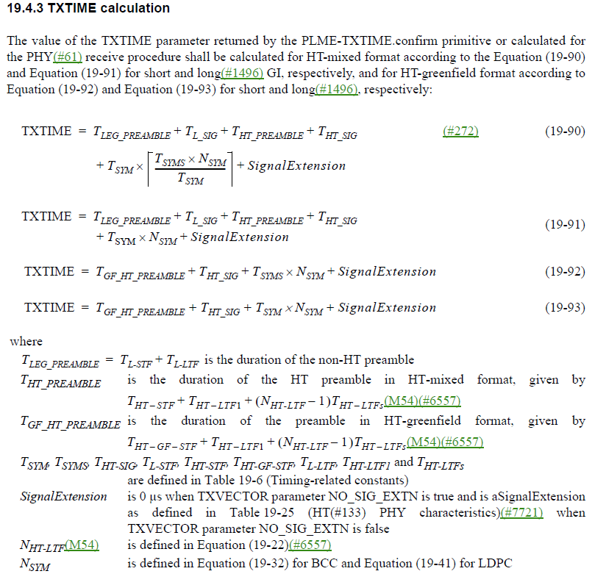

**Changes to Section 26.3.19 HE receive procedure**

***To TGax editor:*** ***P239L46*** *replace reference from (21-106) to (26-124) with the proposed changes below.*

The PHY entity shall maintain PHY-CCA.indication(BUSY, channellist) primitive for the predicted duration of the transmitted PPDU, as defined by RXTIME in Equation (26-124), for all supported modes, unsupported modes, Reserved HE-SIG-A Indication, and invalid HE-SIG-A CRC. Reserved HESIG-A Indication is defined as an HE-SIG-A with Reserved bits equal to 0 or TBD. If the HE-SIG-A indicates an unsupported mode, the PHY shall issue a PHY-RXEND.indication(UnsupportedRate)primitive.

**Changes to Section 26.3.19 HE receive procedure**

***To TGax editor:*** ***P240L4*** *replace reference from (21-106) to (26-124) with the proposed changes below.*

The PHY entity shall receive HE-STF for 4 μs after HE-SIG-A. The PHY entity shall maintain PHY-CCA.indication(BUSY, channellist) primitive for the predicted duration of the transmitted PPDU, as defined by RXTIME in Equation (26-124), for all supported modes, unsupported modes, Reserved HE-SIG-A Indication, and invalid HE-SIG-A CRC.

**Changes to Section 26.4.3 TXTIME and PSDU_LENGTH calculation**

***To TGax editor:*** ***P158L49*** *replace the current equation from (26-14) with the proposed changes below and add signalextension description text as described below.*

 (24-16)

where

TXTIME (in μs) is defined in 26.4.3 (TXTIME and PSDU_LENGTH calculation).

*m* is 1 for an HE MU PPDU and HE extended range SU PPDU, and 2 otherwise.

*SignalExtension is 0 μs when TXVECTOR parameter NO_SIG_EXTN is true and is aSignalExtension as defined in Table 19-25 (HT(#133) PHY characteristics)(#7721) when TXVECTOR parameter NO_SIG_EXTN is false*

***To TGax editor:*** ***P242L23*** *replace the current equations from (26-131) to (26-133) with the proposed changes below.*

***------------- Begin Text Changes ---------------***

 (26-131)

 (26-132)

 (26-133)

***------------------------------------------------------------***

***To TGax editor:*** ***P242L39*** *add the definition of SignalExtension after T*HE_PREAMBLE *below.*



*SignalExtension is 0 μs when TXVECTOR parameter NO_SIG_EXTN is true and is aSignalExtension as  
 defined in Table 19-25 (HT(#133) PHY characteristics)(#7721) when TXVECTOR   
 parameter NO_SIG_EXTN is false*



***------------------------------------------------------------***