IEEE P802.11
Wireless LANs
IEEE 802.11 TGax, MU Ad hoc
July 2016 TGax Meeting Minutes
Date: 2016-05-16
Author(s):
Name | Affiliation | Address | Phone | email
Kiseon  Ryu | LG |  |  | kiseon.ryu@lge.com
Kaushik Josiam | Samsung |  |  | k.josiam@samsung.com
Sigurd Schelstraete | Quantenna Communications |  |  | sigurd@quantenna.com
Abstract
The meeting minutes from the MU Ad Hoc group meeting of TGax in the IEEE 802.11 San Diego session July 25th – 29th, 2016.
IEEE 802.11 Task Group ax, MU Ad hoc
San Diego, CA
July 25th – 29th, 2016

MU Adhoc Session #1
Tuesday, July 26th, 2016, PM2 TGax Session (4 – 6 PM)

- The meeting called to order by Kaushik Josiam (Samsung), the co-chair of the TGax MU Ad hoc

- Announcement
  - Agenda Document 11-16/1012r0 is on the server.
  - Meeting Protocol: The Chair asked to state name and affiliation when speaking for the first time.
  - Attendance reminder.
    - The attendance server: https://imat.ieee.org/

- The chair reviewed the mandatory 5 slides of P&P.
  - Instructions from the WG Chair. [reviewed, did not review]
  - Participants, Patents, and Duty to Inform. [reviewed, did not review]
  - Patent Related Links. [reviewed, did not review]
  - Call for potentially essential patents.
    - Chair asked if anyone is aware of potentially essential patents
[Asked. Did not ask]
    - Potentially essential patents
[None reported. Reported as follows]
  - Other Guidelines for IEEE WG Meetings.

- The Chair identified 12 presentations assigned by the TGax chair to be treated in MU Ad hoc
  - No new presentations, other than those listed in the agenda, were requested.

- The Chair asked for approval of the agenda
  - No objection raised

- Presentation of contributions
  - 11-16/880 UL MU Transmission Rules - EDCA backoff

- SP1: Do you agree to add the following text to the 11ax Spec draft:
  - Insert the following at the end of 10.22.2.2:
  - When an HE STA successfully receives the corresponding acknowledgement frame in response to the MPDU sent in HE trigger based PPDU, the backoff for the associated EDCAF resumes the backoff counter countdown

No objection to SP
SP passes

- SP2: Do you agree to add the following text to the 11ax Spec draft:
  - Insert the following at the end of 10.22.2.2:
  - When an HE STA does not receive the corresponding acknowledgement frame in response to the MPDU sent in HE trigger based PPDU, the backoff for the associated EDCAF resumes the backoff counter countdown

No objection to SP
SP passes

- SP3: Do you agree to add the following text to the 11ax Spec draft:
  - Insert the following at the end of 10.22.2.2:
  - If an HE STA does not successfully receive the corresponding acknowledgement frame in response to the MPDU sent in an HE trigger based PPDU, the short retry counters and long retry counters for the associated EDCAF are not changed

No objection to SP
SP passes

  - 11-16/926r1 Soliciting UL_MU_ACK

SP1: Do you support the following:
- It is mandatory at the non AP HE STA to support reception of Trigger in the DL MU PPDU aggregated with Data and respond with an ACK/BA/M-BA if the QoS ACK Policy in the DL A-MPDU is set to 01 (Trigger based UL MU ACK) and the STA has not set the UL MU Disable to 1.

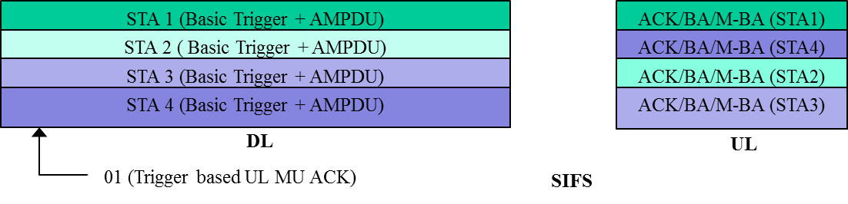

No objection to SP
SP passes

SP2: Do you support the following:
- It is mandatory at the non AP HE STA to support reception of DL MU PPDU with QoS ACK Policy set to Block Ack or No ACK followed by a MU-BAR within SIFS followed by transmission of the ACK/BA/M-BA appropriately if the STA has not set the UL MU Disable to 1.

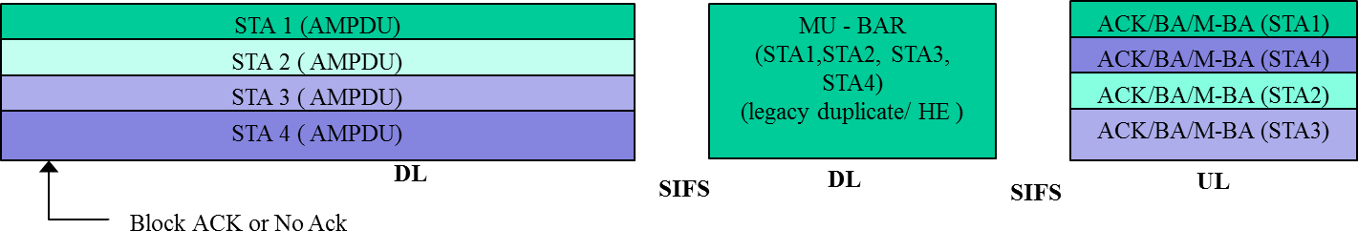

No objection to SP
SP passes

- 11-16/0958 | UL OFDMA for Unassociated STA
Withdrawn by presenter

  - 11-16/866r2 Comment Resolution of Section 26.3.13 MU-MIMO

866r3 will be produced based on comments received during discussion.
SPs will be run on the basis of r3.

To be revisited.

  - 11-16/875r2 CR for the section 10.3.2.8a CS Condition to Respond CTS

CID 1070: Accepted with no objection
CID 2226: Accepted with no objection
CID 693: Accepted with no objection
CID 125: Accepted with no objection
CID 2650: Accepted with no objection
CID 2651: Accepted with no objection

  - 11-16/876r2 CR for the section 25.5.2.4 UL MU CS CCA and CS Required Bit

CID 768: Accepted with no objection
CID 829: Accepted with no objection
CID 979: Accepted with no objection
CID 978: Accepted with no objection
CID 1546: Accepted with no objection
CID 1295: Accepted with no objection
CID 2710: Accepted with no objection
CID 2709: Accepted with no objection
CID 2187: Accepted with no objection
CID 2647: Accepted with no objection
CID 2266: Accepted with no objection

- The chair recessed the session at 6 pm

