IEEE P802.11
Wireless LANs
Proposed Resolutions to CID 2665, 2719
Date: 2016-07-25
Author(s):
Name | Affiliation | Address | Phone | email
Jing Ma | NICT |  |  | majing@nict.go.jp

Abstract
This submission proposes resolutions for comments with the following CIDs:
- CIDs: 2665, 2719

Revisions:

- Rev 0: Initial version of the document.

Interpretation of a Motion to Adopt

A motion to approve this submission means that the editing instructions and any changed or added material are actioned in the TGax D0.1 Draft. This introduction is not part of the adopted material.

Editing instructions formatted like this are intended to be copied into the TGax D0.1 Draft (i.e. they are instructions to the 802.11 editor on how to merge the text with the baseline documents).

TGax Editor: Editing instructions preceded by “TGax Editor” are instructions to the TGax editor to modify existing material in the TGax draft. As a result of adopting the changes, the TGax editor will execute the instructions rather than copy them to the TGax Draft.

CID | Clause Number | Page | Line | Comment | Proposed Change | Resolution
2665 | 25.9.2 | 63 | 47 | How to adjust backoff counter during the period of time that is taken by the receiving STA to validate the PPDU is not clear. | Clarify how to adjust backoff counter during the period of time that is taken by the receiving STA to validate the PPDU. | Revised:  Agree in principle with the comment. Proposed resolution is inline with the suggested change
2719 | 25.9.2 | 63 | 51 | Behavior after the BUSY state needs to be defined. Backoff should continue as if the OBSS PPDU was "not received at all". | Add text; "After the BUSY medium condition is released, the STA should resume its backoff procedure as the PPDU was not received at all (in insertion of IFS)." | Revised  Agree in principle with the comment. Proposed resolution is inline with the suggested change

Discussion
Abstract
This document provides resolutions for the following CIDs on Clause 25.9.3. The baseline for this comment resolution document is 802.11ax Draft 0.1.
- CIDs: 705, 706

The commenters pointed out the backoff procedure should be clarified in spatial reuse operation.

1, So far, spatial reuse operation is specified in draft D0.1 as follows

A STA should regard an inter-BSS PPDU with a valid PHY header and that has receiving power/RSSI below the OBSS PD level used by the receiving STA and that meets additional TBD conditions, as not having been received at all (e.g., should not update its NAV), except that the medium condition shall indicate BUSY during the period of time that is taken by the receiving STA to validate that the PPDU is from an inter-BSS, but not longer than the time indicated as the length of the PPDU payload.

2, We agree with the commenters on elaborating the specific behaviors concerning backoff counter during the SR operations, and we propose that
- Basically, the baseline backoff procedure is maintained during the period of time that is taken by the receiving STA to validate the PPDU. When an inter-BSS PPDU arrives at a STA,
- The backoff procedure of that STA is suspended if the channel is indicated as BUSY at the beginning of preamble based on the legacy CS mechnism.
- Then, after receiving HE-SIG-A / MAC header successfully,
  - If the channel is determined to be IDLE using SR based CS mechanism (inter-BSS frame & the receiving power < PD_level) for the duration of an AIFS before backoff procedure is allowed to resume.
  - If the channel is determined to be BUSY using SR based CS mechanism, the receiving process continues and the backoff procedure is still suspended.
- Meanwhile it is also necessary to carefully consider the interaction of the backoff procedure with PHY and the interactions between MAC and PHY layers. We propose propose to define the interaction mechanisms between MAC and PHY layers for supporting SR operations. The details are described as follows.

2-1 The MAC timing and PHY receive procedure of intra-BSS frame reception case is illustrated as follows:

Fig.1 MAC timing and PHY receive procedure (intra-BSS frame reception case)
It can be seen that, the MAC timing and PHY receive procedure for intra-BSS frame reception case are the same as the baseline procedure.
1) When PHY detects the RX power is higher than CCA-SD at the beginning of the preamble, PHY issues PHY-CCA.indication (BUSY) primitive to indicate channel BUSY status to MAC. Then MAC suspends backoff procedure.
2) After the PHY-CCA.indication (BUSY) primitive is issued, the PHY entity shall begin receiving the training symbols. Then after receiving valid L-SIG, RL-SIG and HE-SIG-A successfully, the PHY entity may issue a PHY-RXSTART.indication(RXVECTOR) primitive.
3) Following training and signal fields, the Data field shall be received including a series of PHY-DATA.indication(DATA) primitive exchanges.
4) After the reception of the final bit of the PPDU successfully, the PHY issues a PHY-RXEND.indication(NoError) primitive, then issues a PHY-CCA.indication(IDLE).
5) The MAC is allowed to resume backoff procedure after determining that the channel remains IDLE for the duration of an AIFS.

2-2 Accroding to the SR operation defined in 11ax D 0.1, the MAC timing and PHY receive procedure for inter-BSS frame reception case is illustrated as case A, B, and C respectively, and is not as in baseline

Case A: SR is allowed & RX power is lower than OBSS PD level

Fig.2 MAC timing and PHY receive procedure (inter-BSS frame reception case A)

It can be seen that, when SR transmission is allowed and RX power is lower than OBSS PD level,
1) When PHY detects the RX power is higher than CCA-SD at the beginning of the preamble, PHY issues PHY-CCA.indication (BUSY) primitive to indicate channel BUSY status to MAC. Then MAC suspends backoff procedure.
2) After the PHY-CCA.indication (BUSY) primitive is issued, the PHY entity shall begin receiving the training symbols. Then after receiving valid L-SIG, RL-SIG and HE-SIG-A successfully, the PHY entity may issue a PHY-RXSTART.indication(RXVECTOR) primitive.
(We propose to define interactions between PHY and MAC entities for supporting SR operation (the following 3) ~ 4) which are also shown in fig.2 marked in blue))
3) Subsequently, if the BSS COLOR, SPATIAL REUSE within the RXVECTOR indicate the receiving PPDU is an inter-BSS PPDU and SR transmission is allowded, the MAC issues PHY-SR.request(OBSS PD level) to indicate PHY entity.
4) Then the PHY compares the RX power with OBSS PD level. The PHY may issue a PHY-RXEND.indication(SR based terminated) primitive if RX power is lower than OBSS PD level. As well as, the PHY shall issue a PHY-SR.confirm(IDLE) to MAC entity.
5) The MAC is allowed to resume backoff procedure after determining that the channel remains IDLE for the duration of an AIFS.

Case B: SR is allowed & RX power is higher than OBSS PD level

Fig.3 HE PHY receive procedure (inter-BSS frame reception case B)

It can be seen that, when SR is allowed and RX power is higher than OBSS PD level,
1) When PHY detects the RX power is higher than CCA-SD at the beginning of the preamble, PHY issues PHY-CCA.indication (BUSY) primitive to indicate channel BUSY status to MAC. Then MAC suspends backoff procedure as shown in fig.3.
2) After the PHY-CCA.indication (BUSY) primitive is issued, the PHY entity shall begin receiving the training symbols. Then after receiving valid L-SIG, RL-SIG and HE-SIG-A successfully, the PHY entity may issue a PHY-RXSTART.indication(RXVECTOR) primitive.
(We propose to define interactions between PHY and MAC entities for supporting SR operation (the following 3) ~ 4) which are also shown in fig.3 marked in blue))
3) Subsequently, if the BSS COLOR, SPATIAL REUSE within the RXVECTOR indicate the receiving PPDU is an inter-BSS PPDU and SR is allowded, the MAC issues PHY-SR.request(OBSS PD level) to indicate PHY entity.
4) Then the PHY compares the RX power with OBSS PD level. If RX power is higher than OBSS PD level, the PHY continues to receive the PPDU and issues a PHY-SR.confirm(BUSY) to MAC entity at the same time.
5) After the reception of the final bit of the PPDU successfully, the PHY issues a PHY-RXEND.indication(NoError) primitive, then issues a PHY-CCA.indication(IDLE).
6) The MAC is allowed to resume backoff procedure after determining that the channel remains IDLE for the duration of an AIFS.

Case C: SR is not allowed

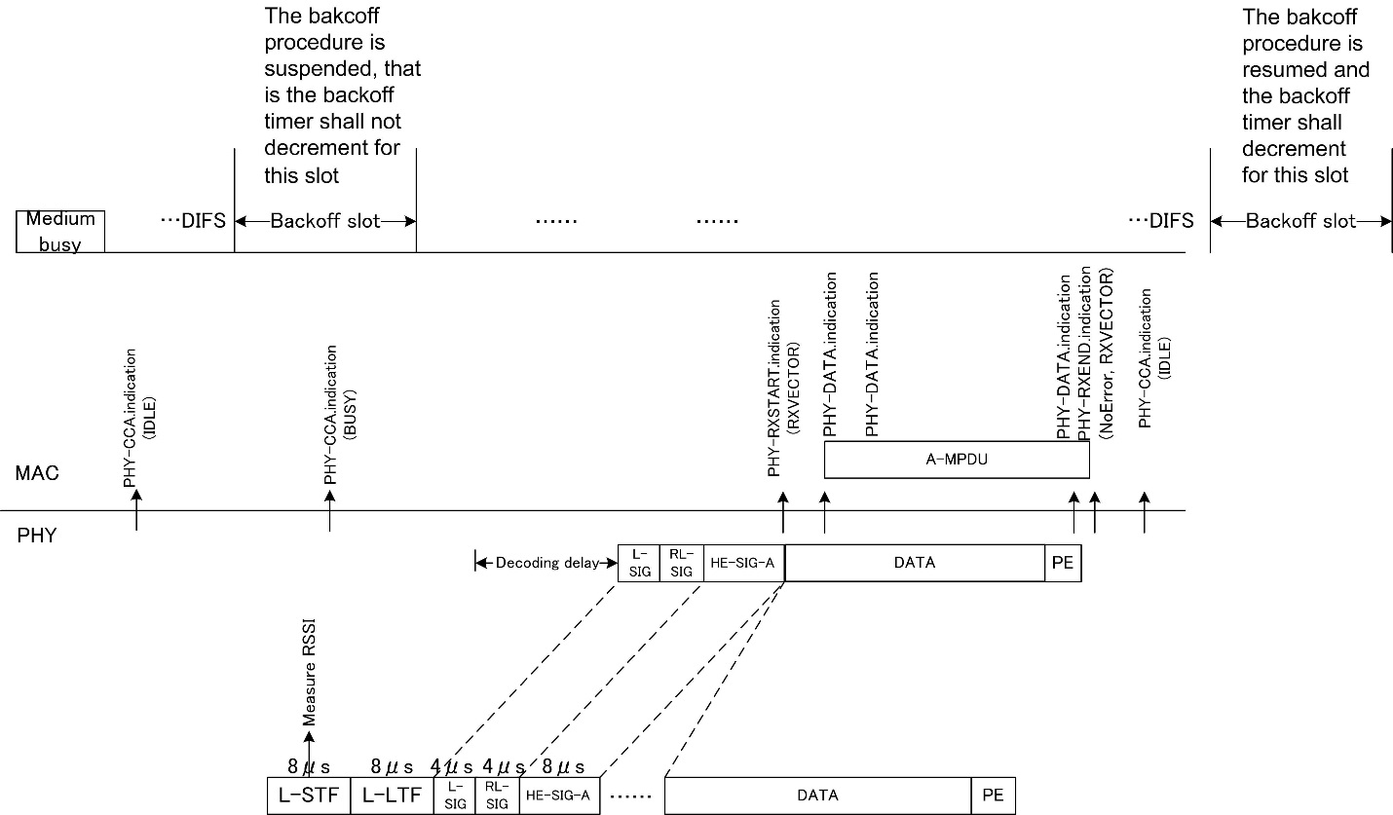

Fig.4 HE PHY receive procedure (inter-BSS frame reception case C)

It can be seen that, when SR is not allowed,
1) When PHY detects the RX_power is higher than CCA-SD at the beginning of the preamble, PHY issues PHY-CCA.indication (BUSY) primitive to indicate channel BUSY status to MAC. Then MAC suspends backoff procedure.
2) After the PHY-CCA.indication (BUSY) primitive is issued, the PHY entity shall begin receiving the training symbols. Then after receiving valid L-SIG, RL-SIG and HE-SIG-A successfully, the PHY entity may issue a PHY-RXSTART.indication(RXVECTOR) primitive.
3) Subsequently, if the BSS COLOR, SPATIAL REUSE within the RXVECTOR indicate the receiving PPDU is an inter-BSS PPDU but SR transmission is NOT allowded, the PHY continues to receive the PPDU.
4) Following training and signal fields, the Data field shall be received including a series of PHY-DATA.indication(DATA) primitive exchanges.
5) After the reception of the final bit of the PPDU successfully, the PHY issues a PHY-RXEND.indication(NoError) primitive, then issues a PHY-CCA.indication(IDLE).
6) The MAC is allowed to resume backoff procedure after determining that the channel remains IDLE for the duration of an AIFS.

Proposed resolution

Summary of the resolution:
1, Add texts which clarify how to adjust backoff counter during the period of time that is taken by the receiving STA to validate the PPDU and behave after BUSY state in section 25.9.2 color code based CCA rules.
2, Change the paragraths below of section 8.3.5.14 PHY-RXEND.indication
3, Add two PHY SAP inter-(sub)layer service primitives to clause 8.3.4 Basic service and options
4, Add HE receive procedure diagram and descricption text in section 26.3.15 HE receive procedure

Detailed implementation of the resolution

Make the following changes to 802.11ax D.01.

Revised for CID 2665 and 2719 per discussion and editing instructions in …
1,
TGax editor: add the sentence in section 25.9.2 Color code based CCA rules on page 81 line 50 as the following:

Accordingly, the baockoff procedure of the receiving STA is suspended during the period of time that is taken by the receiving STA to validate the inter-BSS PPDU. After the BUSY medium condition is released, the backoff procedure is resumes after the medium is idle for the duration of an AIFS. (# 2665, 2719)

2,
TGax editor: change the paragraths below of section 8.3.5.14 as the follows:

(Current in baseline) PHY-RXEND.indication( RXERROR, RXVECTOR)
The RXERROR parameter can convey NoError or one or more values indicating an error condition. A
number of error conditions may occur after the PHY’s receive state machine has detected what appears to be a valid preamble and SFD. The following describes the parameter returned for each of those error
conditions.
— NoError. This value is used to indicate that no error occurred during the receive process in the PHY.
— FormatViolation. This value is used to indicate that the format of the received PPDU was in error.
— CarrierLost. This value is used to indicate that during the reception of the incoming PSDU, the carrier was lost and no further processing of the PSDU can be accomplished.
— UnsupportedRate. This value is used to indicate that during the reception of the incoming PPDU, a nonsupported date rate was detected.
— Filtered. This value is used to indicate that during the reception of the PPDU, the PPDU was filtered out due to a condition set in the PHYCONFIG_VECTOR.
NOTE—The filtered condition might occur in a VHT STA due to GROUP_ID or PARTIAL_AID filtering in the PHY.

(Changed) PHY-RXEND.indication( RXERROR, RXVECTOR)
The RXERROR parameter can convey NoError, SR, or one or more values indicating an error condition. A
number of error conditions may occur after the PHY’s receive state machine has detected what appears to be a valid preamble and SFD. The following describes the parameter returned for each of those error
conditions.
— NoError. This value is used to indicate that no error occurred during the receive process in the PHY.
— FormatViolation. This value is used to indicate that the format of the received PPDU was in error.
— CarrierLost. This value is used to indicate that during the reception of the incoming PSDU, the carrier was lost and no further processing of the PSDU can be accomplished.
— UnsupportedRate. This value is used to indicate that during the reception of the incoming PPDU, a nonsupported date rate was detected.
— Filtered. This value is used to indicate that during the reception of the PPDU, the PPDU was filtered out due to a condition set in the PHYCONFIG_VECTOR.
— SR. This value is used to indicate that during the reception of the PPDU, the reception terminates because of spatial reuse operation.
NOTE—The filtered condition might occur in a VHT STA due to GROUP_ID or PARTIAL_AID filtering in the PHY.

3,
TGax editor: add two PHY SAP inter-(sub)layer service primitives to clause 8.3.4 as the follows:

We suggest to add two new PHY SAP inter-(sub)layer service primitives to clause 8.3.4 basic service and options based on the above discussion.
Two new PHY SAP inter-(sub)layer service primitives are PHY-SR.request (PD_level) and PHY-SR.confirm(IDLE/BUSY). The futher detailed definition about PHY-SR.request (PD_level) and PHY-SR.confirm(IDLE/BUSY) are TBD.

4,
TGax editor: add HE receive procedure diagram and descricption text in section 26.3.15 HE receive procedure on page 176 line 33 as the follows:

A PHY receive procedure is shown in Figure TBD (PHY receive procedure for supporting Spatial Reuse (SR) operation) for supporting SR operation. This receive procedure describes the operation if the detected PPDU is an inter-BSS PPDU with a valid PHY header, and that has receiving power/RSSI below the OBSS PD level used by the receiving STA and that meets additional TBD conditions. The further detailed description about the PHY receive procedure for supporting SR operation is TBD.

Fig. TBD – PHY receive procedure for SR transmision

