IEEE P802.11
Wireless LANs
Comment Resolutions on 1024-QAM TBDs
Date: 2016-07-13
Author(s):
Name | Affiliation | Address | Phone | email
Sriram Venkateswaran  Ron Porat | Broadcom | 190 Mathilda Place, Sunnyvale, CA 94096 | +1-408-922-7684 | sriram.venkateswaran@broadcom.com

Abstract
This submission proposes resolutions for the following comments related to TGax D0.1:
- 1782, 2082, 2083

Revisions:
- Rev 0: Initial version of the document.

Interpretation of a Motion to Adopt

A motion to approve this submission means that the editing instructions and any changed or added material are actioned in the TGax Draft. This introduction is not part of the adopted material.

Editing instructions formatted like this are intended to be copied into the TGax Draft (i.e. they are instructions to the 802.11 editor on how to merge the text with the baseline documents).

TGax Editor: Editing instructions preceded by “TGax Editor” are instructions to the TGax editor to modify existing material in the TGax draft. As a result of adopting the changes, the TGax editor will execute the instructions rather than copy them to the TGax Draft.

CID | Clause Number | P.L | Comment | Proposed Change | Resolution
1782 | 26.3.10.8 | 143, 24 | Where be the constellation map for 1024-QAM? | Add 1024-QAM constellation map | Revised.  Proposed resolution accounts for the suggested change.  TGax Editor to make the changes shown in IEEE 802.11-16/0922r2
2082 | 26.3.10.8 | 143, 28 | Replace "used" with "defined" | see comment | Revised.  Proposed resolution accounts for the suggested change.  TGax Editor to make the changes shown in IEEE 802.11-16/0922r2
2083 | 26.3.10.8 | 143, 29 | TBD | Define | Revised.  Proposed resolution accounts for the suggested change.  TGax Editor to make the changes shown in IEEE 802.11-16/0922r2

Changes to D0.2 related to CID 1782, 2082, 2083

Section 26.3.10.8, page 145, line 57 (D0.2)
Edit the line as follows
1024-QAM modulation is used defined as an optional feature for SU and MU

Section 26.3.10.8, page 145, line 57 (D0.2)
Replace line “For 1024-QAM, the constellation mapping is TBD” with
For 1024-QAM modulation, the mapping between the bits at the output of the interleaver and complex constellation points is shown in Figures 26-xx, 26-{xx+1}, 26-{xx+2} and 26-{xx+3}.

The normalization factor K_{mod} for 1024 QAM is .

Add the figures below

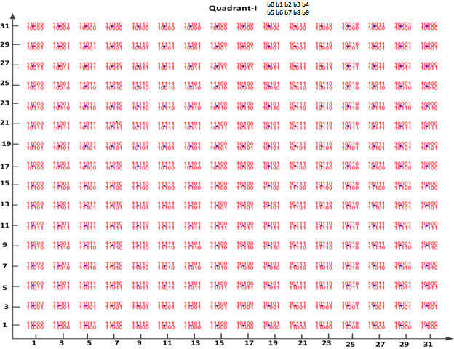

Figure 26-xx: Constellation bit encoding for 1024-QAM (1st quadrant)

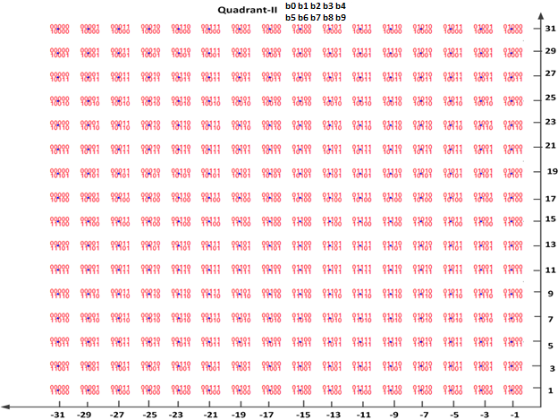

Figure 26-{xx+1}: Constellation bit encoding for 1024-QAM (2nd quadrant)

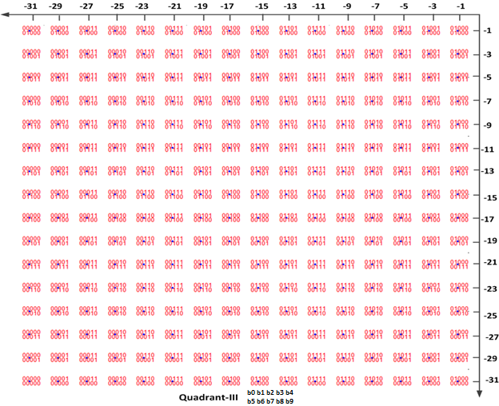

Figure 26-{xx+2}: Constellation bit encoding for 1024-QAM (3rd quadrant)
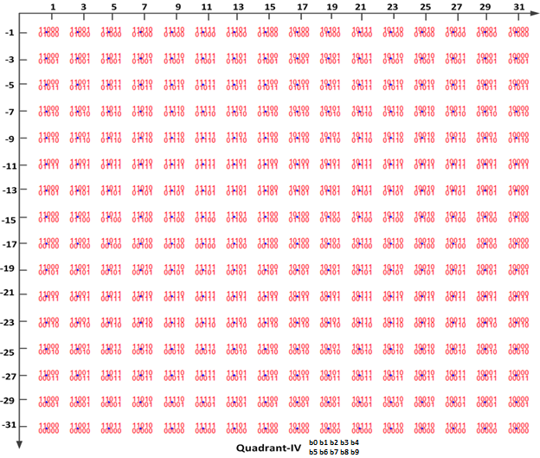

Figure 26-{xx+3}: Constellation bit encoding for 1024-QAM (4th quadrant)

