IEEE P802.11
Wireless LANs
CID 8022, 8023, 8024 resolution text
Date: 2016-07-15
Author(s):
Name | Affiliation | Address | Phone | Email
Thomas Handte | Sony Europe Ltd. | Hedelfinger Str. 61,  70327 Stuttgart, Germany | +49-711-5858-236 | thomas.handte@eu.sony.com
Abstract
This contribution is provided as possible resolution of CID 8022, 8023, 8024.
The changes are relative to Draft P802.11REVmc_D6.0 [1].

Comment

8022 | 2471,22 |  | (Submitted for Thomas Handte)  Table heading is LDPC code rates. However code rate 7/8 is missing. | Add code rate 7/8 to the table | EDITOR

Discussion

DMG has a new code rate 7/8. Table 20-20 provides an overview of LDPC code features, but code rate 7/8 is missing.

Proposed changes:
All changes are in reference to D6.0 [1]

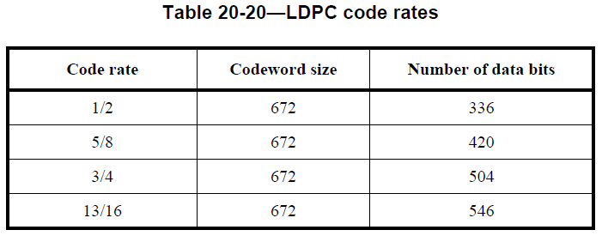
7/8 | 624 | 546

Comments

8023 | 2472.23 |  | (Submitted for Thomas Handte)  LDPC with code rate 7/8 is defined by puncturing of LDPC with CR 13/16. This is likely suboptimal in terms of coding gain and decoder iterations. | Either make a proper definition of a LDPC code table like for code rates 1/2 to 13/16 as in subclause 20.3.8 or consider a distributed rather than a block puncturing. | GEN
8024 | 2472.23 |  | (Submitted for Thomas Handte)  LDPC with code rate 7/8 has a lower CW length as other LDPC codes. However, long CW length is a prerequisite for good error performance in channel with strong phase noise. | It is favorable to design a code rate 7/8 LDPC with 588 data and 84 parity bits. | GEN

Discussion

The LDPC code with code rate 7/8 has suboptimal performance for the reasons mentioned. However, performance loss is rather small and due to timing pressure of REVmc, I would like to withdraw CID 8023 and 8024 and consider a proposal in TGay.

References
[1] Draft P802.11REVmc_D6.0

