IEEE P802.11
Wireless LANs
CIDs for: Section 25.6
HE Sounding Comment Resolution
Date: 2016-05-16
Raja Banerjea | Qualcomm
Simone Merlin
Youhan Kim
Sameer Vermani
Lochan Verma
Bin Tian
Liwen Chu | Marvell
Narendar Madhavan | Toshiba

Abstract
This submission proposes resolutions for multiple comments related to TGax D0.1 with the following CIDs (10 CIDs):
- 55, 1000, 1221, 1915, 2234, 802,1695
- 1222
- 182, 971,2713
- 223

Revisions:
- Rev 0: Initial version of the document.
- Rev 1: Based on Motions passed in May
- Rev 2: Editorial changes, added Table and Figure subheading
- Rev 3: Added changes as suggested by Narendar. Also added changes to resolution as suggested by Alfred.

Interpretation of a Motion to Adopt

A motion to approve this submission means that the editing instructions and any changed or added material are actioned in the TGax Draft. This introduction is not part of the adopted material.

Editing instructions formatted like this are intended to be copied into the TGax Draft (i.e. they are instructions to the 802.11 editor on how to merge the text with the baseline documents).

TGax Editor: Editing instructions preceded by “TGax Editor” are instructions to the TGax editor to modify existing material in the TGax draft. As a result of adopting the changes, the TGax editor will execute the instructions rather than copy them to the TGax Draft.
CID | Commenter | PP.LL |  | Comment | Proposed Change |  | Resolution
55 | Ahmadreza Hedayat | 25.6 | Clarify whether an AP can share the sounding sequence in this clause between a set of UL-MU-capable STAs and another set od STAs that are not UL-MU-capable STAs. |  |  | As in the comment, specify the choices that are available for an AP to perform HE sounding amon these two sets of STAs specfied in this comment. | Revised –  There are two mechanisms that have been accepted and they are defined as SU and MU sounding and the AP can chose either of them.  Proposed resolution provides more details on this aspect.  Make the changes to (use similr language I have in my documents for the instructiosn to the editor).
1000 | kaiying Lv | 25.6 | High efficient sounding sequence should be provided |  |  | comment resolution and supporting PPT will be provided | Revised --.  The comment fails to provide sufficient details. The proposed resolution is to finalize the details for the two sequences for HE sounding that have been defined.
1221 | Liwen Chu | 25.6 | The condition when HE sounding protocol is supported is missing. Add the related rules. |  |  | As in comment. | Revised  Agree in principle. The proposed resolution accounds for the suggested change by clarifying the  conditions which cause HE sounding are provided.
1915 | Sigurd Schelstraete | 25.6 | Change "NDP Announcement frame" to "HE NDP Announcement frame" |  |  | See comment | Revised –  Proposed resolution accounts for the suggested change.  Note: There has to be somewhere a statement that defines the HE NDP Announcement as an HE variant VHT NDP announcement frame.
2234 | Tomoko Adachi | 25.6 | Clarify what kind of sequence variations are allowed for the HE sounding protocol.  The variations should be limited to a minimum for simplicity. |  |  | As in comment. | Revised  Agree in principle with the coment. Proposed resolution provides the details for the  SU and MU sounding sequences
802 | Jing Ma | 60.36 | the draft doesn't clarify how an HE AP solicit beamforming feedback from multiple STAs sequentially through SU transmission. Does it mean that we just follow the sounding protocol with multi-user in 11ac (the example procedure shown in Figure 9-41b41a--Example of the sounding protocol with a single VHT beamformee) |  |  | "An example of soliciting beamforming feedback from multiple STAs through SU transmission sequences are shown in Figure 9-41b41a (Example of the sounding protocol with a single VHT beamformee)" should be added at the end of "an HE AP solicit beamforming feedback from multiple STAs sequentially through SU transmission" | Revised.  Agree in principle with the comment.  Proposed resolution clarifies these missing details.  Provided details
1695 | Oghenekome Oteri | 61.39 | No details on Feedback for HE sounding protocol |  |  | Update draft to reflect March agreements | Revised  Agree and as above. .  Provided details
TGax Editor: Add the subclause below as resolution to (#CID 55, 1000, 1221, 1915, 2234, 2459, 2665,802,1695):

25.6 HE sounding protocol

25.6.1 General
Transmit beamforming and DL-MU-MIMO require knowledge of the channel state to compute a steering matrix that is applied to the transmit signal to optimize reception at one or more receivers. HE STAs use HE sounding protocol to determine the channel state information. Similar to VHT, HE uses explicit feedback mechanism where the HE beamformee measures the channel from the training signal transmitted by the HE beamformer and sends back a transformed estimate of the channel state. The HE beamformer uses this estimate to derive the steering matrix.

25.6.1 Rules for HE sounding protocol sequences
The HE beamformer shall initiate a sounding sequence by transmitting a HE NDP Annoucement frame followed by a HE NDP after SIFS.
If the HE NDP Announcement frame includes more than one STA Info field, the RA of the HE NDP Annoucement frame shall be set to a broadcast address, else it shall be set to the MAC address of the STA whose AID is included in the STA Info field. The HE NDP Announcement frame shall indicate the Ng, codebook and Nc to be used by the intended receiver STAs for the generation of CBF except when the HE NDP Announcement frame contains only one STA Info element with the Feedback Type subfield in the STA Info field is equal to SU. When the HE NDP Announcement frame contains only one STA Info element with the Feedback Type subfield in the STA Info field set to SU, then the Ng, codebook and Nc to be used for the generation of CBF shall be determined by the recipient of the NDP Announcement frame.
A HE beamformer that transmits a HE NDP Announcement frame with more than one STA info field should transmit a Beamforming Report Poll Trigger frame SIFS after the HE NDP to retrieve HE Compressed Beamforming feedback from the intended HE beamformees in the same TXOP. The HE beamformer may subsequently send additional Beamforming Report Poll Trigger frames SIFS after receiving the HE Compressed Beamforming feedback to retrieve subsequent feedbacks in the same TXOP.
A HE beamformer that sets the Feedback Type subfield of a STA Info field to MU shall set the Nc Index to a value less than or equal to the minimum of:
    - The maximum number of supported spatial streams according to the corresponding HE beamformee’s Rx HE-MCS Map subfield in the supported HE-MCS and NSS set field
    - The maximum number of supported spatial streams according to the Rx NSS subfield value in the operating mode field of the most receintly received Operating Mode Notificiation frame or the Operating Mode Notification element wih the Rx NSS Type subfield equal to 0 for the corresponding HE beamformee
    - The maximum number of supported spatial streams according to the Rx NSS subfield value in the most recently received frame that carried a Received Operating Mode Indication subfield (see 25.8 ROMI).
The HE beamformee shall indicate the maximum number of space-time streams it can receive in a HE NDP as well as the total number of space-time streams (summed across all users) it can receive in a DL MU-MIMO packet through the Beamformee STS Capability field. For an HE beamformee, the value of this capability field shall be greater than or equal to 4.
A HE beamformer that sets the Feedback Type subfield of the STA Info field to MU shall set the Ng value in the STA Info field of the HE NDP Annoucement frame to either 0 (for Ng=4) or 1 (for Ng=16).
A HE beamformer shall set the RU Start Index and RU End Index in the STA Info field to indicate the starting RU26 and the ending RU26 of the requested HE compressed beamforming report. The RU Start Index is 7 bits and indicates the lowest RU26 for which the HE beamformer is requesting feedback. The RU End Index is 7 bits and indicates the highest RU26 for which the HE beamformer is requesting feedback. The RU26 location is based on the CH_BANDWIDTH of the HE NDP Announcement when received in a HE PPDU or the CH_BANDWIDTH_IN_NON_HT when the HE NDP Announcement was received in a non-HT PPDU.
The HE beamformer shall set the starting RU index to a value equal to the maximum of:
    - The minimum RU26 located within the channel width in the VHT Operation Information field
    - The minimum RU26 located within the channel width in the Receive Operating Mode Notification Indication (see 25.8)
The HE beamformer shall set the ending RU index to a value equal to the minimum of:
    - The maximum RU26 located within the channel width in the VHT Operation Information field
    - The maximum RU26 located within the channel width in the Receive Operating Mode Notification Indication
A HE beamformer that transmits a HE NDP Announcement frame that has only one STA Info field with the Feedback Type subfield equal to SU shall set the Nc Index field to 0 and the Ng field to 0.
An example of HE sounding protocol with a single HE beamformee is shown in FIG-xxx (Example of the sounding protocol with a single HE beamformee).
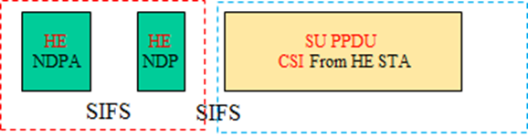
FIG-xxx Example of the sounding protocol with a single HE beamformee
A non-AP HE beamformee that receives a HE NDP Announcement frame for a HE beamformer with which it is associated and that contains the HE beamformee’s AID in the AID subfield of STA Info field, and there is only one STA Info field, shall transmit its HE Compressed beamforming feedback SIFS after receiving the HE NDP. The CH_BANDWIDTH in the TXVECTOR of the PPDU containing the HE compressed beamforming feedback shall be set to indicate a bandwidth not wider than that indicated by the CH_BANDWIDTH of the HE NDP Frame.
An example of HE sounding protocol with more than one HE beamformee is shown in FIG-XXX (Example of the sounding protocol with more than one HE beamformee)
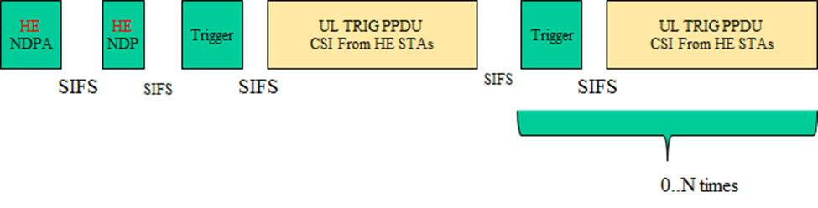
FIG-xxx Example of the sounding protocol with a single HE beamformee
A non-AP HE beamformee that receives a HE NDP Announcement frame from a HE beamforer with which it is associated and that contains the HE beamformee’s AID in any of the STA Info field, and there are multiple STA Info fields in the HE NDP Announcement, shall compute the HE Compressed beamforming feedback after receiving the HE NDP. The STA shall transmit the HE compressed beamforming feedback as a response to a BRP variant Trigger frame that contains the AID of the STA in any of the Per User Info fields following the rules defined in 25.5.2.3 (STA behaviour).
The value of the Sounding Dialog Token Number in the HE MIMO Control field shall be set to the same value as the Sounding Dialog Token Number field in the corresponding HE NDP Announcement frame.
The HE Compressed Beamforming feedback is comprised of the HE Compressed Beamforming Report information and the MU Exclusive Beamforming Report information.

CID | Commenter | PP.LL |  | Comment | Proposed Change |  | Resolution
1222 | Liwen Chu | 25.6 | Whether the fragmentation is allowed in HE sounding is not clear. Make it clear. |  |  | As in comment. | Revised  Agree in principle with the comment.  Added text based on 11ax SFD
TGax Editor: Add the paragraph below (#CID 1222):

25.6.2 Rules for segmented feedback in HE sounding protocol sequences
HE Compressed beamforming feedback shall be transmitted in a single PPDU unless the size of the feedback is greater than 11,454B. The HE beamformer shall support maximum MPDU length for HE Compressed beamforming feedback of size which is the minimum of:
    - 11454 Bytes
    - The size of the HE compressed beamforming feedback requested

CID | Commenter | PP.LL |  | Comment | Proposed Change |  | Resolution
182 | Alfred Asterjadhi | 25.6 | The HE sounding protocol is incomplete. Please clarify the TBDs (NDP Announcement frame format) and also add the missing normative text that covers motions present in the SFD but not reflected in this draft. |  |  | As in comment. | Revised  The NDPA frame description is provided.
971 | kaiying Lv | 76.56 | There is no CQI frame.CQI report is one of the modes of sounding feedback. |  |  | Suggest to change to"Frames transmitted during a broadcast TWT SP are recommended to be limited to: PS-Poll, CQI, QoS Null with buffer status, Sounding Feedback, Management Action..." | Revised  CQI feed back is defined.
2713 | Yuichi Morioka | 61.25 | Subclause 25.6 may be reused for MU of other Measurement protocols defined in subclause 11.11 of REVmc D5.0. |  |  | Add following text as subclause 25.x which includes some modification from the original MU sounding protocol. (Underlined parts were mainly modified from texts in 25.6)  "25.x HE measurement protocol  The HE measurement protocol is initiated by an AP sending an HE Measurement Request frame(TBD) which indicates Measurement type defined in Table9-81(REVmc D5.0).  An HE AP may use the Trigger frame to solicit HE Measurement Report frame from a STA provided that the UL MU Capable field of the most recently received HE Capabilities element from that STA is 1 (see 25.5.2 (UL MU operation)).  An HE AP may solicit Measurement Report frame from multiple STAs sequentially through SU transmission.  An example of the HE Radio measurement protocol using MU operation to solicit report is shown in Figure 25-x [add new figure]."  Also add "Measurement" into reserved Trigger Type field table(p.21 Table 9-ax2) | Rejected  ,  CQI feedback is defined using HE Sounding.

TGax Editor: Add the paragraphs below for (#CID 1222):

9.3.1.20 VHT/HE NDP Announcement frame format
The HE NDP Announcement uses the same Frame Control Type as the VHT NDP Announcement. The frame format of the HE NDP Announcement frame with multiple STA info field is shown in Figure xxx (HE NDP Announcement frame format).
FIG-XXX HE NDP Announcement frame format
Table-XXX HE Sounding Dialog Token
Subfield | Description
Sounding Dialog Token | Bit 1 of the Sounding Dialog Token is set to 1 to indicate HE NDP Announcement

The STA Info for a HE NDP Announcement Frame is shown in FIG – xxx
FIG-XXX STA Info for HE NDP Announcement Frame

The ‘Disambiguition Bit’ is the HE NDP Announcement Frame is set to 1 to prevent a VHT STA from wrongly determining it’s AID in the HE STA Info.
Table-XXX HE NDP Announcement Frame Encoding
Subfield | Description
AID11 | AID11 contains the 11 least significant bits of the AID of a STA expected to process the following HE NDP and prepare the sounding feedback.
Partial BW Info | Inidicates the RU26 Start Index and the RU26 End Index.
Feedback Type + Ng+Codebook | Indicates the feedback type, Ng and the Codebook that the beamformee shall provide feedback.
Disambiguition | Set to 1 to prevent a VHT STA from wrongly determining it’s AID in the HE STA Info
Nc Index | Indicates the number of columns, Nc, in the compressed beamforming feedback matrix  minus 1:  Set to 0 for Nc = 1  Set to 1 for Nc = 2  …  Set to 7 for Nc = 8

The Partial BW Info Field is shown below
FIG-XXX Partial BW Info Field
Table-XXX Partial BW Info Field Encoding
Partial BW Info Field | Description
RU Start Index | The starting RU index indicates the first RU26 for which the HE beamformer is requesting feedback.
RU End Index | The ending RU index indicates the last RU26 for which the HE beamformer is requesting feedback.

The Feedback Type + Ng +Codebook size is shown below
Table-XXX Feedback Type, Ng, codebook size encoding
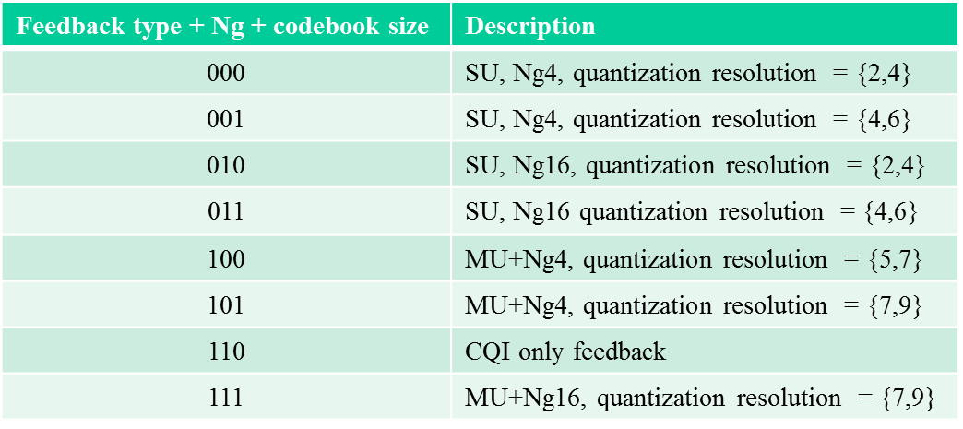

CID | Commenter | PP.LL |  | Comment | Proposed Change |  | Resolution
223 | Alfred Asterjadhi | 79.31 | Define the HE beamforming feedback |  |  | As in comment | Revised –  Agree in pricnciple with the comment. Proposoed resolution accounts for the suggested change.

TGax Editor: Add the paragraphs below (#CID 223):

9.4.1.6x HE MIMO Control Field

Insert the following sentences at the beginning of section 9.4.1.6x:
The HE MIMO Control field is included in every HE Compressed Beamforming frame (see 9.4.1.62. The HE MIMO Control field is defined in Figure xxx (HE MIMO Control field).

FIG-XXX HE MIMO Control Field

The subfields for the HE MIMO Control Fields are defined in Table xxx
Table-xxx HE MIMO Control Field Encoding
Subfield | Description
Nc Index | Indicates the number of columns, Nc, in the compressed beamforming feedback matrix  minus 1:  Set to 0 for Nc = 1  Set to 1 for Nc = 2  …  Set to 7 for Nc = 8
Nr Index | Indicates the number of rows, Nr, in the compressed beamforming feedback matrix minus  1:  Set to 0 for Nr = 1  Set to 1 for Nr = 2  …  Set to 7 for Nr = 8
BW | Indicates the Channel Width that shall be used to determine the starting and ending subcarrier indexes when interpreting the RU Start Index and RU End Index.  Set to 0 for 20 MHz  1 for 40 MHz  2 for 80 MHz  3 for 160 & 80+80 MHz
Grouping | Indicates the subcarrier grouping, Ng, used for the compressed beamforming feedback  matrix:  Set to 0 for Ng = 4  Set to 1 for Ng = 16
Codebook Information | Indicates the size of codebook entries:  If Feedback Type is SU:  Set to 0 for 2 bits for ψ, 4 bits for φ  Set to 1 for 4 bits for ψ, 6 bits for φ  If Feedback Type is MU:  Set to 0 for 5 bits for ψ, 7 bits for φ  Set to 1 for 7 bits for ψ, 9 bits for φ  Νοτε: Τηε χοδεβοοκ σιζε φορ ΜΥ Φεεδβαχκ ωιτη Νγ=16 ισ λιμιτεδ το (9,7)
Feedback Type | Indicates the feedback type:  Set to 0 for SU  Set to 1 for MU  Set to 2 for CQI Feedback (CID #971, 2713)  3 is Reserved
Remaining Feedback Segments | Indicates the number of remaining feedback segments for the associated VHT Compressed  Beamforming frame:  Set to 0 for the last feedback segment of a segmented report or the only feedback  segment of an unsegmented report.  Set to a value between 1 and 6 for a feedback segment that is neither the first nor the last  of a segmented report.  Set to a value between 1 and 7 for a feedback segment that is not the last feedback  segment of a segmented report.  In a retransmitted feedback segment, the field is set to the same value associated with the  feedback segment in the original transmission.
First Feedback Segment | Set to 1 for the first feedback segment of a segmented report or the only feedback segment  of an unsegmented report; set to 0 if it is not the first feedback segment or if the VHT  Compressed Beamforming Report field and MU Exclusive Beamforming Report field are  not present in the frame.  In a retransmitted feedback segment, the field is set to the same value associated with the feedback segment in the original transmission.
RU Start Index | The starting RU index indicates the first RU26 for which the HE beamformer is requesting feedback.
RU End Index | The ending RU index indicates the last RU26 for which the HE beamformer is requesting feedback.
Sounding Dialog  Token Number | The ending RU index indicates the last RU26 for which the HE beamformer is requesting feedback.
In a HE Compressed Beamforming frame not carrying all or part of a HE Compressed Beamforming report, the Nc Index, Nr Index, Channel Width, Grouping, Codebook Information, Feedback Type and Sounding Dialog Token Number are reserved, the First Feedback Segment subfield is set to 0 and the Remaining Feedback Segments subfield is set to 7.

