IEEE P802.11
Wireless LANs
Base MCS and Length Calculation for Extended MCS Set
Date: 2016-05-17
Author(s):
Name | Affiliation | Address | Phone | email
Hiroyuki Motozuka | Panasonic Corporation | 600 Saedo-cho, Tsuzuki-ku, Yokohama, Kanagawa, Japan | +81-45-938-3050 | motozuka.hiroyuki@jp.panasonic.com
Gaius Wee | Panasonic Corporation |  |  | yaohuang.wee@sg.panasonic.com
Takenori Sakamoto | Panasonic Corporation |  |  | sakamoto.takenori@jp.panasonic.com
Lei Huang | Panasonic Corporation |  |  | lei.huang@sg.panasonic.com
Payam Torab | Broadcom Ltd. |  |  | payam.torab@broadcom.com
Assaf Kasher | Intel Corporation |  |  | assaf.kasher@intel.com
Carlos Cordeiro | Intel Corporation |  |  | carlos.cordeiro@intel.com
Alecsander Eitan | Qualcomm Inc. |  |  | eitana@qti.qualcomm.com
HanGyu Cho | LGE |  |  | hg.cho@lge.com
Abstract
This submission proposes to modify the base MCS and Length value in SC header for Extended SC MCS to eliminate the duration calculation error by STAs without Extended SC MCS support.

The changes are relative to Draft P802.11REVmc_D5.4. This contribution is provided as resolution to CID 7142.

Discussion:

The current text in draft 5.4 of REVmc defines the Length field in the PHY SC header to be calculated based on the ratio of modulation and coding rate between Base MCS and actual extended MCS. The formulae are defined in Table 20-18 of Draft 5.4.
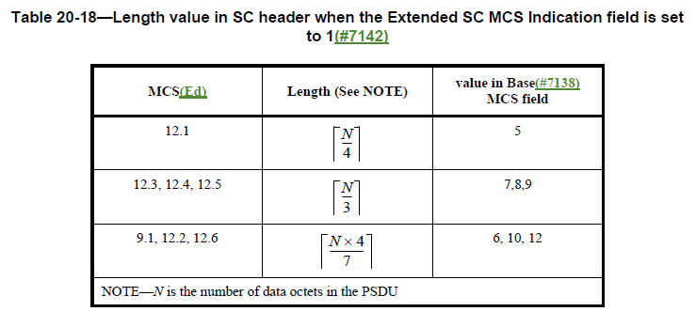
The formulae intend to set Length field value so that a packet with Base MCS and the Length field value has the same PPDU duration to a packet with actual extended MCS and number of octets N. But the formulae cause duration error up to 582 ns for some Ns (number of octets) . This is because the formulae didn’t consider the LDPC code word construction and symbol block construction, i.e., the number of parity bits and padding bits doesn’t derived by the ratio of modulation and coding rate only.

The proposed formulae calculate the Length value based on the number of symbol blocks (N_{BLKS} defined in 20.6.3.2.3.3(LDPC encoding process)) instead of ratio of modulation and coding rate, thus eliminates duration error. Also, the Base MCSs corresponding to extended MCSs are assigned in natural order.

Proposed changes:
All changes are in reference to D5.4

Editor: modify the Description of the Length field in table 20-17 (DMG SC mode header fields) (P2513L49) as follows:
If the Extended SC MCS Indication field is 0,(Ed) indicates the number of data octets in the PSDU; range 1–262 143.
If the Extended SC MCS Indication field is 1, the length of the PSDU is computed according to the following equation:
Length= Base_Length1 - (Base_Length2-N)/4,
where N is the number of data octets in the PSDU, and Base_Length1 and Base_Length2 are computed according to Table 20-18 (Parameters for computing Length field value in SC header when the Extended SC MCS Indication field is set to 1(#7142)). The number of data octets in the PSDU shall not exceed 262 143.(#7142)

Editor: replace the header of table 20-18 (P2515L20) as follows:
Parameters for computing Length field value in SC header when the Extended SC MCS Indication field is set to 1(#7142)

Editor: replace table 20-18 with the following table:

MCS | Base_Length1(Note1,2) | Base_Length2(Note1,3) | value in Base(#7138) MCS field
9.1 | NBLKS×43×42 | NBLKS×5639×68.25 | 6
12.1 | NBLKS×43×52.5 | NBLKS×83×68.25 | 7
12.2 | NBLKS×43×63 | NBLKS×11239×68.25 | 8
12.3 | NBLKS×43×68.25 | NBLKS×210 | 9
12.4 | NBLKS×83×42 | NBLKS×252 | 10
12.5 | NBLKS×83×52.5 | NBLKS×273 | 11
12.6 | NBLKS×83×63 | NBLKS×5613×68.25 | 12
Note1— N_{BLKS} is the number of symbol blocks defined in 20.6.3.2.3.3(LDPC encoding process).
Note2—Base_Length1 is the maximum Length value such that the packet with the base MCS specified in SC header has given N_{BLKS}.
Note3— Base_Length2 is the maximum number of data octets in PSDU such that the packet with the extended MCS has given N_{BLKS}.

Editor: Remove the text in P2515L41-44.:

Editor: Modify the text in P2515L53-57 as follows:
When the MCS belongs to the set {9.1, 12.1, 12.2, 12.3, 12.4, 12.5, 12.6}
bits (X6,X7) of the initial scrambler state are set
to
(Base_Length2-N) mod 4,
where N is the number of data octets in the PSDU, and Base_Length2 is computed according to Table 20-18 (Parameters for computing Length value in SC header when the Extended SC MCS Indication field is set to 1(#7142)). Bits (X1–X5) are set according to the transmitter implementation.

Editor: Remove Table 20-19 (P2516L1)

Editor: modify the value of the Base MCS field in table 20-20 (DMG SC mode modulation and coding schemes(#7138)) (P2516L36) as follows:

MCS | Base MCS Field | Extended SC MCS Indication Field | Modulation | N_{CBPS} | Repetition | Code Rate | Data Rate  (Mb/s)
1 | 1 | 0 | π/2-BPSK | 1 | 2 | 1/2 | 385
2 | 2 | 0 | π/2-BPSK | 1 | 1 | 1/2 | 770
3 | 3 | 0 | π/2-BPSK | 1 | 1 | 5/8 | 962.5
4 | 4 | 0 | π/2-BPSK | 1 | 1 | 3/4 | 1155
5 | 5 | 0 | π/2-BPSK | 1 | 1 | 13/16 | 1251.25
6 | 6 | 0 | π/2-QPSK | 2 | 1 | 1/2 | 1540
7 | 7 | 0 | π/2-QPSK | 2 | 1 | 5/8 | 1925
8 | 8 | 0 | π/2-QPSK | 2 | 1 | 3/4 | 2310
9 | 9 | 0 | π/2-QPSK | 2 | 1 | 13/16 | 2502.5
9.1 | 6 | 1 | π/2-QPSK | 2 | 1 | 7/8 | 2695
10 | 10 | 0 | π/2-16QAM | 4 | 1 | 1/2 | 3080
11 | 11 | 0 | π/2-16QAM | 4 | 1 | 5/8 | 3850
12 | 12 | 0 | π/2-16QAM | 4 | 1 | 3/4 | 4620
12.1 | 7 | 1 | π/2-16QAM | 4 | 1 | 13/16 | 5005
12.2 | 8 | 1 | π/2-16QAM | 4 | 1 | 7/8 | 5390
12.3 | 9 | 1 | π/2-64QAM | 6 | 1 | 5/8 | 5775
12.4 | 10 | 1 | π/2-64QAM | 6 | 1 | 3/4 | 6390
12.5 | 11 | 1 | π/2-64QAM | 6 | 1 | 13/16 | 7507.5
12.6 | 12 | 1 | π/2-64QAM | 6 | 1 | 7/8 | 8085

References:
[1] Draft P802.11REVmc_D5.4
[2] 11-16-0220-03-000m-clause-20-SC-extended-MCSs
[3] 11-16-0541-03-000m- SC-64-QAM-response-to-editor-comments

