IEEE P802.11
Wireless LANs
ARC SC Teleconference Minutes May 2016
Date: 2016-05-04
Author(s):
Name | Affiliation | Address |  | Phone | email
Joseph Levy | InterDigital Communications, Inc. |  | 2 Huntington Quadrangle  4th floor, South Wing  Melville, NY 11747 | +1.631.622.4139 | joseph.levy@interdigital.com
Abstract
Minutes of the IEEE 802.11 ARC Standing Committee teleconference held on 04 May 2016, at 12:00 noon EDT.

Contents:

Wednesday, March 30th, 12:00 noon (EDT) 3

Wednesday, May 4th, 12:00 noon (EDT)

Administration:
Chair: Mark Hamilton, Ruckus
Vice Chair/Secretary Joseph Levy, InterDigital

Meeting call to order by Chair 12:03, 4 May 2016

Proposed Agenda was sent by e-mail via the ARC reflector STDS-802-11-ARC@ieee.org, copied here for reference:

Draft agenda:

- Call to order, patent policy, attendance
- Review presentation on architectural descriptions – Dick Roy (SRA): 11-16-0457-01-0arc-802-11ak-802-1ac-stas-aps-dses-and-convergence-functions.pptx
- AOB
- Adjourn
Note that teleconferences are subject to IEEE policies and procedures, see:
– IEEE Patent Policy
– Patent FAQ
– Letter of Assurance Form
– Affiliation FAQ
– Anti-Trust FAQ
– Ethics
– 802 LMSC P&P
– 802LMSC OM
– 802 WG P&P
– IEEE802.11 WG OM
==================
Administration:
The Chair reminded participants that we are operating under 802.11 policies and procedures as outlined above.

Call for Patents:
The Chair called for potentially essential patents – there was no response to the call.

Attendance:
The following were in attendance:
Mark Hamilton, Ruckus, ARC Chair
Joseph Levy, InterDigital, ARC Vice Chair
Dick Roy, SRA
Philippe Klein, Broadcom
Jon Rosdahl, Qualcomm
Adrian Stephens, Intel

Approval of the Agenda:
The proposed Agenda was agreed

Review presentation on architectural descriptions
This discussion was a continuation of the discussion from the ARC SC Teleconference Meeting of 30 March 2016, minutes for this previous teleconference are available in document 11-16/0503r0.
The following is an abbreviated summary of the discussion:
The chair initiated the discussion approximately where it left off at slide 30 of 11-16/0457r01, provided by Dick Roy, SRA. (Note: Dick had prepared updates to this document but due to events beyond his control he was not able to provide them at this time.)
Slides 30 – The Baggy Pants diagram (copied here for reference):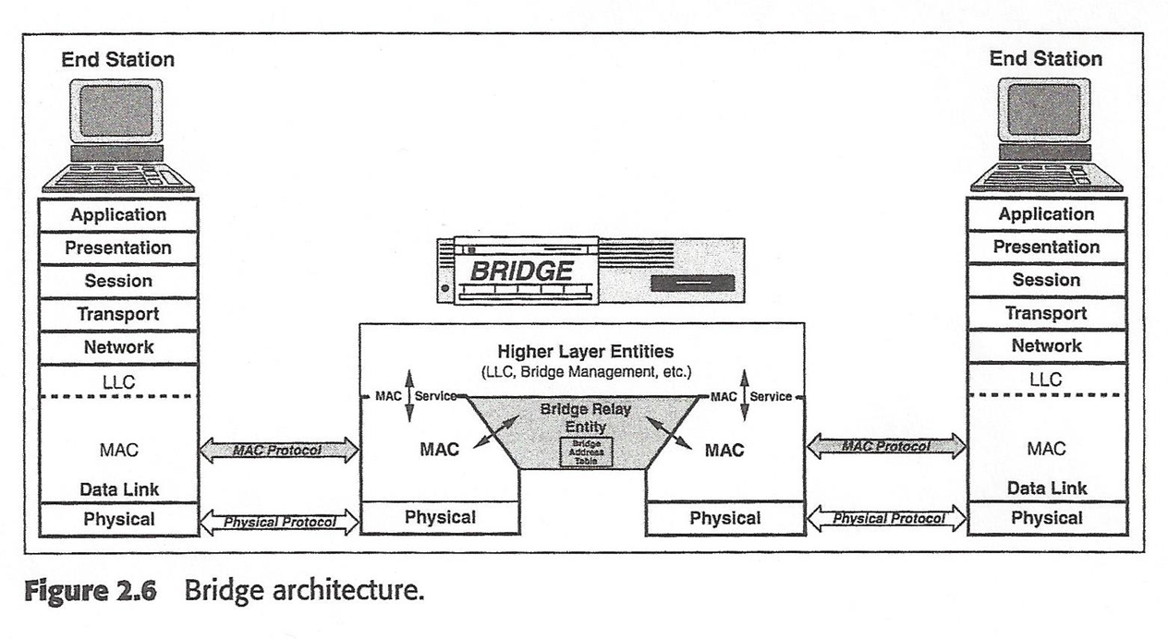

Comment: If the diagonal lines in the Baggy Pants diagram are made vertical lines, then the flow of packets in and out of the bridge with in the MAC layer would be viewed as horizontal and simply as flows in the MAC layer. This would greatly simply the drawing of these flows and allow the architecture to be less complex and clearer. Basically simplifying the diagram as shown on slide 46 of the presentation (copied here for reference):

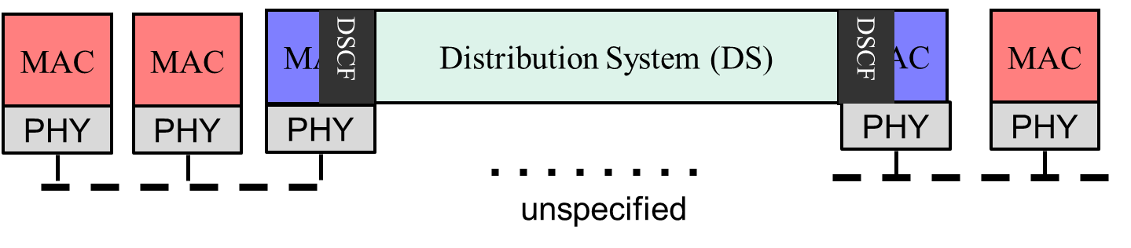
Comment in Response: allowing for horizontal flows does not allow the diagrams to show when a service is being provided or received. The current diagrams all assume that services are provided by the entity the flow is going to. e.g. A flow from the 802.11 MAC to a higher layer entity would such as LLC would be asking the LLC to provide the service of delivering the packet to the appropriate network layer entity. While a flow from the LLC to the 802.11 MAC could be asking the 802.11 MAC to send the flow to the appropriate PHY entity.
The Chair then provided the following diagrams for discussion:
The top diagram is the current view (802.11mc) of how two 802.11 APs in an ESS are connected by the DS. It was pointed out that the DS consists of both MAC and PHY entities, as well as other management and control entities that enable the DS to provide its function of routing and mobility for the ESS.

The lower diagram represents an implementation of the PHY and MAC portions of an ESS built using 802.1Q Bridges. Note this diagram includes two STAs (the ultimate left and right PHY/MAC/Higher Layer entities) connected via wireless interfaces to two AP (the penultimate left and right PHY/MAC entity), which are in turn connected via the PHY/MAC portion of a DS implementation consisting of two 802.1Q Bridge Relays and two PHY/MAC entities that provide for flows between the APs (the DS is 802.1Q Bridges and the antepenultimate left and right PHY/MAC entities).
Consensus of the usefulness of removing the vertical flows shown in the above diagram and replacing them with horizontal flows was not reached. Though the understanding of the various views were clarified.
There was additional discussion regarding not making any new architecture changes to 802.11mc, so that 802.11mc would not be delayed by changes to the architecture diagrams. Though the proposed changes were argued to simplify and clarify the architecture diagrams, consensus was not achieved that these changes would achieve this goal. So it was agreed that the architecture diagrams in 802.11mc should not be changed.
Future sessions / SC activities
No additional teleconferences were scheduled.

The next ARC SC meetings will be at the 802.11 interim meeting May 15-20 2016 in Waikoloa Village, HI, USA, please see posted agenda: 11-16/0518r0
Note several of the teleconference participants are not able to attend the next meeting: Dick Roy, SRA
Philippe Klein, Broadcom.

The Chair adjourned the meeting at 13:32 EDT

