IEEE P802.11
Wireless LANs
NAV setting fixes in DMG network
Date: 2016-05-14
Author(s):
Name | Affiliation | Address | Phone | email
Trainin, Solomon | Intel Corporation |  | 972547885738 | solomon.trainin@intel.com
Carlos Cordeiro | Intel Corporation |  |  | carlos.cordeiro@intel.com
Aharon, Mordechay | Qualcomm |  |  | maharon@qti.qualcomm.com
Assaf Kasher | Intel Corporation |  |  | assaf.kasher@intel.com
Adrian Stephens | Intel Corporation |  |  | adrian.p.stephens@intel.com
Abstract
A DMG CTS frame may contain BF training fields that impact the DMG CTS frame’s length. Impact of the fields on the DMG CTS length is not reflected in the current definition of Setting and resetting the NAV. This contribution proposes text changes to resolve the error

Discussion:
There are two errors in text that defines setting and resetting the NAV in DMG networks.
- The existent text defines: A STA that used information from an RTS frame as the most recent basis to update its NAV setting is permitted to reset its NAV if no PHY-RXSTART.indication primitive is received from the PHY during the TXOP continuation timeout with a duration of (2 x aSIFSTime) + (CTS_Time) + aRxPHYStartDelay + (2 x aSlotTime) starting when the MAC receives a PHY-RXEND.indication primitive corresponding to the end of the RTS frame. The “CTS_Time” shall be calculated using the length of the CTS frame and the data rate at which the RTS frame used for the most recent NAV update was received at.
The existent definition assumes that the CTS_Time is fully predictable because the length of the CTS frame is constant. This assumption is correct for operation in 2.4GHz and 5GHz frequency bands, but it is not correct for DMG (60 GHz) network where the size of the DMG CTS frame depends on variable training fields appended to the end of the CTS frame, which is only known if a STA is able to receive the DMG CTS frame. The training length value may vary from 0 us to almost 91 us. Therefore, using of the length field of the DMG CTS frame to calculate the CTS_Time may cause a substantial difference between expected and real value of the CTS_Time, which results in wrong decision of NAV setup – in fact, the NAV may be not set even if the RTS/CTS handshake succeed and a TXOP is established.
To fix the error a TDMG-CTS time for DMG network is calculated by adding Training Length of the RTS frame multiplied by Length of TRN Unit (2.836us) to the calculated time.
- In the text that is common for non-DMG and DMG networks (10.3.2.4 Setting and resetting the NAV) a PHY-RXSTART.indication primitive that is issued at receive of PLCP Header is used to indicate frame arrival. However in the text that defines DMG specific multiple NAV update preamble detection is used to indicate frame arrival (10.36.10 Updating multiple NAV). Definition in 10.36.10 should be fixed to use the PHY-RXSTART.indication primitive.
Proposed changes:

10.3.2.4 Setting and resetting the NAV
P1300L55

A STA that used information from an RTS frame as the most recent basis to update its NAV setting is permitted to reset its NAV if no PHY-RXSTART.indication primitive is received(#3685) from the PHY during a NAVTimeout period starting when the MAC receives a PHY-RXEND.indication primitive(#5421) corresponding to the detection of the RTS frame.
In non-DMG BSS NAVTimeout is equal to (2 x aSIFSTime) + (CTS_Time) + aRxPHYStartDelay(#1486) + (2 x aSlotTime). The “CTS_Time” shall be calculated using the length of the CTS frame and the data rate at which the RTS frame used for the most recent NAV update was received.
In DMG BSS NAVTimeout period is equal to (2 x aSIFSTime) + TDMG-CTS + StartDelayCompensation + (2 x aSlotTime). Where TDMG-CTS is the duration of a DMG CTS frame calculated using the TXVECTOR TRN-LEN parameter equal to the RXVECTOR TRN-LEN parameter of the received RTS frame and StartDelayCompensation is equal to aSlotTime.
NOTE—This value of StartDelayCompensation is a compromise over the possible values of aRxPHYStartDelay, which are dependent on both the implementation and the DMG PHY mode.

10.36.10 Updating multiple NAV
P1524L30
(#2051)A STA that has updated a NAV(#7491) as a result of the reception of an RTS may reset its
(#7491)NAV(s) as follows. After the NAV(#7491) update for a duration of
NAVTimeout period (10.3.2.4 Setting and resetting the NAV), the STA shall monitor the channel to determine if a PHY-RXSTART.indication primitive is received from the PHY. If such an event has not occurred during this time period, then the STA may reset to 0 any NAV(#7491)(#5463) whose NAV_RTSCANCELABLE value is true.(#5464)

Discussion:
The definition of the PHY-RXEND.indication define it to be the end of the PSDU (8.3.5.14.1). That should mean that it should be generated when the last bit of data is received. However, throughout the draft, the PHY-RXEND.indication is used as the end of on-air transmission, as the determined by the receiving STA. In most PHY clauses the distance between the PHY-RXEND.indication and the end of on air is negligible. However, in DMG PHY the distance can be up to ~50usec, which is much longer from the SIFS (3usec) interval which is started according to this primitive. We therefore propose to change the definition of the PHY-RXEND.indication and to change the receive procedure with the PHY_RXEND.inidication moved to the end of the packet.

Editor: Modify the text in P568L45-47 As follows:
This primitive is an indication by the PHY to the local MAC entity that the PPDU currently being received is complete.

Editor: Modify the text in P2531L1-2 As follows:
At the end of the data portion of a packet that has the Training Length field in the PHY header equal to 0, the PHY shall issue(#5804)a (#1601)PHY-RXEND.indication(No_Error) primitive to the MAC. If the Training Length field in the PHY header is greater than 0
, the PHY(motion_32)shall continue to receive these training fields after the data portion of the packet and measure the channel. (motion_32)After the end of the training fields, the PHY shall generate a (#1601)PHY-CCA.indication(IDLE)(Ed)primitive and the PHY-RXEND.indication(NoError) primitive.

One fix related to SC-64QAM that was missed in the reviews:
Editor: Modify the text in P2514L4-8 as follows:
When the MCS belongs to the set of MCSs {9.1, 12.1, 12.2, 12.3, 12.4 ,12.5 12.6}, bits X1–X7 of the initial scrambler state are set as specified in Table 20-19 (Setting of the initial scrambler state for extended MCSs(#7142)(Ed)).

Editor: Replace figure 20-22 (PHY receive procedure – provided here for reference) with the following figure:
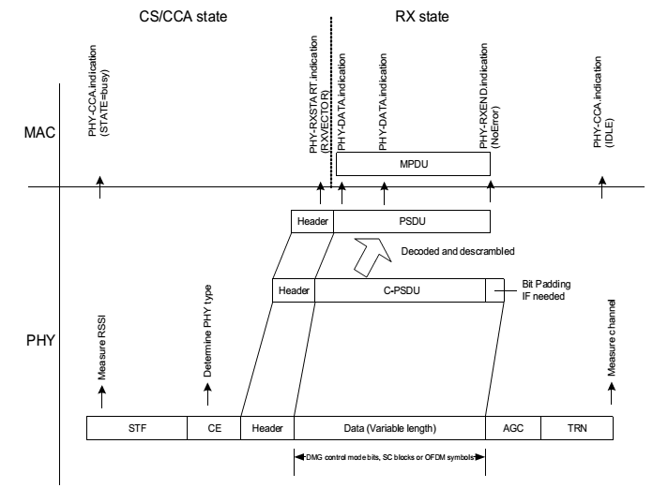

References:
- IEEE P802.11-REVmc/D5.3, April 2016

