IEEE P802.11  
Wireless LANs

|  |  |  |  |  |
| --- | --- | --- | --- | --- |
| Resolution of CID 7085 for D5.0 | | | | |
| Date: 2016-04-27 | | | | |
| Author(s): | | | | |
| Name | Affiliation | Address | Phone | email |
| Graham SMITH | SR Technologies | Davie, FL, USA. | 916 799 9563 | gsmith@srtrl.com |

Abstract

Resolutions for CID 7085 from D5

Green indicates material agreed to in the group,

yellow material to be discussed, red material rejected by the group and

cyan material not to be overlooked.

The “Final” view should be selected in Word.

Withdrawn



**Discussion**

Also note that CIDs 7086, 7087 and 7088 are related to this.

This is tied up with my comments on these related diagrams.

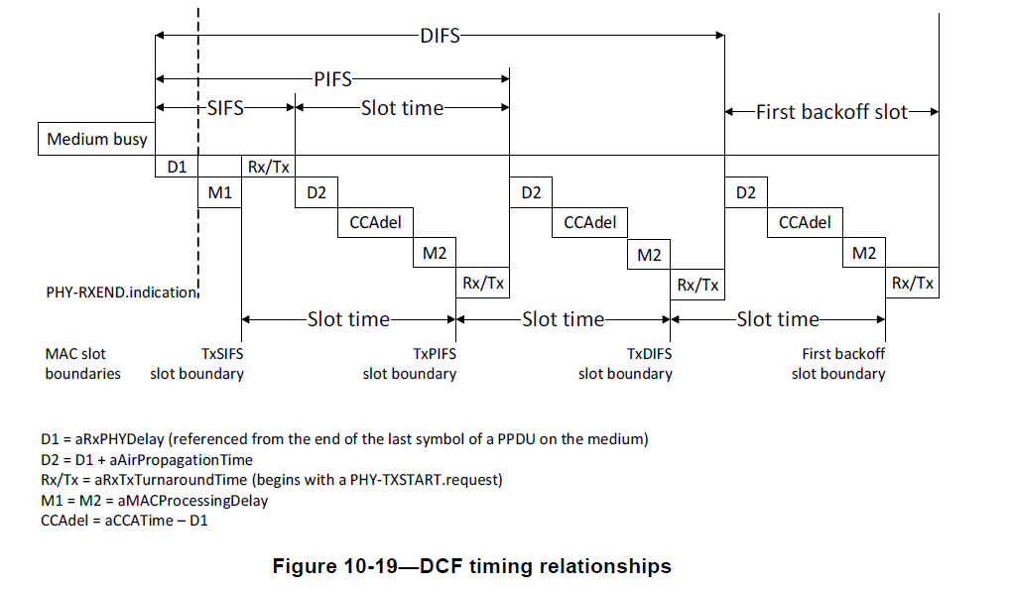

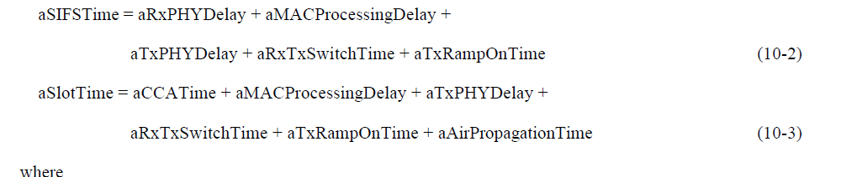

Now as far as the original diagram is concerned the equations are right, but aSIFSTime is not.

SIFS and SlotTime are fixed in the Standard, but all these other bits are not. The only criteria is that all these bit times must completed in a time less than SIFS or SlotTime.

Note that these values have no fixed values at all and are all implementation dependent.

*“The STA may employ any non-negative value for each of the parameters:*

* *aRxPHYDelay*
* *aMACProcessingDelay*
* *aRxTxTurnaroundTime*
* *aTxPHYDelay”*

How, therefore, can the equation 10-2 be correct? Obviously it cannot. There is no criteria that these arbitrary values must add up to be equal to SIFS or TimeSlot, which are fixed values.

In 10-3 the aCCATime makes up the differences so it is correct.

In addition the diagram shows the medium busy condition so backoff must take place. In the proposed diagram this is shown clearer.

**Resolution CID 7085**

REVISED

P1297.39 and 1297.44

aSIFSTime >= aRxPHYDelay + aMACProcessingDelay + aRxTxSwitchTime (10-2)

P534.47 defines aMACProcessingDelay as a fudge factor.

AND

**New Figure 10-19—DCF timing relationships**



*(Aside - Now the diagram shows a backoff situation and the timings make some sense and “agree” with the formula and text)*

REJECT

See P534.47 where the aMACProcessingDelay variable is defined. The equation is accurate, and necessary for that defintion.