IEEE P802.11
Wireless LANs
IEEE 802.11 TGax
March 2016 Macau Meeting Minutes
Date: 2016-03-31
Author(s):
Name | Affiliation | Address | Phone | email
Yasuhiko Inoue | NTT | 1-1 Hikari-no-oka, Yokosuka, Kanagawa 239-0847 Japan | +81 46 859 5097 | inoue.yasuhiko@lab.ntt.co.jp
Abstract
TGax meeting minutes from the IEEE 802.11 Atlanta session, March 14th – 18nd, 2016.

Minutes/motions from the ad hoc groups are contained in the following documents:
- PHY Ad Hoc
  - https://mentor.ieee.org/802.11/dcn/16/11-16-0421-03-00ax-tgax-phy-ad-hoc-march-2016-meeting-agenda.pptx
- MAC Ad Hoc
  - https://mentor.ieee.org/802.11/dcn/16/11-16-0439-01-00ax-mar-2016-macau-tgax-mac-ad-hoc-meeting-minutes.docx
- MU Ad Hoc
  - https://mentor.ieee.org/802.11/dcn/16/11-16-0466-00-00ax-tgax-mu-ad-hoc-meeting-minutes-march-2016.docx
- SR Ad Hoc
  - https://mentor.ieee.org/802.11/dcn/16/11-16-0422-02-00ax-tgax-sr-ad-hoc-march-2016-agenda.pptx

IEEE 802.11 Task Group ax
March 2016 Macau Meeting
Venetian Macau, Macau
March 14th – 18th, 2016

TGax Chair Osama Aboul-Magd (Huawei Technologies)
Vice Chair Simone Merlin (Qualcomm)
Vice Chair Ron Porat (Broadcom)
TGax Secretary Yasuhiko Inoue (NTT)
TGax Technical Editor Robert Stacy (Intel)

Monday, March 14th, 2016, PM1 TGax Session (13:30-15:30)

- The meeting called to order by Osama Aboul-Magd (Huawei Technologies), the chair of the TGax, @13:35
  - About 120 people are in the room.

- Announcement
  - Agenda Doc.11-16/0235r1 on the server. Rev. 2 is the working document.
  - Meeting Protocol: Chair asked to state name and affiliation when speaking for the first time.
  - Attendance reminder.
    - The attendance server: https://imat.ieee.org/

- The chair reviewed the mandatory 5 slides of P&P.
  - Instructions for the WG Chair.
  - Participants, Patents, and Duty to Inform.
  - Patent Related Links.
  - Call for potentially essential patents.
    - Chair asked if anyone is aware of potentially essential patents.
    - No potentially essential patents reported.
  - Other Guidelines for IEEE WG Meetings.

- Agenda items for the week
  - Approve TG and Teleconference minutes since January 2016 meeting.
  - Continue to advance task group documents.
    - Simulation Scenarios
    - Evaluation Methodology
    - Channel Model
    - Function Requirements
    - Specification Framework
  - Ad Hoc meetings
  - Technical Presentations and related straw polls and/or motions.
  - Approve draft D0.1 and start a comment collection process.
  - Schedule Teleconference times.

- General Flow of the meeting
  - Slides 13 and 14 of the 16/0235r1 contain general flow of the meeting.
  - There are eight meeting slots planed for TGax.

 | Monday |  | Tuesday |  | Wednesday |  | Thursday
AM1
AM2 |  |  | TGax  (Ad Hoc) | TGax  (Ad Hoc) |  |  | TGax  (full session)
PM1 | TGax  (full session) |  |  |  | TGax  (Ad Hoc) | TGax  (Ad Hoc)
PM2 |  |  | TGax  (Ad Hoc) | TGax  (Ad Hoc) | TGax  (Ad Hoc) | TGax  (Ad Hoc) | TGax  (full session)
PM3 | TGax  (Ad Hoc) | TGax  (Ad Hoc) | TGax  (full session)

- Call for submissions – we have 48 submissions
  - PHY – 12 submissions
    - 11-15/1354, “SIGA fields and Bitwidths,” Ron Porat (Broadcom)
    - 11-16/0203, “Signalling Support for Full Bandwidth MU-MIMO Compressed SIG-B Mode,” Lei Huang (Panasonic)
    - 11-16/0319, “I-Q Decoupled OFDM: A Solution To I/Q Imbalance,” Shouxing Simon Qu (Blackberry)
    - 11-16/0335, “HE-STF sequences for 160/80+80MHz,” Eunsung Park (LG Electronics)
    - 11-16/0343, “Spectral Mask Discussion,” Hongyuan Zhang (Marvell)
    - 11-16/0344, “PHY Padding Related Issues,” Hongyuan Zhang (Marvell)
    - 11-16/0346, “11ax Pilot Sequence,” Bin Tian (Qualcomm)
    - 11-16/0349, “HE-SIG-B Compression Mode,” Kaushik Josiam (Samsung)
    - 11-16/0367, “Power Scaling of L-LTF and L-STF,” Yakun Sun (Marvell)
    - 11-16/0389, “Sounding Design,” Sriram Venkateswaran (Broadcom)
    - 11-16/0395, “Preamble transmission for Uplink OFDMA,” Ming Gan (Huawei)
    - 11-16/0397, “HE-SIG-B Signaling Discussions,” John Son (WILUS Institute)

  - MAC – 18 submissions
    - 11-16/0297, “Results for beacon collisions,” Evgeny Khorov (IITP RAS)
    - 11-16/0345, “Simultaneous NAK for MU GCR-BA,” Jinsoo Ahn (Yonsei Univ.)
    - 11-16/0347, “Fragmentation for MU frames-Follow up on parameters,” Alfred Asterjadhi (Qualcomm)
    - 11-16/0352, “Considerations on MU initial link setup,” Woojin Ahn (Yonsei Univ.)
    - 11-16/0353, “MU-RTS/CTS for TWT Protection,” Hanseul Hong (Yonsei Univ.)
    - 11-16/0358, “Maximal A-MPDU Size,” Liwen Chu (Marvell)
    - 11-16/0359, “Management ACK,” Liwen Chu (Marvell)
    - 11-16/0361, “Ack Policy of UL MU frame,” Jeongki Kim (LG Electronics)
    - 11-16/0362, “Multi-TID Aggregation Limit,” Chittabrata Ghosh (Intel)
    - 11-16/0365, “Multi-STA BA Design,” Xiaofei Wang (InterDigital)
    - 11-16/0368, “MAC padding options for legacy trigger frame,” Zhou Lan (Broadcom)
    - 11-16/0369, “M-BA aggregated trigger frame,” Zhou Lan (Broadcom)
    - 11-16/0377, “Sounding Sequences Clarifications,” Simone Merlin (Qualcomm)
    - 11-16/0378, “Extended BA Bitmap,” Simone Merlin (Qualcomm)
    - 11-16/0383, “RU Signaling in Trigger Frame,” Yunbo Li (Huawei)
    - 11-16/0396, “Issues on BSS Color Bits Collision,” Geonjung Ko (WILUS Institute)
    - 11-16/0399, “Considerations on Trigger Frame for Random Access Procedure,” Evgeny Khorov (IITP RAS)
    - 11-16/0404, “BlockAck-Bitmap,” Dengyu Qiao (Huawei)

  - SR – 7 submissions
    - 11-16/0212, “Enterprise Scenario DSC and Color,” Graham Smith (SR Technplogies)
    - 11-16/0310, “DSC Proposed Text,” Graham Smith (SR Technplogies)
    - 11-16/0350, “Enterprise Scenario TPC and DSC,” Graham Smith (SR Technplogies)
    - 11-16/0360, “Simulation results of spatial reuse with various MCSs,” Junichi Iwatani (NTT)
    - 11-16/0382, “Discussion on Spatial Reuse Operations in 11ax,” Yunbo Li (Huawei)
    - 11-16/0403, “Spatial Re-Use with Adaptive CCA and TPC Simulation,” Frank Hsu (MediaTek)
    - 11-16/0414, “Adjustment Rules for Adaptive CCA and TPC,” James Wang (MediaTek)

  - MU – 6 submissions
    - 11-16/0331, “Power Control for Multi-User Transmission in 802.11ax,” Kome Oteri (InterDigital)
    - 11-16/0333, “Issue related to unused UL OFDMA RUs,” Stephane Baron (Canon)
    - 11-16/0340, “Random Access UL MU Resource Allocation and Indication,” Leonardo Lanante (Kyushu Institute of Technology)
    - 11-16/0371, “Further consideration for MU-RTS/CTS,” Jin Ma (NICT)
    - 11-16/0379, “Trigger Frame Format,” Simone Merlin (Qualcomm)
    - 11-16/0413, “Power Control for UL MU,” Arjun Bharadwaj (Qualcomm)

  - TG – 5 submissions
    - 11-15/1095, “OFDMA Performance in 11ax,” Suhwook Kim (LG Electronics)
    - 11-16/0066, “Views on UL MU Features,” Joonsuk Kim (Apple)
    - 11-16/0355, “Snapshot of Residential Use 2016,” Carol Ansley (ARRIS Group)
    - 11-16/0364, “AID Assign Rules Based on BSS Color and HE Operation Element,” Jianhan Liu (MediaTek)
    - 11-16/0394, “Achieving High Efficiency in Medium Access via Roster Mode,” Sean Coffey (RealTek)

  - Ad Hoc meeting scheduling
    - Ad Hoc slot assignment
      - MAC … 4, PHY … 2, SR … 2, MU … 2.
    - Chair asked if there are any objections to approve the TGax schedule as follow.
      - There are no objections. The TGax schedule is approved.

 | Monday |  | Tuesday |  | Wednesday |  | Thursday
AM1
AM2 |  |  | TGax  (PHY) | TGax  (MAC) |  |  | TGax  (full session)
PM1 | TGax  (full session) |  |  |  | TGax  (PHY) | TGax  (MAC)
PM2 |  |  | TGax  (SR) | TGax  (MAC) | TGax  (MAC) | TGax  (MU) | TGax  (full session)
PM3 | TGax  (SR) | TGax  (MU) | TGax  (full session)

- Agenda for Monday, March 14th, PM1 (13:30 – 15:30).
  - Proposed Agenda for Monday PM1:
    - Call meeting to order
    - Patent policy, etc.
    - Call for submissions
    - Set Ad Hoc Groups schedule and approve agenda
    - Summary from January 2016 meeting
    - SFD review – Editor
    - TG motions
      - Approve TG meeting and Telecon minutes since January 2016 meeting.
      - Approve the latest SFD revision
    - Timeline
    - Ad Hoc group Rules
    - Presentations
      - 11-16/0066r5, “Views on UL MU Features” Joonsuk Kim
      - 11-15/1095r6, “OFDMA Performance in 11ax” Suhwook Kim
    - Recess

  - Chair asked if there are any other items – No items proposed. Meeting will be conducted based on this order.

- Summary from January 2016 Meeting
  - Passed a number of affecting aspects of the TG Specification Framework.
    - PHY
    - MAC
    - MU
  - Latest revisions of the Specification Framework is available at:
    - https://mentor.ieee.org/802.11/dcn/15/11-15-0132-16-00ax-spec-framework.docx
  - Presentation on draft TG specification 11-16/0024r0
  - The TG conducted a couple of Teleconferences (Feb 4th , and March 3rd )
    - https://mentor.ieee.org/802.11/dcn/16/11-16-0212-00-00ax-enterprise-scenario-dsc-and-color.pptx
    - https://mentor.ieee.org/802.11/dcn/16/11-16-0024-01-00ax-proposed-draft-specification.docx
    - https://mentor.ieee.org/802.11/dcn/16/11-16-0297-00-00ax-results-for-beacon-collisions.pptx
  - Chair asked if there is any addition, modification or correction – No response.

- TG Motions

  - Motion: Approve TGax minutes of meetings and teleconferences from January 2016 interim meeting to today:
    - https://mentor.ieee.org/802.11/dcn/16/11-16-0096-02-00ax-tgax-january-2016-atlanta-meeting-minutes.docx
    - https://mentor.ieee.org/802.11/dcn/16/11-16-0262-01-00ax-tgax-teleconference-minutes-february-4th-2016.docx
    - https://mentor.ieee.org/802.11/dcn/16/11-16-0301-01-00ax-tgax-teleconference-minutes-march-3rd-2016.docx
    - https://mentor.ieee.org/802.11/dcn/16/11-16-0150-00-00ax-tgax-mu-ad-hoc-meeting-minutes-january-2016.docx
    - https://mentor.ieee.org/802.11/dcn/16/11-16-0110-00-00ax-jan-2016-atlanta-tgax-mac-ad-hoc-meeting-minutes.docx
    - https://mentor.ieee.org/802.11/dcn/16/11-16-0119-00-00ax-ieee-802-11-tgax-january-2016-atlanta-phy-ad-hoc-meeting-minutes.docx

    - Moved: Al Petrick, Second: Yasu Inoue
    - Discussion: No discussion.
    - Result: The motion was accepted with no objection.

  - SFD Review and Motion
    - Robert Stacy went through the latest revision of the TGax Specification Framework document (11-15-0132-15)
      - PHY
      - MAC

    - Move to accept document 11-15/0132r15 as the current revision of the TG Specification Framework document.

    - Moved by Robert Stacy, Seconded by Rakesh Taori.
    - Discussion: No discussion.
    - Result: The motion was accepted with no objection.

- Timeline
  - Slide 25 of the agenda document

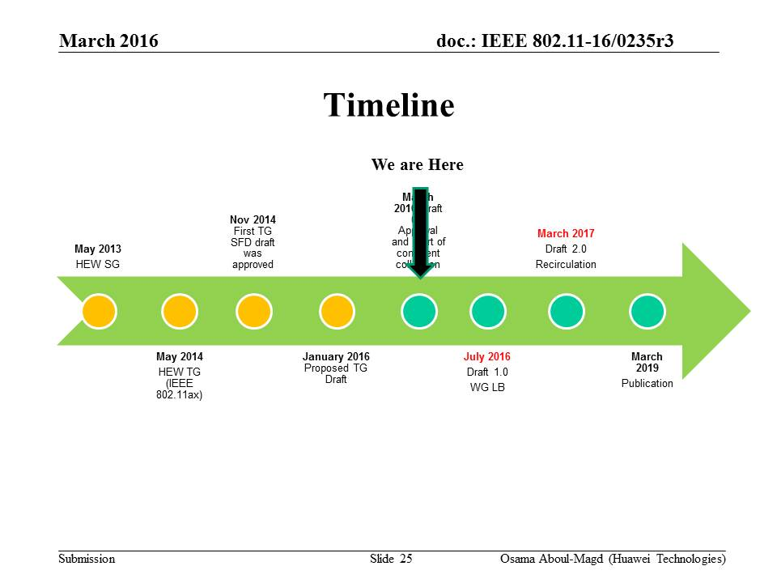

  - Plan is;
    - To approve draft D0.1 and start comment collection process..
    - Creation of draft D1.0 is July 2016. Considering the period of comment collection and resolution, creation of draft D1.0 may be September 2016.

- Ad Hoc Group Rules
  - A straw poll needs to achieve at least 75% at the ad-hoc level to be converted to a motion at the TG level.
  - In the case a consensus cannot be reached within an Ad Hoc group (a stalemate that prohibits further progress), the subject is moved to the Task group, if an Ad Hoc straw poll vote to move the subject to the Taskgroup achieves > 50% approval.
  - A straw poll affecting the Spec Framework has to start with,
    - Do you agree to add to the TG Specification Frame work document?
      - x.y.z. <feature description>
  - For further details, please see 11-15-0075r0
  - Minutes of the Ad Hoc group meetings will be available on mentor.

- Presentations
  - Joonsuk Kim (Apple) presented “Views on UL-MU features (SPs only Part I)” based on the submission 11-16-0066-05.
    - This submission was presented during the last meeting. Only the straw polls are conducted.

    - Straw Polls
      - Straw Poll #1: Do you agree to add following text in SFD?
- A non-AP STA that is UL MU-MIMO Tx capable shall support DL MU-MIMO Rx
      - Discussion – No discussion.
      - Result: Y/N/A = 67/0/12. This straw poll will be converted to a motion.

      - Straw Poll #2: Do you agree to add following text in SFD?
- A non-AP STA that is UL OFDMA Tx capable shall support DL OFDMA Rx
      - Discussion – No discussion.
      - Result: Y/N/A = 66/0/9. This straw poll will be converted to a motion.

  - Suhwook Kim (LG Electronics) presented “OFDMA Performance in 11ax” based on the submission 15/1095r6.
    - Summary:
      - Updated Simulations Results of OFDMA considering following points;
        - MU-RTS/CTS
        - Preamble detection @ STA side.
        - BSS channelization
      - Simulation results showed marginal performance gain for the scenario in slide 9.
      - Next step is to include more features being discussed in TGax such as RTS/CTS for UL-OFDMA contention and Dense AP scenarios, channel feedback model and sophisticated scheduler.
    - Discussions:
      - No discussion.

  - Carol Ansley (ARRIS Group) presented “” based on the submission 16/0043r0.
    - Summary:
      - A snapshot of data that is relevant to 11ax simulation scenarios and goals.
      - This snapshot of current behavior can be compared to the simulation models as a checkpoint.
    - Discussions:
      - A member asked about the 5GHz devices if they are 802.11n or 802.11ac – The answer is it is hard to tell.
      - Another member asked for a clarification on the graph.
      - There are questions about the measurement conditions such as place and time.

- AoB
  - PM2 is ad hoc sessions
    - SR – Venetian A&B, Level 3.
    - MU – Florence 2305 + 2306, Level 1.

- TGax meeting recessed @ 15:16 until Tuesday evening (19:30).
There will be ad hoc sessions this evening during PM3 (EVE) session.

Monday, March 14th, 2016, PM3 TGax Ad Hoc Sessions (19:30-21:30)

- SR Ad hoc – Venetian Ballroom A&B, Level 3
  - Agenda: 11-16-0422

- MU Ad hoc – Florence 2305 & 2306, Level 1
  - Agenda: 11-16-0419

Tuesday, March 15th, 2016, AM2 TGax Ad Hoc Sessions (10:30-12:30)

- PHY Ad hoc – Venetian Ballroom A&B, Level 3
  - Agenda: 11-16-0421

- MAC Ad hoc – Florence 2202 + 2203 + 2302 + 2303, Level 1
  - Agenda: 11-16-0427

Tuesday, March 15th, 2016, PM2 TGax Ad Hoc Sessions (16:00-18:00)

- SR Ad hoc – Venetian Ballroom A&B, Level 3
  - Agenda: 11-16-0422

- MAC Ad hoc – Florence 2202+2203+2302+2303, Level 1
  - Agenda: 11-16-0427

Tuesday, March 15th 2016, PM3 TGax full Session (19:30-21:30)
- The meeting called to order by Osama Aboul-Magd (Huawei Technologies), the chairperson of TGax, @19:35.
  - Agenda 11-16/0235r3 is on the server. Rev 4 is working document.

- Administrative Items
  - Chair reminded the IEEE 802 and IEEE 802.11 P&P.
  - Chair asked people to address himself/herself when speaking for the first time.
  - Attendance

- Agenda for this session
  - Proposed Agenda for Tuesday PM3
    - Call Meeting to order
    - IEEE 802 and 802.11 IPR Policy and procedure
    - Agenda Setting
    - Progress Review
    - Presentations
      - https://mentor.ieee.org/802.11/dcn/16/11-16-0364-02-00ax-aid-assign-rules-based-on-bss-color-and-he-operation-element.pptx
      - https://mentor.ieee.org/802.11/dcn/16/11-16-0394-00-00ax-achieving-high-efficiency-in-medium-access-via-roster-mode.pptx

    - Recess
  - Chair asked if there are any objections to proceed with this agenda – no objections.
    - The agenda approved.

- Progress Review
  - Status of each ad hoc
    - SR – completed the work in PM2 today.
    - PHY – 9 presentations finished. 2 presentations left for tomorrow PM1.
    - MU – 2 submissions left. Will finish the work in PM2 tomorrow.
    - MAC – 7 submissions are left. Have enough time to finish the work.
  - No arrangement will be needed.

- Presentations
  - Jianhan Liu (MediaTek) presented “AID Assign Rules Based on BSS Color and HE Operation Element” based on the submission 16/0364r2.
    - Summary
      - An AID assign rule based on partial BSS color is proposed that enables HE devices to identify the BSS color of both HE packets and VHT packets.
      - An HE operation element IE to make the propose AID assign rule optional.
    - Discussions
      - .

    - Straw Poll: Do you agree to add the following AID assign rule to the IEEE 802.11ax SFD?
The AP may send a TBD IE that includes a field 'N‘. If the value indicated by the field N is greater than 0, then the AP shall allocate AIDs according to the formula

- The TBD IE contains the number of partial BSS color bits used and the partial BSS color bits
      - Discussion: No discussion.
      - Result: Y/N/A = 57/0/13. This straw poll will be converted to a motion.

  - Sean Coffey (RealTek) presented “Achieving High Efficiency in Medium Access via Roster Mode” based on the submission 16/0394r0.
    - Summary
      - Rosters (i.e., ordered lists) greatly reduce EDCA medium access overhead, by providing 11ax devices with predictable and unique backoff slots, and without requiring scheduling or duration information.
      - This presentation extends the previous ones, via:
A—an intuitive development showing how this mode naturally fits with ordinary EDCA;
B—results showing throughput gains (where the challenge is to make these gains be low); and
C—a motion
    - Discussions
      - A member is not happy with the text in straw poll saying “no two STAs are permitted to transmit simultaneously” since it is one mode of operation agreed in TGax.
      - A member commented that different interference conditions are not considered in the analysis. Also the possibility of collision needs to be taken into account.
      - Another member asked for a clarification on the roster procedure if it is centralized control. The answer is it is still based on the EDCA.
      - There was a question about OBSS interference. A protection mechanism can be used for that case.

    - Straw Poll: Do you agree to add to the SFD:
The 11ax specification shall include at least one mode of operation in which:
- an AP may specify the order (within some specified time period) in which (a specified set of) STAs are permitted to transmit,
- no two STAs are permitted to transmit simultaneously,
- the durations of the STA transmissions are not signalled in advance of their commencement, and
- a STA’s starting transmission time is determined by the actual (rather than scheduled) end of the previous STA’s transmission
      - The straw poll was deferred since people need more time to think about it.

- Discussion: Draft Approval and Comment Collection Process
- Discussion
  - May and July sessions will be spent for the comment resolution.
  - A member asked at least 21 days for comment collection period.
  - Another member asked for the process after 21 days.
    - Prepare comment spreadsheet.
    - Start comment resolution by teleconferences.
  - Chair mentioned that July may not be a realistic timeline to approve the draft 1.0.
- Plans
  - Approval of document 11-16/0024r1 as draft D0.1
  - Start a comment collection (CC) period for 21 days on the draft (D0.1)
  - Draft D0.1 will be modified as a result of two inputs:
    - Resolution of comments received during the CC period.
    - New features (can be part of the CC, i.e new features can be submitted as part of the comment resolution).
  - A new draft (D0.2) will be generated in YYYY and may go to another CC period (??)
  - Draft 1.0 in September 2016.

- AoB
  - None

- Recess @ 21:15 until Thursday AM2. There will be ad hoc sessions in Wednesday PM1 and PM2.

Wednesday, March 16th 2016, PM1 TGax Ad Hoc Sessions (13:30-15:30)
- PHY ad hoc Venetian A&B (L3)
  - Agenda: 11-16-0421

- MAC ad hoc Florence 2202+2203+2302+2303 (L1)
  - Agenda: 11-16-0427

Wednesday, March 16th 2016, PM2 TGax Ad Hoc Sessions (16:00-18:00)
- MU ad hoc Venetian A&B (L3)
  - Agenda: 11-16-0419

- MAC ad hoc Florence 2202+2203+2302+2303 (L1)
  - Agenda: 11-16-0427

Thursday, March 17th, 2016, AM2 TGax full Session (10:30-12:30)

- The meeting called to order by Osama Aboul-Magd (Huawei Technologies), the chairperson of the TGax, @10:30 AM
  - Agenda 16/0235r6 is on the server. Rev. 7 is the working document.

- Announcement/Reminder
  - Chair reminded IEEE 802 and 802.11 IPR P&P.
  - Chair asked people to state name and affiliation when addressing for the first time in the session.
  - Chair reminded people to do attendance.

- Agenda for this session
  - Thursday AM2 and PM2
    - Call Meeting to order
    - Announcement/Reminder
      - IEEE 802 and 802.11 IPR Policy and procedure.
      - Attendance
    - Agenda Setting
    - Presentations (if any)
    - TG Motions
    - Timeline update
    - Goals for May 2016
    - Conference Calls Schedule
    - AOB
    - Adjourn
  - Chair asked if there are any modifications to the agenda.
  - Agenda approved without objections.

- Presentations – No presentation left.

- Motions – TG documents

  - Draft 0.1 Motion
    - Move to accept document 11-16/0024r1) as the TG draft specification D0.1, and start a 21 day comment collection period.
      - https://mentor.ieee.org/802.11/dcn/16/11-16-0024-01-00ax-proposed-draft-specification.docx
    - Moved by Robert Stacy, Seconded by Simone Merlin.
    - Discussion – No discussion.
    - Result: Y/N/A = 75/0/5, motion passes.

  - PHY Motions
    - PHY Motion #132: Move to add the following 1x/2x HE-STF sequences for 160/80+80MHz to the 11ax SFD.

      - 1x HE-STF_{160MHz}(-1008:16:1008) = [M, 1, -M, 0, -M, 1, -M, 0, -M, -1, M, 0, -M, 1, -M] *(1+j)/sqrt(2)
        - M = {-1 -1 -1 +1 +1 +1 -1 +1 +1 +1 -1 +1 +1 -1 +1}
      - 1x HE-STF_{80+80MHz} = [1x HE-STF_{80MHz,Prime}, 1x HE-STF_{80MHz,Second}]
        - 1x HE-STF_{80MHz,Prime}(-496:16:496) = [M, 1, -M, 0, -M, 1, -M] *(1+j)/sqrt(2)
        - 1x HE-STF_{80MHz, Second}(-496:16:496) = [-M, -1, M, 0, -M, 1, -M] *(1+j)/sqrt(2)
      - 2x HE-STF_{160MHz}(-1016:8:1016) = [M, -1, M, -1, -M, -1, M, 0, -M, 1, M, 1, -M, 1, -M, 0,
-M, 1, -M, 1, M, 1, -M, 0, -M, 1, M, 1, -M, 1, -M] *(1+j)/sqrt(2)
        - 2x HE-STF_{160MHz}(±1016) = 0
        - 2x HE-STF_{160MHz}(±8) = 0
      - 2x HE-STF_{80+80MHz} = [2x HE-STF_{80MHz,Prime}, 2x HE-STF_{80MHz,Second}]
        - 2x HE-STF_{80MHz,Prime}(-504:8:504) = [M, -1, M, -1, -M, -1, M, 0, -M, 1, M, 1, -M, 1, -M] *(1+j)/sqrt(2)
- 2x HE-STF_{80MHz,Prime}(±504) = 0
        - 2x HE-STF_{80MHz, Second}(-504:8:504) = [-M, 1, -M, 1, M, 1, -M, 0, -M, 1, M, 1, -M, 1, -M] *(1+j)/sqrt(2)
          - 2x HE-STF_{80MHz,Second}(±504) = 0

      - Moved by Eunsung Park, Seconded by Ron Porat.
      - Discussion: No discussion.
      - Result: The motion was accepted with no objection.

    - PHY Motion #133: Move to add to the following text in SFD chapter 3.4:
      - For 20MHz PPDU, the transmit spectrum shall not exceed the maximum of the interim transmit spectral mask and –53 dBm/MHz at any frequency offset, for both 2.4GHz and 5GHz bands.
      - For 40MHz PPDU, the transmit spectrum shall not exceed the maximum of the interim transmit spectral mask and –56 dBm/MHz at any frequency offset, for both 2.4GHz and 5GHz bands.
      - For 80MHz and 160MHz PPDUs, the transmit spectrum shall not exceed the maximum of the interim transmit spectral mask and –59 dBm/MHz at any frequency offset.

      - Moved by Hongyuan Zhang, Seconded by Ron Porat.
      - Discussion: No discussion.
      - Result: The motion was accepted with no objection.

    - PHY Motion #134: Move to replace Table-3 NSD.short in 3.3.5 Padding and packet extension of SFD to the following table
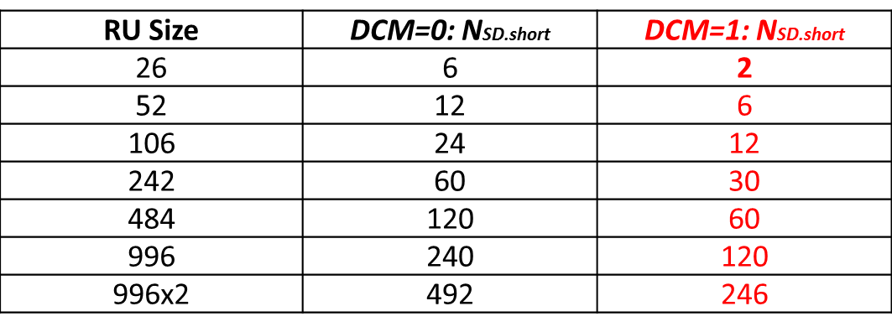
      - Moved by Hongyuan Zhang, Seconded by Ron Porat.
      - Discussion: No discussion.
      - Result: The motion was accepted with no objection.

    - PHY Motion #135: Move to add the following text in SFD 3.3.5.
  - The post-FEC bits are un-specified by 11ax spec.
  - The content of PE field is un-specified by 11ax spec.

      - Moved by Hongyuan Zhang, Seconded by Ron Porat.
      - Discussion – No discussion
      - Result: The motion was accepted with no objection.

    - PHY Motion #136: Move to add a Doppler bit in SIGA for HE SU and HE SU extended range, in TBD location for HE MU and in the trigger frame.

      - Moved by Ron Porat, Seconded by Yasu Inoue.
      - Discussion – No discussion.
      - Result: The motion was accepted with no objection.

    - PHY Motion #137: Move to add to the spec framework : 1bit is added for STBC indication in SIGA of the MU PPDU
        - This bit indicates STBC for all users in the payload and doesn’t apply to SIGB
        - STBC is not applied in MU-MIMO Rus

      - Moved by Ron Porat, Seconded by Yasu Inoue.
      - Discussion – No discussion.
      - Result: The motion was accepted with no objection.

    - PHY Motion #138: Move to add to the TG Specification Frame work document:
- in trigger based UL PPDUs, multiple SR fields (>=2) are signaled, where each SR field corresponds to a different subband of the PPDU

      - Moved by Ron Porat, Seconded by Yasu Inoue
      - Discussion – No discussion.
      - Result: The motion was accepted with no objection.

    - PHY Motion #139: Move to add to agree that 11ax pilot sequences shall reuse the 11ac/ah pilot sequences as shown in slides 13 and 14 in the document 11-16/0346r0.

      - Moved by Bin Tian, Seconded by Ron Porat.
      - Discussion – No discussion.
      - Result: The motion was accepted with no objection.

    - PHY Motion #140: Move to agree that 11ax pilot sequence shall be applied in the same way as in 11ac SSP
- Pilot values are shifted on pilot tones from symbol to symbol for each RU
- Overlaying pilot polarity value: same as in 11ac

      - Moved by Bin Tian, Seconded by Ron Porat
      - Discussion – No discussion.
      - Result: The motion was accepted with no objection.

    - PHY Motion #141: Move to add the following description to the SIGB number of symbols fields in Table 2 in the SFD: HE-SIG-A fields for the HE MU PPDU of the SFD:

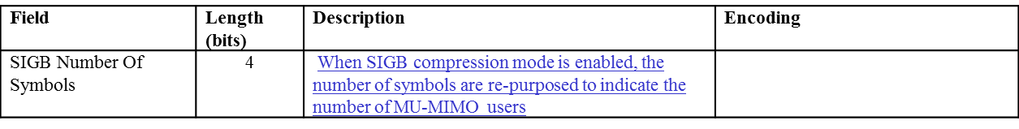

      - Moved by Kaushik Josiam, Seconded by Ron Porat.
      - Discussion – No discussion.
      - Result: The motion was accepted with no objection.

    - PHY Motion #142: Move to modify the HE-SIG-B compression mode description in the SFD [Page 9, line 2-4 in 11-15-0132-15-00ax-spec-framework.docx] as follows:
- In an HE MU PPDU the HE-SIG-A field shall indicate the number of STAs when full bandwidth MU-MIMO compressed SIG-B mode is indicated. Details are TBD. When SIGB compression mode is enabled, the SIGB number of symbols are re-purposed to indicate the number of MU-MIMO users
- [PHY Motion 111, Janaury 2016, see [26]]

      - Moved by Kaushik Josiam, Seconded by Ron Porat
      - Discussion – No discussion.
      - Result: The motion was accepted with no objection.

    - PHY Motion #143: Move to modify the HE-SIG-B compression mode description in the SFD [Page 9, line 2-4 in 11-15-0132-15-00ax-spec-framework.docx] as follows:
- A compression bit is carried in the HE-SIG-A MU format to differentiate full BW MU-MIMO from OFDMA MU PPDU. In case of full BW MU-MIMO, the following conditions hold:
- Only applicable for RU sizes 242, 484, 996, 2*996
- The RU information in HE-SIG-B common field is not signalled.
- For bandwidth > 20 MHz, the user specific sub-fields are split equitably between the two HE-SG-B Channels i.e, For k user MU-MIMO PPDU, 1, … $\left\lceil k/2\right\rceil$ use specific sub-fields in HE-SIG-B channel 1 and $\left\lceil k/2\right\rceil$ + 1, … , k user specific sub-fields in HE-SIG-B channel 2.
- [PHY Motion 111, Janaury 2016, see [26]]

      - Moved by Kaushik Josiam, Seconded by Ron Porat
      - Discussion – No discussion.
      - Result: The motion was accepted with no objection.

    - PHY Motion #144: Move to modify the current SFD as following
- The L-SIG, RL-SIG, HE-SIG-A and HE-SIG-B fields are always transmitted with same total power per tone as L-LTF field (in cases when L-LTF is not being boosted). The L-STF has the same total power as the L-LTF.

      - Moved by Lei Wang, Seconded by Ron Porat
      - Discussion – No discussion.
      - Result: The motion was accepted with no objection.

    - PHY Motion #145: Move to add to the spec framework that
- The tones used for channel feedback shall be a subset of the sets given below:
- NDP bandwidth 20 MHz:
- Ng = 4 [-120:4:-4:4:4:120] + edge (±2,±122)
- Ng = 16 [-116:16:-4:4:16:116] + edge (±2,±122)

- NDP bandwidth 40 MHz:
- Ng = 4/16 [-244:Ng:-4:4:Ng:244]

- NDP bandwidth 80 MHz:
- Ng = 4/16 [-500:Ng:-4:4:Ng:500]

      - Moved by Sriram Venkateswaran, Seconded by Ron Porat
      - Discussion – No discussion.
      - Result: The motion was accepted with no objection.

    - PHY Motion #146: Move to add to the spec framework that
- 2X HE-LTF sequence shall be the only mandatory mode for NDP. 4X HE-LTF shall not be supported in NDP.

      - Moved by Sriram Venkateswaran, Seconded by Ron Porat
      - Discussion – No discussion.
      - Result: The motion was accepted with no objection.

    - PHY Motion #147: Move to add to the spec framework that
- The NDP always has extension of 4uS.
- The NDP shall support the CP values 0.8 us and 1.6 us.

      - Moved by Sriram Venkateswaran, Seconded by Ron Porat
      - Discussion – No discussion.
      - Result: The motion was accepted with no objection.

    - PHY Motion #148: Move to add to the spec framework that
- AP can request beamforming feedback over partial BW which is less than the NDP BW. The indication of the feedback BW goes in NDPA.

      - Moved by Sriram Venkateswaran, Seconded by Ron Porat
      - Discussion – No discussion.
      - Result: The motion was accepted with no objection.

    - PHY Motion #149: Move to add to the spec framework that
- The granularity of channel feedback requested by the AP is a 26 tone RU. The AP signals start and end 26 tone RUs requested for feedback.

      - Moved by Sriram Venkateswaran, Seconded by Ron Porat
      - Discussion – No discussion.
      - Result: The motion was accepted with no objection.

    - PHY Motion #150: Move to add to the spec framework that
- The max Nc for sounding feedback that a BFee can support shall be negotiated through a capability exchange at association.

      - Moved by Sriram Venkateswaran, Seconded by Ron Porat
      - Discussion – No discussion.
      - Result: The motion was accepted with no objection.

    - PHY Motion #151: Move to add to the spec framework that
- AP shall control the Ng, quantization, and Nc of the sounding FB in NDPA except in the special case of a NDPA addressed to a single STA which requests SU type feedback. In the aforementioned special case, the STA controls these quantities.

      - Moved by Sriram Venkateswaran, Seconded by Ron Porat
      - Discussion – No discussion.
      - Result: The motion was accepted with no objection.

    - PHY Motion #152: Move to add to the spec framework that
- A channel quality indicator only (CQI-only) feedback (exact metric TBD) will be supported by the sounding protocol in 11ax. The request for CQI-only feedback goes in NDPA.

      - Moved by Sriram Venkateswaran, Seconded by Ron Porat
      - Discussion – No discussion.
      - Result: The motion was accepted with no objection.

    - PHY Motion #153: Move to add the following into 11axSFD
- 3.1 General
- The non-contiguous channel bonding will be supported in 802.11ax by:
  - Transmitting using OFDMA PPDU format by nulling the tones of one or more secondary channels in 80 MHz and 160 (80+80) MHz;
  - Modes for non-contiguous channel bonding are TBD;
  - Non-contiguous channels within primary or secondary 80 MHz only exists at AP side.
  - Signaling for non-contiguous channel bonding is contained in BW subfield of HE-SIG-A and/or HE-SIG-B. Details are TBD.

      - Moved by John Son, Seconded by Greg Ko
      - Discussion
        - A member asked for a clarification on this motion. The intension of this motion is only to add the last bullet.
        - A member mentioned that this motion does not change anything in the spec.
      - Result: Y/N/A = 40/14/31, Motion fails.

    - PHY Motion #154: Move to add the following text to the IEEE 802.11ax SFD
- UL pre-HE-STF preamble is sent only on the 20 MHz CH(s) where the HE modulated fields are located.
  - The UL pre-HE-STF preamble includes legacy preamble, RL-SIG and HE-SIG-A and HE modulated fields refer to HE-STF, HE-LTF and data fields.

      - Moved by Ming Gan, Seconded by Yunbo Li
      - Discussion – No discussion.
      - Result: The motion was accepted with no objection.

  - MAC Motions
    - MAC Motion #67: Move to add the following text to 11ax SFD:
- A HE STA can announce its maximum A-MPDU length limits to 2²¹ or 2²²

      - Moved by Liwen Chu, Seconded by Simone Merlin
      - Discussion – No discussion.
        - There were friendly amendment on the motion text.
      - Result: The motion was accepted with no objection.

    - MAC Motion #68: Move to add to the 11ax SFD:
- The recipient indicates the maximum number of TIDs of the MPDUs that the originator can aggregate in a multi-TID A-MPDU in MU PPDU

      - Moved by Robert Stacy, Seconded by Simone Merlin
      - Discussion – No discussion.
      - Result: The motion was accepted with no objection.

    - MAC Motion #69: Move to add to the 11ax SFD:
- Within a single A-MPDU containing MPDUs with different value of TIDs, the MPDUs with the same TID value are not required to be in contiguous A-MPDU subframes

      - Moved by Robert Stacy, Seconded by Simone Merlin
      - Discussion – No discussion.
      - Result: The motion was accepted with no objection.

    - MAC Motion #70: Move to add to the SFD the definition of a variant of the Compressed BA frame format with a 256-bits BA Bitmap field

      - Moved by Simone Merlin, Seconded by George Cherian
      - Discussion – No discussion.
      - Result: The motion was accepted with no objection.

    - MAC Motion #71: Move to add to the SFD:
- Reserved bit(s) in Fragment Number field are used to indicate the length of the BA Bitmap within the same BA Information field.

      - Moved by Simone Merlin, Seconded by George Cherian
      - Discussion – No discussion.
      - Result: The motion was accepted with no objection.

    - MAC Motion #72: Move to add the following text into the SFD
- The spec shall define a length indication of Block Ack Bitmap subfield included in Fragment Number subfield of the Block Ack Starting Sequence Control field for a multi-STA BA frame, if the Block Ack Bitmap and the Block Ack Starting Sequence Control subfields are present.

      - Moved by Dengyu Qiao, Seconded by Simone Merlin
      - Discussion – No discussion.
      - Result: The motion was accepted with no objection.

    - MAC Motion #73: Move to insert the 802.11ax SFD
- “The RA field of a Multi-STA BA for a single STA should be set to the MAC address of that STA.”

      - Moved by Xiaofei Wang, Seconded by Kome Oteri
      - Discussion – No discussion.
      - Result: The motion was accepted with no objection.

    - MAC Motion #74: Do you support to add to SFD
- 9.3.1.23 Trigger frame
- Use 8 bits to signal the RU allocation for each STA in per user info field of Trigger frame.
  - The first bit indicates the allocated RU is located in the primary or non-primary 80MHz.
  - The mapping of the subsequent 7 bits indices to the RU allocation is defined in the table below.

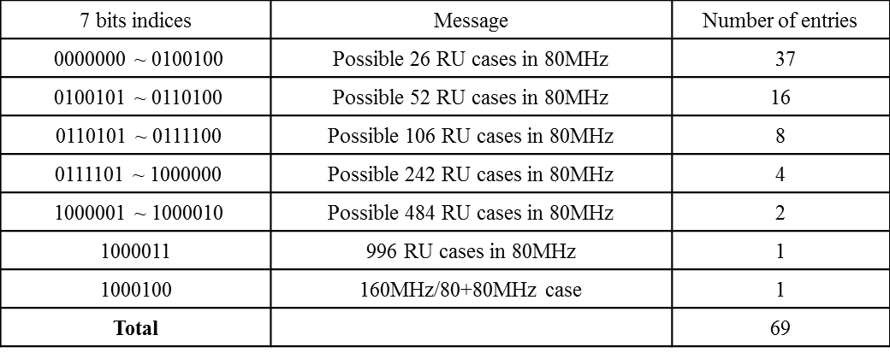

      - Moved by Yunbo Li, Seconded by Simone Merlin
      - Discussion – No discussion.
      - Result: The motion was accepted with no objection.

    - MAC Motion #75: Move to add to the SFD
- the draft specification shall specify that when a Trigger needs to be padded to allow sufficient UL PPDU transmission preparation time, the padding shall be at the MAC layer and the padding shall not include an FCS

      - Moved by Matt Fischer, Seconded by Simone Merlin
      - Discussion – No discussion.
      - Result: The motion was accepted with no objection.

    - MAC Motion #76: Move to add to the SFD
- The draft specification shall specify that M-BA/BA/ACK may be aggregated with a trigger frame in an A-MPDU without accompanying Data

      - Moved by Matt Fischer, Seconded by Simone Merlin
      - Discussion – No discussion.
      - Result: The motion was accepted with no objection.

    - MAC Motion #77: Move to add to SFD
- The ACK Policy of the QoS data frame(s) sent in an HE trigger-based PPDU shall be set to 00 (Normal Ack or Implicit BAR) when the QoS data frame requires to be acknowledged (i.e., the Ack Policy cannot be set to 11 (Block Ack)).

      - Moved by Jeongki Kim, Seconded by Simone Merlin
      - Discussion – No discussion.
      - Result: The motion was accepted with no objection.

    - MAC Motion #78: Move to add to the SFD
- An HE STA specifies the following parameters related to fragmentation:
- Minimum Fragment Size: The minimum payload size for the first fragment of an MSDU supported by the STA
  - Possible values: 128, 256, 512, Unspecified/No Limit
- Maximum Number of F-MSDUs: The maximum number of fragmented MSDUs/MMPDUs that can be concurrently received by the STA
  - Possible values: 1, 2, 4, 8, 16, 32, Unspecified/No Limit
  - Note: Whether the counter is per <RA, TA> or per <RA, TA, TID> is currently TBD.

      - Moved by Alfred Asterjadhi, Seconded by Simone Merlin
      - Discussion – no discussion
      - Result: The motion was accepted with no objection.

    - MAC Motion #79: Move to add the following text to 11ax SFD:
- A value of 15 in the TID subfield in the Per STA Info field of the M-BA frame indicate the successful acknowledgement of a management frame that requires an immediate response and is carried in the soliciting A-MPDU

      - Moved by Liwen Chu, Seconded by Simone Merlin
      - Discussion – No discussion.
      - Result: The motion was accepted with no objection.

    - MAC Motion #80: Move to add to the SFD the following sounding sequence:

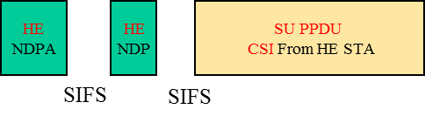

- HE NDPA is addressed to 1 STA

      - Moved by Simone Merlin, Seconded by Jianhan Liu
      - Discussion – No discussion.
      - Result: The motion was accepted with no objection.

    - MAC Motion #81: Move to replace the sounding sequence figure in SFD section 4.6 with following one

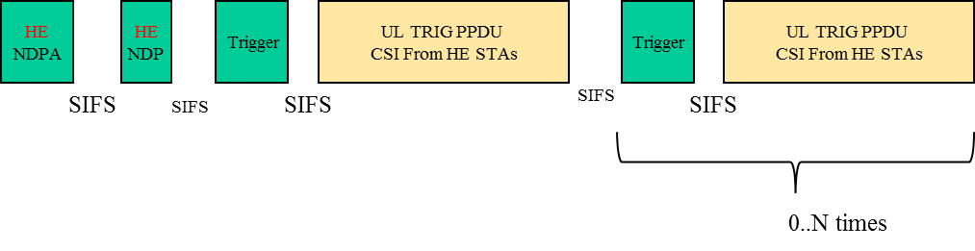
- HE NDPA is addressed to multiple STA

      - Moved by Simone Merlin, Seconded by George Cherian
      - Discussion – No discussion.
      - Result: The motion was accepted with no objection.

    - MAC Motion #82: Move to add to the TG Specification Framework document
- Spec shall define a mechanism to protect TWT SP.
- A TWT requesting STA sets the TWT Protection subfield to 1 in TWT Request frame to request the AP to provide protection of the set of TWT SPs using a NAV protection mechanism defined in 802.11ax (e.g. (MU)RTS/CTS or CTS-to-self, etc)

      - Moved by Jinsoo Ahn, Seconded by Woojin Ahn
      - Discussion – No discussion.
      - Result: The motion was accepted with no objection.

    - MAC Motion #83: Move to add the following AID assign rule to the IEEE 802.11ax SFD:
The AP may send a TBD IE that includes a field 'N‘. If the value indicated by the field N is greater than 0, then the AP shall allocate AIDs according to the formula

- The TBD IE contains the number of partial BSS color bits used and the partial BSS color bits

      - Moved by Jianhan Liu, Seconded by Simone Merlin
      - Discussion – No discussion.
      - Result: The motion was accepted with no objection.

  - MU Motions
    - MU Motion #47: Move to add following text in SFD
- A non-AP STA that is UL MU-MIMO Tx capable shall support DL MU-MIMO Rx

      - Moved by Joonsuk Kim, Seconded by Reza Hedayat
      - Discussion – No discussion.
      - Result: The motion was accepted with no objection.

    - MU Motion #48: Move to add following text in SFD
- A non-AP STA that is UL OFDMA Tx capable shall support DL OFDMA Rx

      - Moved by Joonsuk Kim, Seconded by Reza Hedayat
      - Discussion – No discussion.
      - Result: The motion was accepted with no objection.

    - MU Motion #49: Move to add following to the TGax SFD
- In an HE trigger-based PPDU transmission, a power pre-correction mechanism is needed

      - Moved by Kome Oteri, Seconded by Allan Jones
      - Discussion – No discussion.
      - Result: The motion was accepted with no objection.

    - MU Motion #50: Move to add following to the TGax SFD
- The power control mechanism shall be flexible enough to allow for scheduling both class A and class B devices in the same HE trigger-based PPDU transmission.

      - Moved by Kome Oteri, Seconded by Allan Jones
      - Discussion – No discussion.
      - Result: The motion was accepted with no objection.

    - MU Motion #51: Move to add the following to the TGax SFD
- In a DL HE-MU-PPDU, the AP may set different transmit powers for different resource units.

      - Moved by Kome Oteri, Seconded by Allan Jones
      - Discussion – No discussion.
      - Result: The motion was accepted with no objection.

    - MU Motion #52: Do you agree to add the following power control mechanism for UL MU transmissions to the SFD?
- AP signals the following in the Trigger frame that schedules the UL MU transmission.
  - In the common info field: AP Tx Power: ${Tx}_{pwr}^{AP}$ (dBm).
  - In the per user info field: Target_{RSSI} (dBm) for each STA that is scheduled in the Trigger frame.
    - The number of bits in the Target RSSI is TBD.
- STA sets its Tx power per the following equation.
  - ${Tx}_{pwr}^{STA}$(dBm) = ${PL}_{DL}$ (dB) + Target_{RSSI} (dBm)
    - Where PL_{DL} (dB) is the DL path loss computed by the STA based on the AP transmit power signaled in the Trigger message and the measured RSSI of the Trigger message.
    - Target_{RSSI} (dBm) is signaled by the AP in the trigger message.

      - Moved by Arjun Bharadwaj, Seconded by Kaushik Josiam
      - Discussion – No discussion.
      - Result: The motion was accepted with no objection.

    - MU Motion #53: Move to add the following text to the SFD
- STAs that participate in HE trigger-based PPDU transmit the power headroom in triggered UL MU transmissions to assist in the AP’s MCS selection
  - Details of STA headroom definition are TBD.

      - Moved by Arjun Bharadwaj, Seconded by Kaushik Josiam
      - Discussion – No discussion.
      - Result: The motion was accepted with no objection.

    - MU Motion #54: Move to add the following text to the SFD
- STAs that participate in HE trigger-based PPDU shall support +/-3dB Relative Tx power requirements for Class B devices.
  - Relative Tx power accuracy is defined as the accuracy of the change of the transmit power in consecutive UL MU transmissions.

      - Moved by Arjun Bharadwaj, Seconded by Kaushik Josiam
      - Discussion – No discussion.
      - Result: The motion was accepted with no objection.

    - MU Motion #55: Move to amend the Trigger Frame format in the SFD as shown in document IEEE802.11-16/0379r0

      - Moved by Simone Merlin, Seconded by George Cherian
      - Discussion – No discussion.
      - Result: The motion was accepted with no objection.

  - SR Motions
    - SR Motion #6: Move to add to SFD
– Include the “SR_allowed” signaling in HE-SIGA to indicate whether SR operation is allowed or not.
    - use a value of Spatial Reuse field to indicate SR is disallowed.
    - The conditions to disallow SR are TBD.

      - Moved by Yunbo Li, Seconded by Yanchun Li
      - Discussion – No discussion.
      - Result: The motion was accepted with no objection.

    - SR Motion #7: Do you support to replace the text in 5.1 of SFD P35L1“and a reduction in the TXPWR may be accompanied by an TBD increase in the OBSS_PD threshold value" with the “following adjustment rules:

Adjustment Rule for OBSS_PD

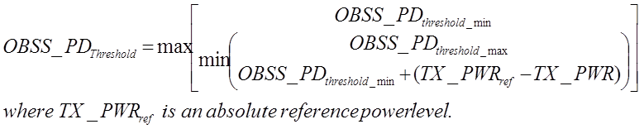

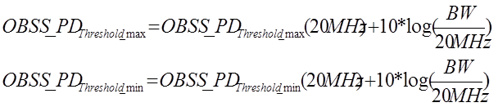

– Preserves fairness for the lower power devices.
- TX_PWRref can be a TBD level (preferred value 23 dBm)
- Class A: TX_PWR=transmit power
- Class B: TX_PWR=transmit power+TBD dB

      - Moved by Jianhan Liu, Seconded by Ron Porat
      - Discussion
        - A member commented on the motion text, however, motion text was not changed.
      - Result: Y/N/A = 51/3/24, motion passes.

- Timeline update
  - TGax Timeline was updated as follow.
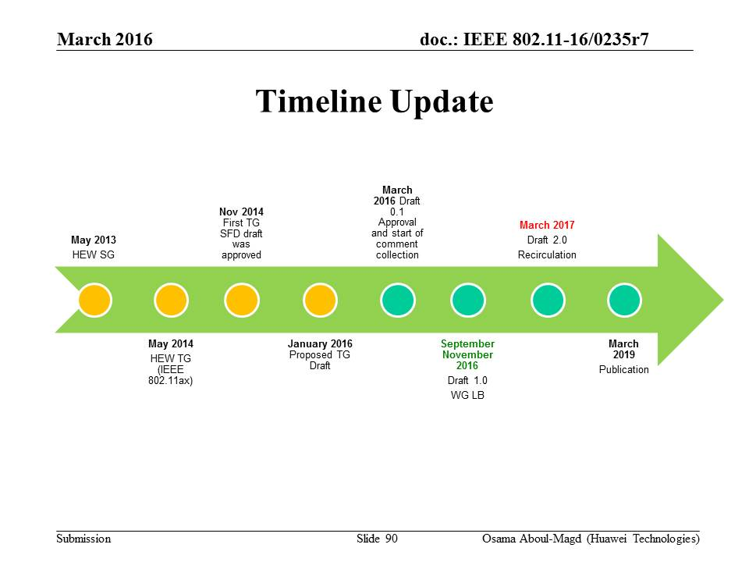

- Plans for the May 2016
  - Comment resolution.
  - Technical presentations.

- Teleconference planning
  - Chair suggested four conference calls after the comment collection period.
    - Thursday, April 14th & 28th, 2016, 10:00-12:00 (ET)
    - Thursday, April 21st & May 5th, 2016, 20:00-22:00 (ET)
  - Chair asked if there is any objection to this plan. No objection.

- AOB
  - OLD BUSINESS – PHY Motion #155.

  - PHY Motion #155: Move to modify the SFD as follows:
There are only three pre-HE-STF preamble formats definition
- SU Format(mandatory)/Trigger based UL
- MU format (mandatory)
- Extended range SU format (mandatory)
    - Moved by David Xun Yang, Seconded by Ross Jian Yu
    - Discussion – Clarification required if all those formats are mandatory. The answer was yes.
    - Result: Y/N/A = 49/4/23, motion passes.

- Adjournment
  - TGax adjourned for the week @ 12:35.

Thursday, March 17th, 2016, PM2 TGax full Session (16:00-18:00)
TGax session in Thursday PM2 was cancelled since the task group finished it work for the week.

