IEEE P802.11
Wireless LANs
Resolution for CIDs 7278, 7280, 7281 to 7290
Date: 2016-02-02
Author(s):
Name | Affiliation | Address | Phone | email
Graham SMITH | SRT Wireless | Davie, FL, USA. | 916 799 9563 | gsmith@srtrl.com
Mark Rison | Samsung
Abstract
This submission proposes resolution for CID 7278, 7280, 7281 to 7290
Green indicates material agreed to in the group,
yellow material to be discussed, red material rejected by the group and
cyan material not to be overlooked.

The “Final” view should be selected in Word.

7278 and 7280 were ariginally included in 16/0237.

Captured the original thinking and then a fuller proposal from Mark.

Can start discussion at Page 10.

Identifiers | Comment | Proposed change
CID 7278  Mark Rison  144.01 | In Clause 6, when an OperationalRateSet is passed down in MLME-JOIN/START.request, it can't include rates not in dot11SupportedDataRatesRxTable | Add this caveat to the "Valid range" cell (where it currently says 1-127). Make a similar statement about HT-MCS and VHT-MCSes

Identifiers | Comment | Proposed change
CID 7280  Mark Rison  6.3.11.2.2  201.52 | The BSSBasicRateSet can't include rates not in both dot11SupportedDataRatesRxTable and dot11SupportedDataRatesTxTable | Add this caveat to the "Valid range" cell (where it currently says 1-127). Make a similar statement about HT-MCS and VHT-MCSes

Discussion:
6.3.4.2. P159.51 MLME-JOIN.request

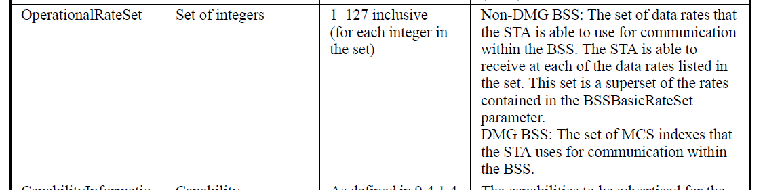

6.3.11.2 MLME-START.request
6.3.3.3 MLME-SCAN.confirm
“BSSBasicRate Set is defined in 6.3.11.2”

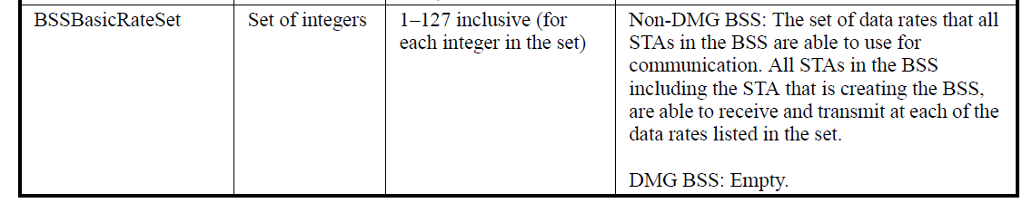

OperationalRateSet is defined at P37.35 and refers to the Supported Rates and BSS Membership Selectors element.

730.38
9.4.2.3 Supported Rates and BSS Membership Selectors element
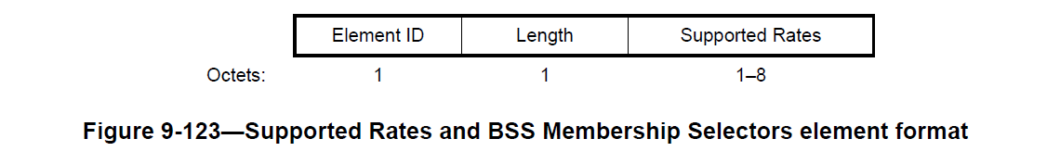
730.58
“…each Supported Rate contained in the BSSBasicRateSet parameter is encoded as an octet with the MSB (bit 7) set to 1, and bits 6 to 0 are set to the data rate,…”…“Rates not contained in the BSSBasicRateSet parameter are encoded with the MSB set to 0, and bits 6 to 0 are set to the appropriate value from the valid range column of the DATARATE row of the table in 6.5.5.2…”
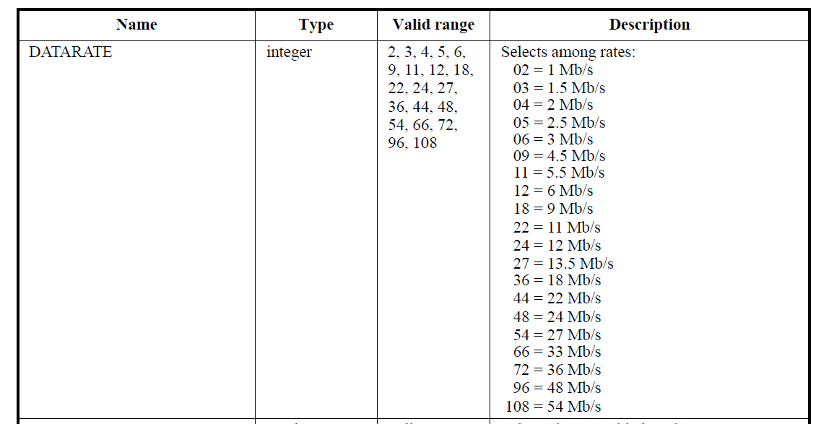

P740.14
9.4.2.13 Extended Supported Rates and BSS Membership Selectors element
“BSSBasicRate Set is defined in 6.3.11.2”

(Maybe this should be added to 9.4.2.3 where it first appears)

Commenter refers to dot11SupportedDataRatesRXTable
P2412.23 HT PHY MIB attributes
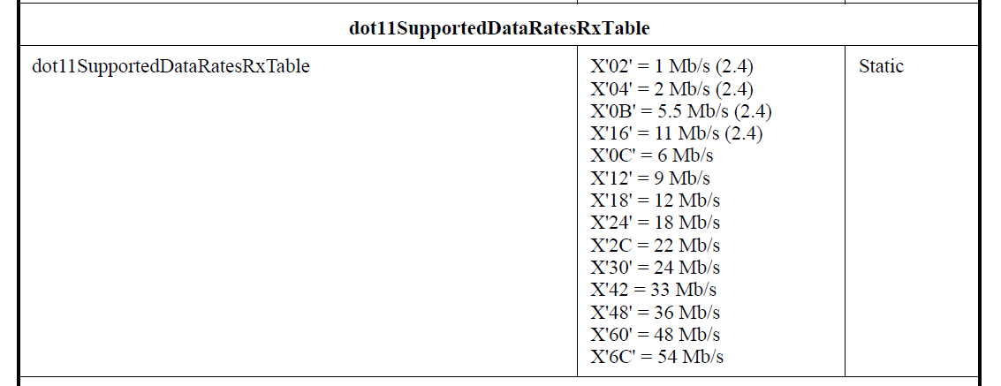

Aside: I think 22Mb/s and 33Mb/s should now be removed asthey are from obsolete PHY??
22 and 33 are at following places in the “Valid range” and the “Description” columns
P537.16 and 20
P2317.31 and 33, 47 and 50
P2412.17 and 19, 34 and 36
Opinions??

An AP adds a (B) bit to indicate “basic rate” (from the BSSBasicRateSet). I don’t know why a STA should indicate Basic Rates unless it is as a confirmation?
BSSBasicRateSet is clear, it is the basic rates

So the commenter is pointing out that the OperationalRateSet and the BSSBasicRateSet can only be from the 11b/g list. This is clear for the “9.4.2.3 Supported Rates and BSS Membership Selectors element” and 9.4.2.13 Extended Supported Rates and BSS Membership Selectors element” which refer to the Table 6.5.5.2.

So what about OperationalRateSet? This is a “superset of BSSBasicRateSet”.
“Superset” means that all the rates in the BSSBasicRateSet are in the OperationalRateSet and it also contains rates not in the BSSBasicRateSet.

SO after all that, it does seem that the the limits of the rates are restricted to those in Table 6.5.5.2. The description in the cited tables does set the limit and whether it is necessary to spell this out in the “Valid range” column to me does not seem necessary, hence the recommended resolution is “Reject”

MARK - That’s not the problem (well, except that 6.5.5.2 allows for e.g. 33 Mbps). The problem is that the operational rate set cannot include 108 (54 Mbps), say, if this is not in dot11SupportedDataRatesRxTable, even though it is in T6.5.5.2

BUT all the rates are in dot11SupportedDataRatesRXTable. Mark says that if the AP, for some reason, does not include 54 Mb/s in its dot11SupportedDataRatesRXTable then it cannot include 54Mb/s in its OperationalRateSet. I suppose the question is whether these are independent entities or whether they are, in fact, linked?
IT WAS AGREED THAT THEY ARE LINKED.

Now as to the HT-MCS. In the MLME-START.request the HT capabilities element is included.
9.4.2.56 HT Capabilities element includes the “Supported MCS Set” 16 octets. This has a bitmask to set the supported MCSi index values MCS 0 to 76.
MARK
“The HT Caps shows the operational HT-MCS set. The HT Op shows the basic HT-MCS set. The MIB variables defining a device’s HT-MCS capabilities are dot11SupportedMCSTxTable and dot11SupportedMCSRxTable; for VHT-MCS capabilities they are dot11VHTTxVHTMCSMap and dot11VHTRxVHTMCSMap”

OK, I know that the Basic HT-MCS Set is part of the HT Operation element. (I also know that in the vast majority of APs, if not all, I have looked at, this field is all zeros.)
“HT Operation” is in
MLME-SCAN.confirm (Probe Response and Beacons), AND
MLME- START.request
“Valid Range: as defined in 9.4.2.57 (HT Operation Element)”
“A bitmap size 128 bits”

RESOLUTION:

REVISE

At P159.33 and P202.5
Add the following to the “Valid Range” entry of “OperationalRateSet”:
“Only data rates in dot11SupportedDataRatesRxTable may be present”

Mark R suggests
At 159.30 (JOIN.req):
OperationalRateAndMembershipSelectorSet | Set of integers | A value in dot11SupportedDataRatesRxTable, or in Table 9-77 and corresponding to a supported feature (for each integer in the set) | Non-DMG BSS: The set of data rates and features that the STA is able to use for communication within the BSS. The STA is able to receive at each of the data rates listed in the set and with each of the features listed in the set. This set is a superset of the rates contained in the BSSBasicRateAndMembershipSelectorSet parameter in the SelectedBSS parameter.  DMG BSS: The set of MCS indexes that the STA uses for communication within the BSS.

At P201.54
BSSBasicRateSet
Add the following to the “Valid Range” entry of “BSSBasicRateSet”:
“Only data rates present in dot11SupportedDataRatesRxTable and dot11SupportedDataRatesTxTable may be present”

Mark R Suggests
At 201.52 (START.req):
BSSBasicRateAndMembershipSelectorSet | Set of integers | A value in both dot11SupportedDataRatesRxTable and dot11SupportedDataRatesTxTable, or in Table 9-77 and corresponding to a supported feature (for each integer in the set) | Non-DMG BSS: The set of data rates and features that all STAs in the BSS are able to use for communication. All STAs in the BSS, including the STA that is creating the BSS, are able to receive and transmit at each of the data rates listed in the set and with each of the features listed in the set.  DMG BSS: Empty.
OperationalRateAndMembershipSelectorSet | Set of integers | A value in dot11SupportedDataRatesRxTable, or in Table 9-77 and corresponding to a supported feature (for each integer in the set) | Non-DMG BSS: The set of data rates and features that the STA is able to use for communication within the BSS. The STA is able to receive at each of the data rates listed in the set and with each of the features listed in the set. This set is a superset of the rates contained in the BSSBasicRateAndMembershipSelectorSet parameter.  DMG BSS: The set of MCS indexes that the STA uses for communication within the BSS.

At P202.44 and P153.17
Add the following to the “Valid Range” entry of “HT Operation”
“Only MCSs present in dot11SupportedMCSTxTable and dot11SupportedMCSRxTable may be present”

Mark R suggests
Delete the BSSMembershipSelectorSet row at 202.48.

At P153.06 and P202.40
Add the following to the “Valid Range” entry of “HT Capabilities”
“Only MCSs present in dot11SupportedMCSTxTable and dot11SupportedMCSRxTable may be present”

At P156.52
Add the following to the “Valid Range” entry of “VHT Capabilities”
“Only MCSs present in dot11VHTTxVHTMCSMap and dot11VHTRxVHTMCSMap may be present in the RX VHT-MCS Map subfield of the Supported VHT-MCS and NSS Set”

Mark R suggests
Delete the BSSMembershipSelectorSet row at 202.48.
At 173.47 (ASSOC.cfm):
SupportedRateAndMembershipSelectorSet | Set of integers | 1–127 inclusive (for each integer in the set), bit 7 is set to 1 to indicate that a rate or feature is a member of the BSSBasicRateAndMembershipSelectorSet. | The set of data rates (in units of 500 kb/s) and features that are supported by the AP or PCP, including indication of which rates and features are part of the BSSBasicRateAndMembershipSelectorSet (according to 9.4.2.3 (Supported Rates and BSS Membership Selectors element)).
Or even split this out into basic and operational? This would be
more consistent and arguably cleaner, for a SAP.

Identifiers | Comment | Proposed change
CID 7282  Mark Rison  6.3.4.2.2  159.30  CID 7284  6.3.7.4.2  177.36  CID 7286  6.3.8.4.2  190.50  CID 7287  6.3.11.2.2  201.52  CID 7288  6.3.27.3.2  246.60  CID 7289  6.3.27.4.2  247.58  CID 7290  6.3.27.4.2  249.03 | 126 and 127 are not valid "rate"s (they're BSS membership selectors) | Change "1-127" to "1-125"
CID 7283  6.3.7.3.2  173.47  CID 7285  6.3.8.3.2  187.29 | 126 and 127 are not valid "rate"s (they're BSS membership selectors) | Change "1-127" to "1-125" and add a row for BSSMembershipSelectorSet
CID 7281  6.3.3.3.2  150.51 | 126 and 127 are not valid "rate"s (they're BSS membership selectors) | Change "1-127" to "1-125" here and at the top of the next page

Discussion

Example table entry 6.3.4.2. P159.30

730.38
9.4.2.3 Supported Rates and BSS Membership Selectors element

And indeed we see that 126 and 127 are BSS membership selector values
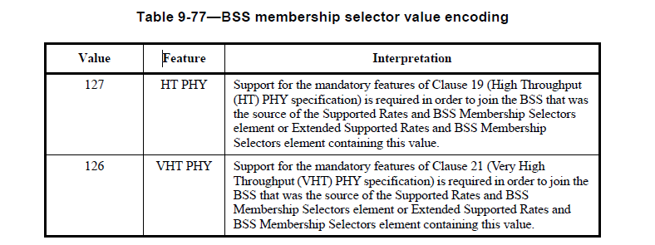

So, as the commentor states, the operational rate set is only contained in the range 0 -125
Where the BSS MembershipSelector Set is required has been identified in the comments.

Hence,

Proposed Resolutions to CIDs 7281 to 7290
ACCEPT

MARK RISON’s PROPOSAL

Identifiers | Comment | Proposed change
CID 7278  Mark RISON  6  144.01 | In Clause 6, when an OperationalRateSet is passed down in MLME-JOIN/START.request, it can't include rates not in dot11SupportedDataRatesRxTable | Add this caveat to the "Valid range" cell (where it currently says 1-127). Make a similar statement about HT-MCS and VHT-MCSes
CID 7280  Mark RISON  6.3.11.2.2  201.52 | The BSSBasicRateSet can't include rates not in both dot11SupportedDataRatesRxTable and dot11SupportedDataRatesTxTable | Add this caveat to the "Valid range" cell (where it currently says 1-127). Make a similar statement about HT-MCS and VHT-MCSes
CID 7281  Mark RISON  6.3.3.3.2  150.51 | 126 and 127 are not valid "rate"s (they're BSS membership selectors) | Change "1-127" to "1-125" here and at the top of the next page
CID 7282  Mark RISON  6.3.4.2.2  159.30 | 126 and 127 are not valid "rate"s (they're BSS membership selectors) | Change "1-127" to "1-125"
CID 7283  Mark RISON  6.3.7.3.2  173.47 | 126 and 127 are not valid "rate"s (they're BSS membership selectors) | Change "1-127" to "1-125" and add a row for BSSMembershipSelectorSet
CID 7284  Mark RISON  6.3.7.4.2  177.36 | 126 and 127 are not valid "rate"s (they're BSS membership selectors) | Change "1-127" to "1-125"
CID 7285  Mark RISON  6.3.8.3.2  187.29 | 126 and 127 are not valid "rate"s (they're BSS membership selectors) | Change "1-127" to "1-125" and add a row for BSSMembershipSelectorSet
CID 7286  Mark RISON  6.3.8.4.2  190.50 | 126 and 127 are not valid "rate"s (they're BSS membership selectors) | Change "1-127" to "1-125"
CID 7287  Mark RISON  6.3.11.2.2  201.52 | 126 and 127 are not valid "rate"s (they're BSS membership selectors) | Change "1-127" to "1-125"
CID 7288  Mark RISON  6.3.27.3.2  246.60 | 126 and 127 are not valid "rate"s (they're BSS membership selectors) | Change "1-127" to "1-125"
CID 7289  Mark RISON  6.3.27.4.2  247.58 | 126 and 127 are not valid "rate"s (they're BSS membership selectors) | Change "1-127" to "1-125"
CID 7290  Mark RISON  6.3.27.5.2  249.03 | 126 and 127 are not valid "rate"s (they're BSS membership selectors) | Change "1-127" to "1-125"
CID 7292  Mark RISON  6  144.01 | There are some parameters called "SupportedRate", but this concept is not defined | Change to "OperationalRateSet" for MLME-(RE)ASSOCIATE.indication and MLME-DLS.*

Discussion:

Whereas:

- dot11SupportedDataRatesRxTable and dot11SupportedDataRatesTxTable are the mechanism by which pre-HT rate capabilities are indicated by the device to the SME. It makes no sense for pre-HT rates not indicated as supported by the device to be specified for MLME-JOIN/START.request etc.
- There are similar tables for HT and VHT support
- The over-the-air signalling of support for pre-HT rates is overloaded with signalling of “membership selectors”. By definition these use values that do not correspond to possible pre-HT rates. This is achieved because the highest possible pre-HT rate, which is now fixed for eternity, is 54 Mbps, which is signalled as 108, allowing values between 109 and 127 to be used as membership selectors
- There are two rate sets: the operational rate set, which indicates the rates a STA can receive, and the basic rate set, which indicates the rates all STAs in the BSS can transmit and receive
- The membership selectors currently defined (note TGak is defining new ones), namely HT and VHT, only make sense as “basic”, i.e. all STAs in the BSS must support the feature (so any pre-HT STA cannot join the BSS), because “operational” support is indicated by other elements, namely HT and VHT Capability elements. This pattern should probably be formalised, since it makes little sense to hide an “operational” feature in the Supported Rates and Membership Selector element rather than having a dedicated element or capabilities bit for this
- DMG is weird so should be kept isolated behind a cordon sanitaire (it already is in some places)
- At the SAP level we should not be confusing matters with the slightly obscure way in which the supported/operational rates/membership selectors are encoded over the air

Proposed changes:

Change the rows at 150.50, 151.3 and 153.23 (SCAN.cfm BSSDescription) as follows, respectively:

BSSBasicRateSet | Set of integers | Non-DMG BSS: 1–127108 inclusive (, for each integer inmember of the  set) | Non-DMG BSS: The set of data rates (in units of 500 kb/s) that all STAs in the BSS are able to use for communication. All STAs in the BSS are able to receive and transmit at each of the data rates listed in the set.  DMG BSS: Empty. | Adopt
OperationalRateSet | Set of integers | Non-DMG BSS: 1–127108 inclusive (, for each integer inmember of the set)  DMG BSS: 0–24, for each member of the set | Non-DMG BSS: The set of data rates (in units of 500 kb/s) that the peer STA is able to use for communication within the BSS. The peer STA is able to receive at each of the data rates listed in the set. This set is a superset of the rates contained in the BSSBasicRateSet parameter.  DMG BSS: The set of MCS indexes that the peer STA uses for communication within the BSS. | Do not adopt
BSSMembershipSelectorSet | Set of integers | A value from Table 9-77 (BSS membership selector value encoding), for each member of the set | The BSS membership selectors that represent tThe set of features that all STAs in the BSS are able to use for communicationshall be supported by all STAs to join this BSS. | Adopt

Change the row at 159.30 (JOIN.req) as follows:

OperationalRateSet | Set of integers | Non-DMG BSS: a value in dot11SupportedDataRatesRxTable1–127 inclusive (, for each integer inmember of the set)  DMG BSS: 0–24, for each member of the set | Non-DMG BSS: The set of data rates (in units of 500 kb/s) that the STA is able to use for communication within the BSS. The STA is able to receive at each of the data rates listed in the set. This set is a superset of the rates contained in the BSSBasicRateSet element of the SelectedBSS parameter.  DMG BSS: The set of MCS indexes that the peer STA uses for communication within the BSS.

At 159.44 after “As defined in 9.4.2.56 (HT Capabilities element)” add “; HT-MCSes in the element are present in dot11SupportedMCSRxTable and the highest supported data rate in the element does not exceed dot11HighestSupportedDataRate” in the same cell.

Change the row at 173.47 (ASSOC.cfm) as follows (the first and last row are new):

BSSBasicRateSet | Set of integers | Non-DMG BSS: 1–108, for each member of the  Set | Non-DMG BSS: The set of data rates (in units of 500 kb/s) that all STAs in the BSS are able to use for communication. All STAs in the BSS are able to receive and transmit at each of the data rates listed in the set.  DMG BSS: Empty.
SupportedRatesOperationalRateSet | Set of integers | Non-DMG BSS: 1–127108 inclusive (, for each integer inmember of the set) , bit 7 is set to 1 to indicate that a rate is a member of the BBSBasicRateSet.  DMG BSS: 0–24, for each member of the set | Non-DMG BSS: The set of data rates (in units of 500 kb/s) that are supported by the AP or PCP, including indication of which rates are part of the BSSBasicRateSet (according to 9.4.2.3 (Supported Rates and BSS Membership Selectors element)) the AP or PCP is able to use for communication within the BSS. The AP or PCP is able to receive at each of the data rates listed in the set. This set is a superset of the rates contained in the BSSBasicRateSet parameter.  DMG BSS: The set of MCS indexes that the AP or PCP uses for communication within the BSS.
BSSMembershipSelectorSet | Set of integers | A value from Table 9-77 (BSS membership selector value encoding), for each member of the set | The set of features that all STAs in the BSS are able to use for communication.

Change “SupportedRates,” at 172.61 to “BSSBasicRateSet, OperationalRateSet, BSSMembershipSelectorSet,” over three lines).

Change the row at 177.46 (ASSOC.ind) as follows (the first and last row are new):

BSSBasicRateSet | Set of integers | Non-DMG BSS: 1–108, for each member of the  Set | Non-DMG BSS: The set of data rates (in units of 500 kb/s) that the STA that is requesting association is able to use for communication within the BSS. The STA is able to receive and transmit at each of the data rates listed in the set.  DMG BSS: Empty.
SupportedRatesOperationalRateSet | Set of integers | Non-DMG BSS: 1–127108 inclusive (, for each integer inmember of the set)  DMG BSS: 0–24, for each member of the set | Non-DMG BSS: The set of data rates (in units of 500 kb/s) that are supported by the STA that is requesting association the STA that is requesting association is able to use for communication within the BSS. The STA is able to receive at each of the data rates listed in the set. This set is a superset of the rates contained in the BSSBasicRateSet parameter.  DMG BSS: The set of MCS indexes that the AP or PCP uses for communication within the BSS.
BSSMembershipSelectorSet | Set of integers | A value from Table 9-77 (BSS membership selector value encoding), for each member of the set | The set of features that the STA that is requesting association is able to use for communication.

Change “SupportedRates,” at 176.61 to “BSSBasicRateSet, OperationalRateSet, BSSMembershipSelectorSet,” over three lines).

Make the equivalent changes to the MLME-REASSOCIATE primitives.

Change the rows at 201.52, 202.3 and 202.48 (START.req) as follows, respectively:

BSSBasicRateSet | Set of integers | Non-DMG BSS: a value in both dot11SupportedDataRatesRxTable and dot11SupportedDataRatesTxTable1–127 inclusive (, for each integer inmember of the  set) | Non-DMG BSS: The set of data rates (in units of 500 kb/s) that all STAs in the BSS are able to use for communication. All STAs in the BSS, including the STA that is creating the BSS, are able to receive and transmit at each of the data rates listed in the set.  DMG BSS: Empty.
OperationalRateSet | Set of integers | Non-DMG BSS: a value in dot11SupportedDataRatesRxTable1–127 inclusive (, for each integer inmember of the set)  DMG BSS: 0–24, for each member of the set | Non-DMG BSS: The set of data rates (in units of 500 kb/s) that the STA is able to use for communication within the BSS. The STA is able to receive at each of the data rates listed in the set. This set is a superset of the rates contained in the BSSBasicRateSet parameter.  DMG BSS: The set of MCS indexes that the peer STA uses for communication within the BSS.
BSSMembershipSelectorSet | Set of integers | A value from Table 9-77 (BSS membership selector value encoding), for each member of the set | The BSS membership selectors that represent tThe set of features that all STAs in the BSS, including the STA that is creating the BSS, are able to use for communicationshall be supported by all STAs to join this BSS. The STA that is creating the BSS shall be able to support each of the features represented by the set.

At 202.36 after “As defined in 9.4.2.56 (HT Capabilities element)” add “; HT-MCSes in the element are present in dot11SupportedMCSRxTable and the highest supported data rate in the element does not exceed dot11HighestSupportedDataRate” in the same cell.

At 202.42 after “As defined in 9.4.2.57 (HT Operation element)” add “; HT-MCSes in the element are present in both dot11SupportedMCSRxTable and dot11SupportedMCSTxTable” in the same cell.

At 204.21 after “As defined in 9.4.2.158 (VHT Capabilities element)” add “; VT-MCSes in the element are present in dot11VHTRxVHTMCSMap and the highest supported data rate in the element does not exceed dot11VHTRxHighestDataRateSupported” in the same cell.

At 202.42 after “As defined in 9.4.2.57 (HT Operation element)” add “; VT-MCSes in the element are present in both dot11VHTRxVHTMCSMap and dot11VHTTxVHTMCSMap” in the same cell.

Change the row at row at 246.60 (DLS.cfm) and 247.58 (DLS.ind) as follows:

SupportedRatesOperationalRateSet | Set of integers | Non-DMG BSS: 1–127108 inclusive (, for each integer inmember of the set) | Non-DMG BSS: The set of data rates (in units of 500 kb/s) that are supported by the peer MAC entity the peer STA is able to use for direct link communication. The peer STA is able to receive at each of the data rates listed in the set.

Change the row at row at 249.3 (DLS.rsp):

SupportedRatesOperationalRateSet | Set of integers | Non-DMG BSS: a value in dot11SupportedDataRatesRxTable1–127 inclusive (, for each integer inmember of the set) | Non-DMG BSS: The set of data rates (in units of 500 kb/s) that are supported by the local MAC entity the STA is able to use for direct link communication. The STA is able to receive at each of the data rates listed in the set.

Change “SupportedRates” to “OperationalRateSet” at 246.34, 247.39, 248.41.

Change the first para of 11.1.7 Supported rates and extended supported rates advertisement as follows:

A STA shall include rates from its OperationalRateSet parameter and BSS membership selectors from its
BSSMembershipSelectorSet parameter in frames it transmits containing Supported Rates and BSS Membership Selectors elements and Extended Supported Rates and BSS Membership Selectors elements
according to the rules described in this subclause.

An HT AP for a BSS with at least one basic HT-MCS shall not, however, require that a STA indicate HT in its BSSMembershipSelectorSet, as the STA’s HT capabilities are indicated through the presence of an HT Capabilities element, and similarly for VHT.

In 6.3.3.3.2 make sure that the only thick line within the table is that immediately below the table heading (as repeated on successive pages). Err, and in other tables too (e.g. the one in 6.3.8.4.2).

At 511.12 and 511.27 change “–1 to 7920 (for each integer in the set)” to “–1 to 7920, for each member of the set”.

At 2.4 after ““x to y”” add “or “x–y””.

