IEEE P802.11
Wireless LANs
SB1 Comment Resolution Part1
Date: 2016-03-168
Author(s):
Name | Affiliation | Address | Phone | email
Yongho Seok | NEWRACOM
Abstract
This submission proposes resolutions of comments received from TGah 1st Sponsor Recirculation Ballot (TGah Draft 6.0).
- CIDs: 9070, 9002, 9072, 9073, 9003, 9071, 9074, 9001, 9076, 9077, 9004 (11 CIDs)

Note: The revision 2 is proposing resolutions of CID 9001 and 9004 on Page 6 and 7.

Interpretation of a Motion to Adopt

A motion to approve this submission means that the editing instructions and any changed or added material are actioned in the TGah Draft. This introduction is not part of the adopted material.

Editing instructions formatted like this are intended to be copied into the TGah Draft (i.e. they are instructions to the 802.11 editor on how to merge the text with the baseline documents).

TGah Editor: Editing instructions preceded by “TGah Editor” are instructions to the TGah editor to modify existing material in the TGah draft. As a result of adopting the changes, the TGah editor will execute the instructions rather than copy them to the TGah Draft.

CID | Page | Clause | Comment | Proposed Change | Resolution
9070 | 76.00 | 9.2.4.1.1 | S1G control frame cannot be carried in non S1G PPDU | remove "n S1G" in "that is not an S1G Control frame" | Revised-  Agree In principal.  Because S1G control frame cannot be carried in non S1G PPDU, it is unnecessary wording.  TGah Editor removes, at P76 L2-3, “of a frame that is not an S1G Control frame”
9002 | 80.00 | 9.2.4.1.11 | The terms "TXOP initiator" and "TXOP responder" are not defined and are not used in the baseline. I believe the use of thses terms is not correct since TXOP is not initiated, it is actually obtained using EDCA or HCCA. Therefore the TXOP has a holder or an owner, but no initiator. | I think it is easy to fix the langauge by using the word "transmitter" in place of "TXOP Initiator" and the word "receiver" in place of "TXOP responder" | Revised-  Agree in principal.  TXOP initiator is not defined. But, the TXOP responder is defined in our base spec.  So, for the TXOP initiator, a correct terminology is TXOP holder.  TGah Editor replaces, at P80 L29, “TXOP initiator” with “TXOP holder”.
9072 | 89.00 | 9.2.5.2 | The sender of PS-Pollд does not know whether the responder will respond with RTS frame, while the "estimated" TXOP requirement below should still hold | remove "and an RTS frame generated by an S1G STA as part of a BDT exchange" | Revised-  “In a PS-Poll+BDT frame and an RTS frame generated by an S1G STA as part of a BDT exchange the Duration/ID field is determined as follows:”  The sentence does not mean a PS-Poll+BDT frame that has a RTS frame as a response frame.  But, for clarification,  TGah Editor replaces, at P89 L37, “and” with “or”.
9073 | 89.00 | 9.2.5.2 | There is no AC constraint in BDT, the definition of T_pending should be revised | add an alternative definition of T_Pending and T_txop for the case of BDT | Revised-  Agree in principal.  Because PPDUs in a BDT exchange may carry Data frames of any TID, the T_pending should be revised for considering any TID.  But, T_txop represents the TXOP limit and a BDT exchange is still subject to TXOP duration limits for the current AC. So, an alternative definition for T_txop is not needed.  TGah Editor insert the following sentence after “- Any RDG” at P89 L30  “- Any BDT”
9003 | 91.00 | 9.3.1.1 | It seems there is a typo there. The caption under Figure 9-18c reads, "Frame Control field for S1G Control frames when Subtype subfield is equal to 10". Looking at table 9-1 of REVmc5.1, the control frame with subtype equal to 10 is PS-Poll. As far as I know BW indication is used in RTS/CTS exchange. I am wondering if 10 need to be replaced by 11 (RTS subtype). I hope my binary conversion is correct. It has been a very long time :-). | Change 10 to 11 if necessary. | Rejected-  A dynamic bandwidth indication mechanism of S1G STA supports to use a PS-Poll frame. Especially, a target use case is a BDT exchange.
9071 | 92.00 | 9.3.1.5.1 | It is already specificied that 2 MSBs are set to 1. The phrase "Bit 15 of the Duration/ID field of a PS-Poll frame is set to 1." is redundant. | delete "Bit 15 of the Duration/ID field of a PS-Poll frame is set to 1." | Accepted
9074 | 240.00 | 10.3.2.1 | It is not clear or defined what "The duration in a SIG STA" is. This sentence is therefore confusing. | Change "The duration" to "The NAV duration" or to "The medium occupation duration" | Revised-  That sentence is a successive part of the previous paragraph.  It seems that a new paragraph makes a confusion to a commenter.  TGah Editor merge the corresponding paragraph with the below modifications “  The duration information in a frame transmitted by an S1G STA is also available in PS-Poll+BDT frames, NDP CTS frames, in NDP Ack frames whose Idle Indication field value is 0, and in NDP_2M PS-Poll-Ack frames whose Idle Indication field is 0.” into the previous paragraph.
9076 | 318.00 | 10.49.1 | This sentence (definition of SST STA) is incorrect as it does not allow the use of the RPS element to activate channels, as specified in the last sentence of the previous paragraph in L53. | Change the sentence to "An SST STA is an S1G STA that is associated with an SST AP and that chooses a subset of the operating channels enabled for SST operation on which to operate in the BSS, when SST operating channels are activated by the AP as indicated in the SST element (aperiodic operation only) or RPS element" | Revised-  Agree in principal.  The SST operating channels can be activated in the SST operation element and the RPS element, in addition to the SST element.  TGah Editor changes P318 L57-59 as the following (by inserting “, the SST operation element, or the RPS element” at the end of the sentence.)  “An SST STA is an S1G STA that is associated with an SST AP and that chooses a subset of the operating channels enabled for SST operation on which to operate in the BSS, when SST operating channels are activated by the AP as indicated in the SST element, the SST operation element, or the RPS element.”
9077 | 320.00 | 10.49.2 | On page 319 line 14, it is specified that RPS element can be used to supplement SST element in aperiodic operation for a SST BSS. However on page 320, line 56, the allowed channel is entirely determined by SST element. | change the sentence to "In an SST BSS, an SST STA shall not transmit in a channel that is not the primary channel of the BSS if the corresponding bit of the SST Channel Activity Bitmap is 0 in the most recently received SST element or RPS element from its associated AP" | Revised-  Agree in principal.  In additional to the proposed change (adding RPS element), fix the following editorial error, from “SST Channel Activity Bitmap” to “Channel Activity Bitmap”.  TGah Editor changes P320 L56-58 as the following  “In an SST BSS, an SST STA shall not transmit in a channel that is not the primary channel of the BSS if the corresponding bit of the Channel Activity Bitmap is 0 in the most recently received SST element or RPS element from its associated AP.”

CID | Page | Clause | Comment | Proposed Change | Resolution
9001 | 268.00 | 10.13.1 | "The values of the Protocol Version field in the Frame Control field of the MPDUs contained in an A-MPDU shall be the same."  "An S1G STA with dot11PV1MACHeaderOptionImplemented equal to true shall use the PV1 format instead of the PV0 format to transmit QoS Data, Action, and Action No Ack frames..."  The Block ACK Request does not exist for the PV1 frame.  So, for the explicit Block ACK Request, a stand-alone PPDU is only allowed.  Because the explicit Block Ack Request is popularly used by TOP holder, for improving the efficiency the PV0 control frame should be allowed to aggregate with PV1 frame. | Change P258 L49-50 as the following:  - The values of the Protocol Version field in the Frame Control field of the MPDUs contained in an A-MPDU shall be the same, except for a control frame with the Protocol Version field equal to 0 in which case the control frame can be aggregated with PV1 frame. | Accepted

Discussion:
Current PV1 frame exchange rule can not aggregate the Block ACK Request frame and the PV1 DATA frame.
For transmitting the Block ACK Request, a TXOP holder shall transmit it in a stand-alone PPDU as the following:

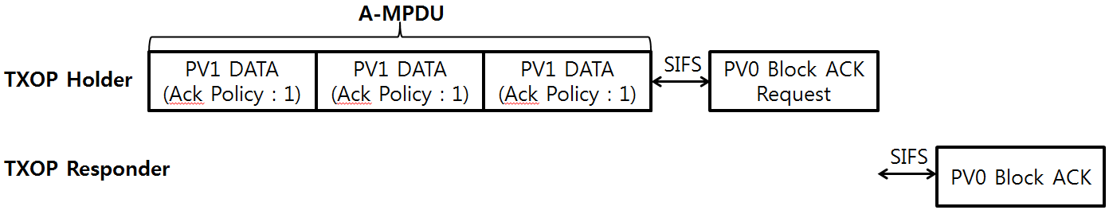

But, for a gain of PV1 frame, it is reasonable to allow an aggregation of PV0 Block ACK Request and the PV1 DATA frame, as the following.

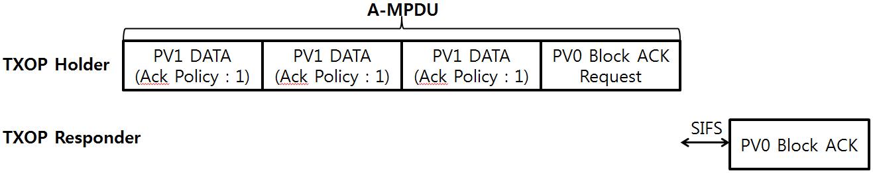

CID | Page | Clause | Comment | Proposed Change | Resolution
9004 | 537.00 | B4.4.2 | The IEEE 802.11ah amendment defines more than 30 new frames and a bunch of those NDP frames. It is hard for me to believe that no new frame exchange sequences were introduced. Yet the amendment doesn't have an Annex G. | Identify the new frame sequences introduced by 11ah and add an Annex G. | Rejected-  The commenter does not indicate specific changes that would satisfy the comment.  The detailed discussion for CID 9004 can be found from the below URL.  https://mentor.ieee.org/802.11/documents?is_dcn=311&is_group=00ah&is_year=2016

Discussion:

Regarding the Annex G
Please refer the following discussion of REVmc.

188 | 2307.00 | G | Annex G does not cover all HT sequences | Extend Annex G to cover all HT sequences. Otherwise deprecate it, but make sure it's not the only place where some rule or other is expressed

Discussion:
The 802.11n sequence are largely complete. AFAIK, it is only the aspect of Beamforming training that is not fully covered. And it may be that this is indeed covered, although I haven’t done the work to show this.

We have normative references to Annex G. In REVmb days, Annex G was for a time informative. Then we discovered the normative references, and so we made it normative. Any change to deprecate Annex G would necessarily require that it be made informative and any normative references removed.

Proposed Resolution:
Rejected. The commenter does not indicate specific changes that would satisfy the comment.

The same concern arisen by the BRC is that the Annex G is not a requirement of any amendment.
The 802.11ad and 802.11af amendments did not amend Annex G to add its frame exchanges either.

