IEEE P802.11
Wireless LANs
DMG low-power SC A-PPDU and other MAC fixes
Date: 2016-03-14
Author(s):
Name | Affiliation | Address | Phone | email
Payam Torab | Broadcom Ltd. |  |  | payam.torab@broadcom.com
Abstract
Resolution to

- CID 7174 (undefined A-PPDU aggregation for DMG low-power SC)
- CID 7176 (clarification on capability to return SNR values or a prior TXSS operation)

All changes are relative to Draft P802.11REVmc_D5.0.

Torab, Payam | 7174 | 2474.45 | 20.7.2.3.5 | A-PPDU aggrergation is not defined for DMG low-power SC mode (how adjacent PPDUs are transmitted is undefined) | Text will be provided to define A-PPDU aggregation for low-power SC mode. | GEN | DMG PHY

20.7.2.3.5 Blocking

The blocking for the low-power SC is illustrated in Figure 20-18 (Blocking for DMG low-power SC mode). The data is partitioned into blocks of length 512 wherein each 512-block is constructed from 8 subblocks. Each subblock is of length 64. The first subblock is a G64, which is the π/2-BPSK symbols sequence generated by the 64 point Golay sequence Ga64 defined in 20.11 (Golay sequences). The starting index for the first symbol π/2 rotation is 0, and subblocks 2 to 8 are constructed in the same way, i.e., a data portion of 56 symbols followed by a guard interval of 8 symbols. Note that each 512-block carries 392 symbols of data and 120 symbols of guard.

If the Additional PPDU field within the PHY header is equal to 0, the final block transmitted is followed by Ga₆₄. If the Additional PPDU field within the PHY header is equal to 1, the final block transmitted of the last PPDU in an A-PPDU is followed by Ga₆₄.

The G8 guard interval is a copy of the last 8 samples of Ga64.

NOTE—A STA might estimate the channel impulse response from the CEF, and decides whether to equalize using the 512-block or the short 64-subblock. For example, if the channel impulse response energy is almost concentrated in 8 taps, a 64-equalizer can be used; otherwise, a 512-equalizer is used.

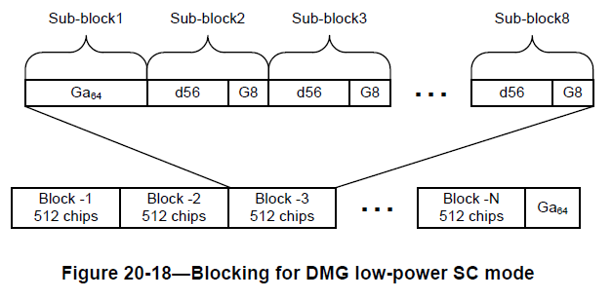

Torab, Payam | 7176 | 1105.24 | 9.5.4 | Definition of the Chan-FBCK-CAP subfield can suggest that returning channel measurement information (including but not limited to SNR list) -in general- is an option or capability. Since this is not the case (for example, during a BRP following a TXSS, the responding STA can be asked to return an SNR list for all received sectors from the preceding TXSS, and the responding STA is required to respond with the information in this case), I propose to add a NOTE to clarify that the Chan-FBCK-CAP capability applies to returning channel measurement during beam refinemnet only. | Add the following NOTE after the Chan-FBCK-CAP subfield definition in line 24,  NOTE--Regardless of the value of the Chan-FBCK-CAP subfield, a DMG STA is required to return the SNR values from the last TXSS if it receives a BRP frame with the TXSS-FBCK-REQ field and the SNR Requested subfield within the FBCK-REQ field set to 1 (see 10.38.6.4 (BRP phase execution)).

9.5.4 BRP Request field
...
The Chan-FBCK-CAP subfield is set to 1 to indicate the STA is capable to return channel measurement during beam refinement. The Chan-FBCK-CAP subfield is set to 0 to indicate the STA is able to return only BS-FBCK during beam refinement.
NOTE--Regardless of the value of the Chan-FBCK-CAP subfield, 10.38.6.4 requires a DMG STA to return the SNR values from the last TXSS if it receives a BRP frame with the TXSS-FBCK-REQ field and the SNR Requested subfield within the FBCK-REQ field both set to 1.

