IEEE P802.11  
Wireless LANs

|  |  |  |  |  |
| --- | --- | --- | --- | --- |
| Resolutions for CID 7292 D5.0 | | | | |
| Date: 2015-11-02 | | | | |
| Author(s): | | | | |
| Name | Affiliation | Address | Phone | email |
| Graham SMITH | SRT Wireless | Davie, FL, USA. | 916 799 9563 | gsmith@srtrl.com |

Abstract

Resolutions for a number of CID 7292 from D5

Green indicates material agreed to in the group,

yellow material to be discussed, red material rejected by the group and

cyan material not to be overlooked.

The “Final” view should be selected in Word.



Discussion

There are no instances of “SupportedRate”

There are 10 instances of “Supported Rate” or “supported rate”

All but 2 of these are in 9.4.2.3 Supported Rates and BSS Membership Selectors element AND 9.4.2.13 Extended Supported Rates and BSS Membership Selectors element. (operational rate se definition and PICS PC27 P2692.55

There are 169 instances of “Supported Rates”

There are 14 instances of SupportedRates all in Clause 6.

“Supported Rates” is a field in the Supported Rates and BSS Membership Selectors element 9.4.2.3 P730.38

**9.4.2.3 Supported Rates and BSS Membership Selectors element**

The Supported Rates and BSS Membership Selectors element specifies up to **eight rates in the OperationalRateSet** parameter, as described in the MLME-JOIN.request and MLME-START.request primitives, and zero or more BSS membership selectors. The Information field is encoded as 1 to 8 octets, where each octet **describes a single Supported Rate** or BSS membership selector (see Figure 9-123 (Supported Rates and BSS Membership Selectors element format)).

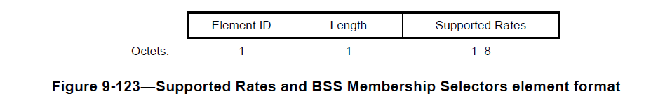

Within Beacon, Probe Response, Association Response, Reassociation Response, Mesh Peering Open, and Mesh Peering Confirm frames, **each Supported Rate contained in the BSSBasicRateSet parameter** is encoded as an octet with the MSB (bit 7) set to 1, and bits 6 to 0 are set to the data rate, if necessary rounded up to the next 500 kb/s, in units of 500 kb/s.

OK so in text I think the concept is clear.

Operational Rate Set is the complete set of rates that a STA is capable of receiving.

Supported Rates are the individual rates that the STA is capable of receiving.

BACK TO COMMENT

This presumeably refers to the use of “SupportedRates” in Clause 6. The first appearance is at P172.60 and then defined at P173.47

MLME-ASSOCIATE.confirm

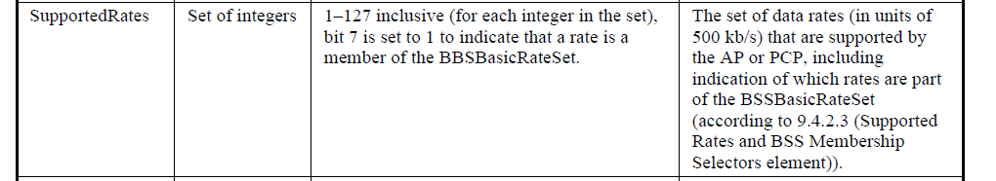

And similarly at P177.36

MLME-ASSOCIATE.indication



We have separate CIDs dealing with the Valid Range.

Let’s look at OperationalRateSet.

There are 16 instances of “OperationalRateSet”

P37.38

**operational rate set:** The set of data rates that a STA is capable of receiving. The operational rate set is defined locally by the OperationalRateSet parameter of the MLME-START.request or MLME-JOIN.request primitive. The operational rate set of a peer is defined by the data rates (i.e., excluding the MSB of each **Supported Rate)** from the peer's **Supported Rates** and BSS Membership Selectors element and, if present, the **Extended Supported Rates** and BSS Membership Selectors element.

MLME-JOIN.request P159.30

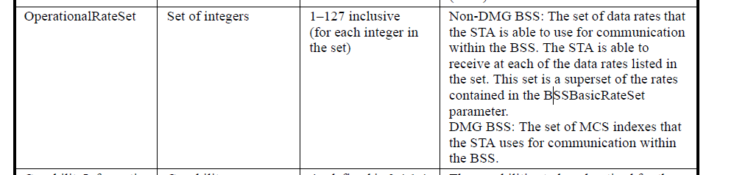

On first look, difficult to see what is the difference? Both are super sets of the BSSBasicRateSet, both are the set of data rates that the STA can use.

As far as I can see the difference is that Supported Rates are those specifically included in the Supported Rates and BSS Membership Selectors element and the Extended Supported Rates and BSS Membership Selectors element BUT the OperationalRateSet **is the combination of them** i.e. a set.

**Hence, after all that, as in each of the MLMEs it is the complete set of rates that is referred to the “SupportedRates” should be replaced by “OperationalRateSet”.**

Namely in the following:

MLME-ASSOCIATE.confirm

MLMR-ASSOCIATE.indication

MLME-REASSOCIATE.confirm

MLME-REASSOCIATE.indication

MLME-DLS.confirm

MLME-DLS.indication

MLME-DLS.response

I think that there is no need to change the Descriptions.

**Proposed Resolution**

REVISED

At the following locations replace “SupportedRates” with “OperationalRateSet”

P172.61

P173.47

P176.61

P177.36

P186.24

P187.29

P190.01

P190.50

P246.34

P246.60

P247.39

P247.58

P248.41

P249.03