IEEE P802.11  
Wireless LANs

|  |  |  |  |  |
| --- | --- | --- | --- | --- |
| Resolution of several CIDs for D5.0 | | | | |
| Date: 2016-03-14 | | | | |
| Author(s): | | | | |
| Name | Affiliation | Address | Phone | email |
| Graham SMITH | SR Technologies | Davie, FL, USA. | 916 799 9563 | gsmith@srtrl.com |

Abstract

Resolutions for a number of CIDs from D5

7085,7272,7179,7178,7038,7773,7580,7541,7496,7586,7822,7789,7435

Green indicates material agreed to in the group,

yellow material to be discussed, red material rejected by the group and

cyan material not to be overlooked.

The “Final” view should be selected in Word.



**Discussion**

Also note that CIDs 7086, 7087 and 7088 are related to this.

This is tied up with my comments on these related diagrams.

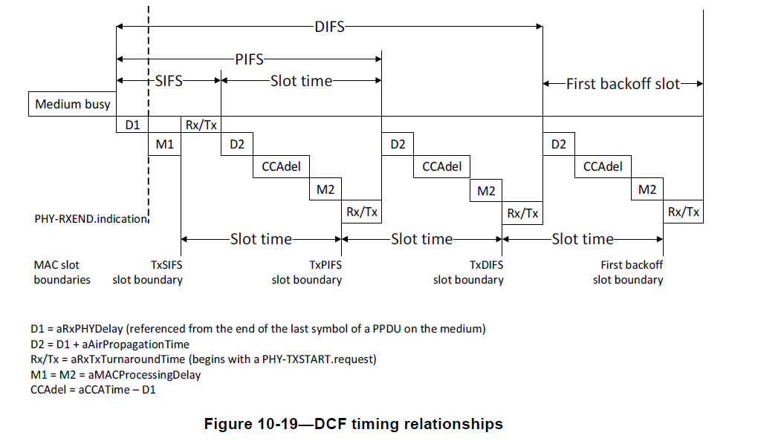

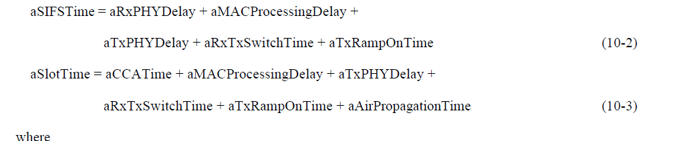

Now as far as the ddiagram is concerned the equations are right, but clearly, they are not correct.

For example, all these times are very small and in no way will add up to be equal to SIFS or SlotTime.

In another comment I point out that this diagram is completely misleading and in fact wrong. SIFS and SlotTime are fixed in the Standard, but all these other bits are not. The only criteria is that all these bit times must completed in a time less than SIFS or SlotTime.

Note that these values have no fixed values at all and are all implementation dependent.

*“The STA may employ any non-negative value for each of the parameters:*

* *aRxPHYDelay*
* *aMACProcessingDelay*
* *aRxTxTurnaroundTime*
* *aTxPHYDelay”*

But if these times are to mean anything, they are not just a number to be picked out of the air. Only one missing is *aCCATime,* what is this? First of all it is “implementation dependent” (in all PHY characteristic Tables).

“… the maximum time (in microseconds) that the CCA mechanism has available to detect the start of a valid IEEE Std 802.11 transmission…”

Again, no fixed value and in practice very short. Why the fixation with implementation switch over times? Thus simply confuses what the basic timing for DCF is.

How, therefore, can the equations 10-2 and 10-3 be correct? Obviously they cannot. There is no criteria that these arbitrary values must add up to be equal to SIFS or TimeSlot, which are fixed values.

In addition what about the Rx/Tx time, this is shown in every slot in the diagram. The STA only uses this when it actually is ready to transmit, and that is when the backoff timer has reached 0. As the diagram is drawn, the idea is that the STA waits SIFS minus Rx/Tx then calculates the backoff timer value. This is also not true. The wait period is DIFS. Also in the diagram the medium is busy at the beginning hence a random backoff slot must be calculated. So the STA must wait DIFS then backoff.

So the commenter is right but also the diagram needs to be changed.

Note also that the formulas do not even agree with the (old) diagram.

aSIFSTime is shown as D1 + M1 = aRxPHYDelay + aMACProcessingDelay ONLY

Why is a TXPHYDelay and aTXRampOn there as well as Rx/Tx

**We should have the formulas at least agree with the diagram, they do not at present.**

**Also note that**

aSIFSTime = aRxPHYDelay + aMACProcessingDelay +

aTxPHYDelay + aRxTxSwitchTime + aTxRampOnTime (10-2)

Diagram has

aSIFSTime = aRxPHYDelay + aMACProcessingDelay + (aRxTxSwitchTime)

If we have aRxTxSwitchTime then OK adding aTxPHYDelay + aTxRampOnTime, but this should not be in aSIFSTime.

Comments raised at first presentation, March 14, were along the lines of

The indeterminant terms are not properly described and relate back to when they probably had significant values. We should describe their use better.

Why? This is implementation stuff, the important point is to describe how DCF works, not how the STA changes modes – this is all implementation stuff and not directly pertaining to the basic idea of how DCF works. All it tends to do is muddy the water.. At the moment the diagram is totally misleading and an effort to make it more aligned with the real timing, as requested in previous discussions, was not even considered on merit.

**Resolution CID 7085**

REVISED

P1297.39 and 1297.44

aSIFSTime >= aRxPHYDelay + aMACProcessingDelay (10-2)

aSlotTime >= aCCATime + aMACProcessingDelay + aTxPHYDelay +

aRxTxSwitchTime + aTxRampOnTime + aAirPropagationTime (10-3)

AND

**New Figure 10-19—DCF timing relationships**



Now the diagram shows a backoff situation and the timings make some sense and “agree” with the formula.



**Discussion**

*The Quiet Channel element is used to indicate that the secondary 80 MHz channel of a VHT BSS is to be quieted during a quiet interval, and to indicate if the primary 80 MHz channel of a VHT BSS can be used during the quiet interval.* ***A quiet interval is established using either a Quiet element (see 9.4.2.23 (Quiet element)) or the Quiet Channel element if its AP Quiet Mode field is equal to 1****. Furthermore, the Quiet Channel element indicates the conditions under which the primary 80 MHz channel of the VHT BSS may be used during the quiet interval.*

*The Quiet Channel element may be included in Beacon frames, as described in 9.3.3.3 (Beacon frame format), and Probe Response frames, as described in 9.3.3.11 (Probe Response frame format).* ***The use of Quiet Channel elements is described in 11.9.3 (Quieting channels for testing).***

1062.50

*The AP Quiet Mode field specifies STA behavior during the quiet intervals.* ***When communications to the AP are******allowed*** *within the primary 80 MHz channel of the BSS, then the* ***AP Quiet Mode field is set to 1****. Otherwise, the AP Quiet Mode field is set to 0.*

*If the AP Quiet Mode field is 1, then the Quiet Count field, Quiet Period field, Quiet Duration field, and Quiet Offset field are present in the Quiet Channel element; otherwise, these fields are not present in the Quiet Channel element.*

So obviously the Quiet Channel element is used in infrastructure BSSs. We also have a whole explanation in 11.9.3. So “AP Quiet Mode” seems reasonable.

Obviously later along came DMG and it decided to use it too.

1669.16 we read:

*In a DMG BSS, the following DFS procedures apply:*

*— Associating a STA with an AP or a PCP based on the STA’s supported channels (see 11.9.2 (Association based on supported channels))*

*— Quieting the current channel so it can be tested for interference with less interference from associated STAs (see 11.9.3 (Quieting channels for testing))*

So the Quiet Channel element is definitely used in a DMG BSS.

Let’s look at 11.9.3 P1670.56 and we read

*An AP or a mesh STA may schedule quiet intervals by transmitting one or more mode set Quiet Channel elements or one or more Quiet elements in Beacon frames and Probe Response frames.*

***An IBSS STA may schedule quiet intervals only if it is the DFS owner****. In order to set a quiet interval schedule, the STA transmits one or more Quiet elements or* ***mode set Quiet Channel elements in the first Beacon frame establishing the IBSS****. All IBSS STAs shall continue these quiet interval schedules by including appropriate Quiet elements or mode set Quiet Channel elements in any transmitted Beacon frames or Probe Response frames.*

So IBSS also uses this Quiet Channel element – popular element

Now commenter says we need more description for the IBSS case? What more is needed than that given above and 11.9.3.

**Proposed Resolution CID 7212**

REJECT

“AP Quiet Mode” is a reasonable name for the field even though it may be used in an IBSS. Removing “AP” from the name would then require additional text changes otherwise its use may become confusing. Clause 11.9.3 has sufficient description for the IBSS case.



Is there such a beast as a non-DMG IBSS STA? Is there a DMG IBSS STA? I don’t think so

1. Delete non-DMG IBSS ST and use simply IBSS STA.
2. 1614.44 refers a DMG BSS to this clause. Hence the addition of the “DMG BSS”.

So do we need to refer to the DMG BSS use of this clause?

***11.2.6 Power management in a PBSS and DMG infrastructure BSS***

***11.2.6.4 ATIM frame usage for power management of non-AP STAs***

P1614.44

*“ATIM frame transmissions and MSDU transmissions follow the rules defined in 11.2.3.5 (ATIM frame and frame transmission).*

Proposed Resolution CID 7179

ACCEPT

Or

REVISED

At 1602.16

Replace:

“The following rules describe operation of the ATIM frame and frame transmission to STAs in PS mode in a non-DMG IBSS and in a DMG BSS:”

With

The following rules describe operation of the ATIM frame and frame transmission to STAs in PS mode in an IBSS and in a PBSS:”

OR (so as to avoid the problem)

The following rules describe operation of the ATIM frame and frame transmission to STAs in PS mode:”



*EIFS shall not be invoked if the NAV is updated by the frame that would have caused an EIFS, such as when the FCS fails and the L-SIG TXOP function employs L-SIG information to update the NAV*

So this saying that if the NAV is updated by a frame that fails FCS, do not use EIFS (because the NAV has been correctly updated).

10.26.5 L-SIG TXOP protection, P1417.24

***The L-SIG TXOP protection mechanism is obsolete. Consequently, this subclause might be removed in a laterrevision of this standard.***

Hmm…then this is not a good example and certainly needs to be deleted from the cited text.

So the question still remains, is there an example of when the NAV is correctly updated but the FCS fails?

In the L-SIG Legacy Preamble field 11a/g devices can extract rate and length information and remain off air for the correct duration. HT and VHT STAs spoof the rate to 6Mbps. Hence this is valid case as the 11a/g STA does not even know if the FCS checked out.

Proposed Resolution CID 7178

REVISED

**At P 1273.58**

Replace

“EIFS shall not be invoked if the NAV is updated by the frame that would have caused an EIFS, such as when the FCS fails and the L-SIG TXOP function employs L-SIG information to update the NAV.”

With

“EIFS shall not be invoked if the NAV is updated by the frame that would have caused an EIFS.”



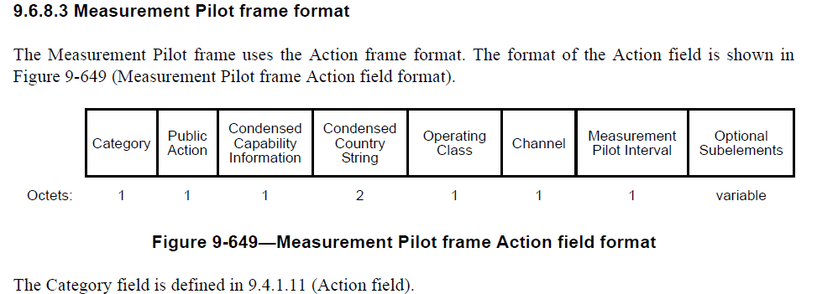

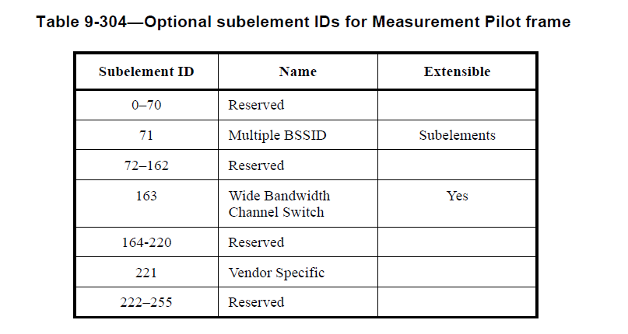

And what is a “subelement”? 9.4.3 P1074.10

*Each subelement is assigned a subelement ID that is unique within the containing element or subelement.*

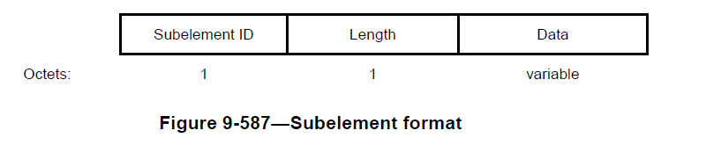

**Note that the Subelement ID is 71 for Multiple BSSID and 163 for Wide Bandwidth Channel Switch, which are the correct Element IDs,** hence a STA would simply see these subelements as IEs. Is that right, is that a problem?

I DON’T KNOW – I DON’T SEE A PROBLEM BUT THE COMMENTER DOES.

Commenter maintains that by adding the subelements, of which there are only two types, it is not possible to know that they are not IEs in their own right? This is correct but does it matter?

The commenter suggests changing the subelement approach to one of optional fields.

*The Wide Bandwidth Channel Switch subelement has the same format as the corresponding element (see 9.4.2.161 (Wide Bandwidth Channel Switch element)) with the constraint that the New Channel Width field indicates an 80 MHz, 160 MHz, or 80+80 MHz BSS bandwidth.*

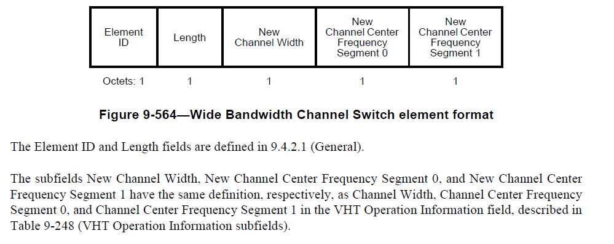

Commenter states that this is only case of using this method. Others

1. Reject 3
2. Make a change 4
3. Abstain 0

Assigned to Adrian



REVISED CID 7039

At 1140.52

Replace cited sentence with

“. The Vendor Specific Content is outside the scope of this Standard.”



This is in 11.16 “20/40MHz BSSS operation”

11.16.9 STA CCA sensing in a 20/40 MHz BSS

*This subclause defines CCA sensing rules for an HT STA that is not a VHT STA*

*At the specific slot boundaries (defined in 10.3.7 (DCF timing relations)) determined by the STA* ***based on the 20 MHz primary channel CCA****, when the transmission begins a TXOP using EDCA (as described in 10.22.2.4 (Obtaining an EDCA TXOP)),* ***the STA may transmit a pending 40 MHz mask PPDU only******if the secondary channel has also been idle*** *during the times the primary channel CCA is performed (defined in 10.3.7 (DCF timing relations))* ***during an interval of a PIFS for the 5 GHz band and DIFS for the 2.4 GHz band*** *immediately preceding the expiration of the backoff counter.*

Three observations:

1. 40 MHz channels in the 2.4 GHz band should be discouraged.
2. DIFS is one SlotTime longer than PIFS, i.e PIFS = 25us, PIFS = 34 us
3. In 2.4 GHz band we could have non-OFDM traffic, i.e. long packets

This is the requirement on the secondary channel. The primary channel has been through the standard sensing and back off routine.

In the DCF scheme the medium must be idle for DIFS …

but for EDCA the medium must be idle for AIFS or SIFS plus AIFSN x TimeSlot. The shortest AIFSN is 1, which makes it the same as PIFS. BUT this is the same for 2.4 and 5 GHz as far as I know.

This sentence is for EDCA so it should have referred to AIFS in my mind.

So we have options (we could vote on this)

1. Make no change assuming this is deliberate and implemented.
2. Make it DIFS for both
3. Make it PIFS for both
4. Make it AIFS for both

My take, probably safest is 1) and Reject comment.

**Proposed Resolution CID 7773**

REJECT

In the 2.4 GHz band there is less room for 40 MHz channels and hence a slightly longer sensing time is valid.



This is

**9.4.2.39 BSS Average Access Delay element**

*“The BSS Average Access Delay element contains the AP Average Access Delay, which is a measure of load in the BSS and is available in both QoS APs and non-QoS APs.”*

It is intended as an indication of the loading of an AP and is intended for all traffic. So there could be a mixture of Access Categories which would certainly skew the results.

EDCAF stands for “EDCA function” and there is one EDCAF per AC.

It talks about “DCF or EDCAF transmitted frames”, or “DCF or EDCAF MPDU” as well as simply “DCF or EDCAF services” and “transmit frames using the DCF or EDCAF over a continuous 30 s measurement window.”

It also states

*P872.44 QoS APs average the access delays for* ***all EDCA transmitted frames of all ACs***

So it is clear that all ACs are intended.

Let’s look at each ocurrance:

P872.37 “If the AP is not currently transmitting any DCF or EDCAF traffic,” – That seems OK

P872.39 The values between 1 and 252 are a scaled representation of the average medium access delay for DCF or EDCAF transmitted frames measured from the time the DCF or EDCAF MPDU is ready for transmission (i.e., begins CSMA/CA access) until the actual frame transmission start time.

Do we need to cover that there are more than one EDCAF? Maybe change to:

“The values between 1 and 252 are a scaled representation of the average medium access delay for all DCF and EDCAF transmitted frames measured from the time the DCF or EDCAF MPDU is ready for transmission (i.e., begins CSMA/CA access) until the actual frame transmission start time.

P873.19 “The value 254 indicates that DCF or EDCAF services are currently unable…” – Seems OK

P873.21 “The AP measures and averages the medium access delay for all transmit frames using the DCF or EDCAF over a continuous 30 s measurement window.” – Maybe make EDCAF plural?

“The AP measures and averages the medium access delay for all transmit frames using the DCF or the EDCAFs over a continuous 30 s measurement window.”

**Proposed Resolution CID 7580**

REVISED

At P872.40 replace “for DCF or EDCAF” with “for all DCF and EDCAF”

At P873.22 replace “or EDCAF” with “or the EDCAFs”



This is being examined in another place with respect to CID 7087 and 7088. Propose to use same resolution here, see 16/0228.

CID 7541



aSlotTime

*“The Slot Time (in microseconds) that the MAC uses for defining the PIFS and DIFSs. See 10.3.7 (DCF timing relations).”*

Agreed,

**Proposed Resolution CID 7496**

REVISED

P533.59

aSlotTime

“The Slot Time (in microseconds) that the MAC uses for defining the PIFS and DIFSs. See 10.3.7 (DCF timing relations).”

Change to:

aSlotTime

“The Slot Time (in microseconds) that the MAC uses for defining IFSs. See 10.3.7 (DCF timing relations).”



Assuming this refers to CID 6460

*What exactly does "mandatory" mean in the context of rates(/MCSs/preambles/etc.) in PHYs? If a rate is "mandatory", does that mean it has to be included in the operational rate set?*

The BRC consideration ended as:

We, the people, believe:

1. The basic rate set is any of the rates supported by the AP
2. The AP’s operational rate is is any of the rates supported by the AP, and a superset of the basic rate set
3. The mandatory rates of the PHY have no effect on the selection of the basic rate set of the AP’s operational rate set
4. A non-AP STA can choose any of the rates it supports in its operational rate set
5. The mandatory rates of the PHY have no effect on the selection of the non-AP STA’s operational rate set

Note, this is inconsistent with:

At 648.11:

|  |
| --- |
| NOTE—No subfield is supplied for ERP as a STA supports ERP operation if it includes all of the Clause 19 (Extended Rate PHY (ERP) specification) mandatory rates in its operational rate set (determined by the OperationalRateSet parameter of the MLME-START.request or MLME-JOIN.request primitive based on whether it started or joined a BSS, respectively). |

which assumes that all the mandatory ERP rates appear in its operational rate set.

*Comment by ‘APS’ “What does this mean? What subfield?”*

__________________________________________________________________________________________

What do I think? There are 8 instances of “Mandatory rates”

P2234.38 The high rate PHY supports four mandatory rates 1, 2, 5.5 and 11 Mbps

P2239.18 HR/DSSS/short option supports three mandatory rates, 2, 5.5 and 11 Mbps

P2304.41 dot11 Supported Data Rates Tx Table , Mandatory rates 6, 12 and 24 Mbps for 20 MHz channels (then adds for 10 and 5 MHz channels)

P2305.10 dot11 Supported Data Rates Rx Table , Mandatory rates 6, 12 and 24 Mbps for 20 MHz channels (then adds for 10 and 5 MHz channels)

Call me fussy but “mandatory rate” seems pretty clear - you must support it. Hang on I am getting déjà vu all over again. In answering CID 7292 I noted that:

Operational Rate Set is the complete set of rates that a STA is capable of receiving.

Supported Rates are the individual rates that the STA is capable of receiving.

Sooo…if dot11 Supported Data Rates Rx Table and dot11 Supported Data Rates Tx Table has “mandatory rates” then, for me, the Operational Rate Set MUST include them.

For me

**Proposed Resolution CID 7586**

REJECT

The supported Data Rates Rx table specifically includes “mandatory rates”. The Operation Rate Set is the complete set of rates that the STA is capable of receiving and as such must also include the mandatory rates as per the dot11 Supported Data Rates Rx Table.



9.6.5.2 ADDBA Request frame format

*The Block Ack Starting Sequence Control field is defined in 9.3.1.8 (BlockAckReq frame format).*

The referred to text is at 603.45

*The BAR Information field of the Basic BlockAckReq frame contains the Block Ack Starting Sequence Control subfield, as shown in Figure 9-27 (Block Ack Starting Sequence Control subfield). The Starting Sequence Number subfield of the Block Ack Starting Sequence Control subfield contains the sequence number of the first MSDU for which this Basic BlockAckReq frame is sent. The Fragment Number subfield is set to 0.*

Agreed, sort of,

Proposed Resolution CID 7822

REVISED

At P1123.60

Replace

“The Block Ack Starting Sequence Control field is defined in 9.3.1.8 (BlockAckReq frame format).”

With

“The Starting Sequence Number subfield of the Block Ack Starting Sequence Control subfield (see Figure 9-27) contains the sequence number of the first or next (in the case of a renegotiation of a block ack agreement) MSDU to be sent under this block ack agreement. The Fragment Number subfield is set to 0.”



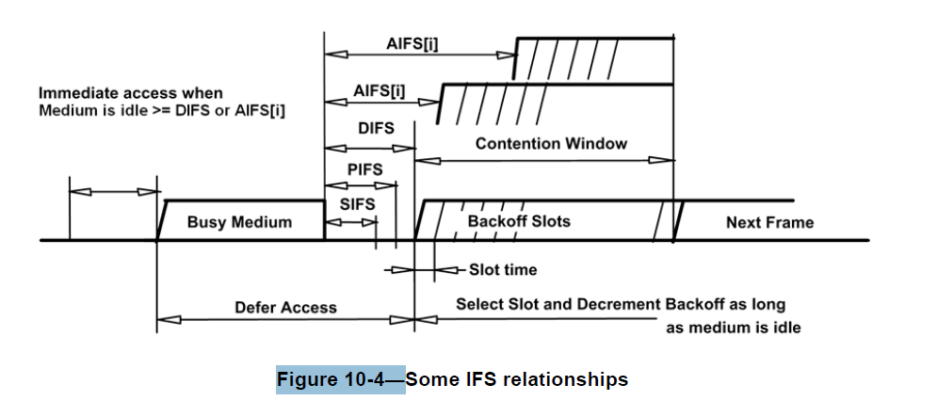

Figure 10-4

There is no need to even have this statement about access as this clause is “IFS” and subclause is “General” simply defining the IFSs. It has nothing to do with access at this point. However could leave it and just tidy it up to make clear what the immediate access is about.

I need to redraw the Figure. Here it is



Figure 10-10

This is in section on “Ack procedure”

*After a reception of a frame requiring acknowledgment, transmission of the Ack frame shall commence after a SIFS, without regard to the busy/idle state of the medium. (See Figure 10-10*

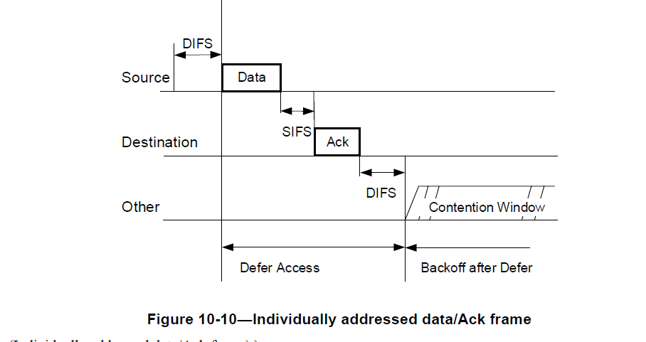

So again, nothing really to do with the deferring and backoff. It does however show what the other STAs are doing while the data and Ack are happening. The do indeed defer for DIFS (if DCF) or AIFS (if EDCA) and then, in this case, as the medium was busy, need to backoff if they have a packet to transmit.

Now what about that DIFS in front of the Source Data? That is indeed misleading. Reading the text there is no need to show this at all. So I think we need to edit the Figure



Figure 10 -14

This is in the DCF section

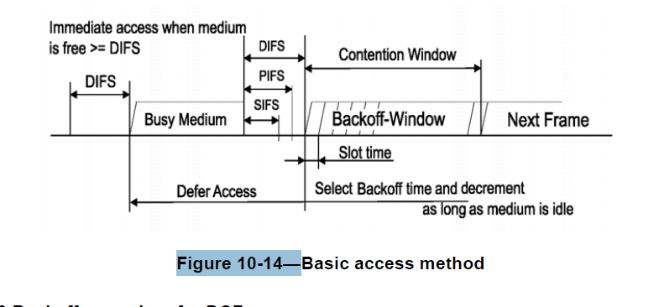

This is trying to convey the DCF access. Is it clear that the “Immediate access when medium is free>= DIFS refers to the very beginning DIFS? After that we have the medium busy case which is correct.

Have I got to redraw this, rats, I suppose so. Wondering if the SIFS and PIFS are actually needed?



Proposed Resolution CID 7789

REVISED

Replace Figure 10-4 with



Replace Figure 10-10 with



Replace Figure 10-14 with





9.4.1.4

This the Capability Information field for non –DMG STA.

*An AP sets the ESS subfield to 1 and the IBSS subfield to 0 within transmitted Beacon or Probe Response frames. An IBSS STA sets the ESS subfield to 0 and the IBSS subfield to 1 in transmitted Beacon or Probe Response frames. A mesh STA sets the ESS and IBSS subfields to 0 in transmitted Beacon or Probe Response frames.*

So we have covered for Beacons and Probe Responses:

* AP
* IBSS STA
* Mesh STA

An Association Request does indeed contain the Capability information. See Table 9-29, P629.40.

In this case the ESS and IBSS non-AP STA does not use these fields.

**Proposed Resolution CID 7435**

REVISED

At 655.31

*An AP sets the ESS subfield to 1 and the IBSS subfield to 0 within transmitted Beacon or Probe Response frames. An IBSS STA sets the ESS subfield to 0 and the IBSS subfield to 1 in transmitted Beacon or Probe Response frames. A mesh STA sets the ESS and IBSS subfields to 0 in transmitted Beacon or Probe Response frames. Otherwise the ESS and IBSS subfields are reserved.*

*Check with Carlos on how to tell if an AP or PCP when probing. Adrian as sent email*