IEEE P802.11
Wireless LANs
Resolutions for some comments on 11mc/D5.0
Date: 2016-05-13
Author(s):
Name | Company | Address | Phone | email
Mark Hamilton | Ruckus Wireless | 350 W. Java Dr  Sunnyvale, CA | +1.303.818.8472 | mark.hamilton2152@gmail.com
Abstract
This submission contains proposed resolutions to miscellaneous MAC Ad Hoc comments on REVmc D5.0 Sponsor Ballot.

References herein are to REVmc Draft 5.0.

R0 – initial version, with CIDs: 7131
R1 – proposed resolutions for CIDs: 7807, 7317, 7324, 7378, 7792, and 7378.
R2 – updated per discussion on April 1, 2016 REVmc teleconference. CID 7792 needs more work.
R3 – updated resolution for CID 7792, adding discussion and a question for the TG. Added proposed resolutions ready for group discussion/approval on CIDs: 7069, 7553, 7816, 7817 and 7819.
R4 – approved resolutions for CIDs 7069, 755, 7816 and 7817 on April 25 Cambridge F2F. CID 7819 carried forward, still ready for approval. Updated CID 7792 per discussion during April 25 Cambridge F2F; ready for approval. Added proposed resolutions for CIDs: 7814 and 7826, ready for approval. CIDs 7790 and 7146 need external help/discussion. CIDs 7150 and 7808 need more time for large reviews of the draft text.
R5 – Updated proposed resolutions on CIDs 7790 and 7814, per discussion on April 28 at Cambridge F2F. New proposed rejection on CIDs 7150 and 7808. CID 7814 is still pending investigation on DMG Relay behavior.

CID 7131:

7131 | Stephens, Adrian | 3581.57 | N.2 | "A STA can also form an integral part of an AP". I thought an AP always contained a STA, otherwise we would have to change all statements of the form "A STA that receives an RTS shall sent a CTS" to say "An AP or STA that receives...". I'm sure we don't want to do that work. | Replace "ACM_STA" by "AP" throughout Annex N, and delete the para at line 57.

Discussion:

Yes, an AP always contains a STA. But, not all STAs are contained within an AP (there are other STAs, in clients, etc., of course). So, it seems correct to say that “A STA can also form an integral part of an AP”.

But, if this is too confusing, would it be better to say, “An AP is comprised of a STA and other functions outside the STA known as the DSAF”? If we do that, we’ll need to describe the DSAF here, which is probably a good idea, but is the start of the slippery slope toward the resolution to CID 7150 – to rewrite Annex N to align better with the latest normative text description of an AP. I suggest we defer going down to this slope, to handle it as part of CID 7150.

As for replacing “ACM_STA” with “AP”, those are not the same thing. This is consistent with the normative description of an AP, as comprising a STA (the “ACM_STA” in Annex N) and a DSAF. However, there are sentences/phrases in Annex N which confuse the idea that the AP contains an ACM_STA, and those could be corrected/clarified:

At 3582.36:
Often the functions of an AP, (which includes an ACM_STA), a DS, and a portal, are combined into a single device, referred to in this annex as an access unit (AU).

At 3583.61:
The primary functions of the WLAN system, … are provided by the ACM_STA, AP, and DS entities

The rest of the uses of ACM_STA seem to be consistent with the current and normative structures/definitions.

Proposed Resolution:

REVISED.

Modify at 3582.36 as shown:
Often the functions of an AP, (which includes an ACM_STA), a DS, and a portal, are combined into a single device, referred to in this annex as an access unit (AU).
Modify at 3583.61 as shown:
The primary functions of the WLAN system, … are provided by the ACM_STA, AP, and DS entities

CID 7807:

7807 | Hamilton, Mark | 96.06 | 4.4.1 | Why is the first paragraph of 4.4.1 here? It (and the first sentence of the second paragraph) should be the first paragraph of 4.4.4. | Move the first paragraph, and first sentence of the second paragraph, of 4.4.1 to be the start of subclause 4.4.4 instead. Replace the first sentence of the second paragraph with, "IEEE Std 802.11 explicilty does not specify the details of implementation of the architectural components."

Discussion:

Context:
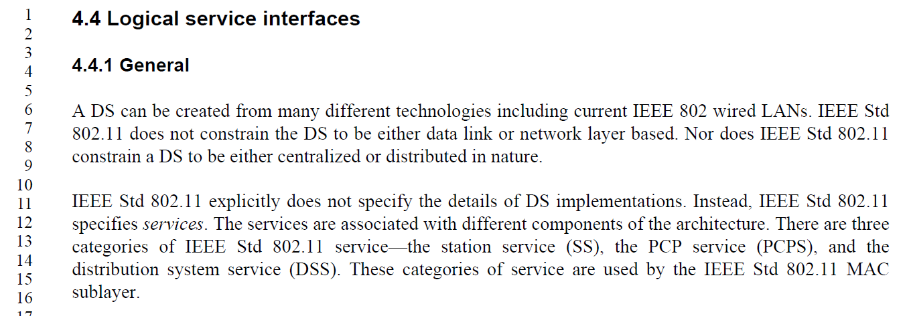

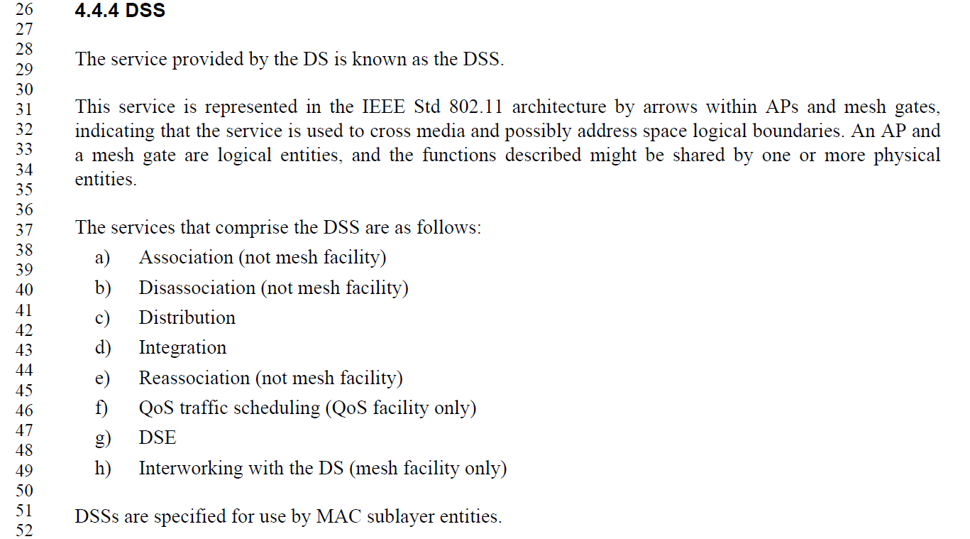

Agree, that the first paragraph and first sentence of the second paragraph currently in 4.4.1 are specific to the DS, and make more sense in 4.4.4. Move these sentences to be near the start (but not literally the start) of subclause 4.4.4, with modification for flow:

The service provided by the DS is known as the DSS. IEEE Std 802.11 explicitly does not specify the details of DS implementations structure. Instead, IEEE Std 802.11 specifies the services that are provided by a DS implementation. A DS can be created from many different technologies including current IEEE 802 wired LANs. IEEE Std 802.11 does not constrain the DS to be either data link or network layer based. Nor does IEEE Std 802.11 constrain a DS to be either centralized or distributed in nature.

IEEE Std 802.11 explicitly does not specify the details of DS implementations. Instead, IEEE Std 802.11 specifies services.

Note that the second sentence of the second paragraph in 4.4.1 (which would become the start of 4.4.1 also needs modification for flow:

IEEE Std 802.11 explicitly does not specify the details of DS implementations. Instead, IEEE Std 802.11 specifies services to aid understanding how the architectural components are logically organized. The services are associated with different components of the architecture. There are three categories of IEEE Std 802.11 service—the station service (SS), the PCP service (PCPS), and the distribution system service (DSS). These categories of service are used by the IEEE Std 802.11 MAC sublayer.

Proposed Resolution:

REVISED.

Make changes as shown in 11-16/290r2, for CID 7807. These changes effect the commenter’s intent, with additional editorial clean up.

CID 7317:

7317 | RISON, Mark | 1554.34 | 11.1.2.1 | "A STA contained in the AP or PCP shall initialize its TSF timer independently of any simultaneously started APs or PCPs" -- this cannot in general be acheved, unless the APs/PCPs are coordinated. Needs to be restricted to managed ("enterprise/corporate") contexts, but this is arguably out of scope of the standard anyway | Change to "A STA contained in the AP or PCP shall initialize its TSF timer independently of any simultaneously started APs or PCPs it is aware of", or delete

Discussion:

Context:
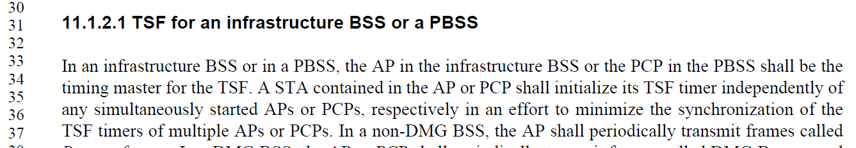

Agree, in concept. But, there is no reason to restrict this “shall” to synchronizing with other APs or PCPs that were initialized at the same time. What we really are trying to achieve is no implementation-caused synchronization of TSFs across the infrastructure BSS (or PBSS) regardless of startup methods or timing.

Proposed Resolution:

REVISED.

Change the sentence, as shown:
A STA contained in the AP or PCP shall independently initialize its TSF timer independently of any simultaneously started APs or PCPs, respectively in an effort to minimize the synchronization of the TSF timers of multiple APs or PCPs.

CID 7324:

7324 | RISON, Mark | 48.30 | 9.4.2.2 | "When the UTF-8 SSID subfield of the Extended Capabilities element is equal to 1 in the frame that includes the SSID element, the SSID is interpreted using UTF-8 encoding." -- but the extended caps are static so it doesn't have to be in the same frame | Delete the sentence

Discussion:

Context (from REVmc D5.0 page 730):
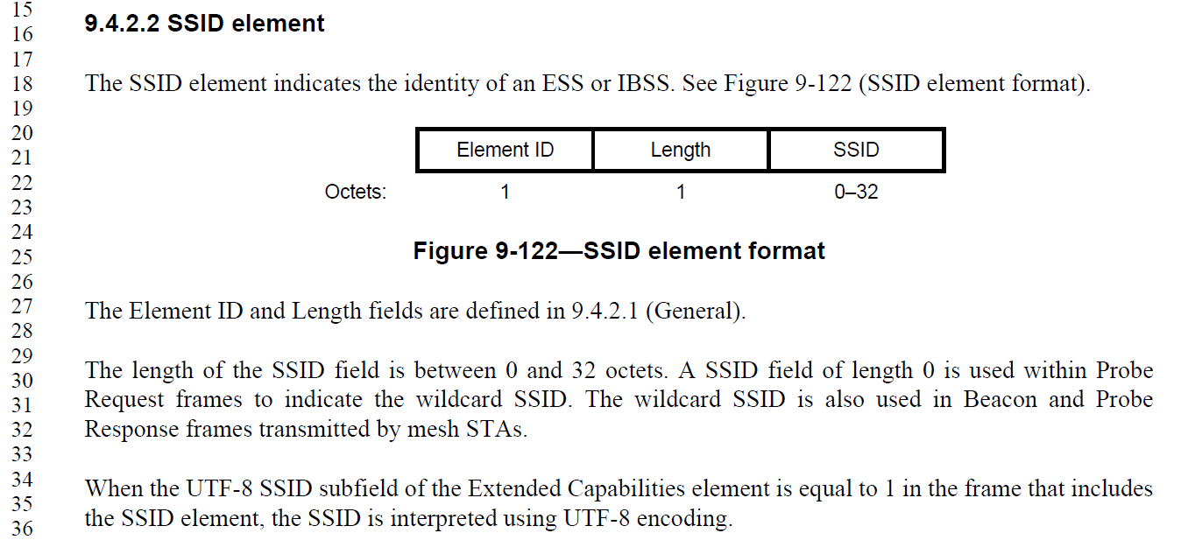

Agree, in concept. There are uses of the SSID element in contexts other than the Beacon that also carries the Extended Capabilities element (with the UTF-8 SSID capability bit). The encoding of the SSID is presumably intended to be static based on whether the UTF-8 SSID capability is in effect, even if not present in the same frame.

However, the sentence cannot simply be deleted, as that would lose the formatting requirement that applies when the UTF-8 SSID capability is in effect. Further, this is only aid to the reader for the format of the SSID field, in the frame format clause, so simply deleting it is not the best approach.

Proposed Resolution:

REVISED.

Change the sentence at P730.34, as shown:
The SSID is interpreted using UTF-8 encoding Wwhen either the UTF-8 SSID subfield of the Extended Capabilities element is present in the frame that includes the SSID element and the UTF-8 SSID subfield is equal to 1, or when the Extended Capabilities element is not present in the same frame and the UTF-8 SSID subfield is equal to 1 in the most recently received Extended Capabilities element from the same STA, in the frame that includes the SSID element, the SSID is interpreted using UTF-8 encoding.

CID 7378:

7378 | RISON, Mark | 126.47 | 4.10.7 | It says "PMK or PSK key identifier" -- what's a pairwise shared key key identifier? Also at line 49 | Change both to "PMK identifier"

Discussion:

Context:
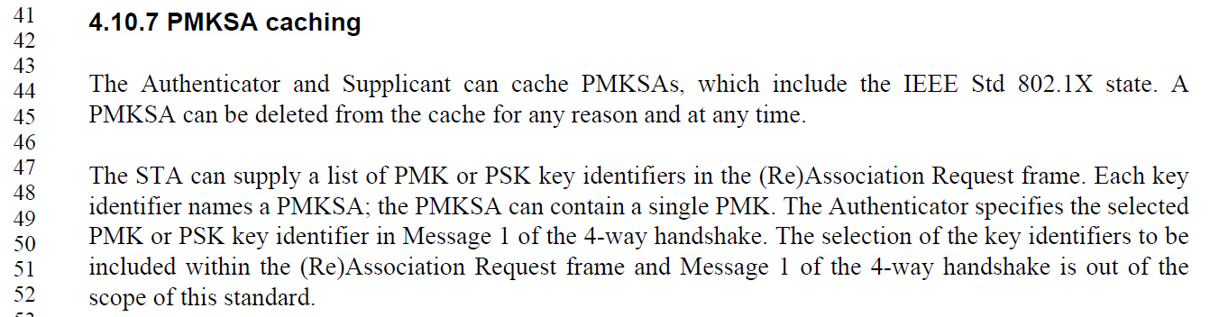

Agree, in concept. Clarify the instructions, as shown below.
.

Proposed Resolution:

REVISED.

Change both occurrences of “PMK or PSK key identifiers” to “PMK identifiers” and “PMK or PSK key identifier” to “PMK identifier” (P126.47 and P126.49).

CID 7658:

7658 | RISON, Mark | 79.32 | 4.3.13 | What about dot11VHTExtendedNSSBWCapable? | Add a line "--- "dot11TVHTExtendedNSSBWCapable" replaces "dot11VHTExtendedNSSBWCapable".

Discussion:

Context (from REVmc D5.0 page 730):
. . .
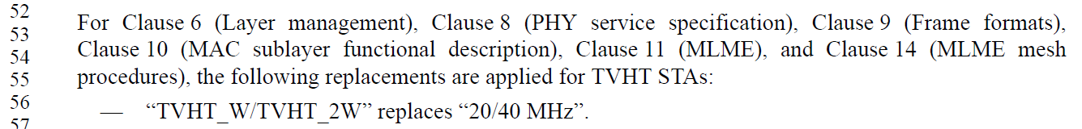
. . .
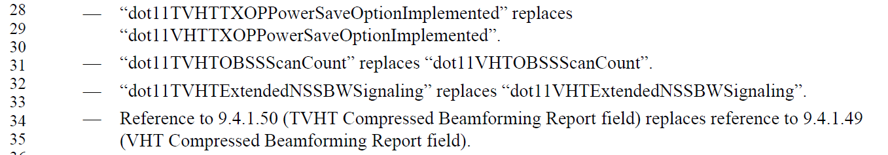

On a quick scan, …ExtendedNSSBWCapable appears to be different from (for example) …OBSSScanCount, in that dot11VHTExtendedNSSBWCapable is already explicitly called out fairly broadly in clauses 9, 10 and 11. It is not quickly apparent that there is a problem with this MIB attribute not being in the list in 4.3.13.

Proposed Resolution:

REJECTED.

The commenter did not provide sufficient evidence that this particular MIB attribute needs to be included in the list in 4.3.13. That is, just because the attribute in not in this list, a missing behavioural requirement has not been identified.

CID 7069:

7069 | Stephens, Adrian | 854.62 | 9.4.2.31 | " An incoming MSDU that is not classified to a particular TS may be classified to another active TS based on the frame classifier for that TS." - normative verb in clause 9 | Move normative behaviour to clause 10/11.

Discussion:

Context:
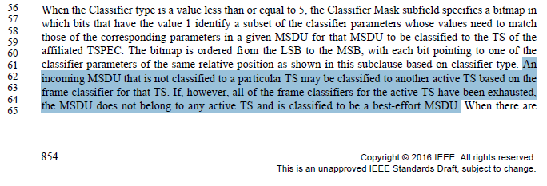

In general, agree with the commenter that this is normative behavioural text, and is probably better to be moved out of clause 9. Further, note that the next sentence is similar in this regard, so the entirety of the highlighted text above should move.

Proposed Resolution:

REVISED.

Move the two sentences starting “An incoming MSDU” and “If, however, all of the frame classifiers” to P1645L20, just before the sentence starting “See 5.1.1.3”.

CID 7553:

7553 | RISON, Mark | 104.50 | 4.5.4.3 | Does "PMKSA caching" include "mesh PMKSA caching", given that a "mesh PMKSA" is not a type of "PMKSA"? Is mesh PMKSA caching even defined? | Delete "or mesh PMKSA" at the end of the sentence

Discussion:

Context:
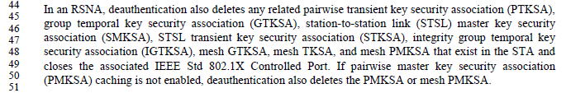

Note that the previous sentence (previous to the cited sentence) indicates that the mesh PMKSA is always deleted upon deauthentication. Regular (non-mesh) PMKSA is not listed in that sentence, as it is covered by the cited sentence. Thus, it seems these two sentences have gotten out of consistency with each other.

The mechanisms for caching a PMKSA and using a cached PMKSA appear almost entirely in subclause 12.6.10, “RSNA authentication in an infrastructure BSS”. The mechanisms for mesh peering (when using security) are in 14.5, “Authenticated mesh peering exchange (AMPE)”. The AMPE procedures include their own mechanisms for the situation where the two mesh STAs already have an established PMKSA (since this is quite likely within a mesh, due to the multiple peering and dynamic nature of mesh).

It seems the best conclusion is that the mesh PMKSA should be deleted, per the first sentence, and the second sentence corrected.

Proposed Resolution:

ACCEPTED.

CID 7816:

7816 | Hamilton, Mark | 64.19 | 4.2.5 | 4.2.5 says 802.11 has to act like a _wired_ network. No, it has to act like an 802 network (including 802.1 MAC Service requirements). | Delete "wired"

Discussion:

Context:
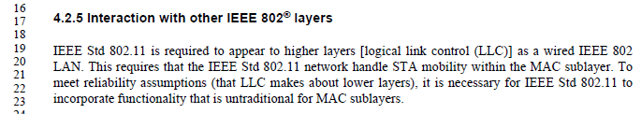

The cited sentence would in fact be correct to say 802.11 is required to appear as an IEEE 802 network (of generic type). However, the point of the paragraph is to emphasize that generic IEEE 802 networks have assumptions about reliability and don’t expose mobility, adding complications to a wireless network standard like IEEE 802.11 to deliver the same service.

So, some more re-wording is probably in order.

Proposed Resolution:

REVISED.

Change the sentence to, “IEEE Std 802.11 is required to appear to higher layers [logical link control (LLC)] as a general-purpose IEEE 802 LAN.”

CID 7817:

7817 | Hamilton, Mark | 133.54 | 5.1.5.1 | In Figure 5-1, put BA sscoreboarding between Address 1 address filtering and Duplicate Detection. | In Figure 5-1, add a block to the Receiving flow side for "Block Ack scoreboarding", between "Address 1 address filtering" and "Duplicate Detection". Use "(null)" for the transmitting flow side. Same thing in Figure 5-2.

Discussion:

Context:

“Scoreboarding” was introduced with HT block ack, and subsequently reused within GCR and DMG.

In 10.24.7.2, we can see that the Scoreboard concept was intended to be between the Deaggregation and the Receiver Reordering architectural blocks.

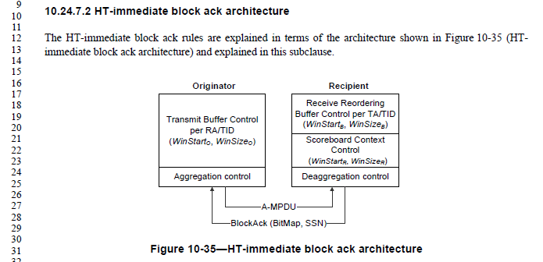

The following subclauses for other types of block ack all reference back to the HT-immediate block ack architecture, other than explicitly listed difference, none of which relate to the placement of the scoreboarding in the overall architecture. So, it seems this does apply, generally.

Looking at Figure 5-1, we see some options for the placement of this block:

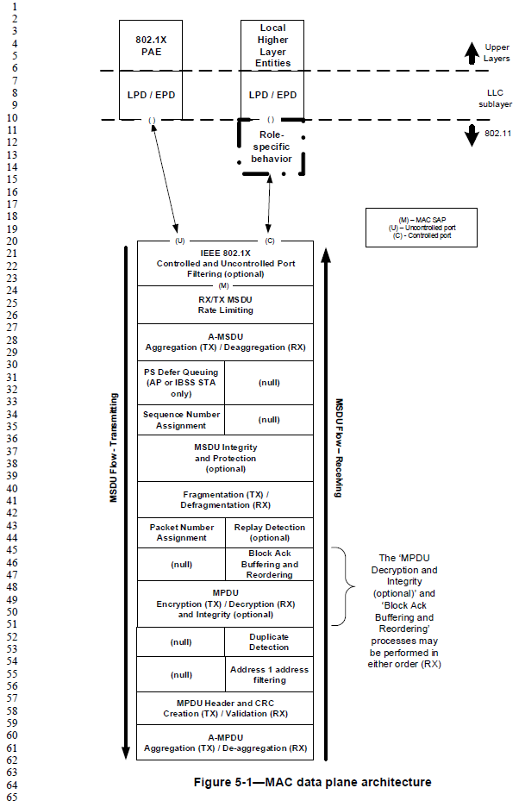
To optimize operation, the following are noted:
- Doing the scoreboarding before (below) MPDU Header and CRC Validation is not appropriate, since blocks which fail this check should be retransmitted to correct the error.
- Doing the scoreboarding before (below) the Address 1 filtering is also not sensible, since the context of the block ack agreement is only between the appropriate STAs (from the ADDBA negotiation).
- Doing the scoreboarding after (above) the Duplicate Detection is acceptable, but would not produce a different result, since recording the reception of a duplicate frame more than once into the scoreboard bitmap, has no effect.
- Doing the scoreboarding after (above) the MPDU Decryption similarly has no effect.
- Doing the scoreboarding after (above) the Block Ack Buffering and Reordering would be inappropriate, since blocks are only delivered out of this functional block in order, meaning only after the oldest one is received. This would defeat the purpose of block ack and the scoreboarding facility. This was also understood by the authors of 10.24.7, when defining the (limited) architecture to have scoreboard before (below) the Buffering and Reordering step.

Thus, it seems that locating the scoreboarding between the "Address 1 address filtering" and "Duplicate Detection" blocks is a reasonable choice.

Proposed Resolution:

ACCEPTED.

As an aid to the editors (and reviewers of this document), the following figures are provided (and will be provided in Visio, separately):

CID 7792:

7792 | RISON, Mark | 1294.18 | 10.3.4.4 | "The AP shall attempt to  deliver one MSDU or MMPDU to the STA that transmitted the PS-Poll frame, using any frame exchange  sequence valid for an individually addressed MSDU or MMPDU." -- can also deliver an A-MSDU | Add, ", A-MSDU" after each "MSDU"

Discussion:

Context:
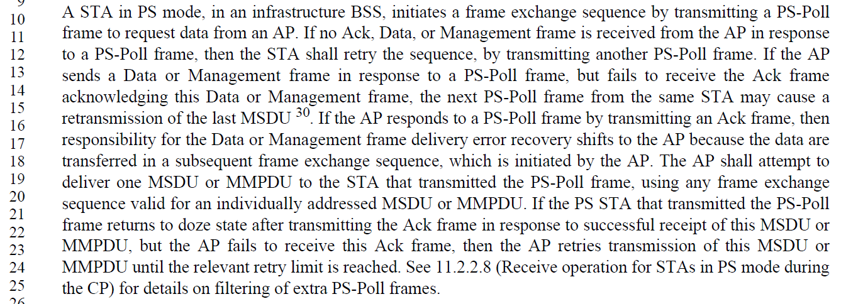

It seems reasonable that an A-MSDU could be used in this context. Certainly, if the A-MSDU contains only one MSDU (the A-MSDU ‘wrapper’ being used for other purposes), then this seems perfectly fine. It is less clear if the polling non-AP STA was expecting and can handle getting multiple MSDUs contained in an A-MSDU. However, since such a STA has negotiated the use of A-MSDU for transmission to it, and the limits on such use, it seems reasonable that those same limits would be workable for the STA while in power save. Thus, the proposal is to accept this change in principle.

Upon further discussion, it was asked if we can just use “individually addressed bufferable unit (BU)” instead of the phrase “MSDU, A-MSDU or MMPDU”? Would that be equivalent, or perhaps even more accurate and correct?

On the face of it, this seems reasonable, since the text here would end up with the phrase “MSDU, A-MSDU or MMPDU, and a BU is defined in clause 3.2 as, “bufferable unit (BU): An MSDU, A-MSDU (HT STAs and DMG STAs only) or bufferable MMPDU”. The slight difference of the adjective “bufferable” before MMPDU does not seem to significantly change the semantics in this context.

Looking at the phrase “individually addressed bufferable unit (BU)” more carefully, it seems that for a BU to have been buffered, it must be individually addressed, per 11.2.2. So, the phrase can be simplified to “buffered BU”.

However, we need to examine the context, also. This comment is about text in the DCF subclause. But, A-MSDUs are transmitted using QoS data frames, per 9.3.2.2.2. And, QoS data frames are generally sent using HCF, since that provides the differentiated channel access per Access Category. So, would an A-MSDU ever be sent with DCF rules, anyway? We need to turn to the text in 10.22, for HCF, where we see that “The EDCA channel access protocol is derived from the DCF procedures described in 10.3 (DCF) ..” Further review shows that there is no additional text in the EDCA subclause relevant to PS-Poll behavior. So, it seems that for EDCA (at least), the DCF foundation is assumed to be used, and thus the changes in 10.3 are in order.

Proposed Resolution:

REVISED

Replace “MSDU or MMPDU” with “buffered BU” at the first occurrence. Replace “MSDU or MMPDU” with “BU” throughout the rest of the paragraph (3 more occurrences). Note to Editor, keep the phrase “individually addressed” (one occurrence) where it is.

CID 7819:

7819 | Hamilton, Mark | 131.29 | 5.1.5.1 | Fix 5.1.5.1 4th paragraph to be in the right order. | Align the order of items in the text with Figure 5-1 (running up the Receiving side of the stack).

Discussion:

Context:
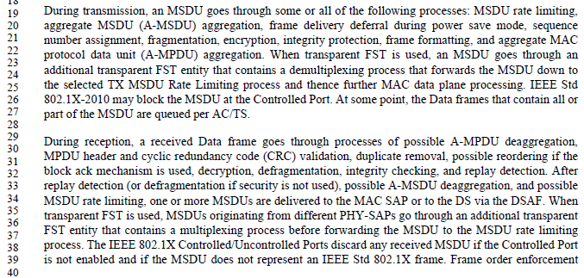

Actually, the third and fourth paragraphs could use order alignment. Also the FST language could be clarified slightly.

Proposed Resolution:

REVISED.

Modify the third and fourth paragraphs of 5.1.5.1 as indicated:

During transmission, an MSDU goes through some or all of the following processes: MSDU rate limiting, aggregate MSDU (A-MSDU) aggregation, frame delivery deferral during power save mode, sequence number assignment, integrity protection, fragmentation, encryption, frame formatting, and aggregate MAC protocol data unit (A-MPDU) aggregation. When transparent FST is used, an MSDU first goes through an additional transparent FST entity that contains a demultiplexing process that forwards the MSDU down to the selected TX MSDU Rate Limiting process, and thence MAC data plane processing per the previous sentence. IEEE Std 802.1X-2010 may block the MSDU at the Controlled Port before the preceding processing occurs. Otherwise, at some point, the Data frames that contain all or part of the MSDU are queued per AC/TS.

During reception, a received Data frame goes through processes of possible A-MPDU deaggregation, MPDU header and cyclic redundancy code (CRC) validation, duplicate removal, decryption, possible reordering if the block ack mechanism is used, replay detection defragmentation, and integrity checking, possible A-MSDU deaggregation, and possible MSDU rate limiting. Then, one or more MSDUs are delivered to the MAC SAP or to the DS via the DSAF. When transparent FST is used, MSDUs originating from different PHY-SAPs go through a final step of a transparent FST entity that contains a multiplexing process before delivering the MSDU . The IEEE 802.1X Controlled/Uncontrolled Ports discard any received MSDU if the Controlled Port is not enabled and if the MSDU does not represent an IEEE Std 802.1X frame.

CID 7826:

7826 | Hamilton, Mark | 653.35 | 9.3.5 | Figure 9-63 is missing some DSes | Insert a box labelled "DS" between the Gate and Portal, and another similar one between the Gate and AP.

Discussion:

Context:
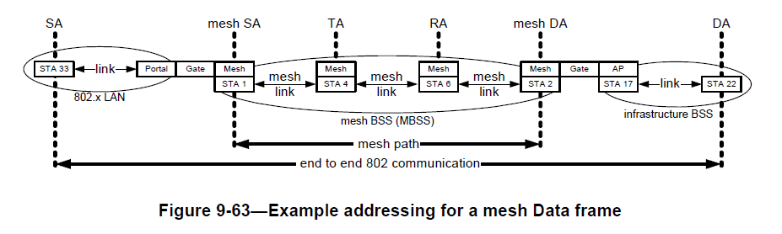

Per 4.3.18.4, mesh gates attach a mesh STA to a DS, see Figures 4-9 and 4-10:
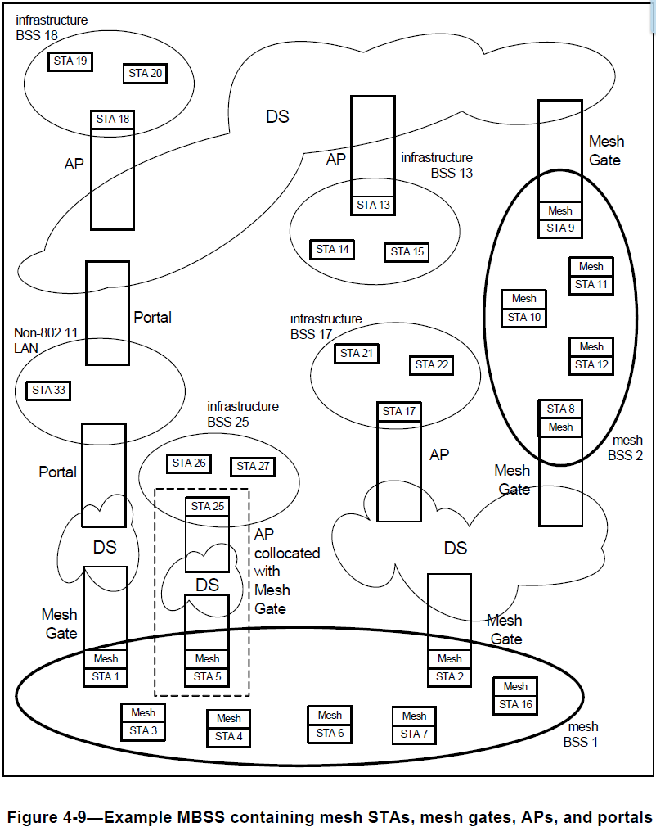
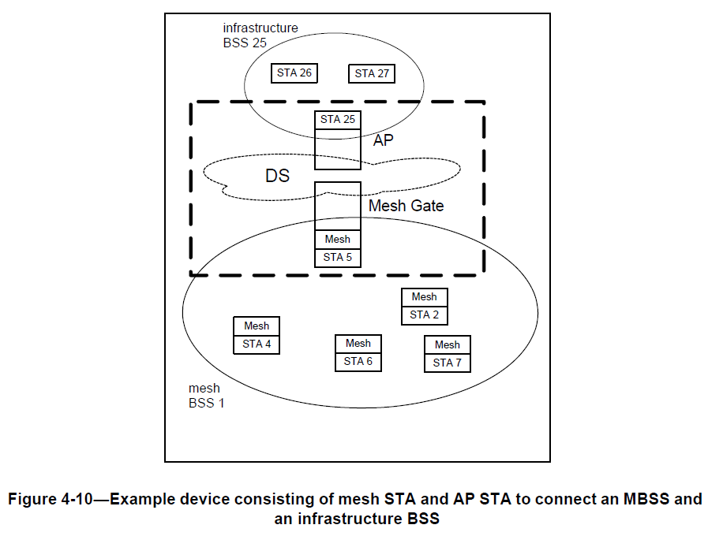

Thus the commenter appears to be correct, a DS is needed in Figure 9-63, even in the collocated mesh gate and AP situation.

Proposed Resolution:

REVISED.

In Figure 9-63, insert a ‘cloud’ labelled "DS" between the Gate and Portal, and another similar one between the Gate and AP (similar to Figure 4-10).

CID 7814:

7814 | Hamilton, Mark | 1357.29 | 10.22.2.7 | There is a problem with this NOTE, in that it describes normative exception behavior that does not seem to be clearly stated in normative text (from three and two paragraphs up, for example). | Change this NOTE to normative text, and mention the exclusion ("except following a PS-Poll" or something similar) in the previous paragraphs two, and three, before this one.

Discussion:

Context (the cited NOTE is at the bottom of the box):
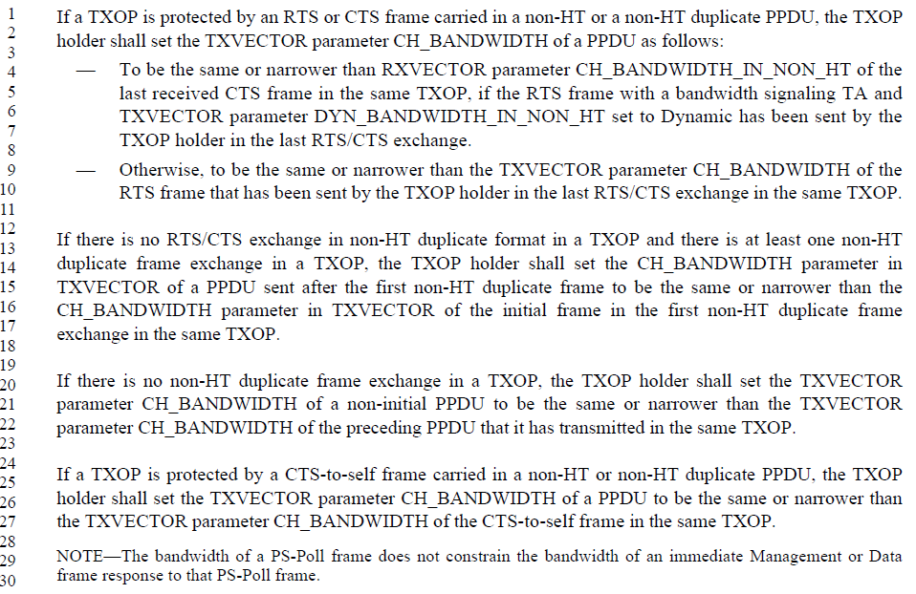

It seems that the paragraphs included in this box cover all the cases:
- RTS/CTS in use: in which case the PS-Poll exception is not relevant, as the RTS or CTS frames will control the bandwidth limitations
- RTS/CTS is not in use and a non-HT duplicate frame exchange is included in the TXOP: in which case the except needs to be noted.
- There is no non-HT duplicate frame exchange in the TXOP: in which case the bandwidth is limited to be the same or narrower than the PPDU previously transmitted by this STA, so the PS-Poll again does not constrain the bandwidth.
- The TXOP is protected by a CTS-to-self: in which case, again, the constraints come from a previous transmission by this STA, not a received PS-Poll.

Thus, only the second case needs the constraint to be explicit.

From Cambridge F2F discussion on April 28: If the NOTE sentence is moved into the text of the second case, it needs to have a “shall” added, so word-smithing is required.

Proposed Resolution:

REVISED.

Delete the NOTE at line 29, and modify the paragraph at line 12, starting “If there is no RTS/CTS exchange” as follows:

If there is no RTS/CTS exchange in non-HT duplicate format in a TXOP, and the TXOP includes at least one non-HT duplicate frame exchange that does not include a PS-Poll, then the TXOP holder shall set the CH_BANDWIDTH parameter in TXVECTOR of a PPDU sent after the first non-HT duplicate frame that is not a PS-Poll to be the same or narrower than the CH_BANDWIDTH parameter in TXVECTOR of the initial frame in the first non-HT duplicate frame exchange in the same TXOP.

CID 7790:

7790 | RISON, Mark | 1289.40 | 10.3.4.2 | It says "pending MPDU". What's one of those? | See CID 6440 resolution

Discussion:

Context:
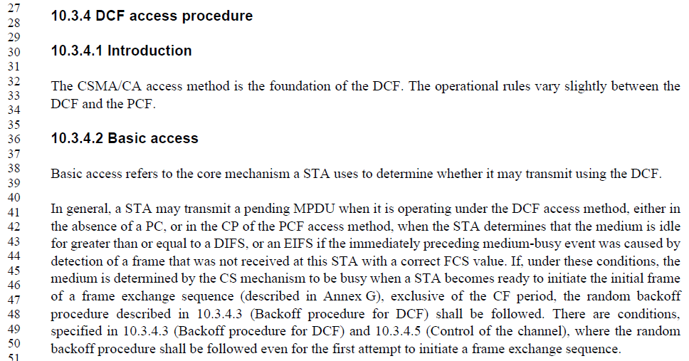

<This is closely related to the ongoing discussion about DCF rules for initial backoff, like CID 7789. In CID 7789, we didn’t directly address the topic, instead modifying the figures to note that there are “specific circumstances” where transmission can start immediately after a DIFS of idle medium (with no backoff time). Has there been agreement on a description of such “specific circumstances” that can be quoted, or reference, from P1289.40? >

See resolution to CID 7086 (11-16/221r3). With that change, can just delete “pending”.

Resulting paragraph at P1289.40, after applying change in 11-16/221r3:
A STA may transmit a pending MPDU when it is operating under the DCF access method, either in the absence of a PC, or in the CP of the PCF access method, when the STA determines that the medium is idle when a frame is queued for transmission, and remains idle for a period of a DIFS, or an EIFS (10.3.2.3.7) from the end of the immediately preceding medium-busy event, whichever is the greater and the backoff timer is zero. Otherwise the random backoff procedure described in 10.3.4.3 (Backoff procedure for DCF) shall be followed.

Proposed Resolution:

REVISED.

After applying the changes in 11-16/221r2 (for CID 7086), delete the word “pending” in the first line of the revised paragraph. (Also changing “a” to “an”.)

CIDs 7150 and 7808:

CID | Commenter | Page | Clause | Comment | Proposed Change
7150 | Stephens, Adrian | 3581.01 | Annex N | Annex N contains terminology that is unique to itself, such as WLAN system and ACM_STA. The understanding of what a DS is has developed and change in the ARC standing committee, resulting in changes to Clause 5. Annex N has been ignored. | Review Annex N and change terminology and architecture to conform to the normative portions of the draft.
7808 | Hamilton, Mark | 96.01 | 4.4 | Review 4.4 through 4.9. How are these descriptions different/aligned with clauses 5, 6, 7 and 8? | Perform technical and editorial review and remove duplication and bring like concepts together.

Discussion:

Both the CIDs are attempting “clean up” work, which seems like a good thing. However, the commenter did not supply details for how to make the changes, so these will require a lot of effort. Further, at this late point in the revision (nearly the last Sponsor Ballot), making sweeping changes to large sections of text is not advisable, even if the intent is to make no technical change. There just isn’t enough time left to get this right, get it thoroughly reviewed to be convinced it is right, and have time for any follow-up clean up on the text.

Proposed Resolution for both CIDs 7150 and 7808:

REJECTED.

The comment fails to identify changes in sufficient detail so that the specific wording of the changes that will satisfy the commenter can be determined.

CID 7146:

7146 | Stephens, Adrian | 134.10 | 5.1.5.1 | A role-specific behaviour is not shown for a DMG relay.  If security on a DMG relay is established for each leg of the relay, then the data-flow must pass through the controlled port, and therefore be shown in the role-specific behaviour. | Determine whether to show a role-specific behaviour for a DMG relay, which would be similar to a mesh STA.

Discussion:

<DMG relay in “link switching” operating mode, or “link cooperation” operating mode?>

<Where is text describing DMG relay (link switching) data forwarding?>

<Link cooperation has to be low in the stack, how do we show/discuss that architecturally?>

Proposed Resolution:

TBD

