IEEE P802.11
Wireless LANs
Resolutions for some comments on 11mc/D5.0
Date: 2016-04-01
Author(s):
Name | Company | Address | Phone | email
Mark Hamilton | Ruckus Wireless | 350 W. Java Dr  Sunnyvale, CA | +1.303.818.8472 | mark.hamilton2152@gmail.com
Abstract
This submission contains proposed resolutions to miscellaneous MAC Ad Hoc comments on REVmc D5.0 Sponsor Ballot.

References herein are to REVmc Draft 5.0.

R0 – initial version, with CIDs: 7131
R1 – proposed resolutions for CIDs: 7807, 7317, 7324, 7378, 7792, and 7378.
R2 – updated per discussion on April 1, 2016 REVmc teleconference. CID 7792 needs more work.

CID 7131:

7131 | Stephens, Adrian | 3581.57 | N.2 | "A STA can also form an integral part of an AP". I thought an AP always contained a STA, otherwise we would have to change all statements of the form "A STA that receives an RTS shall sent a CTS" to say "An AP or STA that receives...". I'm sure we don't want to do that work. | Replace "ACM_STA" by "AP" throughout Annex N, and delete the para at line 57.

Discussion:

Yes, an AP always contains a STA. But, not all STAs are contained within an AP (there are other STAs, in clients, etc., of course). So, it seems correct to say that “A STA can also form an integral part of an AP”.

But, if this is too confusing, would it be better to say, “An AP is comprised of a STA and other functions outside the STA known as the DSAF”? If we do that, we’ll need to describe the DSAF here, which is probably a good idea, but is the start of the slippery slope toward the resolution to CID 7150 – to rewrite Annex N to align better with the latest normative text description of an AP. I suggest we defer going down to this slope, to handle it as part of CID 7150.

As for replacing “ACM_STA” with “AP”, those are not the same thing. This is consistent with the normative description of an AP, as comprising a STA (the “ACM_STA” in Annex N) and a DSAF. However, there are sentences/phrases in Annex N which confuse the idea that the AP contains an ACM_STA, and those could be corrected/clarified:

At 3582.36:
Often the functions of an AP, (which includes an ACM_STA), a DS, and a portal, are combined into a single device, referred to in this annex as an access unit (AU).

At 3583.61:
The primary functions of the WLAN system, … are provided by the ACM_STA, AP, and DS entities

The rest of the uses of ACM_STA seem to be consistent with the current and normative structures/definitions.

Proposed Resolution:

REVISED.

Modify at 3582.36 as shown:
Often the functions of an AP, (which includes an ACM_STA), a DS, and a portal, are combined into a single device, referred to in this annex as an access unit (AU).
Modify at 3583.61 as shown:
The primary functions of the WLAN system, … are provided by the ACM_STA, AP, and DS entities

CID 7807:

7807 | Hamilton, Mark | 96.06 | 4.4.1 | Why is the first paragraph of 4.4.1 here? It (and the first sentence of the second paragraph) should be the first paragraph of 4.4.4. | Move the first paragraph, and first sentence of the second paragraph, of 4.4.1 to be the start of subclause 4.4.4 instead. Replace the first sentence of the second paragraph with, "IEEE Std 802.11 explicilty does not specify the details of implementation of the architectural components."

Discussion:

Context:
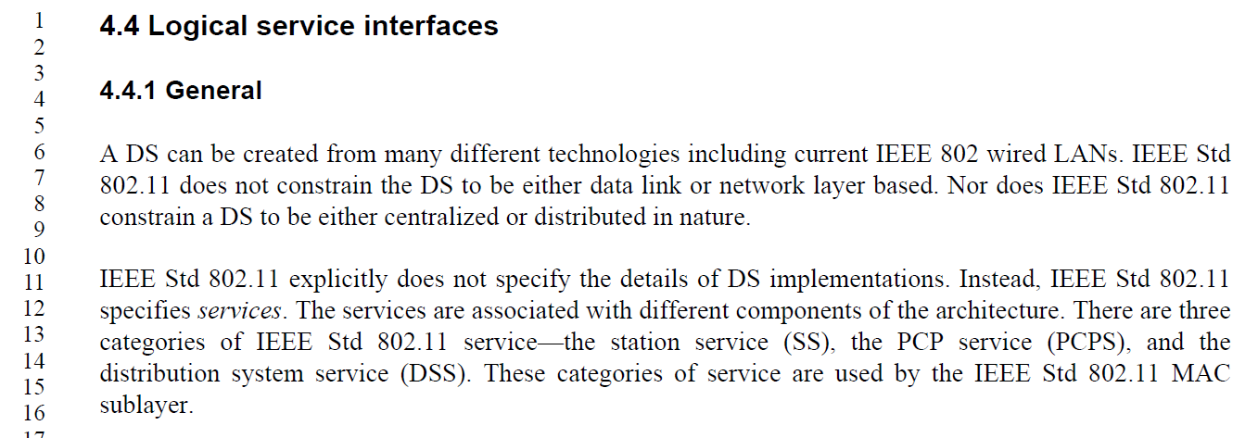

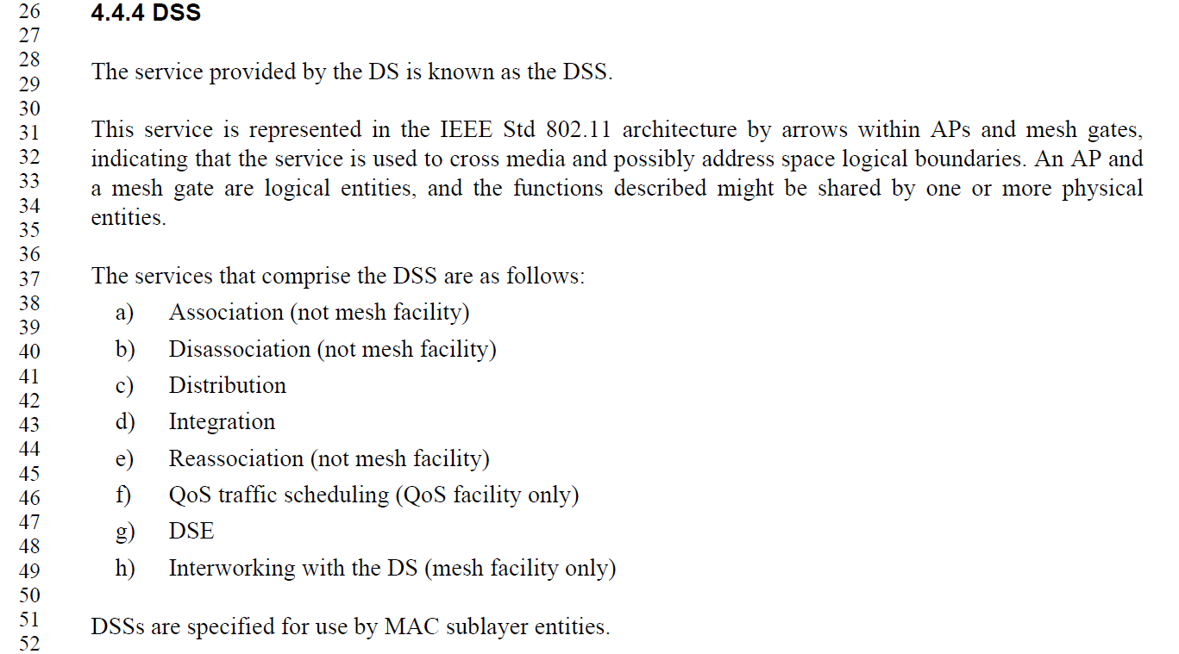

Agree, that the first paragraph and first sentence of the second paragraph currently in 4.4.1 are specific to the DS, and make more sense in 4.4.4. Move these sentences to be near the start (but not literally the start) of subclause 4.4.4, with modification for flow:

The service provided by the DS is known as the DSS. IEEE Std 802.11 explicitly does not specify the details of DS implementations structure. Instead, IEEE Std 802.11 specifies the services that are provided by a DS implementation. A DS can be created from many different technologies including current IEEE 802 wired LANs. IEEE Std 802.11 does not constrain the DS to be either data link or network layer based. Nor does IEEE Std 802.11 constrain a DS to be either centralized or distributed in nature.

IEEE Std 802.11 explicitly does not specify the details of DS implementations. Instead, IEEE Std 802.11 specifies services.

Note that the second sentence of the second paragraph in 4.4.1 (which would become the start of 4.4.1 also needs modification for flow:

IEEE Std 802.11 explicitly does not specify the details of DS implementations. Instead, IEEE Std 802.11 specifies services to aid understanding how the architectural components are logically organized. The services are associated with different components of the architecture. There are three categories of IEEE Std 802.11 service—the station service (SS), the PCP service (PCPS), and the distribution system service (DSS). These categories of service are used by the IEEE Std 802.11 MAC sublayer.

Proposed Resolution:

REVISED.

Make changes as shown in 11-16/290r2, for CID 7807. These changes effect the commenter’s intent, with additional editorial clean up.

CID 7317:

7317 | RISON, Mark | 1554.34 | 11.1.2.1 | "A STA contained in the AP or PCP shall initialize its TSF timer independently of any simultaneously started APs or PCPs" -- this cannot in general be acheved, unless the APs/PCPs are coordinated. Needs to be restricted to managed ("enterprise/corporate") contexts, but this is arguably out of scope of the standard anyway | Change to "A STA contained in the AP or PCP shall initialize its TSF timer independently of any simultaneously started APs or PCPs it is aware of", or delete

Discussion:

Context:
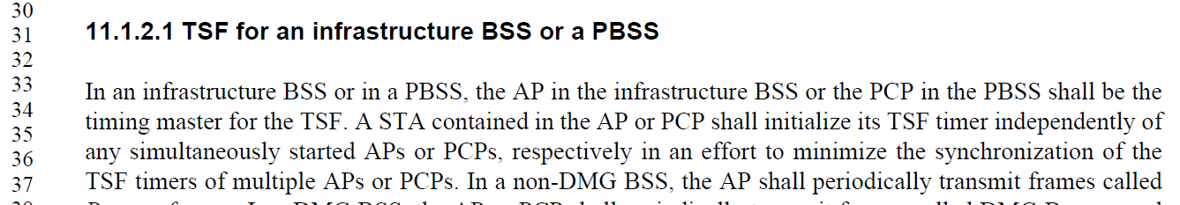

Agree, in concept. But, there is no reason to restrict this “shall” to synchronizing with other APs or PCPs that were initialized at the same time. What we really are trying to achieve is no implementation-caused synchronization of TSFs across the infrastructure BSS (or PBSS) regardless of startup methods or timing.

Proposed Resolution:

REVISED.

Change the sentence, as shown:
A STA contained in the AP or PCP shall independently initialize its TSF timer independently of any simultaneously started APs or PCPs, respectively in an effort to minimize the synchronization of the TSF timers of multiple APs or PCPs.

CID 7324:

7324 | RISON, Mark | 48.30 | 9.4.2.2 | "When the UTF-8 SSID subfield of the Extended Capabilities element is equal to 1 in the frame that includes the SSID element, the SSID is interpreted using UTF-8 encoding." -- but the extended caps are static so it doesn't have to be in the same frame | Delete the sentence

Discussion:

Context (from REVmc D5.0 page 730):
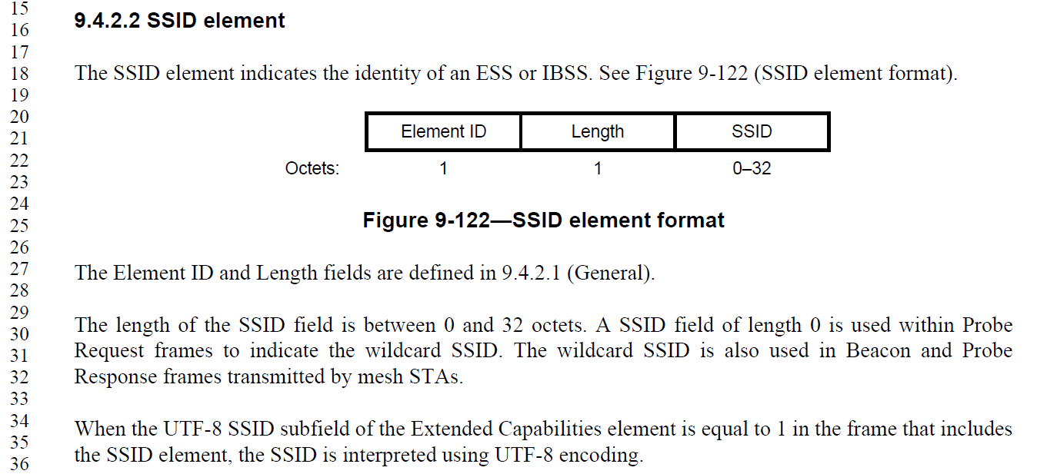

Agree, in concept. There are uses of the SSID element in contexts other than the Beacon that also carries the Extended Capabilities element (with the UTF-8 SSID capability bit). The encoding of the SSID is presumably intended to be static based on whether the UTF-8 SSID capability is in effect, even if not present in the same frame.

However, the sentence cannot simply be deleted, as that would lose the formatting requirement that applies when the UTF-8 SSID capability is in effect. Further, this is only aid to the reader for the format of the SSID field, in the frame format clause, so simply deleting it is not the best approach.

Proposed Resolution:

REVISED.

Change the sentence at P730.34, as shown:
The SSID is interpreted using UTF-8 encoding Wwhen either the UTF-8 SSID subfield of the Extended Capabilities element is present in the frame that includes the SSID element and the UTF-8 SSID subfield is equal to 1, or when the Extended Capabilities element is not present in the same frame and the UTF-8 SSID subfield is equal to 1 in the most recently received Extended Capabilities element from the same STA, in the frame that includes the SSID element, the SSID is interpreted using UTF-8 encoding.

CID 7378:

7378 | RISON, Mark | 126.47 | 4.10.7 | It says "PMK or PSK key identifier" -- what's a pairwise shared key key identifier? Also at line 49 | Change both to "PMK identifier"

Discussion:

Context:
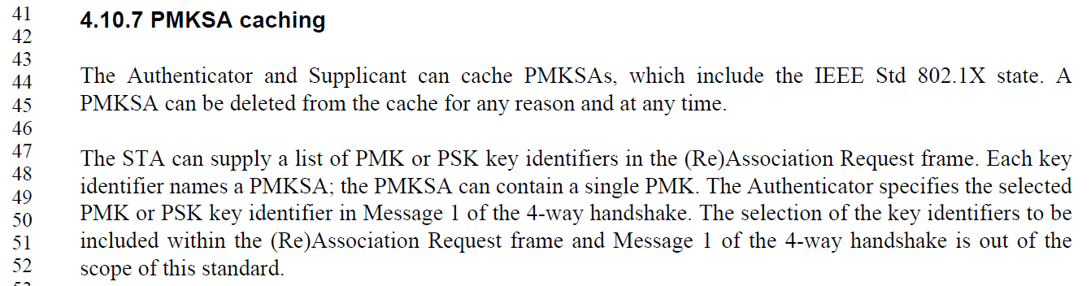

Agree, in concept. Clarify the instructions, as shown below.
.

Proposed Resolution:

REVISED.

Change both occurrences of “PMK or PSK key identifiers” to “PMK identifiers” and “PMK or PSK key identifier” to “PMK identifier” (P126.47 and P126.49).

CID 7658:

7658 | RISON, Mark | 79.32 | 4.3.13 | What about dot11VHTExtendedNSSBWCapable? | Add a line "--- "dot11TVHTExtendedNSSBWCapable" replaces "dot11VHTExtendedNSSBWCapable".

Discussion:

Context (from REVmc D5.0 page 730):
. . .
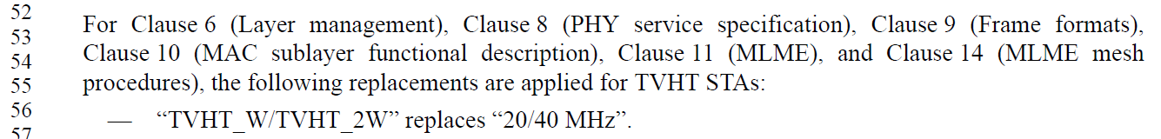
. . .
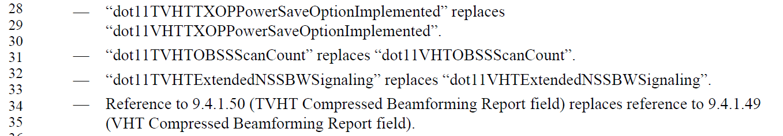

On a quick scan, …ExtendedNSSBWCapable appears to be different from (for example) …OBSSScanCount, in that dot11VHTExtendedNSSBWCapable is already explicitly called out fairly broadly in clauses 9, 10 and 11. It is not quickly apparent that there is a problem with this MIB attribute not being in the list in 4.3.13.

Proposed Resolution:

REJECTED.

The commenter did not provide sufficient evidence that this particular MIB attribute needs to be included in the list in 4.3.13. That is, just because the attribute in not in this list, a missing behavioural requirement has not been identified.

CID 7792:

7792 | RISON, Mark | 1294.18 | 10.3.4.4 | "The AP shall attempt to  deliver one MSDU or MMPDU to the STA that transmitted the PS-Poll frame, using any frame exchange  sequence valid for an individually addressed MSDU or MMPDU." -- can also deliver an A-MSDU | Add, ", A-MSDU" after each "MSDU"

Discussion:

Context:
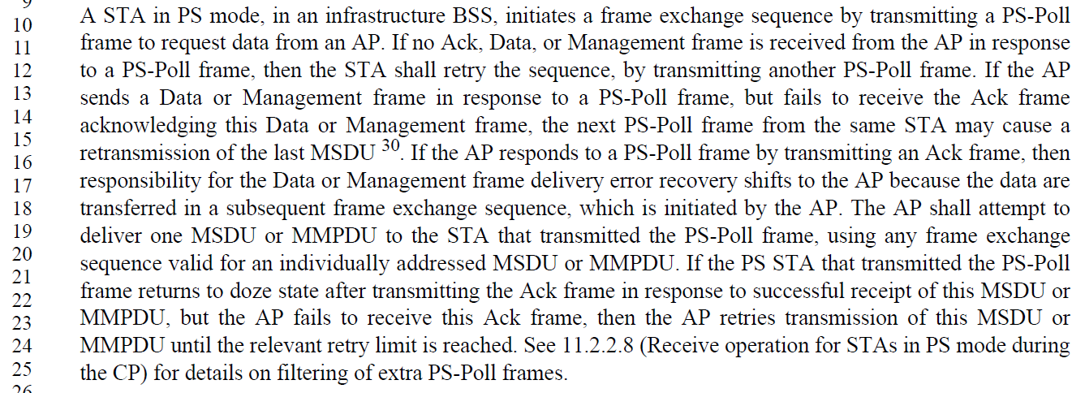

It seems reasonable that an A-MSDU could be used in this context. Certainly, if the A-MSDU contains only one MSDU (the A-MSDU ‘wrapper’ being used for other purposes), then this seems perfectly fine. It is less clear if the polling non-AP STA was expecting and can handle getting multiple MSDUs contained in an A-MSDU. However, since such a STA has negotiated the use of A-MSDU for transmission to it, and the limits on such use, it seems reasonable that those same limits would be workable for the STA while in power save. Thus, the proposal is to accept this change.

Proposed Resolution:

ACCEPTED.

Can we just use “BU” instead?

No proposed resolution, yet:

CID | Commenter | Page | Clause | Comment | Proposed Change
7146 | Stephens, Adrian | 134.10 | 5.1.5.1 | A role-specific behaviour is not shown for a DMG relay.  If security on a DMG relay is established for each leg of the relay, then the data-flow must pass through the controlled port, and therefore be shown in the role-specific behaviour. | Determine whether to show a role-specific behaviour for a DMG relay, which would be similar to a mesh STA.
7150 | Stephens, Adrian | 3581.01 | Annex N | Annex N contains terminology that is unique to itself, such as WLAN system and ACM_STA. The understanding of what a DS is has developed and change in the ARC standing committee, resulting in changes to Clause 5. Annex N has been ignored. | Review Annex N and change terminology and architecture to conform to the normative portions of the draft.
7069 | Stephens, Adrian | 854.62 | 9.4.2.31 | " An incoming MSDU that is not classified to a particular TS may be classified to another active TS based on the frame classifier for that TS." - normative verb in clause 9 | Move normative behaviour to clause 10/11.
7792 | RISON, Mark | 1294.18 | 10.3.4.4 | "The AP shall attempt to  deliver one MSDU or MMPDU to the STA that transmitted the PS-Poll frame, using any frame exchange  sequence valid for an individually addressed MSDU or MMPDU." -- can also deliver an A-MSDU | Add, ", A-MSDU" after each "MSDU"
7553 | RISON, Mark | 104.50 | 4.5.4.3 | Does "PMKSA caching" include "mesh PMKSA caching", given that a "mesh PMKSA" is not a type of "PMKSA"? Is mesh PMKSA caching even defined? | Delete "or mesh PMKSA" at the end of the sentence
7808 | Hamilton, Mark | 96.01 | 4.4 | Review 4.4 through 4.9. How are these descriptions different/aligned with clauses 5, 6, 7 and 8? | Perform technical and editorial review and remove duplication and bring like concepts together.
7814 | Hamilton, Mark | 1357.29 | 10.22.2.7 | There is a problem with this NOTE, in that it describes normative exception behavior that does not seem to be clearly stated in normative text (from three and two paragraphs up, for example). | Change this NOTE to normative text, and mention the exclusion ("except following a PS-Poll" or something similar) in the previous paragraphs two, and three, before this one.
7816 | Hamilton, Mark | 64.19 | 4.2.5 | 4.2.5 says 802.11 has to act like a _wired_ network. No, it has to act like an 802 network (including 802.1 MAC Service requirements). | Delete "wired"
7817 | Hamilton, Mark | 133.54 | 5.1.5.1 | In Figure 5-1, put BA sscoreboarding between Address 1 address filtering and Duplicate Detection. | In Figure 5-1, add a block to the Receiving flow side for "Block Ack scoreboarding", between "Address 1 address filtering" and "Duplicate Detection". Use "(null)" for the transmitting flow side. Same thing in Figure 5-2.
7819 | Hamilton, Mark | 131.29 | 5.1.5.1 | Fix 5.1.5.1 4th paragraph to be in the right order. | Align the order of items in the text with Figure 5-1 (running up the Receiving side of the stack).
7826 | Hamilton, Mark | 653.35 | 9.3.5 | Figure 9-63 is missing some DSes | Insert a box labelled "DS" between the Gate and Portal, and another similar one between the Gate and AP.
7790 | RISON, Mark | 1289.40 | 10.3.4.2 | It says "pending MPDU". What's one of those? | See CID 6440 resolution

