IEEE P802.11
Wireless LANs
Reconsideraton of resolution to CID 5226
Date: 2016-02-24
Author(s):
Name | Affiliation | Address | Phone | email
Tomoko Adachi | Toshiba Corporation |  |  | tomo.adachi@toshiba.co.jp
Masahiro Sekiya | Toshiba Corporation
Adrian Stephens | Intel Corporation

Abstract
This document calls for reconsideration of the resolution to CID 5226.

CID 5226
This comment was submitted to the initial SB for P802.11REVmc D4.0.
CID | Page | Comment | Proposed Change
5226 | 2910.00 | Isn't dot11RSNABIPMICErrors the same with dot11RSNAStatsCMACICVErrors? The reason of thinking like that is because, in 11.4.4.6 BIP reception d), it is said that "... If the result does not match the received MIC value, then the receiver shall discard the frame and increment the *dot11RSNAStatsCMACICVErrors* counter by 1, and terminate BIP processing for this reception." and BIP uses CMAC integrity check. The parameter, dot11RSNAStatsCMACICVErrors, is the counter that is used when there is an error in BIP CMAC integrity check and dot11RSNABIPMICErrors seems to be unnecessary. | Delete dot11RSNABIPMICErrors.

Resolution to CID 5226 in 15/0532r30
And the following resolution to CID 5226 was approved as Motion 186:

Resolution
REVISED (GEN: 2015-12-10 20:58:10Z) Replace dot11RSNAStatsCMACICVErrors with dot11RSNABIPMICErrors AND delete 2909.51 to .61

The intent of the resolution is to use dot11RSNABIPMICErrors instead of dot11RSNAStatsCMACICVErrors and delete the duplicates.

Problems in current D5.1

Body text
There are two places in the body text where dot11RSNAStatsCMACICVErrors is still remaining.
- p.808.11, Table 9-113
- p.1988.61, clause 12.5.4.6 d)

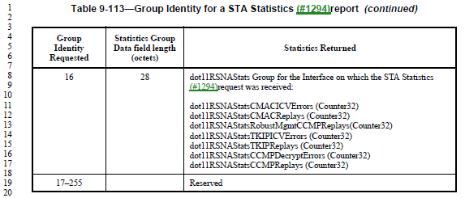
Fig. 1 Snapshot around p.808.11

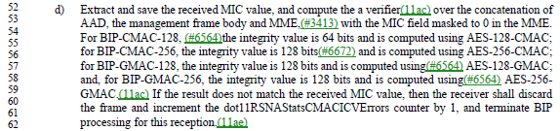
Fig. 2 Snapshot around p.1988.61

- These should be replaced with dot11RSNABIPMICErrors.

MIB
In MIB (Annex C), there are duplicates as a result of (probably) auto-replacements.
- in p.3013.26 and .29, dot11RSNABIPMICErrors appears twice in Dot11RSNAStatsEntry.
- in p.3427.23 and .26, dot11RSNABIPMICErrors appears twice in Dot11ProtectedManagementFrameGroupEntry.
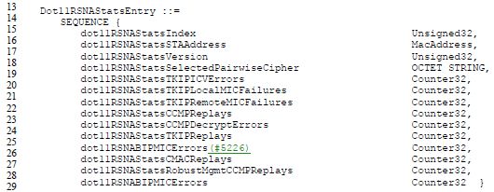
Fig. 3 Snapshot around p.3013.26 and .29

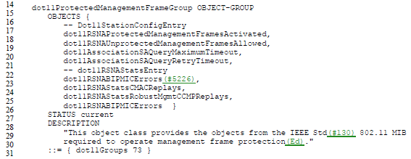
Fig. 4 Snapshot around p.3427.23 and .26

- Either one should be deleted from each of the entry lists.
As the definition of dot11RSNABIPMICErrors appears after that of dot11RSNAStatsRobustMgmtCCMPReplays, it seems to be better to delete the first one from each of the lists.

Proposed Resolution
Replace dot11RSNAStatsCMACICVErrors which appears in the following places in REVmc D5.1 with dot11RSNABIPMICErrors.
- p.808.11, Table 9-113
- p.1988.61, clause 12.5.4.6 d)

Delete the following rows in REVmc D5.1:
- p.3013.26
- p.3427.23
References:
- IEEE P802.11-REVmc/D4.0
- IEEE P802.11-REVmc/D5.0
- IEEE P802.11-REVmc/D5.1
- doc.: IEEE 802.11-15/0532r30, “REVmc Sponsor Ballot Comments”

